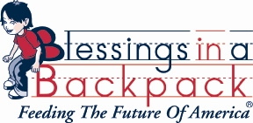
Most Needed Food Items
Hearty soups
Pastas in a can (spegettio’s with meatballs)
Mac and Cheese
Beef Stews
Oatmeal
Apple sauce
Fruit cups
Ramen noodles
Slim Jims
Individual cereal cups
Cheese Crackers
***Jars of peanut butter and jelly (ONLY IN PLASTIC CONTANERS)
Any questions please contact Jennifer Doerrer, Blessings in a Backpack Program Coordinator for Green Local Schools.
jaraddoerr@yahoo.com
Home Phone: 330 896-3085

