What am I paying all this dues for? What good is the Union anyways? I don’t get in trouble so I don’t need the union. Dues seem like a waste of money. I could go on and on with the negative things I hear some of our members say about the union. I thought now might be a good time to remind us all why our union is so important.

Let me start by stating the obvious. The most visible thing our union does is negotiate contracts for us that include pay increases and other benefits. I am quite confident that the Postal Service would love to pay us less to do our jobs every day. I sincerely doubt that when the NALC and USPS sat down to negotiate our latest contract that the pay increases were the Postal Services idea. Granted negotiation is a give and take, we still came out ahead in this contract in my opinion.
Next let’s talk dues. Five minutes or less a day. That’s how long you have to work to pay for your dues. Your dues helps provide representation during interviews and disciple, training and support for our members, events, local and national level negations, assistance in navigating workman’s comp issues and so much more! That’s five minutes well spent.
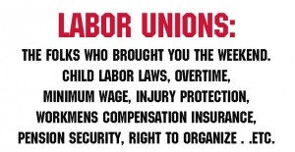
How about discipline? Everyone thinks that union is just there to defend your dirt bag coworkers who don’t deserve their jobs, right? Not true. Life happens. Sometimes bad choices get made but we live and we learn. Everyone deserves a second chance and the union is there to hopefully help you get one. Everyone thinks that will never be them though. They are a good worker so they will never get in trouble. You would be surprised to know how many of your fellow carriers have found themselves in hot water whether it was warranted or not. It could be for attendance because you were taking care of your sick family member or for getting hurt on the job. No one plans to get in trouble but it sure is nice to have “a guy” in your corner when you do.
Then there is the myth that the union is a click and that they don’t really do anything. All the officers and positions are elected or appointed by elected parties. They are voted into office by you, the member, at union meetings. If you don’t like what you see, get involved. Run for office. Come to meetings. Voice your opinion in a constructive way. Help the greater good.
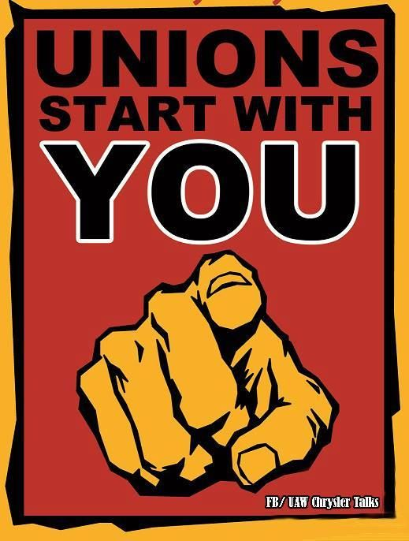
The very definition of a union is “an organized association of workers formed to protect and further their rights and interests.”That’s you! The worker. The union is you. (I feel like I am explaining the term “current resident” to the customer who keeps throwing a letter back in the box.) The union is not just a small group of volunteers, its all of us working together to make work not suck so bad.

There are many more benefits of being a proud union member then those listed above but I just wanted to highlight at least a few.
It’s tough to be one of the folks volunteering time to help our union branch succeed and hear some brothers and sisters speak negatively about it. Please keep in mind that your words are infectious. The point of being a union member is to work together so we can all reap a greater reward. I hope in the future we can work on sowing seeds of solidarity and unity instead.

