Health Insurance - How to enroll
Plan comparisons opm.gov or Benefeds.com
- log onto liteblue.gov
- Click on My HR
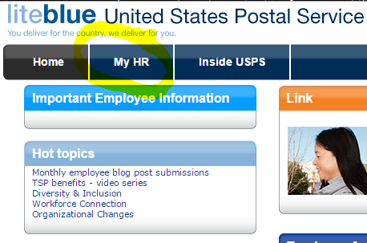
- Click on whichever benefits you are interested in learning more about. In this instance we will do health benefits.
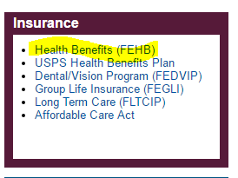
- Scroll down and select the PostalEase link
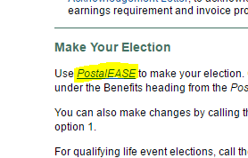

- Click I agree
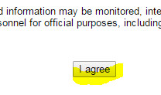
- Enter your liteblue log in info again and click submit
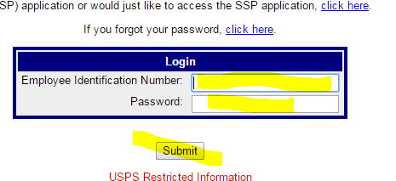

- Click on Federal Employees Health Benefits
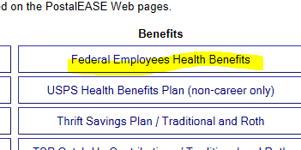
- Scroll to bottom of page and click continue
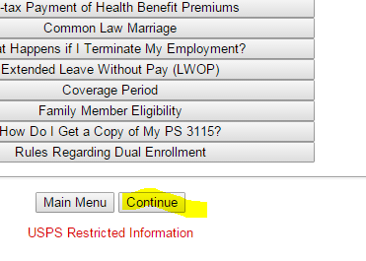
- Click on Current Year
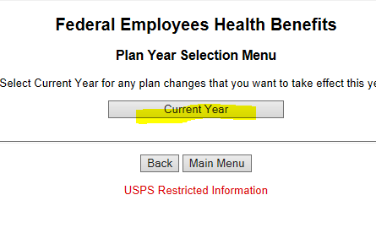
- Click on New Hire
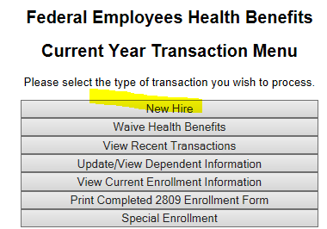

NALC Health Plan Codes:
