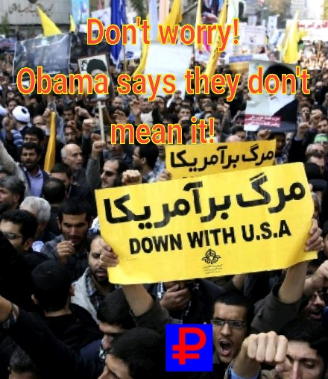

**Be On The Lookout…**

**For Obama’s Backbone!**

In keeping with Obama’s typical lack of action-when it counts-he has once again list his nerve with Iran. Iran has violated at least 2 UN resolutions by test firing ballistic missiles. Also, they fired rockets near a US aircraft carrier in the Persian Gulf.

A normal American president would react by, at a minimum, immediately ordering crushing sanctions on Iran and voiding the useless Iran Nuclear Deal. But, we don’t have a normal president. We have a pathetic jellyfish that will stoop to any level to save his precious Iran Deal. This laughable deal is part of his “legacy”, and he doesn’t give a damn how many people will die because of it. He just wants it to stay until he is out of office. His co-conspirators from the White House have announced Obama is not ready to impose sanctions on Iran. Again, Obama has made America look weak to our enemies. Hopefully, they will get an education on American strength in 2017.

**ISIS: Khmer Rouge 2.0**

**This weeks “Religion of peace” quote:**

“It is permissible to have sexual intercourse with the female captive. Allah the all mighty said”

Blood soaked fanatical freak groups are nothing new. Unfortunately, we have seen this barbarism many times before. There are many similarities between the crazies in ISIS and the crazies in the Khmer Rouge. The Khmer Rouge’s reign of terror lasted over a decade. However, the bloodiest phase was between 1975 and 1980-when they controlled all of Cambodia.

The Khmer Rouge systematically murdered anyone who displeased them or didn’t show sufficient enthusiasm for their disturbed world view. Sound familiar? One of the major differences between ISIS and the Khmer Rouge is their ultimate goals. While the Khmer Rouge was content with making their countrymen and their neighboring countries miserable, ISIS wishes to spread its death and destruction worldwide.

ISIS is a global threat, as opposed to a limited regional threat like the Khmer Rouge. However, the results are the same: lots of dead innocent people. The way the Khmer Rouge was defeated was by direct military action from Vietnam (who were tired of tired of the Khmer Rouge’s bloody border incursions). We should learn from this Cambodian tragedy. The only way to deal with blood-crazed psychos, is to kill them.

|  |  |  |
| --- | --- | --- |
|  | **Khmer Rouge** | **ISIS** |
| **Murdered** | 1.7 Million | Thousands, and counting |
| **Ruler** | Pol Pot | Abu Bark al-Baghdadi |
| **U.N. Reaction** | Gave Khmer Rouge a seat at the UN until 1993-14 years after they were removed from power | Said they do kinda bad things-that’s it. |
| **Goal** | Wanted a classless society | Wants a worldwide Islamic Caliphate |

**Did you know?** Now days, 99.9% of people photographed holding a severed head are Muslim.

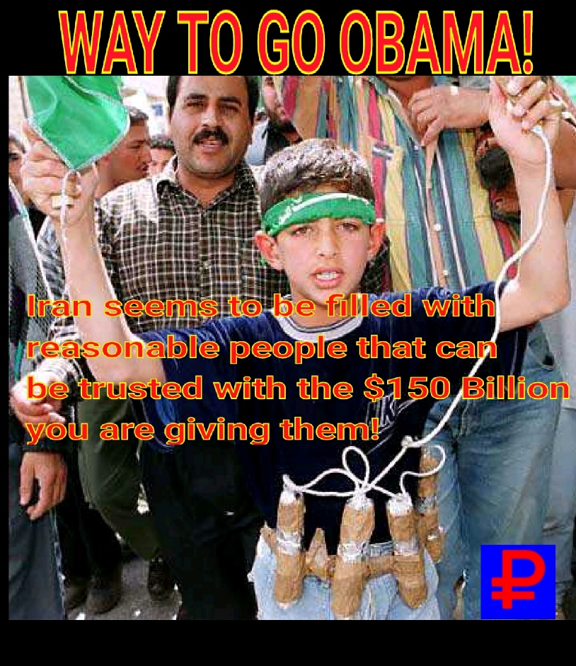

**Written by Patrick Hostis-Owner of Anti-Jihad News**

**Send Comments to:** [**patrick_hostis@yahoo.com**](mailto:patrick_hostis@yahoo.com)