What’s my number?

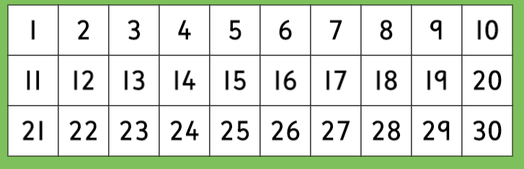
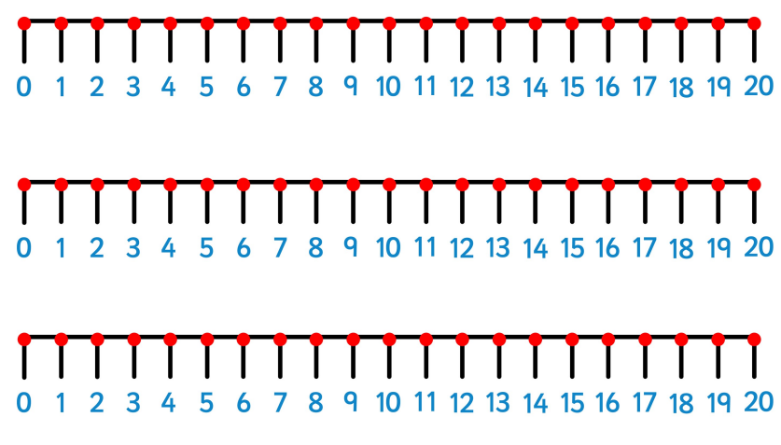

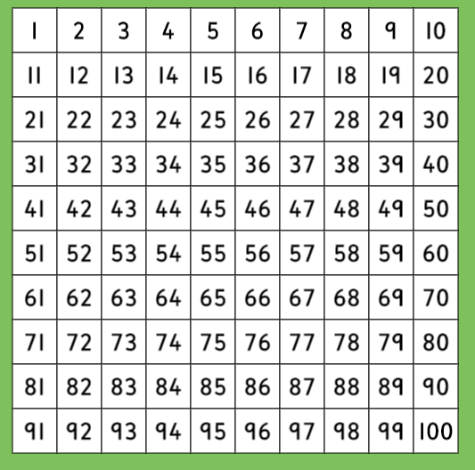
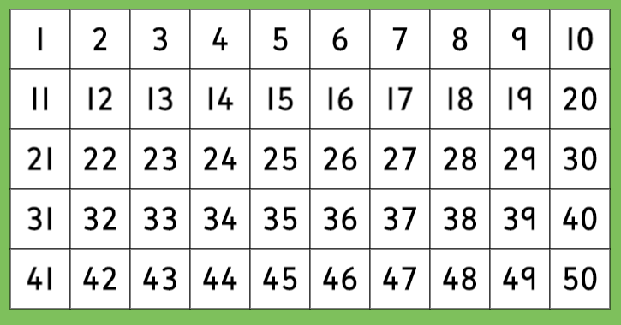

Some questions to ask

Is it a 1 digit number?
Is it a 2 digit number?
Is it bigger than……?
Is it smaller than….?
Is it odd?
Is it even?
Do I say it when I count in 2s?
Do I say it when I count in 5s?
Do I say it when I count in 10s?
Does it come before…..?
Does it come after……?
Is it greater than…..?
Is it less than…..?
Is it between……. And …….?
How many ones does it have?
How many tens does it have?

