How to grow a runner bean plant
Here’s how we sowed and planted our beans.
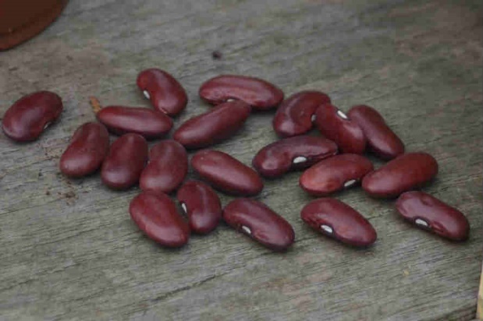
Take 20 pots, sowing compost beans seeds and a spoon. I always find that children will be able to handle a spoon easier than a trowel.
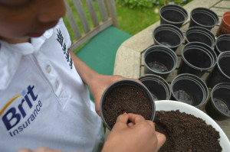
Fill each pot with the sowing compost and press down ensure you leave at least 1/2 an inch space from the top ofthe pot. This makes watering easier. Push in one bean per pot by about 4 cms making sure that it is covered with soil.
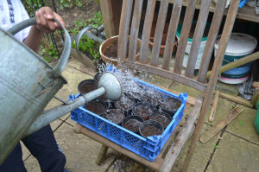
Water in the beans and water regularly in the next couple of weeks. If sowing before the middle of May keep your beans under cover. A couple of days before you are due to plant them out leave them outside to harden off.
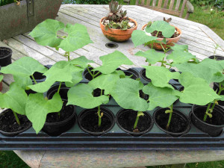
Prepare your ground for transplanting your bean. You will need poles for green beans and runner beans, but not for dwarf beans.
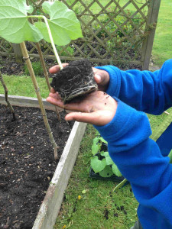
Many seedlings are tiny and very delicate and hence very difficult for children to transplant. The size and robustness of beans seedling make them very easy for children to handle.
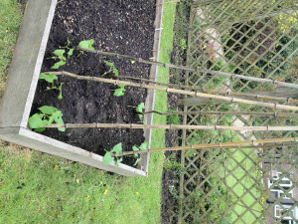
You can also save a few seeds for next year. Allow a few pods to grow on to maturity. Once the pods have turned a pale straw colour they are ready to pick. Lift the plants and shell the pods. Place the dried seed beans in envelopes, writing the variety and date of harvest on the outside, and keep the seeds until next spring in a dark, cool, dry place.
