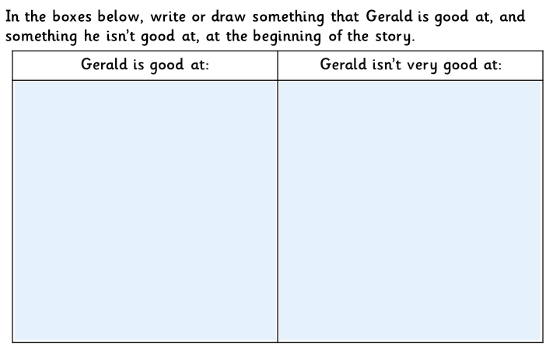
Giraffes Can’t Dance

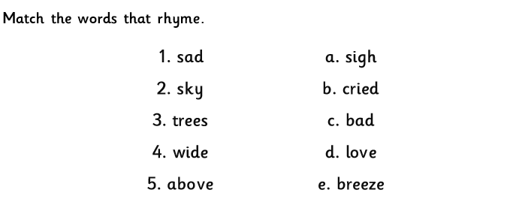

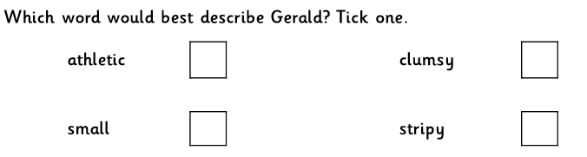

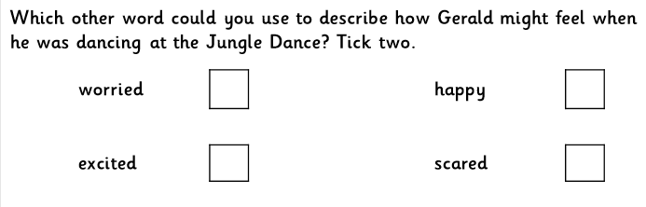

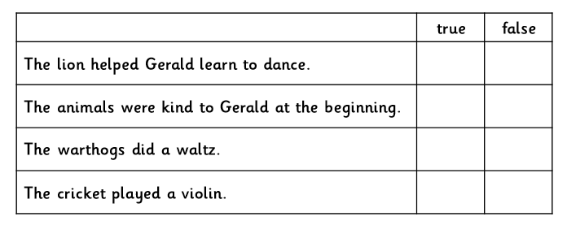

Year 2s – Extra Challenge Questions
Why did Gerald feel sad about the dance? How do you know?
What does ‘swallowed bravely’ mean?
What do you think the cricket means by needing a different song?

