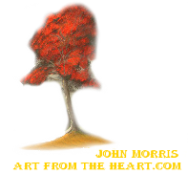
Art School
Course Aims
Week 1.
Introduction and what do you already know?
- Course aims
- How to paint the sky and the water.
- 15 mins at the end to ask questions and chat. While paintings are drying
Week 2
How to paint clouds and mountains
- Adding clouds into the sky
-Thinking about the different shapes of mountains.
- Laying the base colour for the mountain
- 15 mins at the end to ask questions and chat. While paintings are drying
Week 3
Snow and mist
-How to lay snow on the mountains
-Creating mist at the base of the mountains
- 15 mins at the end to ask questions and chat. While paintings are drying
Week 4
Trees from a distance and laying the land
- How to paint trees in the distance, thinking about colour and shape. The further things are away from you the lighter they are.
- How to create the shadow colour for next week’s lesson where we will be looking at how to paint grass.
- 15 mins at the end to ask questions and chat. While paintings are drying
Week 5
Grass painting
- How to create effective looking grass setting in your painting
Week six
- Evergreen trees close up.
- Shape and definition
- Finishing up the painting.
- Review what we have learned in six weeks.

