FRIDAY BPW REAL ESTATE LISTINGS
The next St. Louis Sheriff’s Land Tax Sale is Tuesday, August 26 at 9:00 am in the lobby of the Civil Courts Building (10 N Tucker Blvd). For more information, please visit the City’s site: https://www.stlouis-mo.gov/government/departments/sheriff/Land-Tax-Sales.cfm

REGISTER TODAY! The Civil Rights Enforcement Agency (CREA) is hosting a fair housing conference on September 5, 2014 at the Sheraton Downtown Hotel. Registration deadline is Friday, August 29. The website for conference registration is www.stlcrea.org.

Check out these for-sale properties in Benton Park West! Be sure to share this with friends, family, or anyone interested in investing in our neighborhood. Thank you!

FEATURED LISTINGS

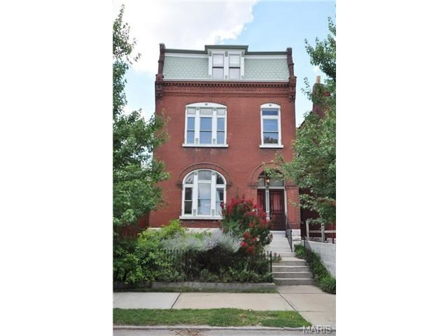
3219 Iowa Avenue, St. Louis, MO 63118 3 beds, 3.5 bath, 2,907 square feet - $325,000

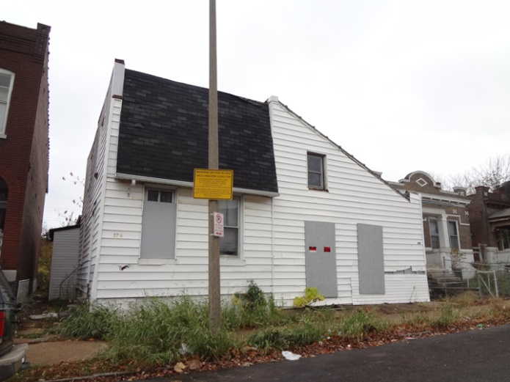LRA PROPERTY: 2716 Utah Street 2 Beds, 1 bath, 1,020 square feet - $1,500
SINGLE FAMILIES – PRIVATE LISTINGS
2854 Arsenal Street, St. Louis, MO 63118 3 beds, 2 baths, 1,940 sq. ft. - $30,000

3128 California Ave, St. Louis, MO 63118 2 beds, 1 bath, 850 sq. ft. - $35,000

3168 California Avenue, St. Louis, MO 63118 5 beds, 2 baths, 1,840 sq. ft. - $40,000

3170 California Avenue, St. Louis, MO 63118 63118 5 beds, 2 baths, 1,840 sq. ft. - $40,000

3258 Compton, St Louis, MO 63118 3 beds, 2.5 bath, 1,100 square feet - $115,000

3249 South Jefferson Avenue, St Louis, MO 63118 4 beds, 1.5 baths, 1,552 square feet - $70,000

3435 Louisiana Avenue, St. Louis, MO 63118 2 beds, 1 bath, 1,034 sq. ft. - $15,900

3318 Michigan Avenue, St. Louis, MO 63118, 2 beds, 1 bath, 901 sq. ft. - $30,000

3334 Nebraska Avenue, St. Louis, MO 63118 2 beds, 1.5 bath, 1,054 sq. ft. - $15,000

3002 Ohio Avenue, St. Louis, MO 63118 3 beds, 3 baths, 2100 sq. ft. $99,888

3131 Ohio Avenue, St Louis, MO 63118 3 beds, 2.5 baths, 2,289 Sq. Ft. - $91,000

3118 Oregon Avenues, St. Louis, MO 63118 2 beds, 1 bath, 777 sq. ft. - $30,000

3218 Oregon Avenue, St. Louis, MO 63118 3 beds, 2 baths, 2,134 sq. ft. - $69,900

3219 Oregon Avenue, St. Louis, MO 63118 4 beds, 2 baths, 2,160 sq. ft. - $150,000

3241 Oregon Avenue, St Louis, MO 63118 3 beds, 2 baths, 840 Sq. Ft. - $50,000

3449 Tennessee Avenue, St. Louis, MO 63118 N/A beds, N/A baths, 2,328 sq. ft. - $14,500 NEW!

2870 Texas Avenue, St. Louis, MO 63118 5 beds, 2.5 baths, 2,856 sq. ft. - $199,900

3142 Texas Avenue, St Louis, MO 63118 3 beds, 2.5 baths, 2,183 square feet - $149,900

3148 Texas Avenue, St Louis, MO 63118 3 beds, 1.5 baths, 1,824 Sq. Ft - $79,900

3165 Texas Avenue St Louis, MO63118 2 beds, 2 baths, 1,056 square feet - $20,000

3253 Texas Avenue, St Louis, MO 63118 3 beds, 2 baths, 1,536 square feet - $65,000

2635 Wyoming Street, St. Louis, MO 3 beds, 2.5 baths, 1,937 sq. ft. - $154,900

2727 Wyoming Street, St. Louis, MO 63118 3 beds, 1.5 baths, 2,645 sq. ft. - $179,900

2818 Wyoming Street, St. Louis, MO 63118 2 beds, 1.5 baths, 1,342 sq. ft. $159,900

3124 Wyoming Street, St. Louis, MO 63118 2 beds, 1 bath, 864 sq. ft. - $75,000

MULTI-FAMILIES – PRIVATE LISTINGS
3001 California Avenue, St. Louis, MO 63118 2-family, 2,100 sq. ft. - $75,000

3304 Louisiana Avenue, St. Louis, Mo 63118 2-family, 2,376 sq. ft. - $105,000

3177 Minnesota Avenue, St. Louis, MO 63118 2-family, 1,824 sq. ft. - $12,900

3231 Minnesota Avenue, St. Louis, MO 63118 2-family, 2,400 sq. ft. - $105,000

3144 Nebraska Avenue, St Louis, MO 63118 2-family, 1,440 square feet - $65,000

3230 Ohio Avenue, St. Louis, MO 63118 2-family, 1,862 sq. ft. - $35,900

2637 Wyoming, St Louis, MO 63118 2-family, 2,840 square feet - $46,000

HUD LISTINGS (US Dept of Housing and Urban Development)
2837 Texas Avenue #A, St. Louis, MO 63118 3 beds, 2.5 baths, 1,491 sq. ft. - $65,000

COMMUNITY DEVELOPMENT ADMINISTRATION (CDA) LISTINGS
Visit the CDA site for information on purchasing. Those with (NSP) by the listing are a part of the Neighborhood Stabilization Program fund. Vacant lots not listed below.

2739 Arsenal Street Single family in front: 1,580 Square feet; Alley house in rear: 700 Square feet (NSP)

3420 Cherokee Street 2-family, 2,008 square feet

3169 Iowa Ave 2-family for rehab as single family, 1,740 square feet (NSP)

3171 Iowa Ave 2-family for rehab as single family, 1,012 square feet (NSP)

2825 S. Jefferson Ave single family, 765 square feet

3130 Ohio Ave Single family, Bed, bath, 2,028 square feet (NSP)

3139 Ohio Ave 2-family, 1,696 square feet

2916 Oregon Ave Demo possible in future, Mixed use, N/A square feet

3175 Oregon Ave Half of 4-family conversion, 1,350 square feet

3147 Pennsylvania Ave Mixed use, 1st floor 1,326 square feet (NSP)

3000-02-04 Texas Ave Townhouse potential: 1,657 sq ft; 1657 sq ft; 1,606 sq ft (NSP)

2821 Texas Ave Single family, 2,006 square feet (NSP)

3021 Texas Ave Single family, 1,400 square feet (NSP)

2918 Wyoming Street 2-family, 2,698 sq ft (NSP)

LAND REUTILIZATION AUTHORITY (LRA) LISTINGS
*Most will be total gut rehabs; vacant lots not listed.
2747 Arsenal Street Commercial - $TBD

2929 California Ave Bed, bath, square feet - $1,500

3330 Iowa Ave Bed, bath, square feet - $1,500

2831 S. Jefferson Ave Bed, bath, square feet - $1,500

3324 Louisiana Ave Single family, 2,028 square feet - $3,000

3209 Nebraska Ave 4-family, 2,970 square feet - $6,000

2839 Ohio Ave 2-family, 4,614 square feet - $6,000

3214 Pennsylvania Ave 4-family, 4,640 square feet - $6,000

2908 Texas Ave Single family, 1,356 square feet - $6,000

2704 Utah Street Mixed use, 3,500 square feet – Appraisal Only

2716 Utah Street 2 Beds, 1 bath, 1,020 square feet - $1,500

2740 Utah Street, 2-family, 1,472 square feet - $3,000

2750 Utah Street Bed, bath, square feet - $3K

3104 Wyoming Street 2-family, 1,710 square feet - $3,000

On most Fridays, we’ll post properties for-sale in our neighborhood. If you have a property you’d like featured, let us know.

Happy Hunting!

Scott McIntosh, Secretary 2014
Benton Park West Neighborhood Association
http://www.bentonparkwest.org/

*Listings are also posted on the BPWNA website and blog.

