A CANDLE FOR CHRISTMAS
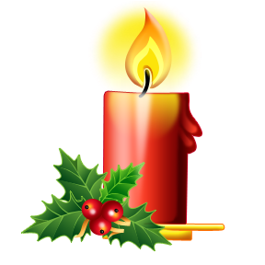
Christmas is a special time for family and friends and many of us will be thinking especially of those who have passed on. Once again this Christmas in St Chad’s we will be lighting candles in memory of those we have loved who are no longer with us. The candles will be lit during a short prayer service at 3.00 pm on Christmas Eve and will burn for approx 48 hours.
The candles will be named and a list of those remembered will be put up on the church noticeboard. We ask for a donation of £5 per candle and each candle can take up to 2 names.
If you would like a candle in memory of someone please fill in the form below and give it, with your donation to Jean Ancliffe, 8 Napley Drive, Mel Rees, The Old Rectory, or Doreen Brassington, Forge Lane.
----------------------------------------------------------------------------------------------------------------------
I would like a candle in memory of :
……………………………………………………………………………………………
……………………………………………………………………………………………
My name, address/tel number
……………………………………………………………………………………………

