6
CINESOUND STUDIOS 1930s

Description
Throughout the documentary Nasht reminds us of Hurley’s strong sense of patriotism, reflecting the values of the time. When Hurley becomes employed by the film production house, Cinesound, he turns his patriotic views to the home stage.
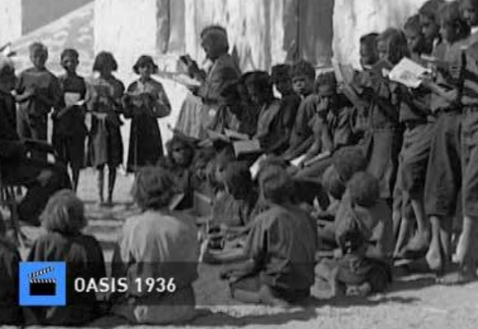
Nasht calls Hurley’s films “patriotic fables”. (48:22) Film historian Graham Shirley says they have “immense national sentiment” (48:30), verging on propaganda. Nasht shows how Hurley faithfully represented the prevailing values through his government funded travelogues. His “mythical stories” (49:42) with their “triumphant message” (50:11) were designed to lift the spirit of the nation. Nasht uses the anachronistic voice-over and heraldic music from Hurley’s films from this period, especially A Nation is Built released in 1938, to show how Hurley was prepared to faithfully represent the government ethos of the time. Here is a man who is far less rebellious as he gets older.

Analysis
The Cinesound section represents a shift for Hurley as an expeditionary adventurer with his “dream of conquering the world” fading and his taking a “salaried job as chief cameraman for Cinesound”. However his role in shaping history through narrative is far from over. This time he turns his talents to “patriotic fables” that had “an almost propagandistic spin on Australia”. Nasht uses film historian Graham Shirley to re-emphasise Hurley’s ability to portray a narrative line: “The Squatter’s Daughter has a look of grandeur, of nobility, of immense national sentiment” and appeals to the common people with “escapist fare”. This is reinforced through archival footage depicting epics full of “patriotic sheep and well-fed farmers”.
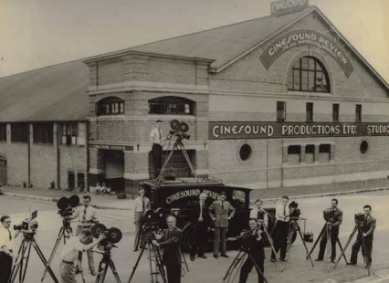
At 48:45 Hurley’s shot of a man on a horse purveying his flock whilst Kookaburras sing in the background is a scene of great national resonance. Yet Hurley was not one to be constrained and reverted to travelogues “representing the prevailing values”. Nasht reveals that these values are not always what we would like to expect, yet as an historical record they allow responders to see how racist Australian society once was, expressed through archival footage from the film Oasis (1936).
Almost casually the newsreel narrator states: “400 natives come under mission influence and twice as many dogs that don’t,” likening Aboriginal people as being “born with the same primitive instincts as their wild dogs”. This ultimately reflects the values of the time and mirrors government policy, expressing the hope that the missionary school is “achieving praiseworthy results in training the rising dark generation to become useful helpers to the settlers and stock feeders in central Australia.”
Nasht affirms that this is a circular process as Hurley’s representation in turn reaffirms the prevailing white view of the time - that the policies had a positive impact on Aboriginal peoples, emphasised through Hurley’s footage of Aboriginal children singing and being educated. This allows current generations to discover how all-pervasive white Australia’s interaction was with its indigenous peoples.
By focusing on the film A Nation is Built (1938), Nasht celebrates Hurley finding another “mythical story” in a young nation rising to glory that supplies a “triumphant message… in uncertain times”. By juxtaposing modern-day images of wheat being harvested to similar archival footage, Nasht links this period to our modern prosperity and Hurley’s role in documenting and discovering it. Images of the Sydney Harbour Bridge, the surf life-saving movement and school children marching reinforce widely held values of the “transformation of the country, from wild bushland to a highly productive, developed commonwealth… has no parallel in human history”. Implicit in this is the lack of recognition of its impact on Aboriginal culture, rehashing the same issues from the Papuan section. Nasht ends this chapter with a brilliant reworking from the end of Hurley’s documentary with its declarative statement: “Thus a nation is built. Finis.”

