5
ANTARCTIC RESEARCH EXPEDITION 1929-30

Description
The chapter begins with Nasht’s plane taking off from PNG, heading back to Australia. (46:27) By now, the audience is familiar with Hurley’s tricks. It’s now the 1930s and the world is no longer as innocent and naïve. Hurley returns to the Antarctic with Sir Douglas Mawson but this time there’s no heroic story for him to depict.
The aim of the British, Australian and New Zealand Research Expedition was promoted as scientific but in reality it was a grab for territory. Hurley’s wife, Antoinette, despite hearing about the expedition for the first time in the newspaper, wrote to Mawson wishing him “great success” and saying she was “extremely pleased at Frank going.”
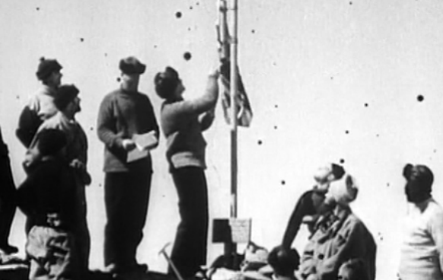
But with limited time ashore due to bad weather, Hurley had to work fast to take photos of Mawson claiming the area on behalf of King George V, the last land grab of the British Empire. On his return to Sydney, desperate to compete with the new films featuring sound (previously they were all silent), Hurley re-enacts Mawson’s proclamation on a cliff at Bondi beach, filmed to resemble a rocky shoal in the Antarctic. (47:05)

Analysis
This short chapter is important due to its reaffirmation of several themes Nasht has explored in the previous chapters. We learn again of Hurley’s disregard for his wife and the putting of his career before everything else when it is narrated that he returns to the Antarctic without telling Antoinette that he was going ... “she read about it in the newspapers.”
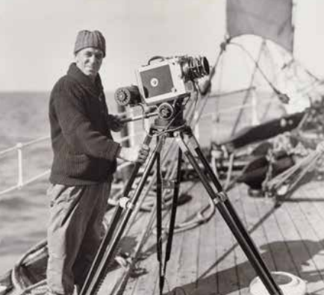
History records a different account of the expedition, suggesting that the return voyage was in the name of “science” but in reality it was a land grab on behalf of the British Empire. Hurley is complicit in this as he reworks his footage and totally recreates elements, re-enacting Mawson’s declaration and including the British national anthem, God Save the King. The narration that “no one noticed” that it was shot on Bondi Beach confirms not merely Hurley’s role as a manipulator but more broadly the manner in which images, sound and texts have been used to affirm historical and government narratives. The fact that Hurley is still seen as a man of the Empire, even after his experiences in the Great War, also allows the audience to discover just how long imperial attitudes existed in Australia some 30-odd years after Federation.

