7
WORLD WAR II 1939-1945

Description
Hurley was rejected twice by the authorities when he tried to join the official photography team in WW2. At the age of 54, he was overtaken by younger photographers who made his work look old fashioned and staged. In 1940, a year into the war, he was finally sent to the Middle East.
Hurley’s biographer Alasdair McGregor says he “resorted to faking again” (51:05) and voice over from a soldier describes how they staged a photograph for Hurley. (51:20) McGregor says Hurley is “taking short cuts with heroism.” (51:38) Nasht says “the magician had run out of tricks”. (51:43) Diary excerpts reveal a lonely and exhausted man. (51:50)
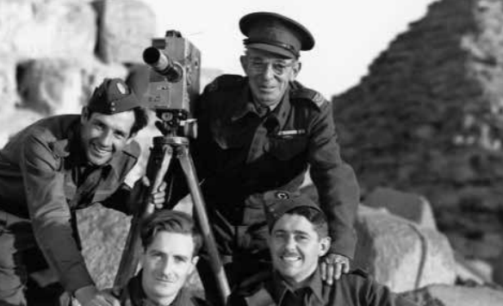
Nasht includes modern-day footage of Jerusalem (52:16), dissolving to Hurley’s photos and his film Cradle of Creation (made in 1944 for the British Government). The commentary is by Hurley himself, and Nasht makes the statement: “Who better to create an illusion of harmony than Hurley?” (52:33)
Analysis
Nasht’s World War 2 section suggests something of a nadir for Hurley’s career. One gets the sense, although only hinted at in the documentary, that Hurley’s personal life is catching up with him. The image of an ageing lonely man – reminiscent of an ageing Ulysses (from Tennyson’s poem) – is an excellent comprehension piece in establishing the concept (or possibly even as a related text), disconnected from his family.
The urge to enlist as a war photographer sees Hurley rejected three times, before he calls in “old favours” and doctors his passport, suggesting a man desperate to relive his past glories and unhappy with a simple family life. Nasht artfully crafts an image of the ageing Hurley, again opening the chapter with a photo of Hurley peering back at us. Yet here at 50:50 to 50:57, rather than the strong adventurer we have seen previously, we see a man seemingly much older than the 54 years of age in his passport – the vulnerable man in military uniform who is juxtaposed in a group photo with much younger colleagues.
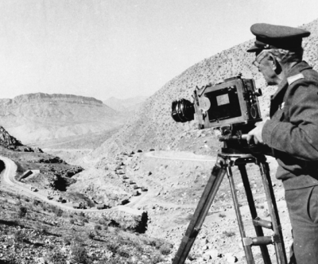
Nasht’s representation is a graphic reminder of a growing sense of pathos, reinforced through the narration that “the magician had run out of tricks” and the growing sense of anger that he was “taking short cuts with heroism”. Nasht at 51:20 uses a dramatised voiceover of how a soldier felt about Hurley’s “tricks” – the voice is strongly Australian suggesting similar working-class origins. By representing the soldier’s voice in this way, Nasht gives the sense that Hurley has lost his role as the inspirer of the working class, in typical larrikin fashion the soldier wryly states: “So we took up prime positions as directed. An engineer rigged the charge and Captain Hurley took an excellent photograph.”
McGregor is used to verify that “the troops didn’t like it” and Nasht at 51:42 accentuates the loss of trust by contrasting Hurley’s trickery with proud images of columns of Australian soldiers. Narration is used to confirm the diaries reveal “a lonely man, exhausted by the struggle” to which Nasht adds Hurley’s dramatised voice – this time it is the voice of a weary Hurley, contemplating the futility of war: “In times of reminiscence I like being alone.” Again Hurley has no thought of his family and home, only a weary plea to see “the madness we call war ended”.
Yet if we are to believe that this is the end of Hurley, we soon discover his resilience and ability to bounce back from hardship; again Nasht does this through narrative, “creating an illusion” of harmony about British rule in Palestine. To a modern audience these images appear even more manipulated, considering our understanding of the events that have followed in this region.

