Little Tears

=

Happy Kids
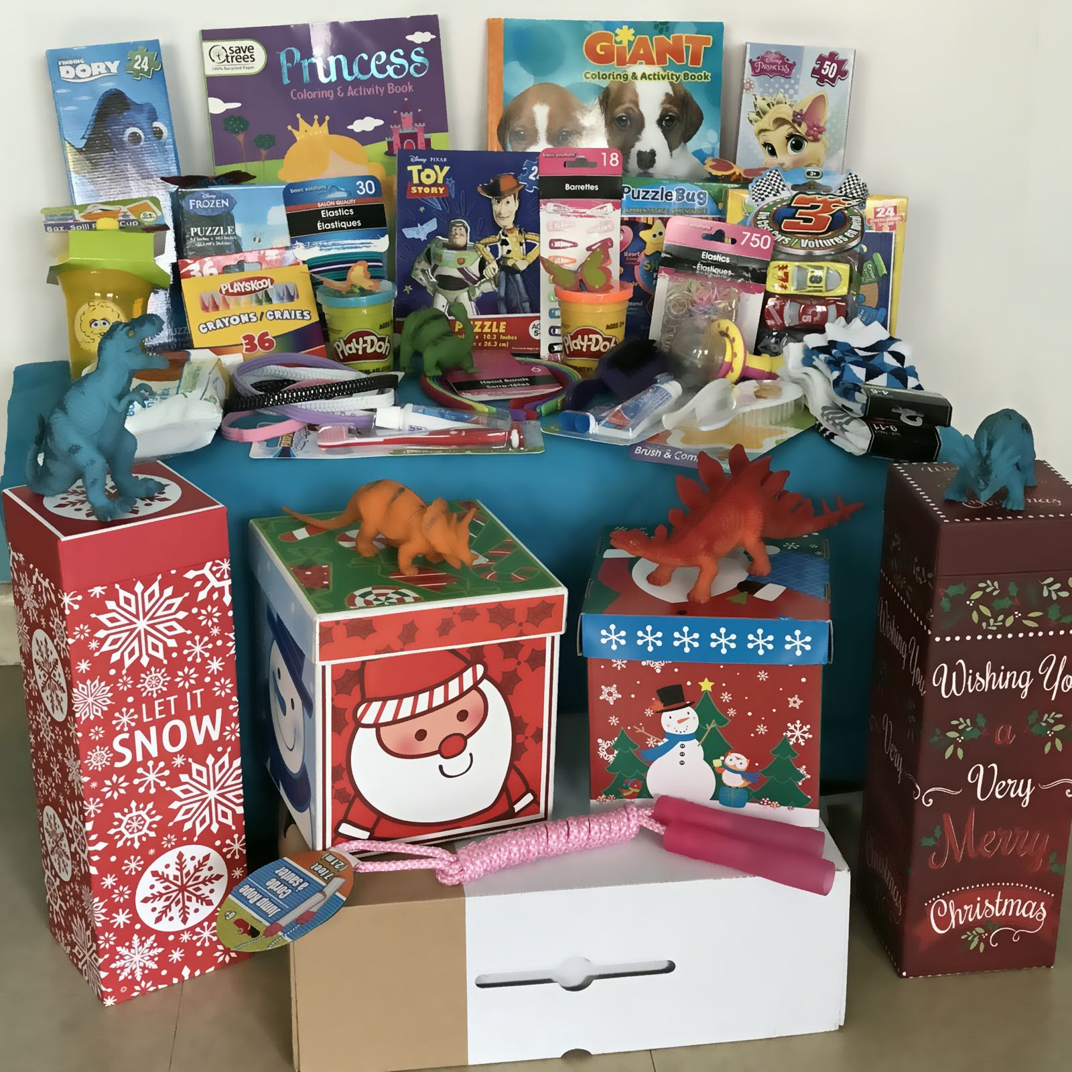 | 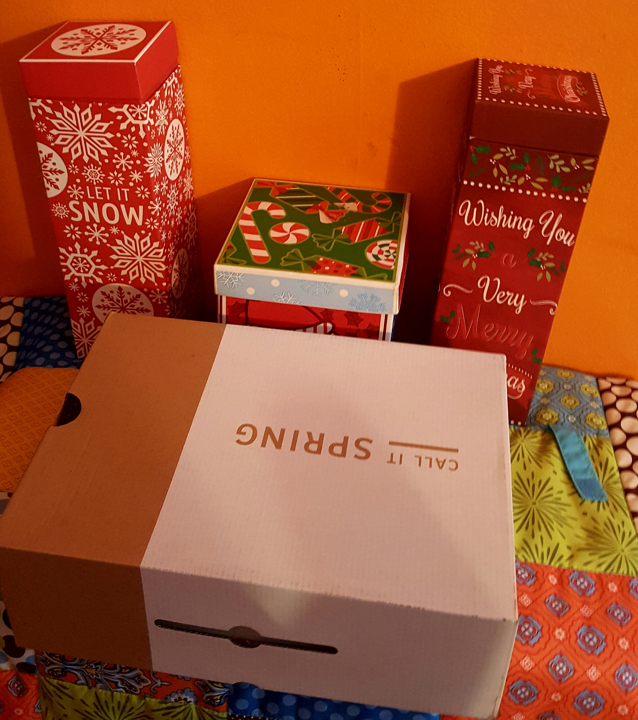

  - Little Tears=Happy Kids Project
Unexpected GIFTS bring TEARS of Joy to Our KIDS!
It’s a wonderful time for all us to show a little gratitude for those children that are less fortunate and turn little tears into smiling little faces. Your little donation can bring a world of happiness to children that are underprivileged in the Dominican Republic, Honduras and Ecuador, in places where a GIFT at this time of the year can bring tears of joy to their little eyes. Make a difference in a child’s life this season of sharing and joy. BECOME a TEAMPLAYER for this CAUSE and take the BOX CHALLENGE!

Little Tears = Happy Kids Project

Unexpected GIFTS bring TEARS of Joy to Our Kids

How it Works! What to fill it up with!
- Choose a normal standard shoe size box (it can be a plastic bin) of your choice.
- Label your box with the gender (Boy or Girl) and age range.
(__0 yrs to 5 yrs) (____6 yrs to 10 yrs) or (__11 yrs to 15 yrs )
- Girls/Boys: Hair accessories, small dolls, arts and craft supplies, crayons, coloring books, hygiene items such as tooth brush, tooth paste, hair brush, school supplies, little puzzles, interior clothing, socks, small toys cars, balls, little blankets, Playdough, educational toys, bibs, baby rattles, shape sorters, baby bottles, baby cereal or powder formula (ANY BOOKS PLEASE MAKE SURE THEY ARE SPANISH). No sharp objects or toys that are violence related. See the attached link for more information on items that can be donated for our Little Tears = Happy Kids Project.
- Suggested Stores to get your box filled with items are: Dollar Tree, .99 Cents Stores, Toys R Us, Target, Walmart, Five and Below, K-Mart or your store of choice.
- CHALLENGE-you need to challenge 3 people (responsible and willing to be a Team player for this task) it can be family, church members, co-workers, Facebook friends or any social media, or different businesses to take the challenge that we detailed above. You can text, email or tag your list and so on. VERY IMPORTANT-DO NOT BREAK THE CHALLENGE and just have fun while at it!
- Date: This event begins December 1, 2016.

Drop-off Location
If you are in the New York area to arrange for pick-up. Drop off can be at Let The Kids Come To Christ Ministry, Inc. 8 West Farms Square Plaza, #3E, BX, NY 10460 or you can mail your package. For other locations please contact us.

To All Our Sponsors: Please email us so that we can attached our children’s thank you letters and pictures of your “Little Tears=Happy Kids” Project donations.

Contact:
Luz Perez-Ruiz-917-209-1604-Leader Organizer
Elizabeth Ortiz-914-483-9877-Outreach
Raquel Ortiz-Outreach Assistant
Ana Morillo-347-357-4082-Outreach Assistant

Email: letthekidscometochrist20@gmail.com
http://www.letthekidscometochristministry.org
https://letthekidscometochrist.com

**P.S. Any monetary contribution is tax deductible.

Keywords: little tears, happy kids, project, crayons, books, arts and craft, smiles, tooth brushes, tooth paste, school supplies, baby bottle, rattles, playdough, educational toys, puzzles, cars, pens, pencils, coloring books, hygiene items, interior clothing, clothes, shoes, socks, shape sorters, hair accessories, dolls, baby formula, baby cereal.

FAQ
- Who is the Organizer of the Event?
Let The Kids Come to Christ Ministry, Inc. is a non-profit organization. Our main mission and focus is to provide charitable humanitarian aid to impoverished children in the US, Dominican Republic, and other communities as the need arises. Our ministry focuses on providing educational school supplies, clothing, shoes, and food to needy children.
- What is the name of the Project?
Little Tear=Happy Kids Project.
- Where is the help or boxes being send to?
The Little Tears=Happy Kids, boxes will be ship to the Dominican Republic, Honduras and Ecuador to underprivileged children that have very scares resources and living conditions are very inhumane.
- What is the start and end date for this project?
This event starts December 1, 2016. (this will be a permanent project for our Ministry.
- What will a monetary donation do for the Ministry?
It will contribute for us to buy additional supplies already mentioned on our project and also help ship the boxes of items to its final destination.
- Where can I see how this Ministry is helping out to impact a child’s life?
http://www.letthekidscometochristministry.org
- Why do I need to give my email?
Our Ministry will be sending Thank you letters from the Children that are receiving the boxes that our sponsors are donating, and we want to forward these thank you letters and pictures to you.
- Is my donation to the ministry tax deductible?
Yes, any monetary contribution to our ministry is tax deductible.
- Can I sponsor a child?
Yes, you can sponsor to help a specific child in our ministry. All you need to do is go to our sponsoring page and choose a child to sponsor for a very low monthly cost.

