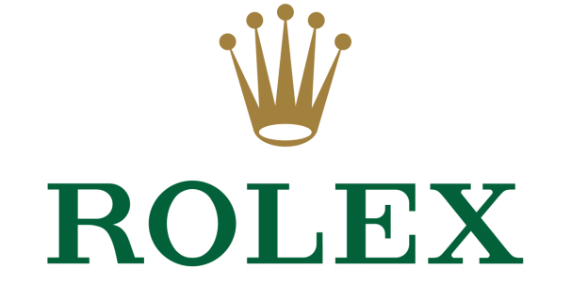

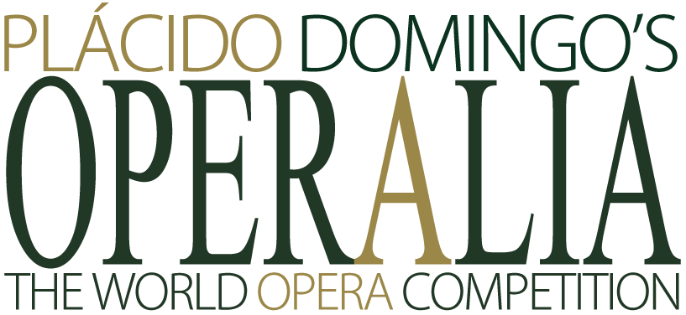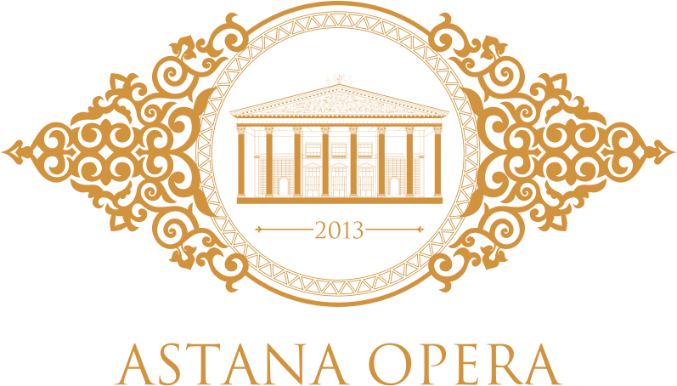
Press Office of the Astana Opera
tel. (7172 -70 95 94; 70 96 19) e-mail: astanaoperapressoffice@gmail.com
May, 2017, Astana
40 talented young vocalists from 17 countries of the world who will take part in the twenty-fifth edition of Placido Domingo’s Operalia, presented by Rolex, have been selected. The tickets are already available for purchase at the Astana Opera.
World’s most prestigious vocal competition Operalia, founded by the great opera singer and conductor Placido Domingo, will take place at the Astana Opera from 24 to 29 July, 2017, within the framework of the “EXPO-2017”, with the support of the Ministry of Culture and Sport of the Republic of Kazakhstan.
The audience will be able to attend all stages of the competition. Quarterfinal and semifinal rounds, which will be held on July 24, 25 and 26, will take place in the form of auditions. The participants will perform their chosen arias from the world opera classics to the accompaniment of the Operalia’s piano accompanists. On July 29, ten finalists will perform and compete at the Finals Concert, accompanied by the Astana Opera Symphony Orchestra conducted by Maestro Domingo himself.
According to tradition, the jury, presided by Placido Domingo as a non-voting mediator, includes distinguished industry professionals – representatives of leading international opera houses. Among them – Artistic Administrator of the Metropolitan Opera (New York, USA) Jonathan Friend, Director of the Wiener Staatsoper (Vienna, Austria) Dominique Meyer, Casting Director of the Royal Opera House (London, United Kingdom) Peter Katona, Casting Director of the Opéra National de Paris (France) Ilias Tzempetonidis, Artistic Director of the Teatro Real (Madrid, Spain) Joan Matabosch and other renowned figures.
Operalia is open to singers of all vocal types (from bass to soprano) aged 18 to 32 years old. The total prize fund is from 180 000 US Dollars. In addition to the winners of the I, II and III prize among male and female voices, the prizes include Birgit Nilsson Prize for performance in the German repertoire of R. Wagner and R. Strauss, Pepita Embil de Domingo and Placido Domingo Sr. prizes for the best zarzuela performance (a Spanish lyric-dramatic genre similar to operetta), the Audience Award in the form of wrist watches offered by Rolex.
Rolex is proud to present Operalia, the World Opera Competition, for the 16th consecutive year, perpetuating its commitment to the arts. Plácido Domingo has been a Rolex Testimonee since 1982, and Rolex is delighted to extend its support to the exceptionally gifted young performers who share its quest for excellence and perfection.
Learn the competition guidelines and follow the news on the Operalia website (http://www.operaliacompetition.org/).
The ticket prices are from 1000 Tenge.
Operalia 2017 Competitors
Alexander Aliev, baritone, Russia, 30
Seungju Bahg, tenor, South Korea, 27
Vlada Borovko, soprano, Russia, 29
Nadia Cerchez, soprano, Moldova, 31
Marco Ciaponi, tenor, Italy, 27
Emanuele Cordaro, bass, Italy, 30
André Courville, bass-baritone, USA, 31
Chao Deng, bass-baritone, China, 28
Joshua Dennis, tenor, USA, 32
Rupert Enticknap, countertenor, UK, 30
Andreas Gies, baritone, Italy, 24
Davide Giusti, tenor, Italy, 30
Elena Guseva, soprano, Russia, 31
Nozomi Kato, mezzo-soprano, Japan, 29
Leon Kim, baritone, South Korea, 30
Ruslana Koval, soprano, Ukraine, 27
Hojoun Lee, baritone, South Korea, 31
Sooyeon Lee, soprano, South Korea, 28
Stanislav Li, baritone, Kazakhstan, 29
Carolina Lippo, soprano, Italy, 30
Mihail Mihaylov, tenor, Bulgaria, 30
Damiana Mizzi, soprano, Italy, 32
Kristina Mkhitaryan, soprano, Russia, 30
Maria Mudryak, soprano, Kazakhstan, 23
Lancelot Nomura, bass, UK/Japan, 30
Emmett O’Hanlon, baritone, USA, 27
So Young Park, soprano, South Korea, 31
Boris Prýgl, bass-baritone, Czech Republic, 25
Damir Saduakhassov, tenor, Kazakhstan, 29
Oksana Sekerina, soprano, Russia, 30
Levy Sekgapane, tenor, South Africa, 26
Iliya Selivanov, tenor, Russia, 27
Anna Sinitsyna, mezzo-soprano, Russia, 29
Valentina Stadler, mezzo-soprano, Germany, 28
Daria Telyatnikova, mezzo-soprano, Russia, 29
Camila Titinger, soprano, Brazil/Italy, 27
Victoria Yarovaya, mezzo-soprano, Russia, 32
Adela Zaharia, soprano, Romania, 29
Joanna Zawartko, soprano, Poland, 29
Rassul Zharmagambetov, baritone, Kazakhstan, 26
Jury Members, Operalia 2017
Giuseppe Acquaviva
Artistic Director, Teatro Carlo Felice di Genova, Italy
Guest Conductor, Astana Opera, Kazakhstan
Marta Domingo
Stage Director
Anthony Freud
General Director, Lyric Opera of Chicago, USA
Jonathan Friend
Artistic Administrator, The Metropolitan Opera, New York, USA
Peter Katona
Director of Casting, Royal Opera House, London, United Kingdom
Davide Livermore
General Manager-Artistic Director, Palau de las Arts, Valencia, Spain
Joan Matabosch
Artistic Director, Teatro Real, Madrid, Spain
Dominique Meyer
Director, Wiener Staatsoper, Austria
Pål Moe
Casting Consultant, Bayerische Staatsoper, Munich, Germany; Glyndebourne Festival Opera, UK; Opéra de Lille, France; Norwegian Opera House
Andrés Rodriguez
Artistic Consultant
Ilias Tzempetonidis
Casting Director, Opéra National de Paris, France

Carolin Wielpütz
Director of the Artistic Administration, Theater Bonn, Germany
