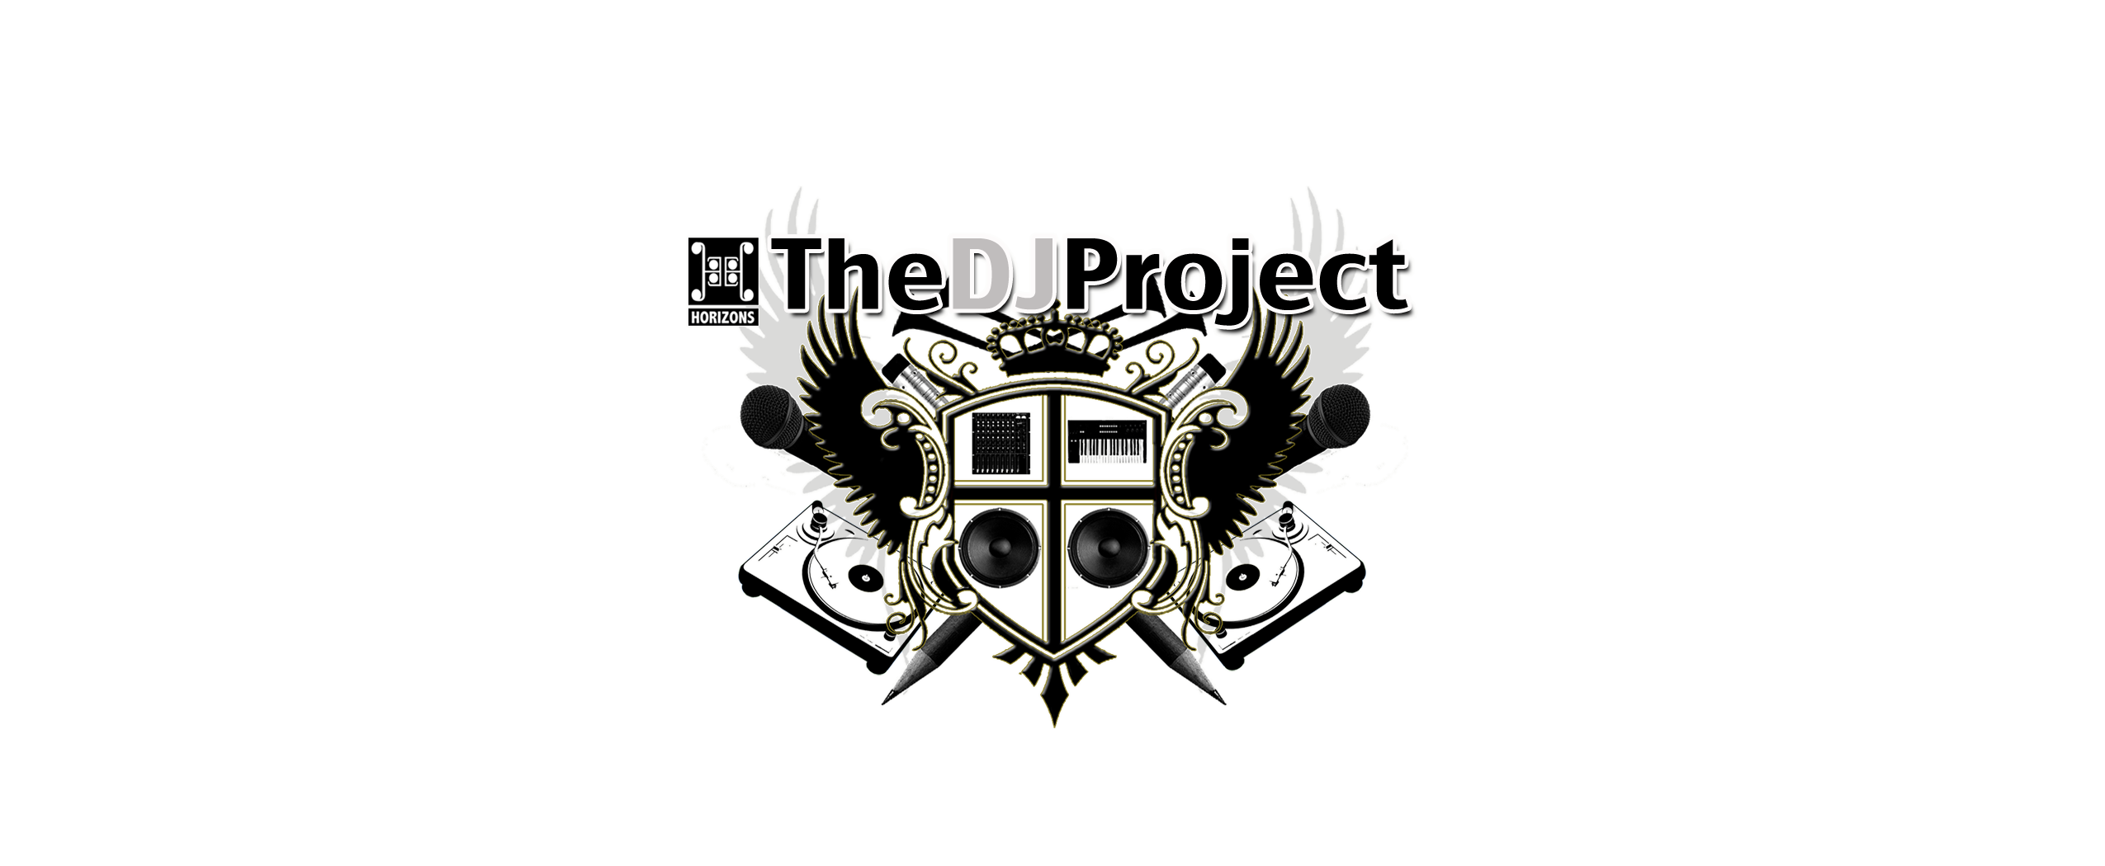
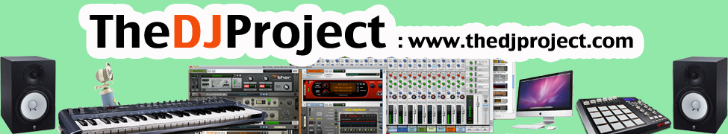
Fall 2016/17 Cycle Application

Name: _____________________________ Age: ______________ Date:_____________
Ethnicity: _____________________Gender:______ Birth Date:_________

Address: ______________________________________________

Phone: _______________ email: _________________________

School: _____________________________

Grade Level: ________

Classes Available:

_____ Audio Production (Beat Making, Media Messaging, Studio Engineering)
Class Schedule: Mon & Tues 4:00-6:00pm

_____ DJIng Classes (Learn to mix music, Serato DJing, Scratching, Mobile DJing)
Class Schedule: Wed & Thus 4:00-6:00pm

_____ Event Production (Planning Events, Working within a Group, Worksite Experience)
Class Schedule: Mon - Friday 4:00-6:00pm

For More Info contact Korise Jubert at (415) 487-6741 or kjubert@horizons-sf.org

