Lesson Framework

Grade:

Standard:
 | Lesson Component | Structure | Check for Understanding & Strategies
Pre-OWL 1 | Preview  Access prior  Knowledge and/or  provide relevance

Learning Objective
Deconstructed
Standard
Review
Sub-skills
necessary
for
this lesson

OWL 1 | Explain the Key Ideas  Concept Map  Definitions  Rules  Conditions |  | *Language Frames
Explain Expert Thinking
Steps/Concept Map
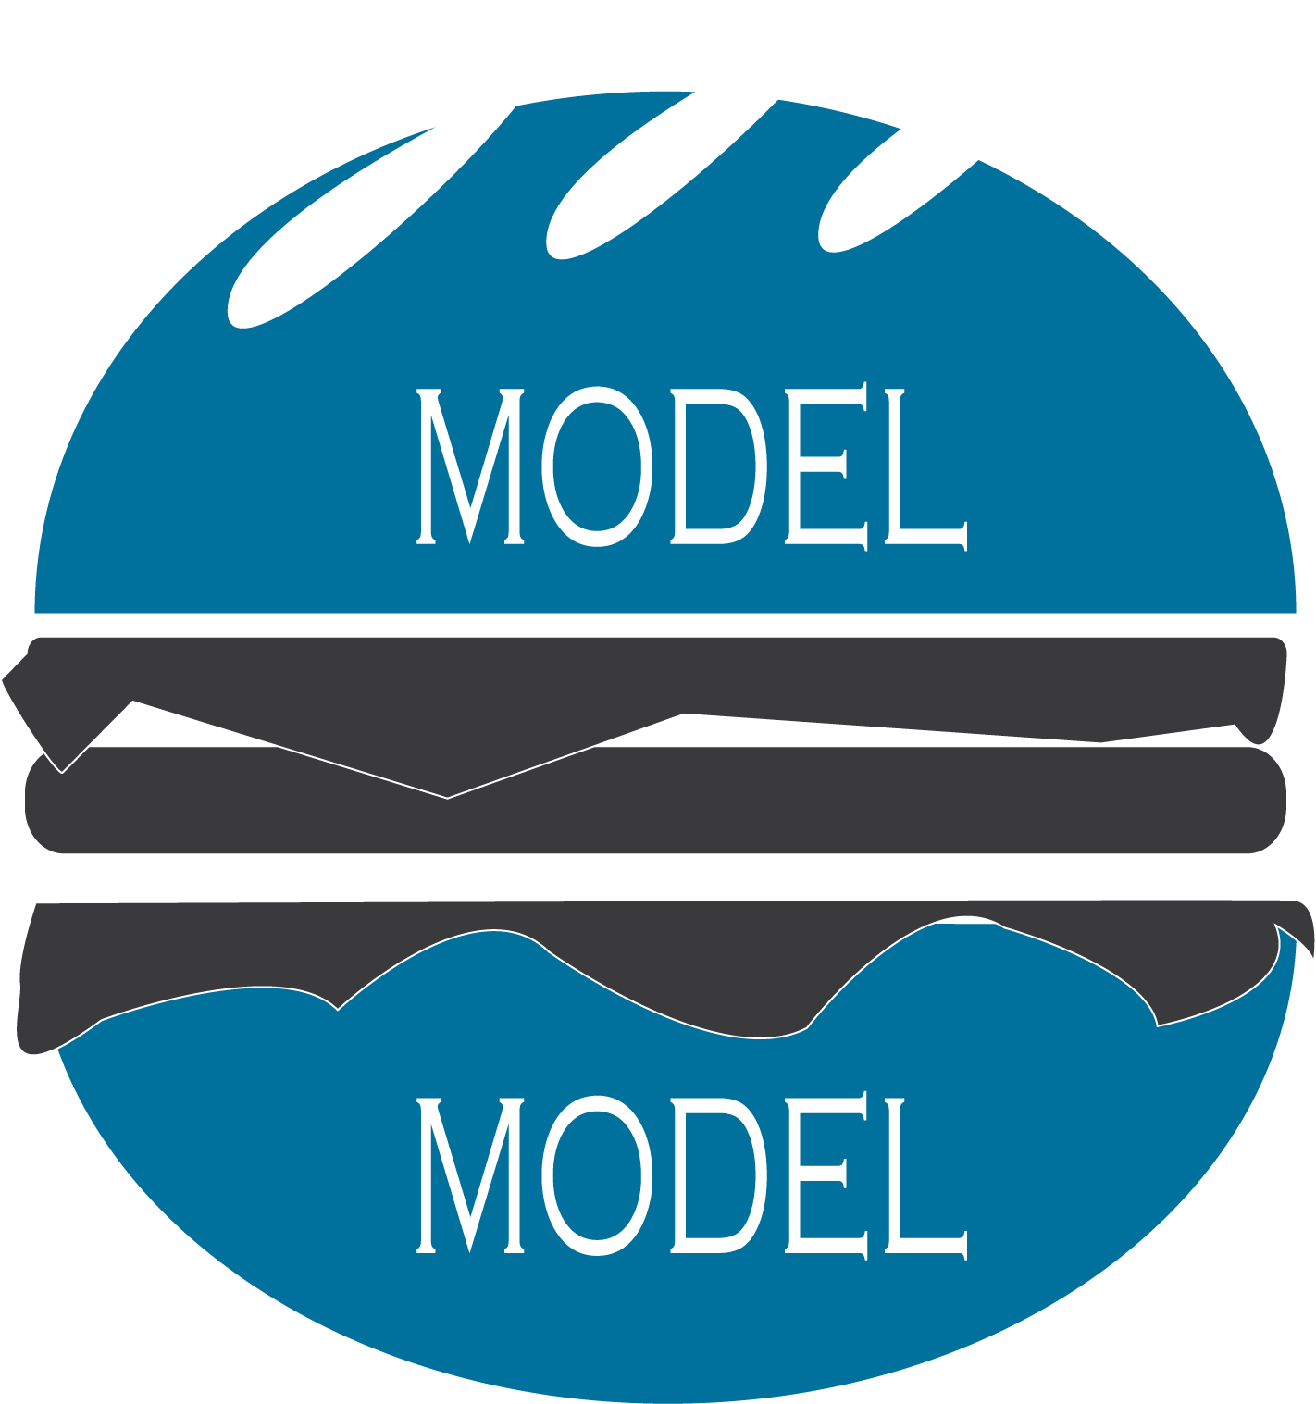
SYNTHESIS | Guided Practice  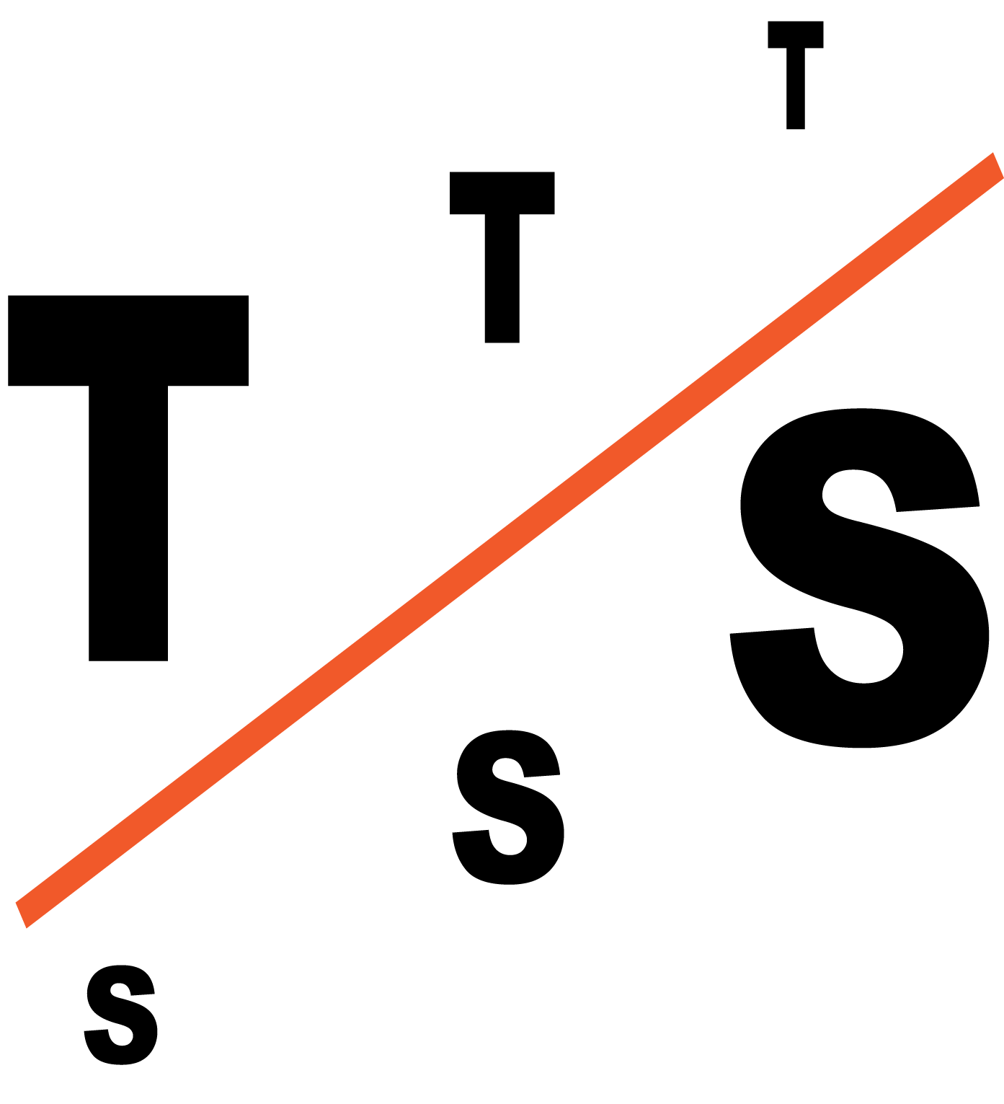Gradual Release |  | *Collaborative Strategies
OWL 2 | 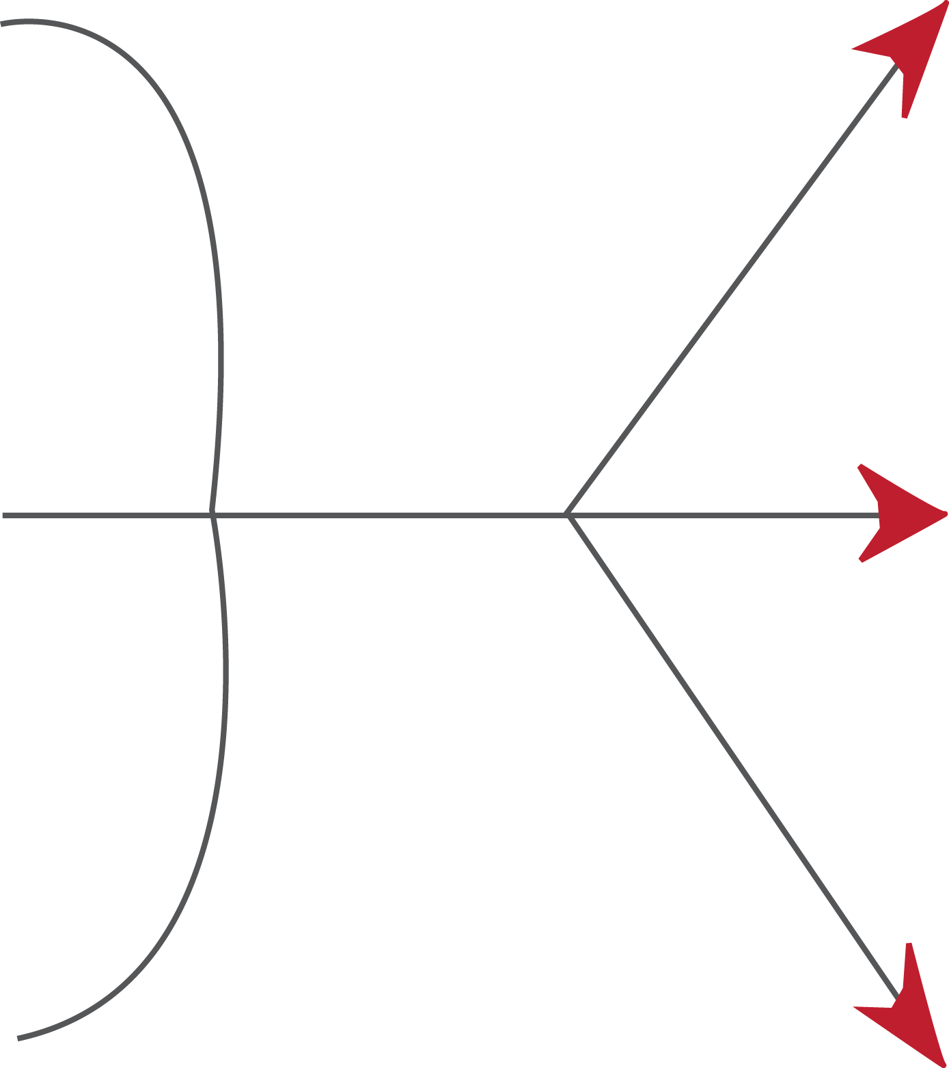Closure  L.O.  Key Ideas  Expert Thinking

Independent Practice
Matches
learning
objective

