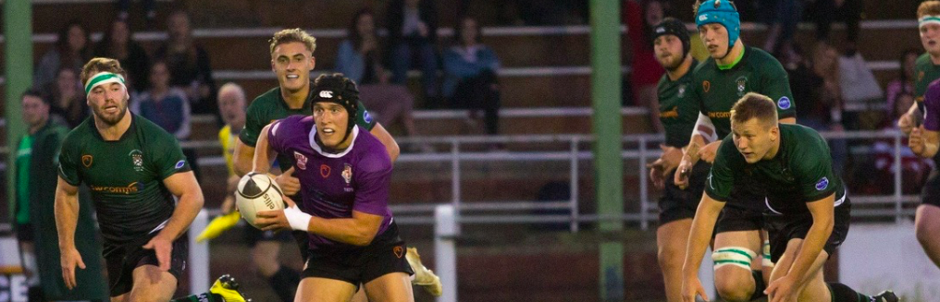
JUST CAN’T GET ENOUGH

THE OFFICIAL NEWSLETTER OF DURFC

The Official Newsletter of DURFC

MESSAGE FROM THE DIRECTOR OF RUGBY
As we reach the halfway point in the leagues, the club continues to thrive, all the teams are in the top 4/5 of all their respective leagues. Put in perspective each of the first 4 teams are in the highest league they are allowed to play as there is a glass ceiling is place.

The 1st XV have completed the double over Bath and have had great home victories over Exeter and Loughborough.

The 2nd XV lie 3rd having beat Loughborough comfortably at home.

The 3rd XV beat Leeds Beckett 2’s (Title favourites) – a fantastic win in the first game of the season.

The 4’s are mid-table and obtained a double victory over Hull 1st, home and away.

The Big Match proved to be a great success in London along with the Big Dinner, involving guest speaker Eddie Jones. It provided a great opportunity for the Club and the Alumni to meet up.

Well done to the boys and team Durham on helping to raise over £5000 from the Charity Match against Exeter, with the funds going towards the Sport in Action Zambia charity.

Looking forward to the final league and knock out rounds next term.

Merry Christmas and a Happy New Year to all our supporters.

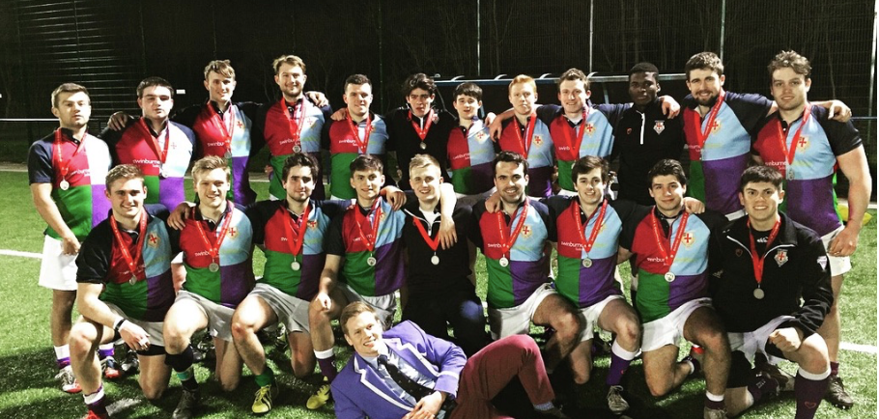
MOVEMBER

MOVEMBER CAMPAIGN
The month of November saw DURFC’s clubmen refrain from shaving their upper lip in the annual Durham University Movember campaign. The Movember Foundation addresses some of main health issues faced by men across the globe, including prostate and testicular cancer, mental health and suicide. As a club, through donations, fundraising and the Movember Charity Match we are pleased to announce that we have raised in excess of £1,500. With the universities current total standing at £9,758, it has been an absolutely formidable effort from everyone involved.

Thank you to all for your generous donations… despite some of the questionable facial hair we provided.

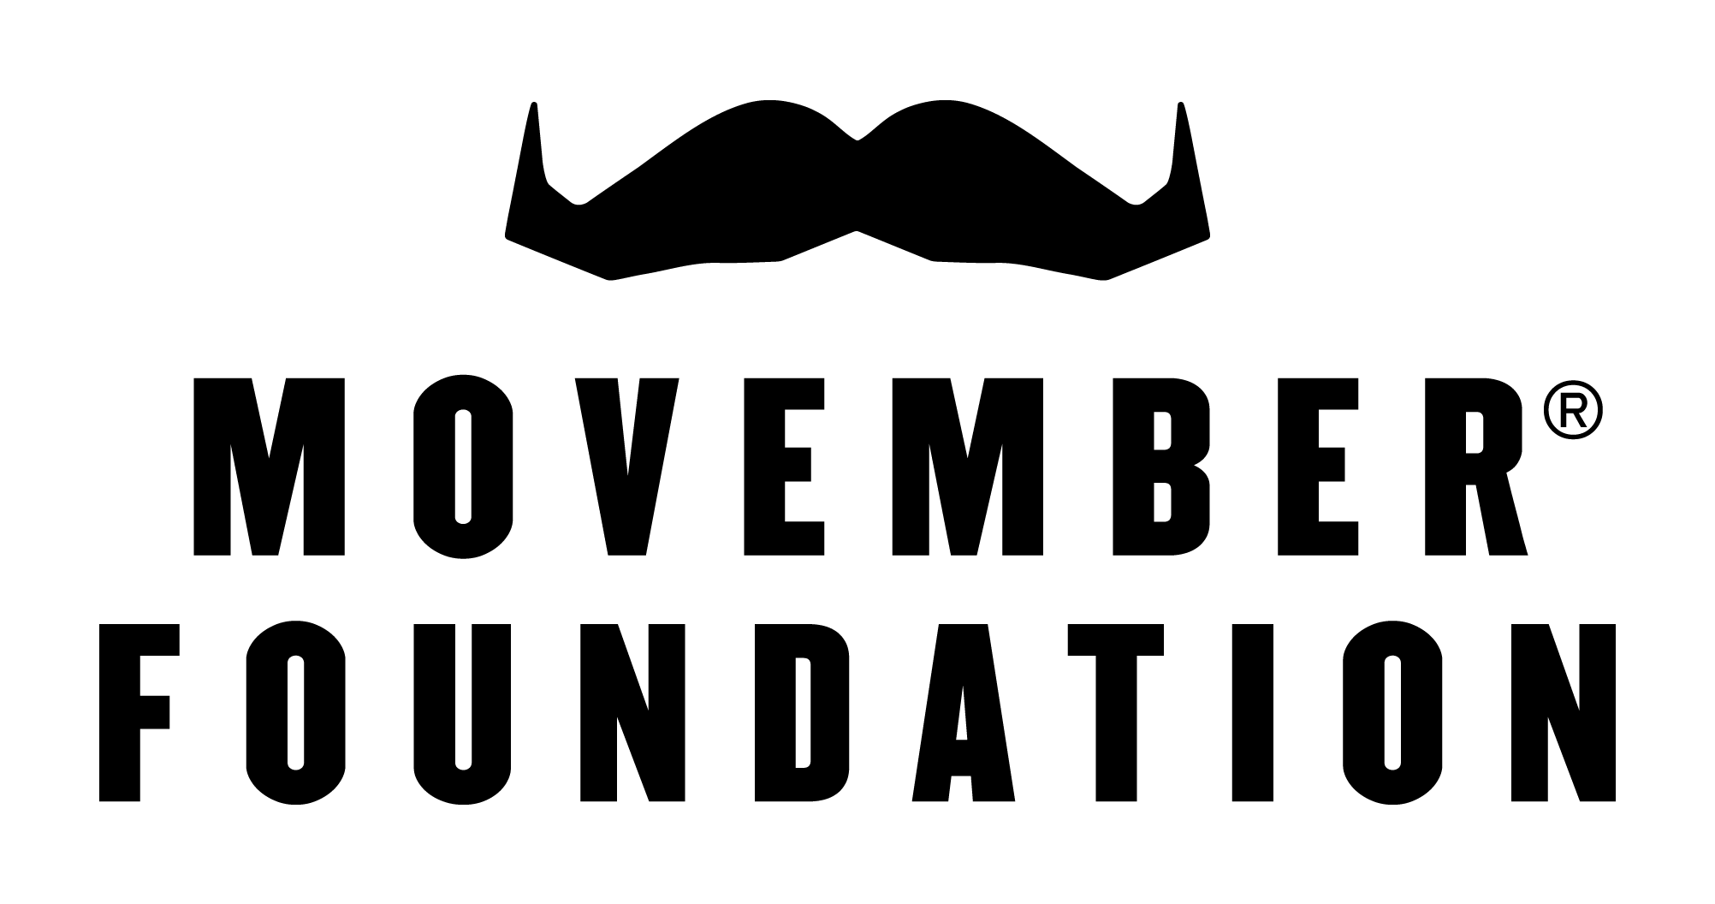

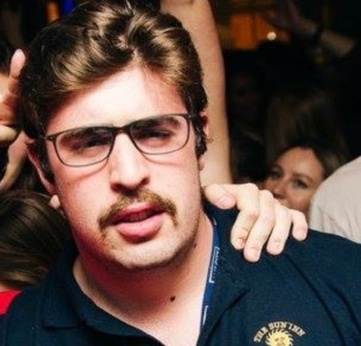
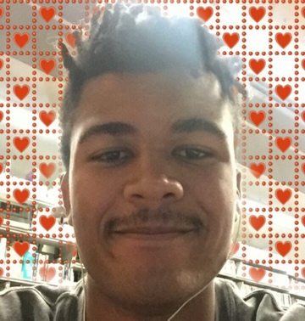
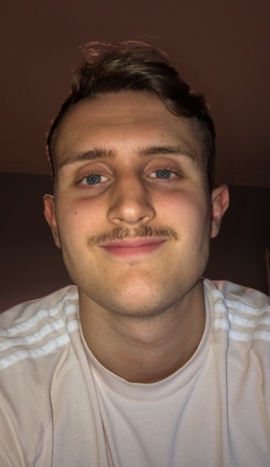
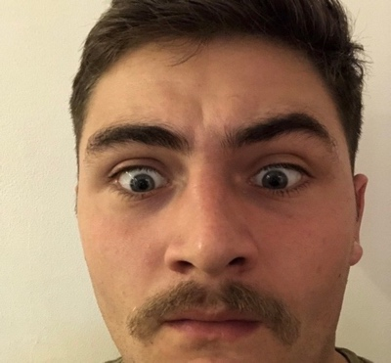

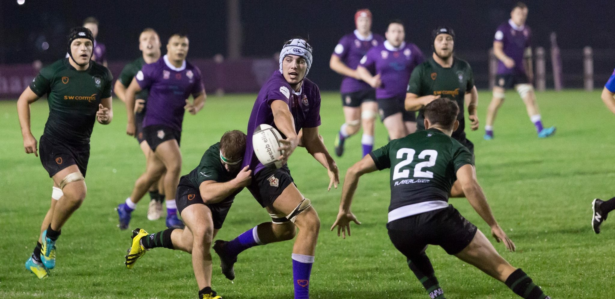
LEAGUE STANDINGS

1st XV:
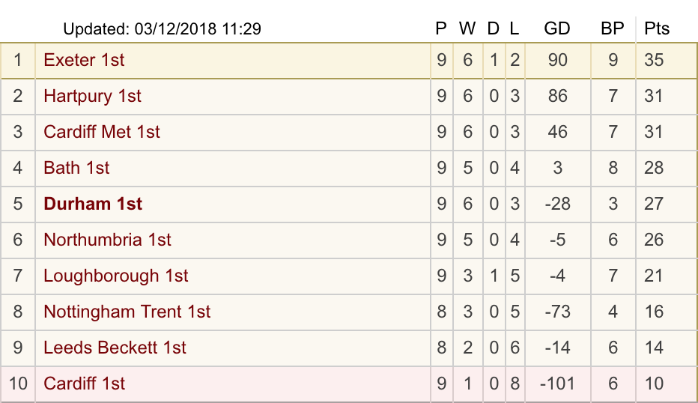

2nd XV:
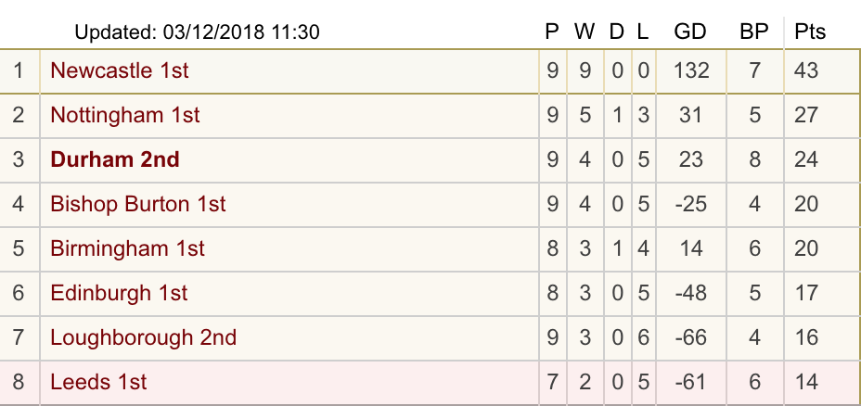

3rd XV:
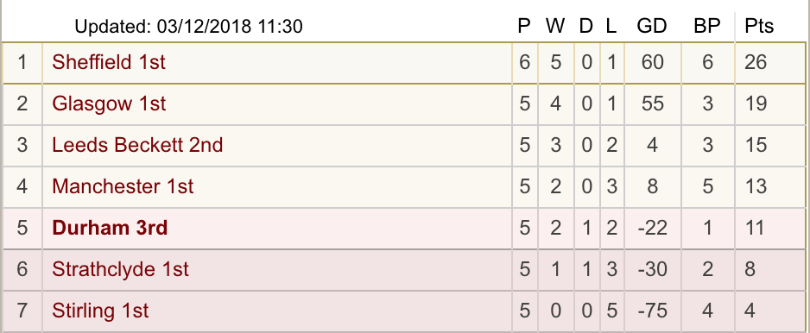

4th XV:

*League standings as of 28th November*

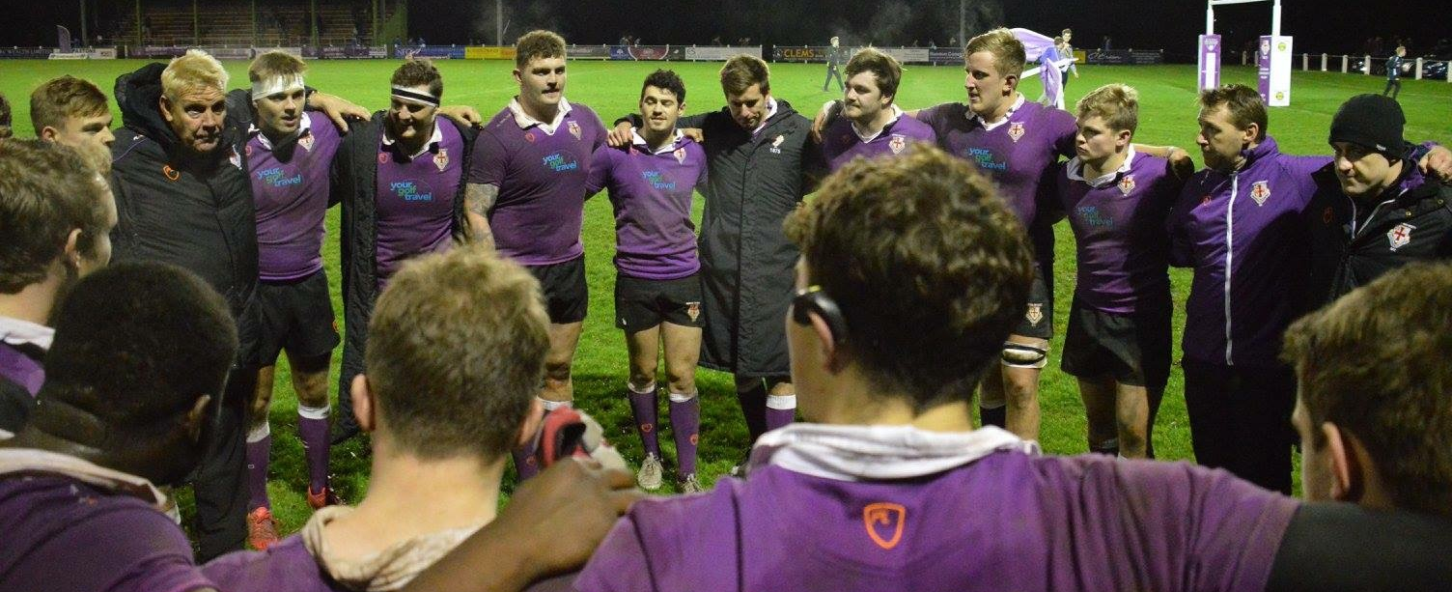
MEET THE TEAM

Meet the Team – Jamie Knight
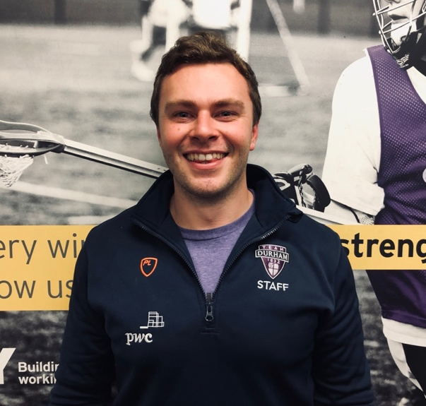

Role:
My primary role is leading the strength and conditioning programme for DURFC. I also oversee rugby league and programme for DMP sharks. I aim to keep non-contact injuries to a minimum whilst improving athletes physical capabilities to enhance on field performance. This involves both gym and field-based training, from plyometrics and weights to repeated sprints and conditioning games. Monitoring athlete wellness and training loads on a weekly basis to predict and prevent injury or illness during the season.

Favourite DURFC Memory:
Every time we do testing in the gym, best club in team Durham!

Interesting Fact:
I was Head Boy at school and appeared on BBC news in an interview.
FOLLOW US
OLLOW US
www.instagram.com/durhamuniversityrfc/

http://twitter.com?DURFC

www.facebook.com/Durfc/
www.durhamunirugby.com

