Landscore’s Gruffalo
Team 1 Christmas Performance
14.11.19

Dear Parents / Carers,

Our Christmas performance this year will be based ‘The Gruffalo’ and we have already been busy learning the story and the songs. Your child has now been given a part. We would be very grateful if you could provide a costume for your child to wear for our performance. You can be as creative as you like with this, but if you are unsure of what to do then please see overleaf for some simple costume ideas (please see the email or school website for a colour copy). Each animal costume could easily consist of a simple, plain, long sleeved t-shirt and leggings or tracksuit trousers in a dark colour. This can then be enhanced by a mask or some sort of headwear to represent the animal. If you are having difficulties with your child’s costume, please come and see us and we will try to help you. Costumes will need to come to school in a ‘named’ bag by Monday 9th December, ready for our dress rehearsal.

The dates for the performances are as follows:
Wednesday 11th December at 2pm (Matinee performance is suitable for pre-school children)
Thursday 12th December at 6pm (No pre-school children please)

Tickets will be available at the office from Monday 2nd December free of charge, but will be limited to 2 tickets per family. Please collect your tickets from the office as you will be asked to present your ticket on the door as you arrive at the performance.

Yours faithfully,

Miss Davey, Mrs Williams, Mr Seller and Miss Coney

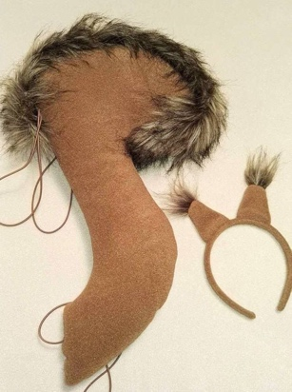
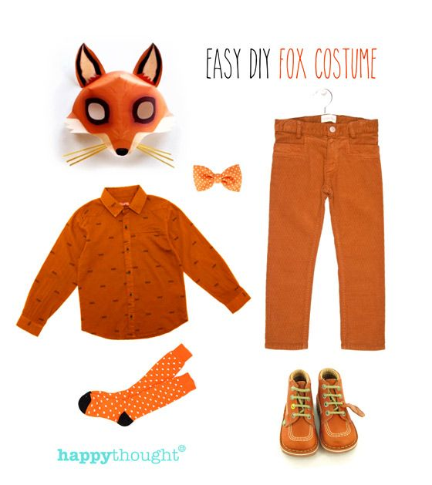
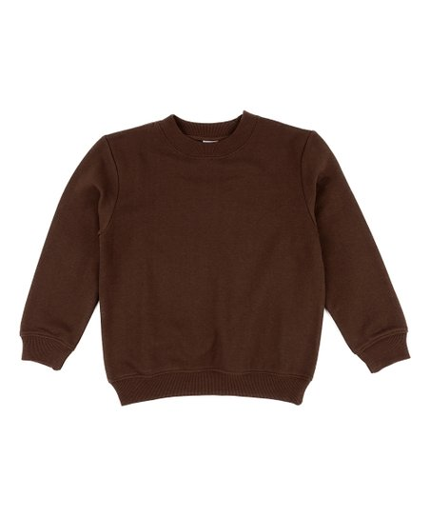
Fox
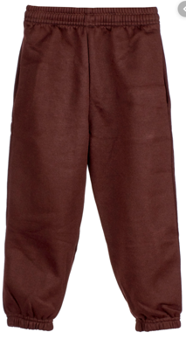

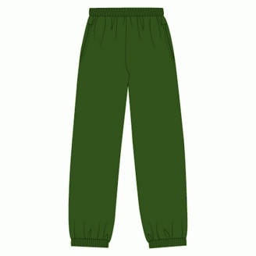
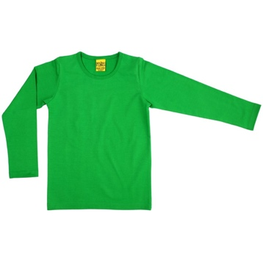
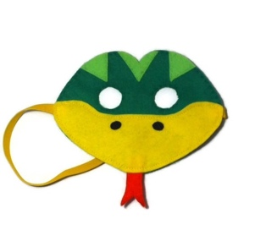
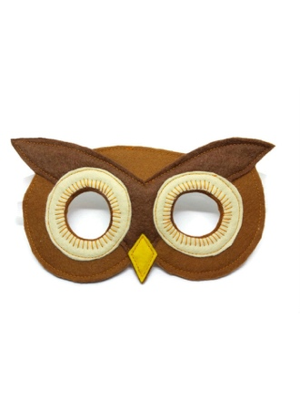
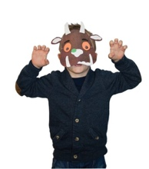
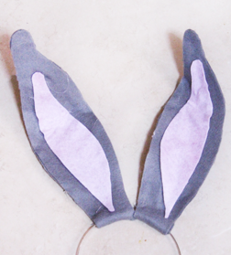
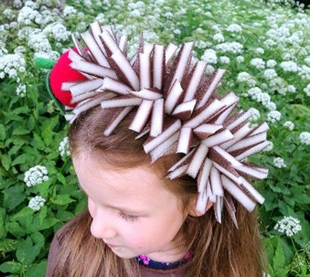
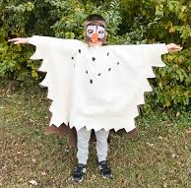
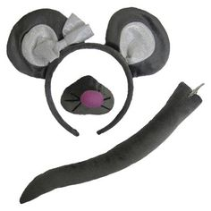
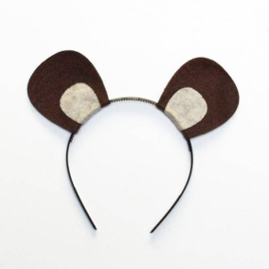
Gruffalo
Snake
Owl
rabbit
hedgehog
squirrel
little brown mouse

