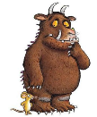 

**Maths**

**Year 1**

Represent and use number bonds and subtraction facts within 10

Add and subtract one digit numbers to 10, including zero

Solve addition and subtraction problems

Recognise and name common 2-D shapes, including: (e.g. rectangles (including squares), circles and triangles)

Recognise and name common 3-D shapes, including: (e.g. cuboids (including cubes), pyramids and spheres)

**Year 2**

Add and subtract two 2-digit numbers

Recognise and use symbols for pounds (£) and pence (p); combine amounts to make a particular value

Find different combinations of coins that equal the same amounts of money

Solve simple problems in a practical context involving addition and subtraction of money

Recall and use multiplication facts for the 2, 5 and 10 times tables

Solve problems involving multiplication

Show that the multiplication of two numbers can be done in any order (commutative)

**English**

Our first book for this half term is Julia Donaldson’s ‘The Gruffalo’. We will then be exploring non-chronological reports and writing our own about woodland animals. Finally, we will be having fun with Christmas poems.

In their writing, the children will be focusing on:

**Year 1:**

- leaving spaces between words

- beginning to show awareness of how full stops are used in writing

- producing own ideas for writing

- making phonic attempts at words

- using any conjunction, such as ‘and’ to join 2 simple sentences

- using appropriate vocabulary, (should be coherent and sensible) in more than three statements

**Year 2:**

- structuring basic sentences correctly, including capitals and full stops in a longer piece of writing

- using interesting and ambitious words sometimes

- using adjectives and descriptive phrases for detail and emphasis

- using conjunctions other than ‘and’ to join 2 or more simple sentences (e.g. but, so, then, or, when, if, that, because)

- varying the structure of sentences to interest the reader

- writing at length, staying on task - close to a side of A4

**Our theme this half term is**

**‘Amazing Authors’.**

**We will be focussing on the work of Julia Donaldson.**

**Science**

Using woodland animals as our inspiration, we will be classifying, describing and comparing a variety of common animals (fish, amphibians, reptiles, birds and mammals).

 

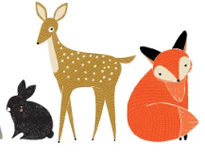

**Art**

We will be focussing on the woodland artwork by John Nolan.

The children will be:

- mixing cold and warm colours

- exploring printing with a range of utensils

- exploring the texture and shapes of trees

- sketching using pencil and charcoal

**PSHE**

Our focus this half term will be ‘Anti-bullying’. The children will learn how to recognise bullying and how to say no to bullying.

We will also cover ‘‘Internet Safety’. The children will learn how to use the internet safely and protect themselves online.

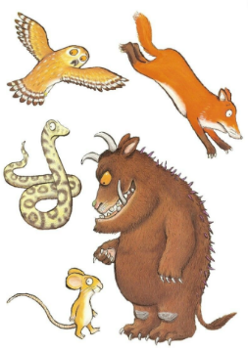

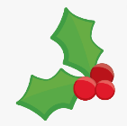   

**Music / Drama**

The excitement will build as we learn the Gruffalo story and a variety of new songs; ready for our Christmas performance…more details to follow!

**Physical Education**

We will be learning how to play handball and developing hockey skills.

**Religious Education**

The children will be focussing on the question, ‘Why does Christmas matter to Christians?’.

They will look at the traditional Nativity story and explore Advent and Christmas. We will be having a Christmas craft day, where the children will make traditional decorations to celebrate Christmas.