Trojans Club

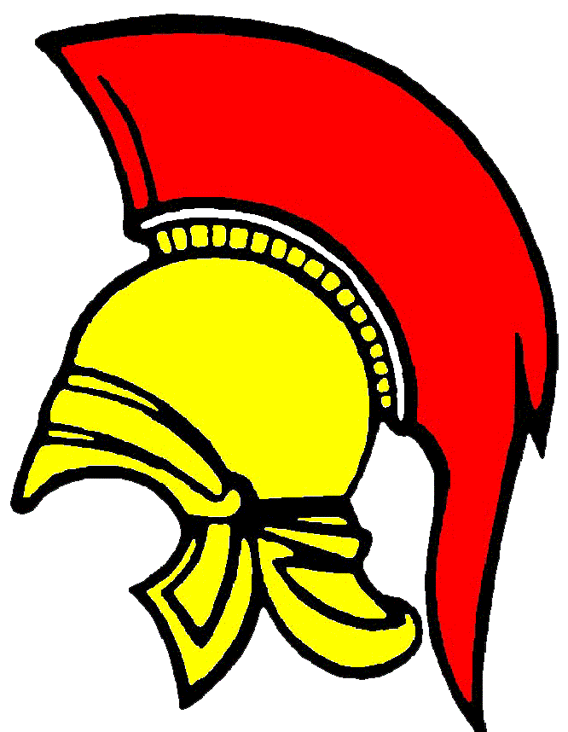

Codes of Conduct Coach, Manager and Club Official

We all have a responsibility to promote the high standards of behavior on and off the field of play of Trojans Club.

By becoming a member of Trojans Club you are agreeing to observe the following Code of Conduct for players at all times.

On and off the field of play, I will:

- Show respect to others involved in the game including match officials, opposition players, coaches, manager, officials and spectators.
- Adhere to the laws/rules and spirit of the game
- Promote Fair Play and high standards of behaviour
- Always respect the match officials decisions
- Never enter the field of play without the referee’s/umprire’s permission
- Never engage in public criticism of the match officials
- Never engage in or tolerate, offensive, insulting or abusive language or behavior

When working with players

- Place the well-being, safety and enjoyment of each player above everything, including winning
- Explain exactly what I expect of players and what they can expect from me
- Ensure all parents/carers of all players under the age of 18 understand these expectations
- Never engage in or tolerate any form of bullying
- Develop mutual trust and respect with every player to build self esteem
- Encourage each player to accept responsibility for their own behavior and performance
- Ensure all activities I organise are appropriate for all players’ ability level, age and maturity

I understand that if I fail to follow the Trojans Club Codes of Conduct the club may impose any/all of the following actions:

- Require me to meet the Club Welfare Officer
- Require me to meet with the club committee
- Monitored by another club coach
- Be required to attend a NGB education course
- Suspended by the club from attending matches or other activities
- Suspended or fined by the club
- Required to leave or be sacked by the club

Signed: Dated:

