Trojans Club

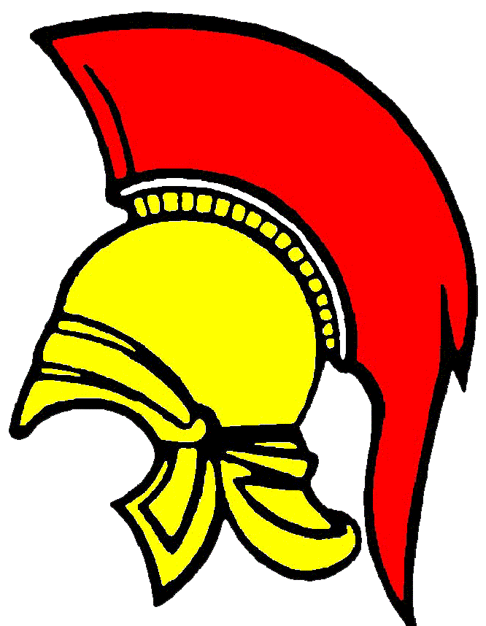

Codes of Conduct Adult

We all have a responsibility to promote the high standards of behavior on and off the field of play of Trojans Club.

By becoming a member of Trojans Club you are agreeing to observe the following Code of Conduct for players at all times.

On and off the field of play, I will:

- Adhere to the laws/rules of the game
- Display and promote high standards of behavior
- Promote Fair Play
- Always respect the match officials decisions
- Never engage in public criticism of the match officials
- Never engage in offensive, insulting or abusive language or behavior
- Never engage in bullying, intimidation or harassment
- Speak to my team-mates, the opposition and my coach/manager with respect
- Remember we all make mistakes
- Win or lose with dignity. Shake hands with the opposing team and match officials at the end of every game

I understand that if I fail to follow the Trojans Club Codes of Conduct the club may impose any/all of the following actions:

- Require me to the apologise to my team-mates, the opposition, match officials or team manager/coach
- Receive a warning from the coach
- Receive a written warning from the Club Committee
- Be required to attend a NGB education course
- Be dropped or substituted
- Be suspended from training
- Not be selected for the team
- Be required to serve a suspension
- Be fined
- Be required to leave the club

Signed: Dated:

