Setting up an interactive writing notebook

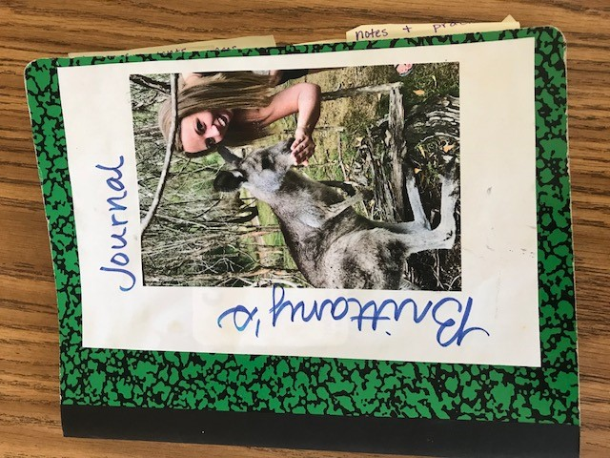 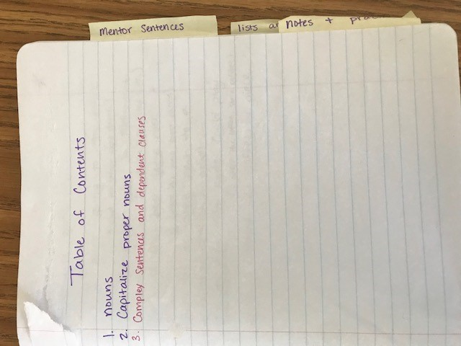

Allow students to personalize their front cover.

Keep a table of contents so that students can refer back to their notes.

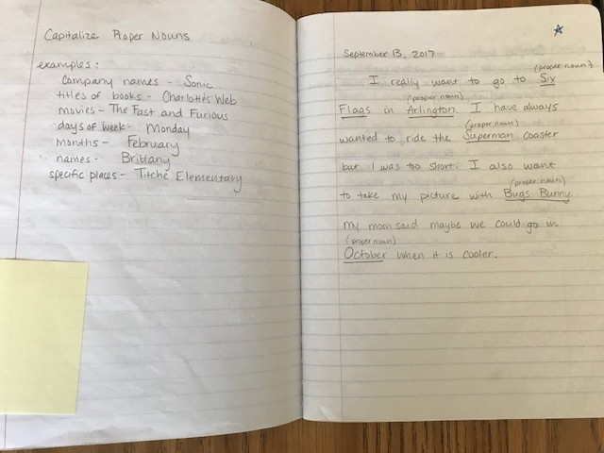

Students demonstrate their learning by authentically practicing the skill to the right.

Students take notes about grammar skills on the left side of their notebook. (Modeling from a teacher anchor chart or projected notes.)

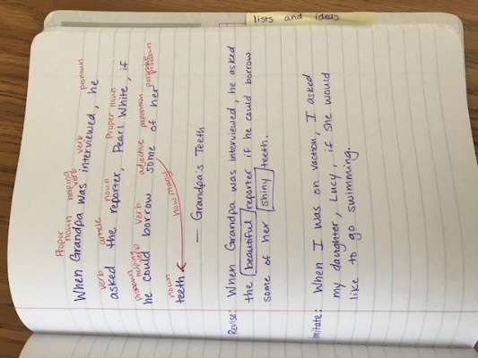 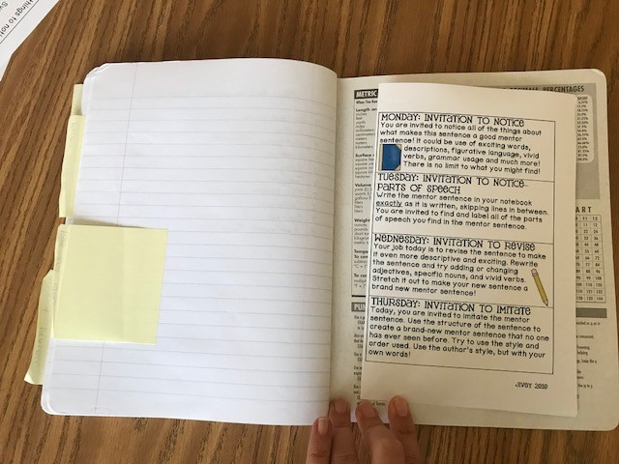

Students can also use their notebook to store mentor sentences in the back.

Routines and tools can be taped to the inside covers of the notebook for reference.