Being Your Higher Self
MEDITATION

The purpose of this meditation is for you to connect with that part of yourself that is your Higher Self, and feel your Higher Self as you.

Sit quietly, focus your mind, relax your body, and start by taking a deep breath. You may want to put on some relaxing music that calms you and takes you higher. You may want a pen and paper beside you you to record your insights.

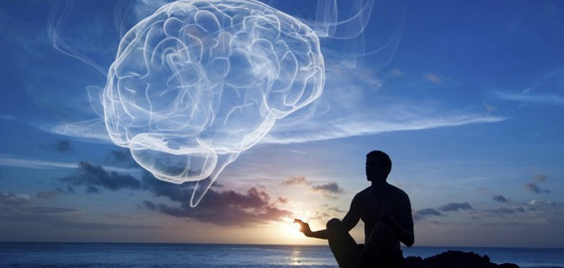

Let’s begin……….

- Sit with your eyes open or closed, if your eyes are open relax your gaze. Adjust you posture so that you are comfortable, perhaps resting your hands by your sides or gently in your lap. Begin by taking a few deep breaths.

- Imagine your entire body relaxing, starting with your toes. Bring a feeling of relaxation into your feet, calves and thighs, then up to the abdomen and lower back, chest, upper back and shoulders. Next relax your arms. Hands, neck, head and face. Let all the tiny muscles around your jaw and eyes, release and relax. Do this until you feel peaceful, focused, and physically comfortable.

- Adjust your posture so that your energy can flow more easily up and down your spine. Breathe a full breath into just your upper chest, moving your diaphragm and lower abdomen as little possible. Breath into your upper chest several times.

- Now breath into your abdomen only several times. Release any tensions anywhere in the body with each out breath.

- Follow this with several breaths into both your upper chest and abdomen. Release any tensions anywhere in the body with each out breath.

- Straighten and lift your upper chest with a deep breath, so your spine is more upright. Notice that as you do this you may also want to adjust the back of your head and neck as if a cord of light is lifting you from the top of your head. This help create fluidity in your emotional body, open your heart center, and make it easier to think in higher vibrational way.

- You are now ready to meet your Higher Self. Imagine that you are being joined by many high beings who are sitting in a circle around you. Take your time and feel the peace, joy and love all around you. These beings are here to assist you in meeting your Higher Self.

- Imagine your Higher Self in the distance, beginning to come toward you. Engage all of your senses as you do this, recognizes what you are thinking or feeling. You might want to picture this a beautiful shimmering light. Greet and welcome your Higher Self. Mentally ask your Higher Self to assist you in making a stronger connection now and always. Feel the radiance of love surrounding you and embracing you. Imagine waves of shimmering light joining you with your Higher Self. As these waves of energy touch you, feel your vibration increase. Feel your molecules, atoms and DNA merging as one with this beautiful, radiant, shimmering light. You are reclaiming a part of your Divine source energy. Let your Higher Self merge with you even more until all your energy patterns are taking on the radiance of your Higher Self. You and your Higher Self are now one, as always and will be.

- As your Higher Self, open your breathing to create a greater flow of energy in your body. Adjust your posture so that you are sitting as your Higher self. As your Higher Self, adjust your shoulders, chest and face to reflect your confidence and wisdom.

- Think of a situation you want guidance with. As your Higher Self, you are going to give yourself advice about this situation. Imagine you are a wise teacher and consultant. Just allow the thoughts to enter your being without placing to much importance on what they are. You may want to speak out loud or write your answers down but don’t engage with them.

- As your Higher Self do you have any other messages or insights, are there any symbols or shapes coming to you. Record everything, don’t Annalise the information now, we can do that when you have finished.

- Thank your Higher Self for joining you today and becoming one with you. Sit as long as you like as your Higher Self.

Connect with me at www.mindseyeopen.com

Or on my social pages mindseyeopen.444

