Addison County PreK Capacity

Contents
Introduction 1
Enrollment Figures 3
Current County-wide PreK Capacity 5
Addison County Parent PreK Survey 7
Provider Survey Information 12
Conclusion 14

Introduction
This report explores the capacity of Addison County Supervisory Unions (Addison Central SU, Addison Northeast SU, and Addison Northwest SU) to implement Act 166, publicly-funded PreKindergarten (PreK), in existing public school and private programs. It explores questions related to how many PreK children there are in our region, where those children are currently enrolled, whether there is capacity to serve PreK children in prequalified, publicly-funded PreK programs, what types of PreK programs families want and need, how many PreK children might take advantage of publicly-funded PreK programs, and whether there is a need for PreK program expansion.
In the 2014 Legislative Session, legislators passed and Governor Shumlin signed Act 166, An Act Related to Universal Publicly Funded Prekindergarten, which requires all Vermont school districts to provide universal publicly funded prekindergarten education for a minimum of ten hours per week for 35 weeks annually for all 3, 4 and 5 year-old children who are not enrolled in kindergarten. Public funding provided through the passage of Act 166 supports high quality early learning and development for preschoolers in Vermont in a program with a licensed teacher. By supporting quality in early education, we increase access for families who expect quality early learning and provide children with the best possible early start to life.

Although Act 166 has been passed, the full implementation of the law has been delayed until next year by most supervisory unions in Vermont. There are a limited number of "early adopters" of the public funding for PreK, including ANESU. All SUs will need to fully serve all 3, 4, and 5 year old children (not in kindergarten) in prequalified programs by next year. Children must have turned 3, 4, or 5 by September 1st and not be enrolled in kindergarten.

Publicly funded PreK programs must be prequalified by the Agency of Education as high quality programs based in either schools or private programs such as child care homes or centers. There is overwhelming evidence that high quality early learning and development is a good, sound public investment. The economic benefits of investing in early childhood are realized in future higher earnings as better educated children grow into adults. In addition, investing in early childhood lowers avoidable costs of child welfare, remedial education, police and corrections, individuals with addiction, and unemployed, underemployed, unproductive, and unhealthy adults. Prequalified programs need to hold at least 3 STARS under Vermont’s quality rating scale, have a licensed early childhood teacher, provide at least 10 hours/week of PreK curriculum following the Vermont Early Learning Standards (VELS), and follow other guidelines set by the Agency of Education and local SUs. Prequalified programs include community private early care centers, home providers, and public school programs.

The universal PreK services are provided at a mix of school-based and private programs, giving families a choice in the location and type of program that will best meet their family’s needs. Providing high-quality early learning opportunities for families often requires full-day, full-year coverage as many families work full time. Supervisory unions pay private programs $3000 in tuition for 10 hours/week of PreK programming over 35 weeks and count the PreK children in their Average Daily Membership (at the rate of .46 FTE, representing about $4271 this school year). Tuition funds are tied to an index that will lead to change over time. Families are responsible for the child care tuition fees beyond the 10 hours/week of publicly funded PreK. If a family is interested in a prequalified program that does not currently have a partnership, they may ask the program to enter into a contract with their SU for the purposes of enrolling their child in the Universal PreK programming.

Act 166 provides for the establishment of geographic limitations or “Prekindergarten Regions” in which a school board may choose to propose to limit the geographic area within which it will pay tuition for prekindergarten education and partner with prequalified programs. In Addison County, only ACSU is pursuing this option for next year, proposing to limit PreK tuition payments to programs within its supervisory union boundaries. ANESU and ANWSU currently partner with prequalified Addison and Chittenden County programs.
Data for this report was collected in August and September 2015 from enrollment figures, STARS and licensing data, private providers and schools/supervisory unions, and a parent survey. The results of this report should help schools and supervisory unions begin to budget for PreK for 2016-17, as well as plan for whether expansion of partnerships or school-based programming is needed.

Enrollment Figures
Overall K-6 enrollment figures for Addison County indicate a grade cohort of approximately 295 children, or 590 children who are 3 & 4 years old. If 72% of these children were to take advantage of the publicly-funded PreK program (in a prequalified program), it would serve 425 children county-wide. If 80% of children took part, 472 children would be served. Although nationwide, 72% appears to be the percentage of children taking part in a universally accessible PreK program, it appears that using the 80% participation rate is more appropriate for Addison County given the high number of families relying on child care for employment (though this rate varies by SU, as noted in the parent survey) and the number of families already accessing early care and education programming. The 80% participation rate also allows for some “cushion” to the budgets in case of a high participation rate or large birth cohort. Nonetheless, in the first years of implementation a smaller cohort of families are likely to participate, possibly making the 72% enrollment projection an appropriate option for some communities.
Enrollment figures by child’s school district of residence are reported below. They were obtained through the state’s data on district census reports from last school year, so may not completely reflect the number of children schools believed they were serving and do not reflect any increases or decreases in population served this year, for example through closing a classroom or increasing the number of private partners.
Town | 2014-15  Publicly-Funded PreK Enrollment | 2014-15 Kindergarten Enrollment (should be about ½ of the average PreK population) | If Kindergarten Enrollment not reflective of average K-6 enrollment, a rough average | If 72% enrollment Publicly-Funded PreK | Projected 80% rate Publicly-funded PreK enrollment | Increase/ decrease over current PreK enrollment (based on 80% enrollment)
ACSU | 117 | 115 |  | 130 | 184 | +69
Bridport | 16 | 12 |  | 17 | 19 | +3
Cornwall | 5 | 10 |  | 14 | 16 | +11
Middlebury | 57 | 54 |  | 78 | 86 | +32
Ripton | 5 | 11 |  | 16 | 18 | +13
Salisbury | 17 | 12 |  | 17 | 19 | +2
Shoreham | 14 | 9 |  | 13 | 14 | 0
Weybridge | 3 | 7 |  | 10 | 11 | +8
ANESU | 96 | 115 | 115 | 130 | 184 | +69*
Bristol | 50 | 35 |  | 50 | 56 | +6
Lincoln | 30 | 13 | 15 | 22 | 24 | -6
Monkton | 14 | 32 | 25 | 36 | 40 | +26
New Haven* | 1 | 8 | 13 | 19 | 21 | +20*
Starksboro* | 1 | 27 |  | 19 | 43 | +42*
ANWSU | 68 | 65 | 76 | 109 | 122 | +54
Addison | 4 | 11 |  | 16 | 18 | +14
Ferrisburgh | 11 | 14 | 25 | 36 | 40 | +29
Vergennes | 53 | 40 |  | 58 | 64 | +11
*New Haven & Starksboro served more PreK children in 2014-15 than are reflected in the state census, but the children were mistakenly left off of the school census data. True census data would likely reflect more stable numbers for these communities with only a slight increase this year.
This model cannot reflect increases or decreases in town population over time, so a particularly large birth increase or decrease in one town would not be anticipated using these figures. However, birth rates as estimated for the entire county for the years 2010-2013 indicate that approximately 295 children were born each year in Addison County: 2010-305 children, 2011-300 children, 2012-284 children, and 2013-293 children. Over time, there has been a gradual decrease in birth rates, but these numbers reflect upcoming PreK students.
According to the SU numbers, ACSU served 105 children last year (12 more children are reflected in state numbers), ANESU served 80 children last year (16 fewer children are reflected in state numbers), and ANWSU served 80 children (12 fewer children are represented in the state numbers).

Current County-wide PreK Capacity
There are 12 prequalified private programs in Addison County currently serve 263 children of PreK age (not all of whom are currently served in publicly-funded PreK). This number fluctuates slightly each year, as children’s schedules influence how many children a program may be serving. An additional 32 Addison County children are known to be enrolled in Chittenden County prequalified programs this year, regardless of whether schools are counting these children in their census (23 children from ANESU, 6 from ANWSU, and 3 from ACSU). Private programs are not able to give a completely consistent figure for their enrollment from each SU, as enrollment numbers are based primarily on parent choice and scheduling, however most indicated that enrollment from each SU has been fairly stable over time. More information on the prequalified programs is available from the provider survey. However, this indicates that about 295 PreK children are served by the currently prequalified private programs in Addison and Chittenden counties (roughly 101 children from ACSU, 128 children from ANESU, 42 children from ANWSU).
An additional 88 children are served by school-based programs (most of which also have capacity to serve a few additional children), and still more are enrolled in programs that are not eligible to become prequalified, both home and center-based.
Nonetheless, with a projected PreK enrollment of roughly 472 children and a current enrollment of 359 in prequalified programs (about 75% of projected need), this indicates a need for additional prequalified programming. This need can be addressed through:
- establishing new programs and/or
- by increasing the number of programs eligible for prequalification
Increasing capacity to serve projected PreK children will depend heavily on identifying the programs that families want and need (i.e. full-time vs part-time). The types of programs preferred by families have been explored by the parent survey. In general, this survey indicates a need for more full-day programming, with a slight preference for full-week and year-round programs in most SUs (see parent survey results for more detail).
There are currently a number of programs who are not eligible to partner under Act 166 (i.e. cannot be prequalified). Of the current 4 & 5 STAR programs serving PreK ages, there are 4 centers and 7 home providers who are not currently prequalified. Several programs would also be able to move up in their STARS level in order to prequalify, possibly even by next year.
The primary barrier for both centers and homes to become eligible for partnership is the presence of a licensed teacher. If centers and home providers are able to contract with a licensed teacher, more of the children enrolled in those locations would be able to be served. One option that is being explored is establishing a group of providers who would contract with an organization for the services of a licensed teacher. So far, several programs have expressed interest in this type of arrangement.
Some centers are interested and would easily be able to obtain prequalification, while others will need to have a longer transition time or are not interested in a partnership. Among the centers that serve PreK-aged children and are not currently prequalified are:
- Addison County Parent Child Center – PreK licensed for 13 (serving fewer)
- The Ark – PreK licensed for 30 (serving fewer)
- Cornerstone – PreK licensed for 40 (serving fewer)
- Newton Academy – PreK licensed for 10 (serving fewer)
- St. Mary’s – PreK licensed for 10 (serving fewer)
- Sapphire Center – PreK licensed for 3 (serving fewer)
- Sunshine – PreK licensed for 24 (serving more)
- Vermont Sun – PreK licensed for 14 (serving more)
License numbers reflect the number of children who may be present at any given time, so each of these centers may actually be serving more or fewer children than are on their license. For example, Vermont Sun this year is licensed for 14, but is serving 18 children in their PreK classroom, and St. Mary’s is licensed for 10, but serving 6. At least two of these programs are likely to attain prequalification by next year and already have a licensed teacher on staff.
Another barrier to partnership is that some of the programs offer a religious or specialized curriculum, and are not able to partner unless they can offer a secular curriculum that is tied to the Vermont Early Learning Standards (VELS) for at least the 10 hours of PreK. Some of these programs may opt to change their curriculum, increasing the possibility of partnering. However, some families may prefer to send their child to religious or specialized programming and not participate in the publicly-funded PreK, much as some families choose a religious or private school for their grade-school children.

Addison County Parent PreK Survey
The Addison County Parent PreK Survey was distributed beginning in September 2015. Information about the survey was disseminated in a variety of ways: the Addison Independent, Minibury, Facebook, via partner programs and schools, other child care programs, email notices to businesses and other community organizations, pediatric and family medicine offices, playgroups, and libraries. Most respondents replied to the online survey, but print copies were also collected. Although it is unclear whether a completely representative sample was obtained, the large number of responses does indicate a fairly good sample size for this region. The survey was open until October 15, 2015.
A total of 223 individuals responded to the Addison County Parent PreK Survey (207 families with children who are 2, 3, or 4 years old). About a quarter of the respondents have a current 2 year-old, 41% have a 3 year-old, and 36% have a 4 year-old. All towns in Addison County except for Lincoln were represented by at least one respondent.
In what Addison County town do you reside?
Answer Options | Response Percent | Response Count
Addison | 4.5% | 10
Bridport | 1.8% | 4
Bristol | 7.6% | 17
Cornwall | 3.1% | 7
Ferrisburgh | 5.4% | 12
Goshen | 0.4% | 1
Granville | 0.0% | 0
Hancock | 0.4% | 1
Lincoln | 0.0% | 0
Leicester | 0.0% | 0
Middlebury | 28.7% | 64
Monkton | 3.6% | 8
New Haven | 9.4% | 21
Orwell | 0.9% | 2
Panton | 1.8% | 4
Ripton | 0.9% | 2
Salisbury | 0.4% | 1
Shoreham | 8.5% | 19
Starksboro | 5.8% | 13
Waltham | 0.4% | 1
Weybridge | 6.3% | 14
Whiting | 0.4% | 1
Vergennes | 9.4% | 21
answered question |  | 223

About 72% of respondents work within the county, with most of these reporting employment in Middlebury. By far, the majority of those families working outside the county are commuting to Chittenden County, especially Burlington (about 19% of the total).
In what town do you work?
Answer Options | Response Percent | Response Count
Addison | 1.9% | 4
Bridport | 0.9% | 2
Bristol | 3.3% | 7
Cornwall | 0.5% | 1
Ferrisburgh | 1.4% | 3
Lincoln | 1.4% | 3
Middlebury | 46.9% | 99
Monkton | 0.5% | 1
New Haven | 1.9% | 4
Ripton | 0.5% | 1
Salisbury | 0.0% | 0
Shoreham | 3.8% | 8
Starksboro | 0.5% | 1
Vergennes | 8.1% | 17
Other (please specify) | 28.4% | 60
answered question |  | 211

Eighty-one percent of respondents (181 families) have children who are currently enrolled in PreK or child care programs. Of the 42 children not currently enrolled in a program, 27 (almost two-thirds) are 2 years old and 91% of these families expect to enroll their child in PreK next year. Currently, 112 of the enrolled children are in current prequalified programs. However, the bulk of these children (59%) are not enrolled in the publicly-funded PreK program this year (encompassing all the 2 year-olds and many ACSU children who are not eligible this year).
76% of families plan to enroll their child in a PreK or child care program next year. The bulk of the families who do not plan to enroll have 4 year-olds who are likely going to kindergarten in the fall, indicating a much higher percentage of families who plan to enroll their child in PreK.
Nearly eighty percent of Addison County families rely on child care so that they can work. Preferred schedules for PreK programs reflect this: 68% of families would prefer full-day programs (vs. 21% preferring part-day programs), 45% would prefer full-week programs (vs. 36% preferring part-week programs), and 40% would prefer year-round programs (vs. 25% preferring part-year programs).
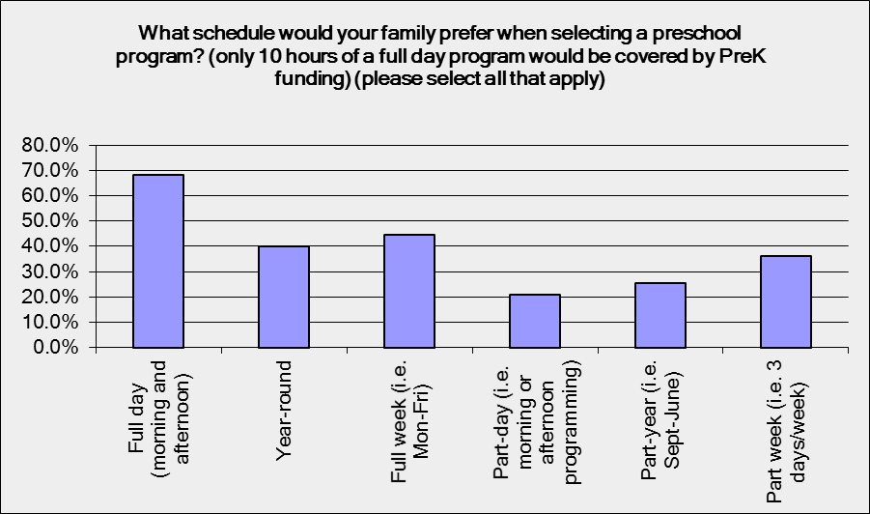
Quality of programming is the most important factor in selecting a program (93% of families chose this as an important factor in their decision). Most families also chose: proximity of the program to their home, ability to match family schedule, program philosophy, and ability to meet child’s needs.
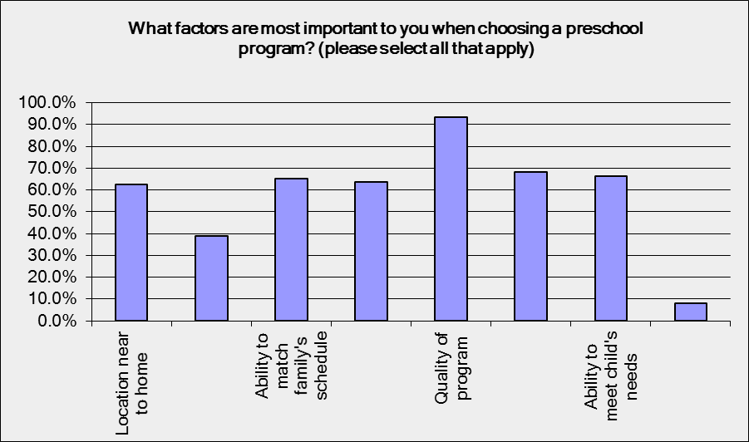
ACSU Summary
104 ACSU families with a child who was 2, 3, or 4 years old answered the PreK Parent Survey (fairly evenly divided between each age). The bulk of these families were from Middlebury, though every town was represented in the responses. Most families also worked in Middlebury, though about 20% work outside of Addison County (11 families) or outside ACSU boundaries (10 families).
82% of families (91 families) report that their child is currently enrolled in a PreK or child care program. Of these, the majority (60 families) are currently enrolled in a prequalified program (with most of the other children reporting enrollment at private full-time center programs like Sunshine or Vermont Sun). Only 16 families report being enrolled in publicly-funded PreK this year, with the bulk of families responding that they are not currently enrolled (74 families) or they don’t know (11 families).
Next year, 80% of ACSU families expect their child to be enrolled in PreK or child care. The bulk of the families that do not anticipate a PreK enrollment next year have 4 year-olds, who presumably will be enrolled in kindergarten. More than two thirds of these children are planning to enroll in a currently prequalified program (46 families). Some families do not yet know where they will enroll.
Nearly eighty percent of ACSU families rely on child care so that they can work. Preferred schedules for PreK programs reflect this: 70% of families would prefer full-day programs (vs. 19% preferring part-day programs), 52% would prefer full-week programs (vs. 32% preferring part-week programs), and 41% would prefer year-round programs (vs. 26% preferring part-year programs).
Quality of programming is the most important factor in selecting a program (94% of families chose this as an important factor in their decision). Most families also chose: proximity of the program to their home, ability to match family schedule, program philosophy, and ability to meet child’s needs.
ANWSU
43 ANWSU families with a child who was 2, 3, or 4 years old answered the PreK Parent Survey (the majority of these are families of 3 year-olds). The bulk of these families were from Vergennes, though every town was represented in the responses and a sizeable proportion came from Ferrisburgh and Addison. A large proportion of families works outside of Addison County, with the bulk of these (15 families) commuting to Chittenden County. About 19% of respondents are employed in Middlebury and 17% in Vergennes.
73% of families (35 families) report that their child is currently enrolled in a PreK or child care program (6 of the remaining 13 families have 2 year-olds this year). Of the enrolled children, about 19 families, or just under half, are currently enrolled in a prequalified program. 19 families also report being enrolled in publicly-funded PreK this year, with 20 families responding that they are not currently enrolled (some of whom have 2 year-olds who are not eligible) or they don’t know (2 families). A sizeable proportion of the ANWSU families that are not currently enrolled in public PreK programming but who do have children in PreK have children at Cornerstone, a religious-based PreK program, though several also have children with home-based providers.
Next year, 67% of families expect their child to be enrolled in PreK or child care. The bulk of the families that do not anticipate a PreK enrollment next year have 4 year-olds, who presumably will be enrolled in kindergarten (8 of the 14 families).
About 74% of ANWSU families rely on child care so that they can work. Preferred schedules for PreK programs reflect a slight preference for full-time programming, though not as distinct as in the other Addison County SUs: 68% of families would prefer full-day programs (vs. 24% preferring part-day programs), 44% would prefer full-week programs (vs. 39% preferring part-week programs), and 41% would prefer year-round programs (vs. 20% preferring part-year programs).
Quality of programming is the most important factor in selecting a program (93% of families chose this as an important factor in their decision). Most families also chose: proximity of the program to their home, ability to match family schedule, program philosophy, and ability to meet child’s needs.
ANESU
55 ANESU families with a child who was 2, 3, or 4 years old answered the PreK Parent Survey (the majority of these are families of 3 or 4 year-olds). The bulk of these families were from Bristol (17 families) or New Haven (21 families) or Starksboro (13 families), though every town except Lincoln was represented in the responses. A large proportion of families works outside of Addison County, with the bulk of these (20 families or 36%) commuting to Chittenden County. About 28% of respondents are employed in Middlebury.
Just over 84% of families (50 families) report that their child is currently enrolled in a PreK or child care program. Of the enrolled children, about 32 families, or about two thirds are currently enrolled in a prequalified program. Most of these children in the prequalified programs are funded; 29 families report being enrolled in publicly-funded PreK this year, with 22 families responding that they are not currently enrolled (some of whom have 2 year-olds who are not eligible) or they don’t know (2 families). A sizeable proportion of the ANESU families that are not currently enrolled in public PreK programming but who are enrolled in a PreK program have children at Cornerstone, a religious-based PreK Program, though several also have children with home-based providers.
Next year, 74% of families expect their child to be enrolled in PreK or child care. All of the families that do not anticipate a PreK enrollment next year have 4 year-olds, who presumably will be enrolled in kindergarten.
82% of ANESU families rely on child care so that they can work. Preferred schedules for PreK programs reflect a slight preference for full-time programming, though more families do not require full-time care throughout the week: 65% of families would prefer full-day programs (vs. 20% preferring part-day programs), 31% would prefer full-week programs (vs. 45% preferring part-week programs), and 35% would prefer year-round programs (vs. 29% preferring part-year programs).
Quality of programming is the most important factor in selecting a program (94% of families chose this as an important factor in their decision). Most families also chose: proximity of the program to their home, ability to match family schedule, program philosophy, and ability to meet child’s needs.

Provider Survey Information
Current private partner providers for the three SUs are:

Addison County:
- Bristol Family Center
- Bristol Preschool/ Sue Owen-Jankowski
- Champlain Valley Head Start (Middlebury)
- Cookie Cummings/Mountain Road Preschool
- Evergreen Preschool
- Gerri Barrows/Discovery Hills
- Lincoln Cooperative Preschool
- Middlebury Cooperative Nursery School
- Mary Johnson Children's Center
- Otter Creek Child Care
- Quarry Hill School
- Starksboro Coop
Chittenden County:
- Hinesburg Nursery School
- Annette's Preschool
- Charlotte's Children Center
- Kinderstart Preschool
- Heartworks (Burlington, Shelburne, & Williston)
- Green Mountain Montessori School
- Kid Logic Learning Center
- Schoolhouse Learning Center
- Sheila Quenneville
- Trinity Children's Center

Not all SUs partner with all providers. ACSU, for example, has a limited number of partners this year, while ANESU and ANWSU do not have enrolled children at all of the above listed partners. The following lists information from an August/September survey of partner providers.
Responses were received from 18 of 22 partner provider programs in both Addison and Chittenden counties. A combined total of 479 preschool-aged children are served by those programs, 263 by the programs that are located in Addison County. Not all of the children enrolled in Addison County programs reside in Addison County, however, so numbers are further broken down by SU of residence below.
Currently 12 programs offer the option of fewer than 20 hours/week as the minimum amount of time a child could attend their program, with most of these offering families a minimum choice of 7-10.5 hours. Twelve programs offer families an option of 40 hours or more (with two others offering more than 35 hours). However, most programs are not currently equipped to offer many slots that are just 10 hours/week for 35 weeks per year. School-based programs, however, do typically offer programs that are just 10 hours/week through the school year.
Most programs operate with a waitlist fewer than 5 children, but both Otter Creek and Mary Johnson have 20 or more children on their waitlist, indicating an ongoing need for full-time programs for PreK children.
Child care providers mentioned the following as important to selection of an early learning program:
Proximity to work/home | 10 | 52.6%
Cost | 14 | 73.7%
Quality | 18 | 94.7%
Ability to match family's schedule | 9 | 47.4%
Ability to meet child's needs | 7 | 36.8%
Other | 1 | 5.3%
ANESU
Partner providers reported 47 eligible 3 year-olds and 81 eligible 4/5 year-olds from ANESU (total of 128 children). All of these children have been funded by ANESU and programs expect that enrollment next year will be approximately the same. For programs that take 2 year-olds, the numbers are similar to those in their 3 year-old classrooms.
ANWSU
Partner providers reported 24 eligible 3 year-olds and 18 eligible 4/5 year-olds from ANWSU (total of 42 children). Currently, three of these children are not funded by ANWSU. Programs expect that enrollment for next year will be very similar. Few of the partner programs have 2 year-old children from ANWSU, but those that do have a similar number to those of the 3 year-olds who are in the programs.
ACSU
Partner providers reported 41 eligible 3 year-olds and 60 eligible 4/5 year-olds from ACSU (total of 101 children). Currently at least 54 of these children are not funded by ACSU. Most of the partner programs that have 2 year-olds report serving lower numbers of these children.

Conclusion
PreK partnership funding and requirements will help to increase quality of early care and education in Addison County, both in private partners and by incentivizing non-partner programs to reach quality standards for prequalification. It will also assist families in accessing the highest quality PreK programs, by reducing tuition costs. Finally, it will benefit children who will be receiving high quality PreK education based on the Vermont Early Learning Standards, a benefit that will be able to be assessed county-wide through TS Gold data.
If we assume an 80% enrollment rate for next year, Addison County will have approximately 472 children enrolled in PreK programming in the fall. In reality, I expect a more gradual change, with perhaps 72% enrollment in the fall, but an increase in the subsequent 2-3 years as the program gains momentum. These children will be served in a mix of full-time and part-time programs, both private and school-based. In general, most of these children can be absorbed by existing programs, but parent and provider data indicates a need for additional full-time child care programs that are eligible for prequalification. In some cases, there may be programs that can become prequalified, and in other cases we need to explore other options, including opening new programs.
One option that deserves substantial exploration is that of hiring a licensed teacher who could serve as a contractor to centers and homes that do not meet prequalification standards primarily due to the lack of a licensed teacher. In order to make this plan work, a “holding agency” would need to volunteer to serve as the licensed teacher’s employer. We would also need to identify specifically which programs that teacher would serve and create a contract system between the programs and the “holding agency”. Increasing the number of programs who can be prequalified in this way will increase options for families, especially those who prefer a home-based PreK program, and will also serve to increase capacity to serve PreK children.
Although the focus of this report is on PreK, we also need to be sensitive to the issues of Addison County child care programming as a whole. Infant and toddler slots, particularly in home-based programs, are often dependent on the enrollment of PreK students as well, given the licensing limitations on ratios. If we lose home-based programs because more centers and school-based programs are opening PreK programs, we will also be decreasing capacity for infant and toddler slots in the region. These slots are already very challenging to find, and yet provide a critical service for the youngest members of our community.
ACSU PreK projections indicate an enrollment of 184. Currently, 101 children are served by prequalified private providers and 44 by school-based programs (total of 145). Although ACSU has not historically funded all of the children in the private programs, there may not be a need to increase the number of programs in this region substantially, though budgets will need to increase to fund the 3 and 4 and 5 year olds in the prequalified programming. ACSU has the bulk of the large centers that are prequalified. Large programs like Mary Johnson, Otter Creek, and Quarry Hill are all prequalified and located in Middlebury. However, MJCC and OCCC also operate with lengthy waitlists and programs like Vermont Sun and Sunshine draw primarily from ACSU, indicating a continued need for prequalified, full-time programming within ACSU. Given the presence of full-time programming within ACSU, it may make the most sense to focus in this region on bringing existing child care programming up to prequalification standards. At this time, it does not appear that ACSU has an unmet need for part-time programming.
ANWSU has a projected PreK enrollment of 122, with 42 children currently served by private partners and 21 served by school-based programs (total 63). Evergreen is ANWSU’s primary prequalified partner program, however ANWSU has few options for prequalified providers offering full-time child care. It appears based on the parent survey and informal information that many families use home providers, relatives, or religious programming for their PreK children. According to the parent survey, fewer families in ANWSU are looking for full-time child care than in other SUs. Furthermore, a significant percentage of ANWSU families commute to Chittenden County, and may choose to use providers in that area. In this SU, it may make sense to look at creation of new programming ideally with a flexible full/part-time model and/or to work with existing home-based and religious programs to offer a secular PreK program.
ANESU is projected to serve 184 children under the enrollment model. Currently, 124 of these children are served by private providers and 23 are served by school-based programs (total of 147). ANESU seems to have a healthy balance of prequalified programs that offer part and full time care, though many families also use home providers, relatives, or religious programming to meet full-time child care needs for their PreK children. Furthermore, a significant percentage of ANESU families commute to Chittenden County, and may choose to use providers in that area. As the PreK program numbers expand, additional programs may need to be created.

