

OCT 1, 2018

COMMONWEALTH OBSERVER

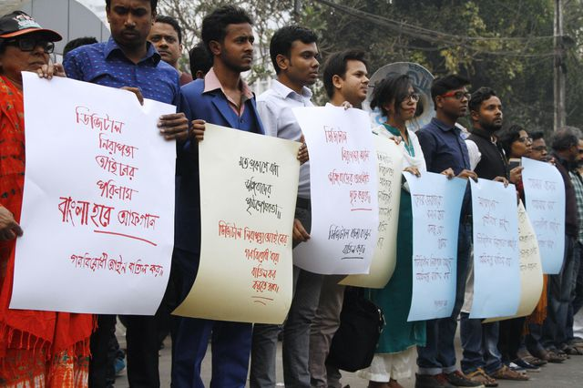**

***Bangladesh Opposition sees Act as threat to freedom of speech***

*Bangladeshi activists hold placards during a protest against the Digital Security Act 2018 which* was *passed by the 350-member parliament in a voice vote with only 11 voting nay.*

*REHMAN ASAD/AFP/Getty —****See Story Page 2***

**The top stories**

Page numbers

2 Bangla Security Act will hamper harmony

2 Bid in to rescind arrest of Pakistani editor

3Pakistannew govt fails to back minorities

4 Paki journos embrace bomb report training

5 Indian soldiers dragging body stirs outrage

6 Malays want govt to toughen HR to religion

6 Indian politicians chant austerity mantra

8.Canada declares Rohinga crisis genocide

9 Recall why NZ women were first to get vote

11 Srti Lanka scorns child killing ransoms,

Page 12 **A glimpse of Commonwealth briefs**

— Let’s learn lessons from Zimbabwe before it is too late

— Cyprus reaches its limits on handling asylum applications

— Refugee children on Nauru 'living without hope' UN told

— Samoa concerns on schools’ reinstated corporal punishment i— Banned Kenyan film challenges stereotypes all mover

Page 13 **Commonwealth Books worth a read**

14 Kiwi on Auschwitz. Islamic militancy in Nigeria. And Outposts today of the British Empire

Page 15 **Compulsory smiles**.

A crisis of memory

**Compiled and edited by Murray Burt, president of Manitoba Royal Commonwealth Society, Canada**

[Facebook](https://www.facebook.com/sharer/sharer.php?u=http://www.nst.com.my/opinion/columnists/2017/05/238745/indias-engaging-diplomacy&t=India%27s%20engaging%20diplomacy)

[Twitter](https://twitter.com/share?url=http://www.nst.com.my/opinion/columnists/2017/05/238745/indias-engaging-diplomacy&via=NST_Online&text=India%27s%20engaging%20diplomacy)

[Google Plus](https://plus.google.com/share?url=http://www.nst.com.my/opinion/columnists/2017/05/238745/indias-engaging-diplomacy)

**Bangladesh parliament passes draconian Digital Security Act;**

**Media views it as hampering harmony and risk to public order**

Telecommunication and Information Communication Minister Mustafa Jabbar last week placed the bill for immediate passage and the 350-member parliament [it](http://www.newagebd.net/article/50996/bangladesh-parliament-passes-digital-security-bill) by voice votes with only 11 lawmakers opposing the bill.

The formulation of the law was initiated in 2015 with the cabinet approving the draft on Jan 29, and placing in the House on April 9.

The Editors' Council on Sept 16 in a statement rejected the bill stating that Sections 8, 21, 25, 28, 29, 31, 32 and 43 [posed serious threats to freedom of expression and media](https://www.thedailystar.net/frontpage/news/draft-digital-security-act-editors-reject-js-body-report-1634866).

Section 8 includes provisions about blocking or removing any information in the digital media over any content deemed hampering harmony, public order, or creating communal hatred, among other things. Section 21 states anyone 'spreading negative propaganda against the Liberation War or the Father of the Nation, National Anthem and national flag' using digital devices or instigating to do so would be punished with imprisonment for up to a life term.

According to Section 25, a person may be jailed up to five years for “deliberately publishing or broadcast on a website something attacking or intimidating or which can make someone feel disgruntled or knowingly publishing or broadcasting false or distorted information.” Section 28 states if anyone hurts religious sentiments, they may face jail up to 10 years. Section 29 states a person may face up to three years if they defame someone as stipulated in Section 499 of the Penal Code through a website. Section 31 states a person may face up to seven years in prison if they are found to have deliberately published or broadcast something on a website which can spread hatred and create enmity.

As per Section 32, if a person commits any crime or assists anyone in committing crimes under colonial era Official Secrets Act, 1923, through electronic medium, he or she may face a maximum 14 years in jail. Section 43 allows a police officer to search or arrest anyone without any arrest warrant. Section 21, 28, 31 and 32 are classified as non-bailable offenses.

The IFJ said: “The gross misuse of laws in Bangladesh, such as Section 57 of the ICT Act, to curtail freedom of expression and stifle critical voices raises serious concerns about these new laws which only strengthen the government's power to control and suppress the media. The problematic provisions including Sections 8, 21, 25, 28, 29, 31, 32 and 43 raise serious concerns about the freedom of the press, with arbitrary provisions with scope for state agencies to harass and intimidation journalists. The IFJ calls for the law to be immediately amended to guarantee press freedom.”—*SOURCE: Ifex;* *posted in* [*Bangladesh*](https://www.ifex.org/bangladesh/)[*Free Expression & the Law*](https://www.ifex.org/free_expression_and_the_law/) *.  ___________________________________________________________________________________________________________*

**Reporters Without Borders asks Pakistani court to rescind warrant for editor’s arrest**

Reporters Without Borders (RSF) calls on Pakistani judicial officials to respect the rule of law by rescinding a warrant for the arrest of Cyril Almeida, the deputy editor of *Dawn*, the country’s leading English-language daily, in connection with an interview with former Prime Minister Nawaz Sharif.

The high court in the eastern city of Lahore issued the “non-bailable arrest warrant” on Sept 24 on the grounds that Cyril Almeida failed to respond to a summons to appear at a hearing earlier the same day in the judicial investigation into Sharif — now one of the bugbears of Pakistan’s military establishment — and another former prime minister on suspicion of treason.

The case has its origin in the [interview that Sharif gave to *Dawn* “](https://www.dawn.com/news/1407192)on May 11 in which he suggested that “people from Pakistan” may have been involved in the major terror attack in the Indian city of Mumbai in 2008. For this, he is being investigated for treason and Almeida is now being treated as an alleged accomplice to treason.

*Harassment*

The Lahore high court’s presiding judge said Almeida had been sent three summonses although the newspaper’s headquarters in Islamabad said only one was received, at the end of last week. Almeida was meanwhile in Karachi, at the other end of the country, and had no choice but to be represented by a lawyer in Lahore. He has been summoned to appear again on Oct 8.

  “It is absolutely unacceptable that Cyril Almeida should be accused of treason simply for interviewing a politician,” said Daniel Bastard, the head of RSF’s Asia-Pacific desk. “We call on the court to immediately withdraw this grotesque arrest warrant, which bears all the hallmarks of an ignominious act of harassment.”

 Bastard added: “Crude procedural abuses are clearly being used to intimidate this journalist in order to deter him from doing his job. And behind him, it is *Dawn’s* editorial freedom that the establishment is targeting.”

*Red lines*

*Dawn* is under growing pressure to comply with the army’s wishes on editorial policy and to respect its red lines, which include the role of the intelligence services and Pakistan’s policy towards its Indian neighbor.

 The now famous interview with Sharif, which *Dawn* published on May 12, resulted in [the newspaper’s distribution being blocked](https://rsf.org/en/news/pakistan-authorities-block-distribution-oldest-newspaper) throughout almost the entire country – an effective way of undermining its finances.

With the warrant for Almeida’s arrest, judicial methods are now being used to place additional pressure on the newspaper. The court also ordered that his name should be placed on the Exit Control List (ECL), which prevents him from leaving the country.

*Dawn* has said Almeida [will comply with the next summons](https://www.dawn.com/news/1434802/lhc-issues-warrants-for-almeida-orders-govt-to-put-him-on-ecl). In 2016, he interrupted his reporting on the US elections to return to testify before a court set up by the Pakistani government. Pakistan is ranked 139th out of 180 countries in [RSF’s 2018 World Press Freedom Index](https://rsf.org/en/ranking). —*SOURCE: Reporters Without Boarders*

*___________________________________________________________________________________________________________*

[**Pakistan new government fails to support minorities**](https://www.gatestoneinstitute.org/12983/imran-khan-pakistan-minorities)

*by* ***Kaswar Klasra***

In a move that raised eyebrows both in Pakistan and abroad, the government succumbed to the pressure of Islamists by asking renowned economist Atif Mian to step down from membership of the prime minister's Economic Advisory Council, solely because he is a member of the persecuted minority Ahmadi community.

Mohammad Abdus Salam was the first Pakistani to receive a Nobel Prize in science, and the second person from an Islamic country, after Egyptian President Anwar Sadat, ever to have been awarded a Nobel Prize in any field.

Mohammad Safdar, a prominent legislator, launched a verbal attack on Ahmadis, calling them a "threat to this country, its Constitution and ideology... Because their's is a false religion, in which there is no concept of jihad for Allah."

Let us hope that the Pakistani leadership's abandonment of Mian is the last such incident.

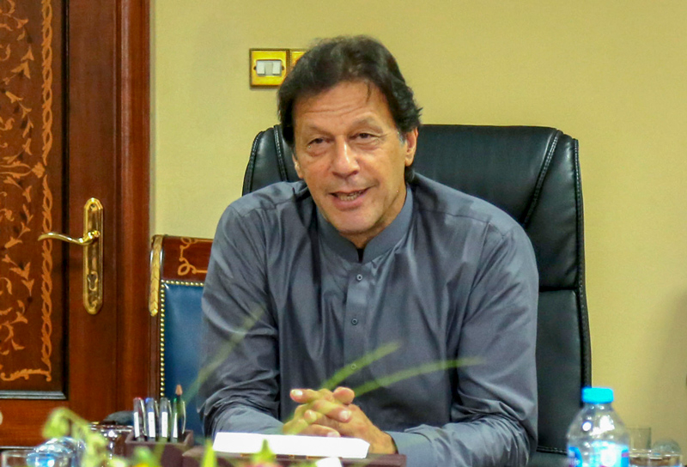

*Pakistan's Prime Minister Imran Khan. (Image source: US State Department)*

Radical Islamists took to the streets of Pakistan on September 1, to protest Prime Minister Imran Khan's appointment of former Princeton University scholar Atif Mian, a minority Muslim of the Ahmadiyya faith, to the Economic Advisory Council (EAC). Demanding that Mian be removed from the EAC, a key forum that advises the prime minister on economic issues, demonstrators threatened to lock down Pakistan's major cities, including Islamabad, its capital.

Mian's appointment was opposed by Pakistan's right wing political parties including "Tehreek-i-Labbaik Pakistan (TLP)", which strongly objected to his Ahmadi faith.

In addition, a well-orchestrated social-media smear campaign is being waged against Mian -- the only Pakistani on the International Monetary Fund's 2014 list of the world's "25 brightest young economists" -- for the sole reason that he adheres to the Ahmadiyya faith.—*SOURCE: The Gatestone Institute*

*___________________________________________________________________________________________________________*

**Pakistan journalists embrace “bomb” report training in toughened workshop**

In a nation that is becoming increasingly fractious, rural Pakistan journalists are being given guidance in avoiding life-threatening dangers on the job.

An example is the inclusion of guidelines where work subjects at scenes involving such issues as coverage after bomb blasts, parcel bomb delivery, booby traps, mob violence, police crowd control, to name a few of the issues covered.

These were considered, for example, at a journalist workshop delivered recently at SammaSatta, in the Bahawalpur Sdistrict Pakistan’s South Punjab.

The region is the hub of strict religious observance, faith festivity and firm feminist control and thus very sensitive to media’s intrusion on a variety of faith-sensitive and sociologically conflicting scenes and subjects.

It was here the workshop was launched by Rural Media Network Pakistan, which includes several rural publications, and where religious norms are closely respected. The 18 participants from press and broadcast in the workshop filled out a questionnaire ahead of time detailing their concerns on the job.

These revealed grave concerns about discrimination at work and on the job, not to mention frequent exposure to violent situations in public. The issues formed the subjects of lectures and guidance by Prof Dr. Sajjad Ahmed Paracha, Prof Shehzad Ali Khan and resource personnel Messrs Nazir Hameed, Nauman Masood Khan.

The participants’ evaluation forms, filled out as the course ended, were universally positive. They urged provision of more such programs by RMNP and DCMF “to sensitize the issues of (journalist) safety and security… and press freedom monitoring committees… an upgraded safety manual, rural press clubs and press freedom monitoring committees.” *SOURCE— Rural Media Network Pakistan; Sehar Ehsan Ahmed*

*___________________________________________________________________________________________________________*

**Controversial photo of Indian troops dragging rebel body Kashmir stirs outrage**

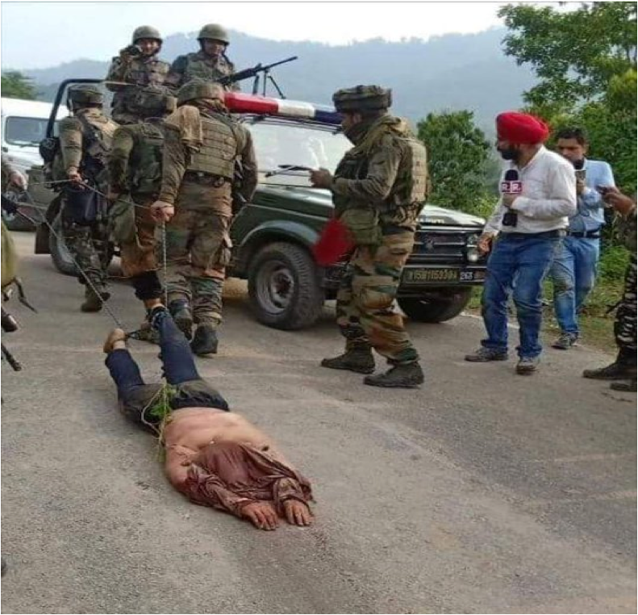

This photograph showing Indian soldiers dragging the bloodied, half-naked body of a rebel has triggered outrage in and outside Indian-administered [Kashmir](https://www.aljazeera.com/topics/issues/indian-administered-kashmir-141021143036795.html), with rights activists calling it a "barbaric" act which violates international humanitarian law.

The incident took place on Sept. 13 in the Kakriyal forests in the Reasi area of Jammu in the southern part of the disputed territory after a seven-hour gun battle in which the army killed three rebel fighters.

Soon after the fighting was over, the image of Indian soldiers dragging the dead fighter with his face down and his feet chained surfaced on social media, attracting widespread condemnation.

Meenakshi Ganguly, South Asia director at US-based Human Rights Watch ([HRW](https://www.aljazeera.com/topics/organisations/human-rights-watch.html)), demanded an immediate inquiry into the "disgraceful action by soldiers in Kashmir who, apparently fearing rigged explosives, dragged the body of a slain militant with a rope".

"This shows poor training and utter failure to respect rights," Ganguly posted on Twitter. The Geneva Conventions, of which India is a signatory, prohibits the mutilation of dead bodies in a conflict.

*___________________________________________________________________________________________________________*

**Malaysia** [**govt urged to strengthen enjoyment of human right to freedom of religion**](https://commonwealthhumanrightsinitiative.cmail20.com/t/i-l-noyhtd-euuejkul-tt/)

The Human Rights Commission of Malaysia (Suhakam) has called on the government to take immediate steps to strengthen the enjoyment of fundamental human right to freedom of religion.

This is in light of the recent detainment of suspected Syiah followers in Kota Baru on Aug 30, during an operation conducted by the Kelantan Islamic Affairs and Religious Department (JAHEAIK). The commission also said that it was ready to play a facilitative role and hoped the government would take fair and constructive steps towards providing equal rights for all religious groups in Malaysia.

Its chairman Tan Sri Razali Ismail said the commission was deeply concerned with the most recent crackdown of the Syiah followers, for practicing their religion despite a right guaranteed in the Federal Constitution.

Razali said the commission would not want to see a situation where religious intolerance, discrimination, social hostilities and incitement to violence based on religion or belief reach new depths in our new Malaysia and believed sensitivity of the subject matter could no longer be a barrier to a firm resolution.

“The glaring inequality facing religious minorities has not changed since Pakatan Harapan coming into power, despite the government’s promise to end discrimination in a moderate, progressive and tolerant Malaysia.

The government must immediately take steps towards guaranteeing legal protections and rights for all religious minorities and to reinforce peaceful and sustainable coexistence among Malaysians. Given the democratic transition in Malaysia, many countries will follow with great interest the developments in Malaysia at the upcoming Universal Periodic Review (UPR) and we can expect the situation of minorities will be a focus for Malaysia.”

He said the commission also believed that the Council of Rulers had the responsibility towards sectors of Malaysian population victimized on the basis of their religious beliefs.— *SOURCE: StraitsTimes*

*___________________________________________________________________________________________________________*

## *Indian politicians chanting austerity mantra, but…*

***By Mahendra Ved***

Chanakya, who lived three centuries before Christ and laid down the Indian laws of governance, diplomacy, economics and much else, also left behind a story about the austerity that a public person should observe. Extending a meeting with the envoy of a neighboring kingdom beyond his normal working hours, Chanakya sent away the staff, put out the lights and lit an earthen lamp. He explained that he could not afford to waste the exchequer's resources.

But few are actually recalling this story. Even Mahatma Gandhi, who practiced and preached austerity, seems forgotten as India's ruling class feverishly seeks to transform itself from indulging in conspicuous consumption to what seems like conspicuous austerity.

Austerity is also getting competitive. A day after Congress chief Sonia Gandhi travelled economy class, her party general secretary and son Rahul travelled by train in a second-class compartment.



Once that happened, there could be no stopping ministers and lawmakers from emulating them. In a hilarious confession, a parliamentarian exchanged his club class seat with an economy class passenger when Sonia, to the surprise of everyone, boarded the aircraft.

One hears some ministers and lawmakers letting anyone who cares know that they do not collect their salaries and allowances. Known to be well off, they obviously do not need to.

Some VIPs have switched to budget airlines. It is good business -- and free publicity -- for the airlines.

In this season of thrift, iftar parties during Ramadan were simple affairs. Offices of the president, the prime minister and the vice-president pruned their guest lists and the fare served was certainly modest.

With the main opposition Bharatiya Janata Party (BJP) never too keen and many others reeling from their poll defeats, the "political iftar" was out.

Nobody wants to be politically incorrect.

How did it start? One suspects the spin doctors at work in the government. After claiming achievements in the first 100 days of the Manmohan Singh government and making further promises, what should be done next to keep the political pot boiling for the state legislature elections due next month?

On another plane, the government was finding it difficult to withdraw security guards for those who lost in the elections and to get them to vacate the government homes.

To be fair, the corrective began at home.

In an unprecedented move, Finance Minister Pranab Mukherjee asked two of his colleagues who had been residing in luxury hotels -- albeit at their own expense and for want of a government house they are entitled to -- to move to "austere" abodes.

External Affairs Minister S.M. Krishna and his deputy, Shashi Tharoor, both first-timers in the Federal Government and political light-weights, were easy targets. They were quick to abide.

The story would have ended there but for a flippant and politically incorrect remark on Twitter by Tharoor. Asked if he would travel "cattle class", having moved out of a luxury hotel, Tharoor said he definitely would, "to express solidarity with holy cows". All hell broke loose.

The BJP was quick to link the cow being holy as per Hindu scripture and in the Indian ethos. Afraid that Tharoor may have unwittingly touched a raw political nerve, his own Congress party officially reprimanded him.

In another unprecedented move, his party senior and Rajasthan state chief minister demanded that Tharoor resign.

The touch of humor caused a tumor for Tharoor, an international civil servant who nearly became the United Nations secretary-general before joining the rough and tumble of domestic politics.

He may have forgotten momentarily that he was no longer on the Colbert Report, one of America's top-rated political satire shows on which he had been a guest a couple of times while he was in New York. He now needs to realize the limits on his freedom of expression in a political arena where the old and traditional still dominate.

Since the austerity mantra is getting competitive and conspicuous, the media has had a great time running stories and debating the issue.

For the corporate sector that drives the media, however, austerity remains unknown unless forced by the recession. So, it does not mind preaching to the political class against "wasteful expenditure". The media says the austerity drive is a sham, even as it relishes the politicians' self-inflicted wounds.

The no-holds-barred debate has now extended to pruning the size of ministries, doing away with aircraft and helicopters bought and maintained by the exchequer, and much more.

Making or spending money is no longer a sin. Caught in the consumption web since the economic reforms, the Indian middle class has come to accept without murmur the perks politicians enjoy in the name of efficiency.

But it can always be aroused on the question of public morality. Asked media personality Rajdeep Sardesai: "If the prime minister -- himself almost Gandhian in his habits -- was serious about tightening the sarkari (government's) belt, he would have downsized the government. "After all, why does he need a 78-member council of ministers, including around 38 ministers of state? Cutting his ministry by half will be a much bigger saving."  
But a prime minister leading a coalition government must accommodate even the "cattle class" from among his allies.

How long this will last, one doesn't know. Tharoor and Krishna, who is US-trained, symbolize a certain social elitism, with which a class-conscious Indian political system is still uncomfortable. But even for the well-entrenched non-elite class, repercussions can be bad if they act brazenly and the public is vigilant.

The Supreme Court censured Uttar Pradesh Chief Minister Maya-wati and gave her just six hours to stop erecting statues, including those of herself, at a whopping cost of Rs50 billion (RM3.6 billion) While no tears will be shed for the two ministers, Mayawati could still get away with her extravagance.

Her supporters from the socially oppressed classes revel in their leader sporting expensive jewellery and cutting birthday cakes, as if in competition with the rich and privileged.

At the end of the day, austerity is more a question of public perception than of the money that could be saved. *—SOURCE: Mehendra Ved, international president of the Commonwealth Journalists Association; India correspondent of the Straits Times, Singapore.* [**mahendraved07@gmail.com**](mailto:mahendraved07@gmail.com)

*___________________________________________________________________________________________________________*

**Canada’s House of Commons declares the Rohingya crisis a genocide**

|  |
| --- |
| Canadian Parliamentarians declared the Rohingya crisis a case of national genocide and called on the International Criminal Court to prosecute senior Myanmar officials for their role in the violent campaign against the Muslim minority group. The unanimous vote endorses recent United Nations findings that detail crimes against the Rohingya, including killings, mass rape and burning of homes.  The motion in the House made no mention of the honorary Canadian citizenship held by Myanmar’s de-facto leader Aung San Suu Kyi, despite increasing calls to revoke the honor. Roughly 725,000 Rohingya have fled to Bangladesh over the past year. — *SOURCE: The Globe and Mail, Toronto* |

*___________________________________________________________________________________________________________*

**Time to recall why NZ was first country where women**

**won the right to vote**

* ***125 years ago Aotearoa New Zealand***



***Katie Pickles***

*The author, Professor of History at the University of Canterbury and current Royal Society of New Zealand Te Apārangi James Cook Research Fellow*

* ***lead the world granting that most profound***
* ***and civil right to a vital element of its society.***

The event was part of an ongoing international movement for women to exit from an inferior position in society and to enjoy equal rights with men.

But why did this global first happen in a small and isolated corner of the South Pacific?

**Setting the stage**

In the late 19th century, Aotearoa New Zealand was a volatile and rapidly changing contact zone where British settlers confidently introduced systematic colonization, often at the expense of the indigenous Māori population. Settlers were keen to create a new world [society that adapted the best of Britain](https://teara.govt.nz/en/ideas-in-new-zealand/page-5) and left behind behind the negative aspects of the industrial revolution – Britain’s [dark satanic mills](https://www.archaeology.co.uk/articles/features/dark-satanic-mills-the-archaeology-of-the-worlds-first-industrial-city.htm).

Many supported universal male suffrage and a less rigid class structure, enlightened race relations and humanitarianism that also extended to improving women’s lives. These [liberal aspirations towards societal equality](https://teara.govt.nz/en/1966/new-zealand-society-its-characteristics/page-2) contributed to the 1893 women’s suffrage victory. At the end of the 19th century, feminists in New Zealand had a long list of demands. It included equal pay, prevention of violence against women, economic independence for women, old age pensions and reform of marriage, divorce, health and education – and peace and justice for all.

The women’s suffrage cause captured widespread support and emerged as the uniting right for women’s equality in society. As [suffragist Christina Henderson](https://teara.govt.nz/en/biographies/2h28/henderson-christina-kirk) later summed up, 1893 captured “the mental and spiritual uplift” women experienced upon release “from their age-long inferiority complex”. Two other factors assisted New Zealand’s global first for women: a relatively small size and population and the lack of an entrenched conservative tradition. In Britain, [John Stuart Mill](https://www.biography.com/people/john-stuart-mill-9408210) presented a [first petition for women’s suffrage to the British Parliament](https://www.bl.uk/votes-for-women/articles/womens-suffrage-timeline) in 1866, but it took until wartime 1918 for limited women’s suffrage there.

**Women as moral citizens**

As a “colonial frontier”, New Zealand had a surplus of men, especially in resource towns. Pragmatically, this placed a premium on women for their part as wives, mothers and moral compasses.

There was a fear of a chaotic frontier full of marauding single men. This colonial context saw conservative men who supported family values supporting suffrage. During the 1880s, depression and its accompanying poverty, sexual licence and [drunken disorder](https://teara.govt.nz/en/alcohol/page-2) further enhanced [women’s value as settling maternal figures](https://teara.govt.nz/en/womens-health/page-4). Women voters promised a stabilizing effect on society.

New Zealand gained much strength from an [international feminist movement](https://teara.govt.nz/en/womens-movement/print). Women were riding a first feminist wave that, most often grounded in their biological difference as life givers and carers, cast them as [moral citizens](https://teara.govt.nz/en/gender-inequalities/page-1).

Local feminists eagerly drew upon and circulated the best knowledge from Britain, America and Europe. When Mary Leavitt, the leader of the US-based [Women’s Christian Temperance Union](https://www.wctu.org/) (WCTU) visited New Zealand in 1885, her goal was to set up local branches. This had a direct impact, leading to the country’s [first national women’s organization](http://www.wctu.org.nz/) and providing a platform for women to secure the vote in order to affect their colonial feminist concerns.

Other places early to grant women’s suffrage shared the presence of liberal and egalitarian beliefs, a surplus of men over women, and less entrenched conservatism. The four frontier US western mountain states led the way with Wyoming (1869), Utah (1870), Colorado (1893) and Idaho (1895). South Australia (1894) and Western Australia (1899) made the 19th century and, before the first world war, were joined by other western US states, Australia, Finland and Scandinavia. Social reformer and suffragist Kate Sheppard, around 1905.

**Local agency**

*Adela Pankhurst, forgotten*

*sister who doesn’t fit neatly*

*Into suffragette history*

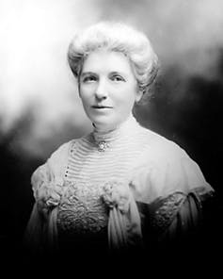

New Zealand was fortunate to have many effective women leaders. Most prominent among them was [Kate Sheppard](https://teara.govt.nz/en/biographies/2s20/sheppard-katherine-wilson). In 1887, Sheppard became head of the WCTU’s Christchurch branch and led the campaign for the vote.

The campaign leaders were well organized and hard working. Their tactics were petitions, pamphlets, letters, public talks and lobbying politicians - this was a [peaceful era](https://natlib.govt.nz/he-tohu/about/womens-suffrage-petition) before the suffragette militancy during the early 20th century elsewhere.

The women were persistent and overcame setbacks. It took multiple attempts in parliament before the Electoral Act 1893 was passed. Importantly, the suffragists got public opinion behind the cause. Mass support was demonstrated through petitions between 1891 and 1893, in total [garnering 31,872 signatures](http://archives.govt.nz/provenance-of-power/womens-suffrage-petition/about), a quarter of Aotearoa’s adult women.

Pragmatically, the women worked in allegiance with men in parliament who could introduce the bills. In particular, veteran conservative [Sir John Hall](https://teara.govt.nz/en/biographies/1h5/hall-john) viewed women’s suffrage as a way to a more moral and civil society.

The Suffrage 125 celebratory slogan “[whakatū wāhine – women stand up](http://women.govt.nz/about/new-zealand-women/history/suffrage-125)!” captures the intention of continuing progressive and egalitarian traditions. Recognising diverse cultural backgrounds is now important. With hindsight, the feminist movement can be implicated as an agent of colonisation, but it did support votes for Māori women. [Meri Te Tai Mangakāhia](https://teara.govt.nz/en/photograph/27887/meri-mangakahia) presented a motion to the newly formed Māori parliament to allow women to vote and sit in it.

New Zealand remains a small country that can experience rapid social and economic change. Evoking its colonial past, however, it retains both a reputation as a tough and masculine place of beer-swilling, rugby-playing blokes and a tradition of staunch, tea drinking, domesticated women.—*SOURCE: The CONVERSATION, University of Canterbury*

*___________________________________________________________________________________________________________*

**Child killing for ransom**

**and other Sri Lanka nightmares**

The progress of ongoing criminal investigations into the grisly killing of several Tamil youths following a racket of abduction for ransom, spearheaded ‘allegedly’ (here, I use the term quite deliberately) by a Naval officer and others during 2008-2009 is the crucible in which this Government and this Presidency’s commitment to promises made, will be tested most severely.

It must be fairly acknowledged that one distinguishing feature of the current ‘yahapalanaya’ administration is that the Navy suspect was arrested and produced before court which would have been out of the question if the Rajapaksas were still in power. Then again, the fact that the Court inquiring into the matter had proceeded to act according to law is also another demonstrable difference when compared to the past.



**Fair differences between**

**then and now**



It must be fairly acknowledged that one distinguishing feature of the current ‘yahapalanaya’ administration is that the Navy suspect was arrested and produced before court which would have been out of the question if the Rajapaksas were still in power. Then again, the fact that the Court inquiring into the matter had proceeded to act according to law is also another demonstrable difference when compared to the past.

These officers of the state must be commended to the highest extent possible for carrying out their functions with due diligence despite the enormous and impossible strains put on them by political forces. However, and despite these undoubtedly positive developments, the key question here is whether the chain of impunity at the highest levels will be broken and those responsible for enabling these acts to take place and persistently protecting the perpetrators will be held accountable to law. For ultimately, systemic impunity is the core issue, not really the arrest, questioning or even punishment of minions who will doubtless be replaced by other minions in the correct political circumstances, perpetuating these crimes from which we have suffered as a nation for decades. Indeed, the arrogance with which the suspect in this ongoing case smiled and strutted while in handcuffs testifies to this web of impunity.

**Central issue of tackling the chain of command**

Sri Lanka is no stranger to the killing of children. The periodic uncovering of graves with the skeletal remains of massacred children decades ago or nearer in time, is just one manifestation. From the killing of child monks in Aranthalawa in 1987 by the Liberation Tigers of Tamil Eelam to the children caught up in reprisal attacks by armed forces stationed in the North and East at the height of the conflict and including the vast numbers of children killed in the South during the second insurrection of the Janatha Vimukthi Peramuna, this earth should weep blood for the countless innocents mowed down in the course of grievous sins committed by ambitious men.

last week marked the International Day of Disappearances as the month comes to an end. These are reflections that are therefore opportune in this context. ‘Disappearances’ and extra-judicial killings mark the lowest ebb of a nation’s functioning. As long as these crimes remain unpunished, from the highest levels of those who ‘protected’ or enabled such atrocities whether in the military chain of command or in the state prosecutor’s office to those carrying out the acts, only nonsense can be spoken of reconciliation.

Put simply, families of those who have had their members disappeared or killed, will not be satisfied by money payments handed out to them or by a state official blandly informing them that a crime has occurred. This, they already know. What they seek is formal state acknowledgement of these acts at the minimum and as a necessary corollary, the chain of impunity to be broken.

Our constitutional jurisprudence has consistently stressed the principle that superior officers exercising responsibility over subordinates who commit rights violations, will themselves be held responsible. There are, of course, some notable and puzzling exceptions to this rule as was evidenced in the Embilipitiya Case where the commanding officer of the camp where Sinhalese school children had been detained and ‘disappeared’ during the eighties in the deep South, due to a personal vendetta of individuals was not held liable in law.

In the Supreme Court, he was given the right to be promoted to the rank of Major General on the basis that he had been acquitted in the criminal courts on the basis that he could not directly be responsible for the enforced disappearance of the children at the army camp. The lenient position taken by the Supreme Court at the time belied constitutional considerations and the protection of rights Parents of the victims had, in fact, testified that they had brought their appeals to this commanding officer in order to find out what had happened to their children but that he had done nothing.

**The law must take its course**

Certainly these were not precedents that afforded reassurance that the Rule of Law was being upheld with fear and favour to none. Writing for the International Commission of Jurists in 2010, I pointed to the fact that this precedent, even when the Bench was otherwise pro-actively responding to violations of fundamental rights, was a major failing (Still Seeking Justice, ICJ).

But despite some aberrant decisions in the exercise of its constitutional jurisdiction, the Court has generally upheld the principle is that a superior officer protecting a subordinate who engages in atrocities or ‘acquiescing’ in that act, will be held responsible. As a matter of law therefore and applying these principles to the ongoing case of the Navy abductions, those who chirrup airily that officers implicated at the highest levels of Sri Lanka’s military hierarchy ‘only’ helped the suspect, must acquaint themselves with the fact that this, as assessed by authoritative local precedents and notably under international law, cannot absolve the individual of legal responsibility, under the criminal law  and certainly in terms of constitutional protections.

What remains is for the law to take its course. Political interference in that process will only be the last nail in the ‘yahapalanaya’ coffin. That much must be categorically said. These killings of children were at the heart of a ransom racket and had pure and common greed behind them. They speak to a particular horror that stands in a category all of its own.

It is a nightmarish and devilish blemish on this nation’s memory and must be exorcised with maximum force.— *SOURCE: Kishali Pinto Jayawardene; Sri Lanka Sunday Times*

* *___________________________________________________________________________________________________________*
* **Rafiki: Banned Kenyan film challenges stereotypes at home and abroad**
* 

*Joyous delight* of young women who fall in love, and their choices ["between happiness and safety."](http://bigworldcinema.com/production/rafiki-2/)

 *Pascal Le Segretain/Getty Images*

*Rafiki* is a film with a "clear intent to promote lesbianism in Kenya.". At least that's what Ezekiel Mutua, CEO of the Kenya Film Classification Board (KFCB), stated when announcing a nationwide [ban against *Rafiki*](http://kfcb.co.ke/wp-content/uploads/2018/04/CEO-STATEMENT-ON-RAFIKI-RESTRICTION-27-4-2018.pdf) earlier this year. Director Wanuri Kahiu would argue there's a bit more nuance to the film. "More than anything, I wanted to tell a love story. It's been really important for me to tell more love stories coming from the continent," Kahiu said in an interview with Kiva Reardon of the [Toronto International Film Festival](https://www.tiff.net/the-review/share-her-journey-wanuri-kahiu/) (TIFF).

Adapted from Monica Arac de Nyeko's short story *Jambula Tree*, *Rafiki* (meaning "friend" in Swahili) is the story of two young women who fall in love, and the choice they must make ["between happiness and safety."](http://bigworldcinema.com/production/rafiki-2/)

The film has been a hot topic of conversation since it premiered at Cannes, not least because it was the first Kenyan film to screen at the prestigious festival. *Rafiki's* colourful cinematography, sharp all-female soundtrack, and talented cast are just a few of the elements viewers are raving about. And for good reason. Its genre — a term Kahiu has coined as "Afrobubblegum" — is challenging Western audiences' expectations of stories coming from Africa. "We're so used to narratives out of Africa being about war, poverty and devastation," [Kahiu said in a TED Talk](https://www.ted.com/talks/wanuri_kahiu_fun_fierce_and_fantastical_african_art). "Where's the fun?" For Kahiu, Afrobblegum is necessary if we want "art that captures the full range of human experiences to tell the stories of Africa."

Afrobubblegum or not, the Kenya Film Classification Board appears to have a one-dimensional view of *Rafiki* as a film with a "homosexual theme" that it deems "contrary to the law." The law in question is Section 162 of Kenya's penal code, which [criminalizes "carnal knowledge against the order of nature"](https://www.hrw.org/world-report/2017/country-chapters/kenya)— SOURCE: *IFEX Global Network*

*___________________________________________________________________________________________________________*

***A glimpse of Commonwealth briefs***

**Let’s learn lessons from Zimbabwe before it is too late**

Mmusi Maimane says SA needs to free itself from anti-democratic, liberation movement politics of the ANC The thing with warning signs is they are most useful when acted on early enough to avert disaster. Sometimes it’s hard to tell warning sign from alarmist conspiracy theory. In 2013, the DA’s warnings about state capture fell on deaf ears, even though many of the red flags were already waving. In 2009, our *Stop Zuma* campaign was denounced as alarmist, even racist.Zimbabwe’s experience offers up valuable lessons to South Africa that we ignore at our peril. It demonstrates how a political elite will destroy a nation’s economy, collapse its wealth and ruin millions of lives if that is the price of holding onto power after its authentic moral authority has evaporated. Zimbabwe’s recent election shows how difficult it is to restore true democracy once a single dominant party has entrenched power over decades. The only observer missions to proclaim the controversial electoral process free and fair were those colluding in the charade: SADC and the AU. Being themselves dominated by liberation movement parties who have similarly entrenched power, it is in their interests to play along.The elections were compromised from the start.

**Cyprus reaches its limits on handling asylum applications**

The EU must tackle the migration issue collectively in the context of the decisions of the June summit, Turkey is not cooperating on readmission and Cyprus has already reached its limits in terms of managing asylum applications, the President of the Republic, Nicos Anastasiades, sressed last week in Salzburg.

During his intervention at the informal working dinner of the 28 Heads of State and Government in Salzburg, President Anastasiades stressed that the immigration “should be tackled collectively by the EU Member States and always on the basis of respect for human rights.” He stressed to his counterparts that “Member States need to work collectively to deal with migratory flows, while respecting human dignity and the basic human rights of migrants.”

**Refugee children on Nauru 'living without hope' UN told**

A legal advocacy group has told the UN Human Rights Council that more than 100 asylum seeker and refugee children are living without hope on Nauru. The Human Rights Law Centre addressed the latest Council session in Geneva.

The Centre's Daniel Webb told the Council that despite the fact the Australian Government was professing its commitment to human rights in Geneva, it continued to indefinitely imprison 102 children in its offshore detention centre on Nauru.

"Imprisoned for fleeing the same atrocities our Government comes here and condemns. And after five years of detention, these children have now lost hope. Some have stopped speaking. Some have stopped eating. A 10-year-old boy recently tried to kill himself."

* **Concern in Samoa over move to reinstate corporal punishment in schools**

Samoa's ombudsman and a Supreme Court judge say they're at a loss as to what has motivated a move to reinstate corporal punishment in the country's high schools. Justice Vui Clarence Nelson and Maiava Iulai Toma have spoken out against the amendment to the Education Act. Samoa banned the use of corporal punishment in 2013. The government at the time saying it was motivated to abolish corporal punishment in all settings.

Maiava, who also heads Samoa's Human Rights Institution, doesn't understand the motivation for change. And Justice Vui Clarence Nelson says he's at a loss to why the Ministry of is pushing the bill. The ministry has not responded to email and telephone requests for comment.

* *___________________________________________________________________________________________________________*
* **30Observer books in the Commonwealth**

*Judith Ann Elson FINDS MORE GREAT STUFF. Our RCS national past president and Commonwealth book reviewer suggests good reading this month with a Kiwi’s view in the Auschwit. Grim Nigeria. And old British Empire dependencies. Enjoy*

***Heather Morris’s*** debut novel *The Tattooist of Auschwitz* is based on the true story of Lale Sokolov. It is a compelling story of love and survival in unspeakable conditions. New Zealander Heather Morris was already living in Australia and writing successful, award-winning film scripts when she was introduced to Lale Sokolov, a Slovakian Jew, in 2003. They became friends and over the next three years Lale shared his story with her. In 1942, Lale was sent to Auschwitz on a “work assignment”. Coming from a comfortable, loving home Lale spoke several languages including German and Russian. He proved useful as a translator of orders to other prisoners, then he was appointed as assistant to the camp Tattooist. Despite his horror at the very idea of tattooing numbers on the arms of fellow prisoners he had little choice. Later he used his position and skills to help others in small ways and occasionally to save lives. Amidst all the horror of the camps, he met a young woman and fell in love. His main focus now was to see her occasionally, to smuggle extra food to her, and when the war ended and they were separated, to find her again. The novel is well-written and fast-paced. It is hard to put down and can be read easily in one sitting. Facts have been checked thoroughly against available documentary evidence. It is a powerful book to remember and read again. I recommend it.

***Helon Habila’s*** African saga, *The Chibok Girls*: The Boko Haram Kidnappings and Islamic Militancy in Nigeria” is a well-written, succinct account of the kidnapping of 276 girls from Chibok Secondary School on April 14, 2014, and of the historical context of the conflict in northern Nigeria. Helon Habila grew up in northern Nigeria. He became a writer, a journalist and a university lecturer in England and now in the USA. He returned to his homeland to meet families of the missing girls and also those girls who had been found or released. Currently, more than 100 are still missing. Habila shows clearly how the lives of ordinary people have been transformed by extremist forces. He outlines the long history of Colonialism and the cultural and religious dynamics that have given rise to the conflicts which still ravage the region to this day. This is a short book which gives an insight into a situation which is not always clear to outsiders.

***Simon Winchester’s*** revised and updated edition of *Outposts: Journeys to the Surviving Relics of the British Empire* is a surprisingly interesting travel book. For three years Simon Winchester crossed the globe visiting the remaining dependencies of what had once been the British Empire. Of the 14 listed, Pitcairn proved to be inaccessible at the time but the other 13 were visited. It is an interesting list: British Indian Ocean Territory, Tristan da Cuna.

**And finally, here’s a serving in the memory crisis department**

**Good thing one of us has one….**

An elderly couple had dinner at another couple's house, and after eating, the wives left the table and went into the kitchen.  The two gentlemen were talking, and one said, "Last night we went out to a new restaurant and it was really great.  I would recommend it very highly."

The other man said, "What is the name of the restaurant?"

The first man thought and thought and finally said, "What is the name of that flower you give to someone you love?  You know... the one that's red and has thorns."

"Do you mean a rose?" he said.

"Yes, that's the one," replied the man.  He then turned towards the kitchen and yelled, "Rose, what's the name of that restaurant we went to last night.