MOTHERS LET YOUR CHILDREN GO
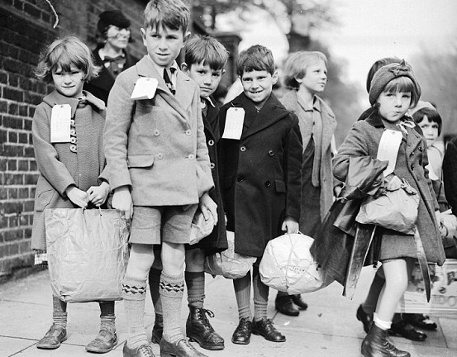

GIVE THEM A NEW HOME WHERE THEY’LL BE SAFE

