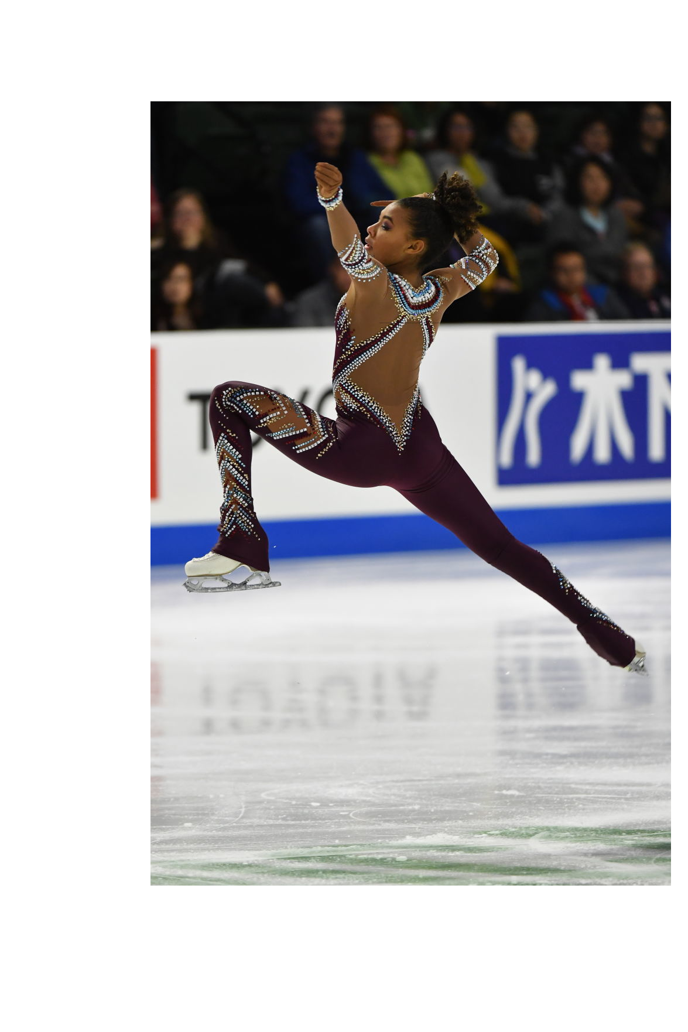

The

Tri-Cities Figure

Skating Club

invites you to see

what you

can do

on the ice!

Toyota Arena Learn to Skate and the

Tri-Cities Figure Skating Club are both part of the United States Figure Skating Association. Learn more at https://www.usfsa.org (stock image- Starr Andrews)

You are invited to come watch some cool programs skated by Tricities Figure Skating Club Skaters . Get inspired, enjoy some refreshments with our club, and then put your skates on!

Present this flyer to skate the 6:00 Arena Public Skate for only $5.

Questions? Message us at https://www.tcfigureskatingclub.org

Come see your future on the ice!

Toyota Arena Learn to Skate:

## Sat. September 14, 5:00 pm

# at the Toyota Arena