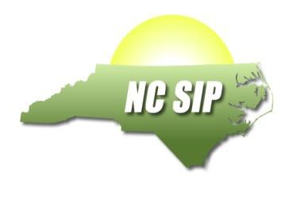
Institution of Higher Education Partner IHE: NC State

 | Name | Address | Email | Phone
NCSIP –IHE  Coordinator (Name and Title) | Edward J. Sabornie, Ph.D., Professor and Coordinator, NC State Graduate Program in Special Education, Department of Teacher Education and Learning Sciences (TELS) | NC State University, College of Education, Poe Hall, Campus Box 7801, Raleigh, NC 27695-7801 | edward_sabornie@ncsu.edu | 919.515.1777
In Process Reading/Math Foundations Instructor(s)
Jody Cleven | Adjunct Professor, Special Education (Reading) | NC State University, College of Education, Poe Hall, Campus Box 7801, Raleigh, NC 27695-7801 | jgcleve2@ncsu.edu | 919.699.9870
Jessica Hunt | Associate Professor, Special Education (Math) | NC State University, College of Education, Poe Hall, Campus Box 7801, Raleigh, NC 27695-7801 | jhunt5@ncsu.edu | 919.515.1772
Valerie Faulkner | Teaching Associate Professor (Math) | NC State University, College of Education, Poe Hall, Campus Box 7801, Raleigh, NC 27695-7801 | valerie_faulkner@ncsu.edu | 919-515-0371

NCSIP Program Information

Brief description of SIP/IHE Goals and activities
- Train TELS Department graduate students in Reading and Math Foundations evidence-based practices
- Revise special education Reading and Math concentration courses to integrate both Reading and Math foundations content into coursework to better equip pre-service and in-service teachers
- Place pre-service teachers during field experiences in classrooms with teachers who are trained in Reading and Math Foundations and are using research-based programs
- Plan for expansion of project to other programs in the School of Education (e.g., Elementary Education, Administration & Supervision)
- Collaborate with SIP personnel and other IHEs to support expansion of project within the state

