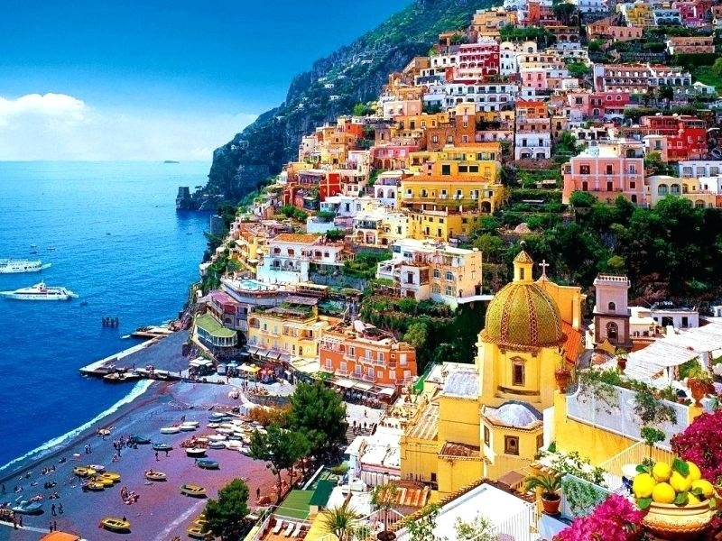

Grand Italian Experience
with Dubai Stopover
23 Spectacular Days – 19 May 2020
Fully escorted by Sonya Wheatley

TUE 19 MAY HOME TO DUBAI
You will be picked up from your front door (within a 35km radius of Port Macquarie) and transferred to Port Macquarie airport for your flight to Sydney and onto to Rome
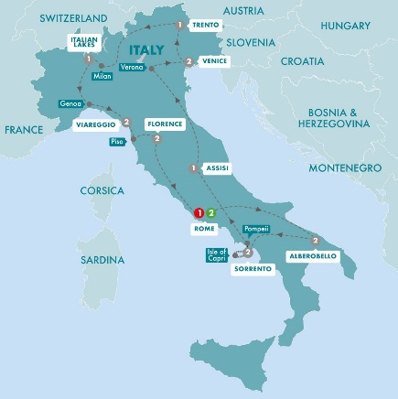
Depart Port Macquarie on Qantaslink QF2171
at 1.50pm
Arrive Sydney at 2.55pm

Depart Sydney on Emirates flight EK413 at 9.10pm

WED 20 MAY DUBAI TO ROME

Arrive Dubai at 5.40am
Depart Dubai on Emirates flight EK097 at 9.10am
Arrive Rome at 1.25pm

On arrival in Rome we will be me and transferred to our accommodation.
Hotel: Crowne Plaza St. Peter’s or similar (3 nights)

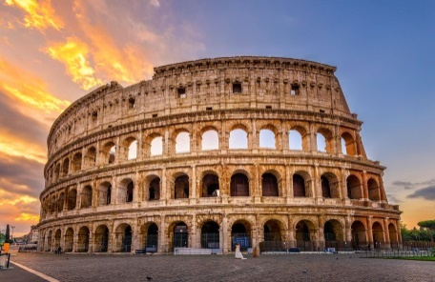
THU 21 MAY ROME DAY AT LEISURE
Blaze a trail through la bella Italia - your epic journey begins in Rome, once the powerful capital of the world and yours to explore. Tonight we begin our 17 Day Trafalgar Grand Italian Experience tour, meeting up with our travel companions and Travel Director for a Welcome Reception and orientation drive introducing you to some of the city’s iconic and unexpected highlights. Meal(s): B, WR Hotel: Crowne Plaza St. Peter’s or similar

FRI 22 MAY ROME SIGHTSEEING AND FREE TIME
Follow in the footsteps of the pilgrims who for centuries have flocked to the Vatican City. Visit St. Peter’s Basilica, one of the holiest sites in Christendom, joining a Local Specialist for an included sightseeing tour.
See Michelangelo’s magnificent Pietà, hewn from the most “perfect” block of Carrara marble. Then, venture into Ancient Rome to see Circus Maximus, where the thundering noise of chariot races once filled the air, followed by a visit to the Colosseum. The afternoon is yours to explore at leisure. Sit on the Spanish Steps, shop up a storm on Via Veneto or continue your encounter with Ancient Rome on Palatine Hill to see the
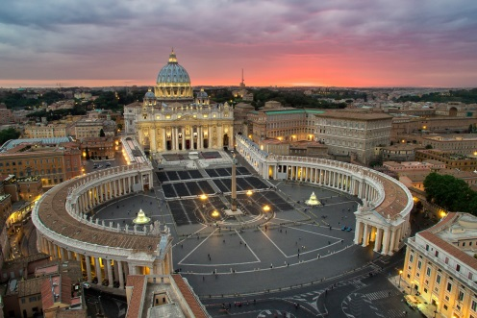
Temple of Apollo and Flavian Palace, among other excavations.
Meal(s): BB Hotel: Crowne Plaza St. Peter’s or similar

SAT 23 MAY ROME – ALBEROBELLO REGION (2 Nights)
We journey east through the Campania Mountains and the orange and olive groves of Puglia near the Adriatic coast, our home for the next two nights. This evening, we enjoy a delicious local dinner at our hotel. Meal(s): BB, DW Hotel: Sierra Silvana or similar

SUN 24 MAY ALBEROBELLO REGION SIGHTSEEING AND FREE TIME
The conical limestone houses of Alberobello take centre stage during our guided tour with a Local Specialist. Here, we’ll see the UNESCO-listed collection of almost 1,500 trulli dating back to the 14th century. Enjoy a leisurely afternoon on your own. Consider an Optional Experience or indulge in delectable local flavours at a local trattoria. This evening, we ‘Connect With Locals’ over a Be My Guest dinner at a traditional masseria. Meal(s): BB, DW Hotel: Sierra Silvana or similar
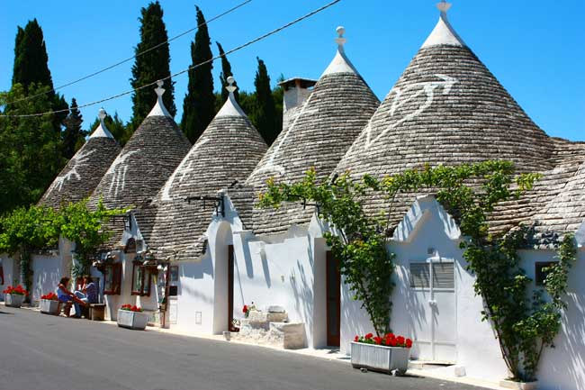
MON 25 MAY ALBEROBELLO REGION - SORRENTO (2 Nights)
The fresh aroma of lemons is your constant companion in the stunning coastal town of Sorrento, your home for the next two nights. View the bustling Piazza Tasso and Corso Italia before spending the rest of the day on your own. Kick back and sip delicious Limoncello di Sorrento, enjoy lunch at the picture-perfect Marina Piccola or spend the afternoon soaking up la dolce vita. Tonight we dine at our hotel in Sorrento.
Meal(s): BB, DW Hotel: La Residenza or similar

TUE 26 MAY ISLE OF CAPRI EXCURSION
Cruise the deep blue waters of the Tyrrhenian Sea to the beautiful Isle of Capri. Enjoy a guided tour of Capri Town, watching the beautiful people sip their cappuccino in the glamorous Piazzetta. Meal(s): BB Hotel: La Residenza or similar

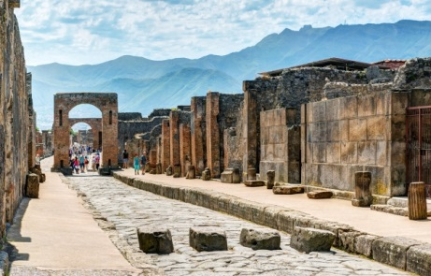
WED 27 MAY SORRENTO – POMPEII - ASSISI
Explore the tragic history of the ancient lost city of Pompeii with a Local Specialist. Gain a deeper understanding of what life was like in this Roman settlement that lay buried for centuries after Mount Vesuvius erupted. Continue your journey through the rolling green and golden fields of Umbria, arriving at the mystical hilltop town of Assisi. Meet your Local Specialist for a visit of the stunning Basilica of St. Francis, featuring exquisite frescoes by Giotto. Tonight, we dine in our hotel. Meal(s): BB, DW Hotel: Grand or similar

THU 28 MAY ASSISSI – VERONA - VENICE (MURANO) (2Nights)
Celebrate the epic tale of Romeo and Juliet during this morning’s visit to the fair city of Verona where you will view Juliet’s Balcony and the Roman Arena built in the 1st century. We venture to the Adriatic coast this afternoon bound for Venice where we will spend two nights. Meal(s): BB Hotel: La Gare MGallery or similar
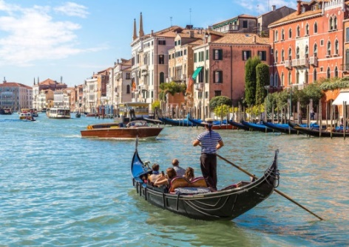
FRI 29 MAY VENICE ORIENTATION AND FREE TIME
‘Dive Into culture’ this morning and witness the delicate craft of Venetian glassblowing that spans centuries. Glide by private launch along bustling waterways to view the Bridge of Sighs, Doge’s Palace and St. Mark’s Basilica before spending free time exploring the city. Stroll along the Grand Canal, nibble on delicious cicchetti at a cosy bacaro or cross the lagoon on an Optional Experience to the colourful Burano Island.
Meal(s): BB Hotel: La Gare MGallery or similar

SAT 30 MAY VENICE (MURANO) - TRENTO
This morning, we traverse pastoral Veneto plains to the sophisticated town of Trento surrounded by the Dolomites. Once located within the Austrian Empire, the town exudes both classical Italian elegance and cultural influences from the north, which you can enjoy at one of its many beer halls or cafés. Consider sampling the delicious local apple strudel, then wander around the Piazza Duomo before checking in to your hotel for the night. Meal(s): BB Hotel: Grand or similar

SUN 31 MAY TRENTO – MILAN – ITALIAN LAKES
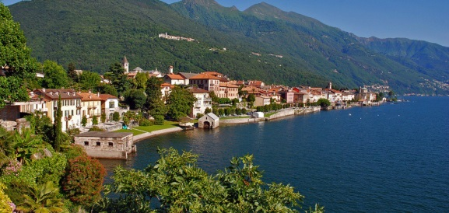
Continue west through Italy’s stunning Lakes District to the sophisticated powerhouse of Milan. You’ll have some free time to explore on your own after an orientation of the city’s iconic sights. See the exquisite Gothic Duomo, La Scala Opera House and the Galleria, one of the world’s oldest shopping malls. We spend this afternoon on the quiet shores of Lake Maggiore, soaking up the pleasant lakeside atmosphere and exploring Baveno. Meal(s): BB, DW Hotel: Simplon/Grand Dino or similar

MON 01 JUN ITALIAN LAKES- GENOA - VIAREGGIO (2 Nights)
Journey to Genoa where a Local Specialist will show us this city’s majestic architecture. Continue to seaside resort of Viareggio where we will dine at our hotel. Meal(s): BB, DW Hotel: Mercure or similar

TUE 02 JUN VIAREGGIO FREE DAY
Indulge in a full free day to soak up the laid back atmosphere. Stroll along the waterfront or consider joining an Optional Experience to Porto Venere and the Bay of Poets where you’ll embark on an encounter with the cliffside villages of Cinque Terre. Meal(s): BB Hotel: Mercure or similar

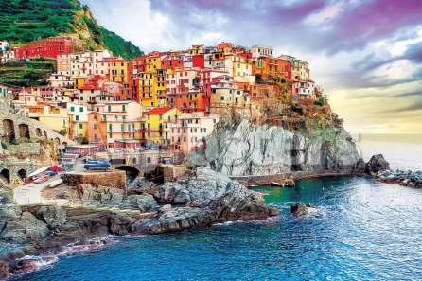
WED 03 JUN VIAREGGIO – PISA- FLORENCE (2 Nights)
Travelling south through the unforgettable scenery of Tuscany, we arrive in Pisa to view its famous Leaning Tower before continuing to the Renaissance city of Florence. This afternoon is yours at leisure to wander through the grand squares and labyrinthine lanes of Florence, whose connection with the Medici family saw this city become one of the world’s most cultural centres. Consider a visit to the Academy of Fine Arts to see the Michelangelo’s statue of David, amble along the Arno River or ascend the stone steps up to Piazzale Michelangelo for spectacular views of the city. Meal(s): BB Hotel: Grand Mediterraneo or similar
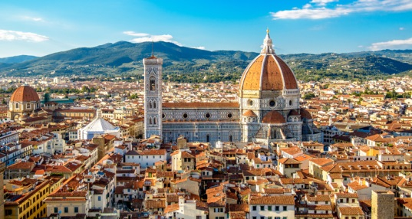
THU 04 JUN FLORENCE SIGHTSEEING AND FREE TIME
Join a Local Specialist this morning to view the city’s finest masterpieces – the magnificent Duomo, Giotto’s Bell Tower and the 13th-century Santa Croce Basilica, the final resting place of Michelangelo, Galileo and Machiavelli. Later, learn about the quality and workmanship of two of this city’s historic industries at demonstrations of Florentine leathercraft and 18-carat gold. Then, spend the rest of our afternoon on your own. Walk across the 400-year-old Ponte Vecchio or wander through the Renaissance Boboli Gardens, stopping for a slice or two of schiacciata along the way. Meal(s): BB Hotel: Grand Mediterraneo or similar
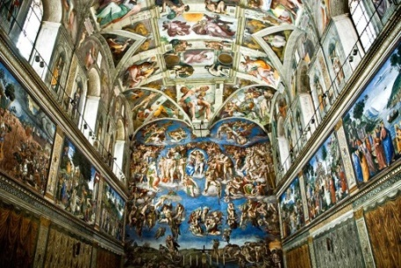
FRI 05 JUN FLORENCE – ROME – VATICAN EXPERIENCE
Journey through the sprawling vineyards of Chianti, past the hill-towns of Umbria before arriving in Rome. This evening we ‘Dive Into Culture’ at an exclusive Farewell dining experience in the Museo Gregoriano Profano, with its centuries of Roman and Ancient Greek sculptures and antiquities, or the magnificent surrounds of the Salone di Raffaello in the Pinacoteca. Gain access to the Museum before dinner, then continue your evening with a tour of the Vatican Museums with a Local Specialist, after it closes to the public, including views of Michelangelo’s magnificent frescoed ceiling in the Sistine Chapel. Meal(s): BB, FD Hotel: Sheraton Parco De Medici or similar

SAT 06 JUN DEPART TO DUBAI
Our epic encounter with Italy has sadly come to an end. We say arrivederci to Rome
and our newfound friends at the end of our Grand Italian Experience. Meal(s): BB

We will be transferred to the airport for our flight to Dubai

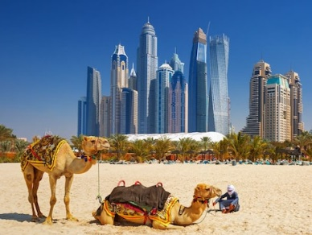
Depart Rome on Emirates flight EK98 at 3.25pm
Arrive Dubai at 11.25pm

On arrival in Dubai we will be transferred to our accommodation for the next 3 nights
Accommodation – Rove Downtown Dubai with Breakfast for 3 nights

SUN 07 JUN DUBAI
A leisurely morning to enjoy Dubai and then this afternoon we join our Sundowner Dune Dinner Safari Tour
The Mysterious desert is the ideal venue for a magical and memorable evening. Experience the serenity and beauty of the Arabian desert with sunset over the dunes, falcon viewing, camel rides, a belly dancing show and a Arabic style buffet with unlimited selected beverages

MON 08 JUN
Today we enjoy a Half day traditional Dubai city tour and time at leisure for exploring or shopping in Dubai

TUE 09 JUN DUBAI TO SYDNEY
We will be transferred to the airport this morning for our homeward bound flight

Depart Dubai on Emirates flight EK412 at 10.15am

MON 10 JUN SYDNEY TO PORT MACQUARIE

Arrive Sydney at 6.05am

Depart Sydney on Qantaslink QF2164 at 9.15am
Arrive Port Macquarie 10.15am

On arrival in Port Macquarie you will be transferred to your home

INCLUSIONS:

- Return transfers from your front door within 35 kms of Port Macquarie to Port Macquarie Airport and return
- Escorted throughout - subject to minimum numbers being met
- Return flight from Port Macquarie to Sydney with Qantaslink
- Economy class air travel with Emirates Sydney to Rome return with a stopover in Dubai
- Breakfast included every day
- 8 dinners whilst on Italy tour
- Audio Headsets for flexible sightseeing while on Italy tour
- Luxury air-conditioned coach with Cherry-picked hotels, all tried and trusted whist on tour
- Hand-picked Trip Highlights whilst on Italy tour
- Optional Experiences and free time whilst on Italy tour
- All porterage and restaurant gratuities whilst on Italy tour
- Must-see sightseeing and surprise extras
- An expert Travel Director and a professional Driver whilst on Italy tour
- All hotel tips, charges and local taxes whist on Italy tour
- 3 nights stopover in Dubai at Rove Downtown with transfers Airport/Hotel/Airport
- Sundowner Dune Dinner Safari and Half day Traditional Dubai city tour

YOUR INCLUDED SIGHTS WHILST ON ITALY TOUR
• VIP ADMISSION to the Vatican Museums
• CITY TOUR in Rome, Alberobello, Capri, Pompeii, Assisi, Genoa and Florence
• ORIENTATION of Venice
• VISIT St. Peter’s Basilica, the Sistine Chapel and the Colosseum in Rome, the excavations at Pompeii and the Basilica of St. Francis in Assisi
• CRUISE to the Isle of Capri and by private launch to St. Mark’s Square in Venice
• VIEW the ancient sites of Rome, St. Mark’s Basilica in Venice, the Cathedral and La Scala Opera House in Milan, the Leaning Tower of Pisa, Santa Croce Basilica and the Duomo in Florence

THE TRAFALGAR DIFFERENCE – ITALY TOUR
• CONNECT WITH LOCALS - Meet Signor Luciano on his Alberobello farm where you can taste seasonal produce, including fresh almonds, cherries, tomatoes and olive oil, as well as enjoy a local stone
masonry demonstration at our Be My Guest dinner. (Day 4)
• STAYS WITH STORIES - Preserving the tradition of Murano glass art, LaGare Hotel retains its industrial architecture,
embodying the spirit of the glass blowers who once plied their trade there. (Day 8)
• DIVE INTO CULTURE- Witness the exquisite craft of glassblowing on Murano Island, a delicate tradition that generations of Venetian craftsmen have perfected over the centuries. (Day 9)
• LOCAL SPECIALIST - For included sightseeing in Rome, Alberobello, Pompeii, Capri, Assisi and Florence

$9475.00 PER PERSON —TWIN SHARE
Single supplement available on request

Initial Deposit $2000.00 per person
Final payment is required by the 10th December 2019 Travel Insurance is Compulsory
We are able to supply you with a quote for Travel Insurance

PORT MACQUARIE TRAVEL  Shop 4, 114 William Street, Port Macquarie NSW 2444  Phone: 02 65831422 Fax: 02 65841037  ABN: 30001435187 | CAMDEN HAVEN TRAVEL AND CRUISE  Shop 4, 75 Bold Street,  Laurieton NSW 2443  Phone: 02 65599048 Fax: 02 65598996

CANCELLATION SCHEDULE AND FEES

If bookings are cancelled the following fees with apply

50% of deposit if cancelled before 30th September 2019

100% of total price if cancelled after final payment

Terms and Conditions apply as shown in the Trafalgar Tours - Europe & Britain 2020 brochure.
For full terms and conditions please contact Port Macquarie Travel

Payment: Costs are based on Cash, Cheque or Direct Deposit, if paying by Credit Card you will incur a 1.32% Fee of the total booking

