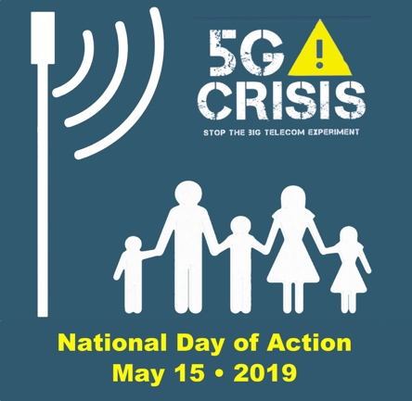

PRESS ADVISORY
5G National Day of Action

Who: (insert name of your group)

What: A sidewalk rally by parents and other concerned citizens in front of the (name of wireless carrier) retail store.

Where: (insert exact street address of the rally)

When: Wednesday, May 15th, 12:00 to 1:30 pm

Why: We are calling on wireless companies to voluntarily stop their deployment of small cell wireless antennas in residential areas until their technology can be proven safe.

Background: Hundreds of scientific studies have shown that long-term exposure to wireless microwave radiation causes biological harm, overwhelming the body's biological, chemical and electrical systems, and creating an opportunity for serious medical issues ranging from neurological problems and cognitive deficits to cancer. Children are more vulnerable to these effects, as their physiology is still developing.

Our children have a right to play in their yards and sleep in their beds without being subject to constant involuntary exposure to microwave radiation that could harm their health, and we have an obligation to protect them.

All parents and their children are invited to join us in this peaceful rally to protect public health.

For information, please call (insert name and phone number of group leaders)

