Easter Eggsercise Hunt!

Four or more teams - each with their own color or egg design.
Set up a big boundary area in which to hide your eggs.

Goal: To be the first team to find 12 eggs and complete all challenges.
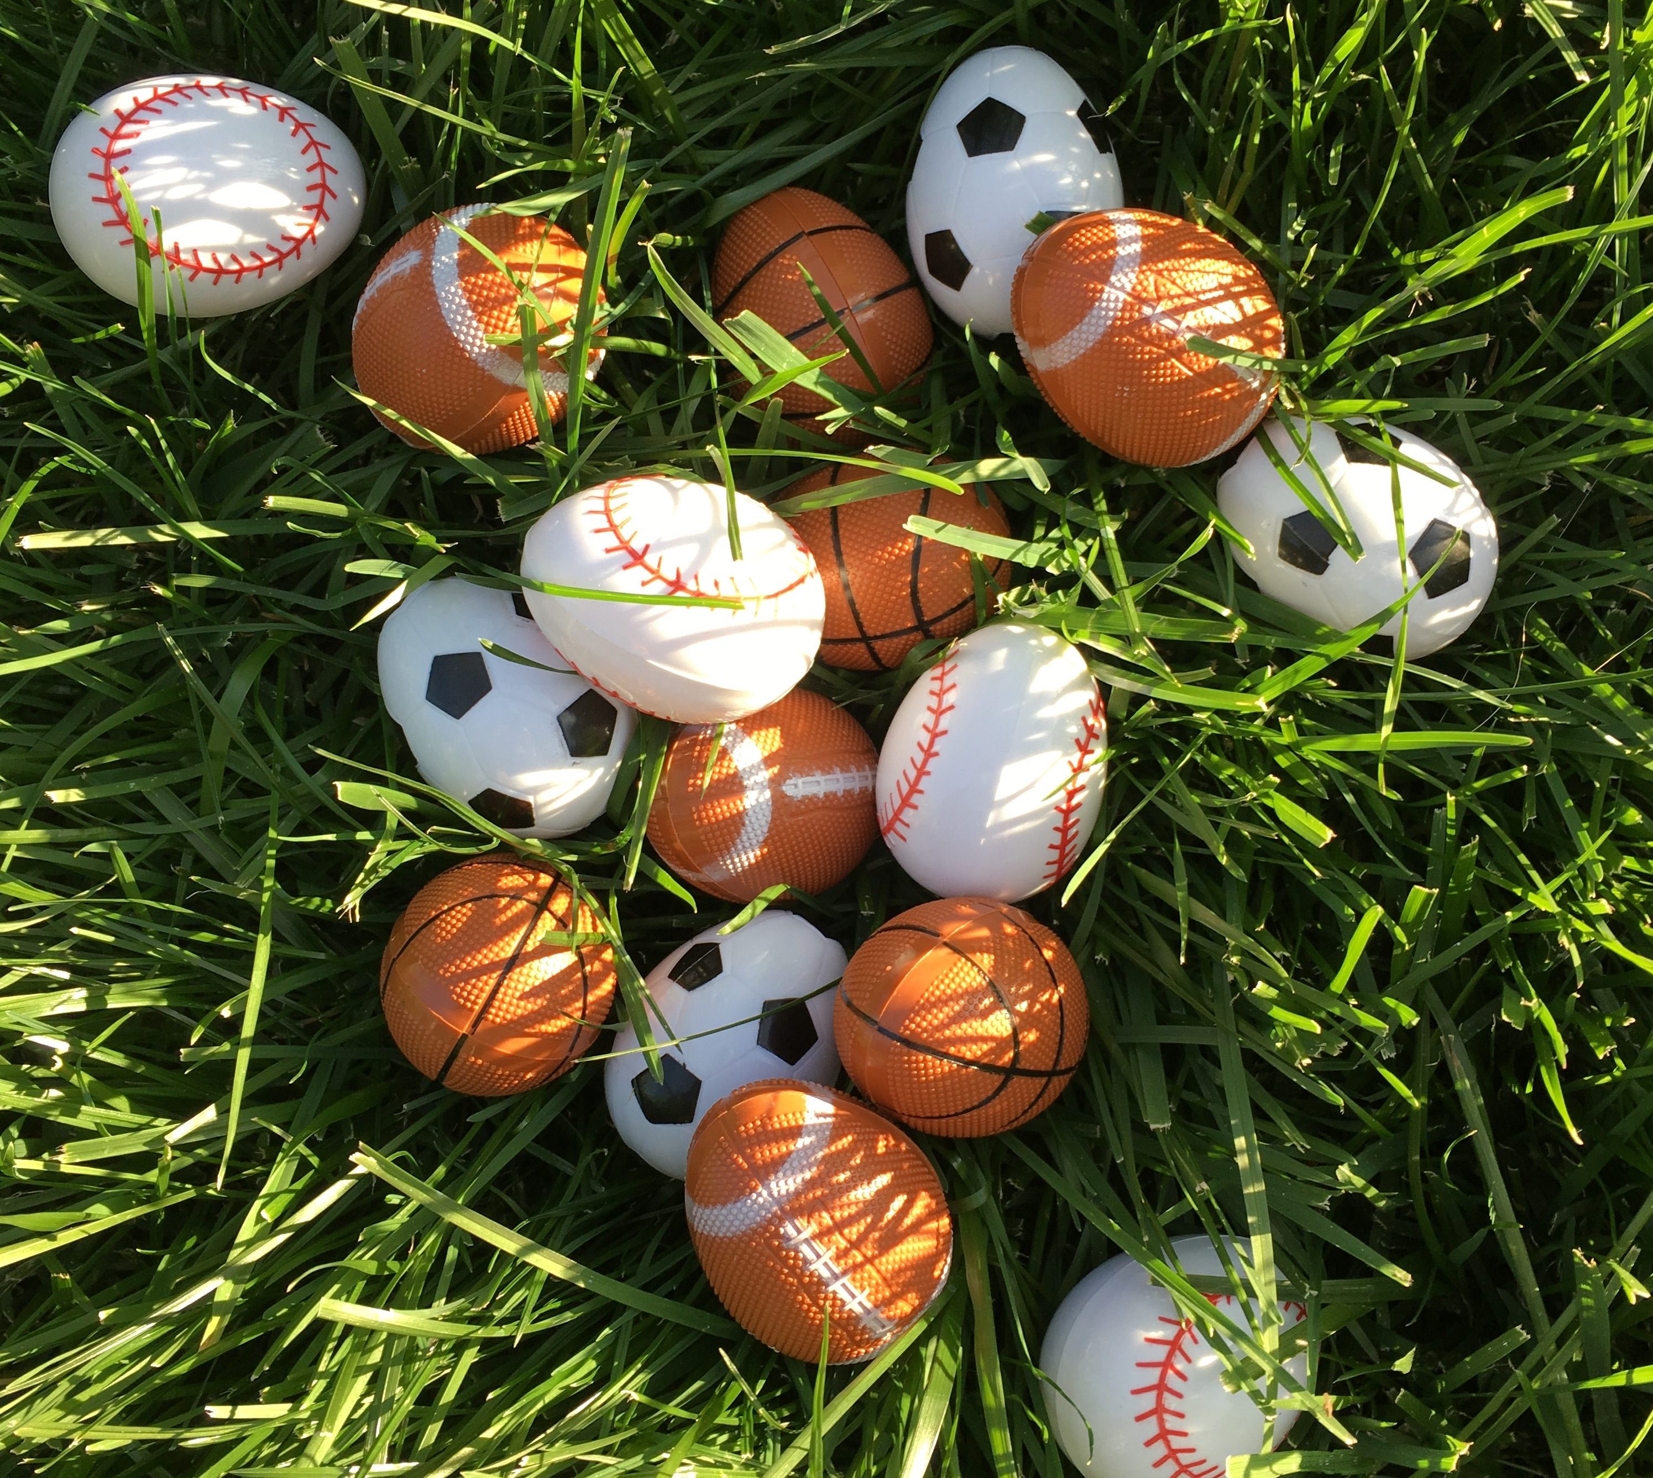

Rules:
- Found eggs must be the color or design for your team
- Upon finding one of your team’s eggs, your whole team performs the task TOGETHER or if a speaking task, each team member shares before continuing
- Collect your eggs as you go, keeping the task safely inside the egg, and bring all 12 eggs to the instructor to collect your prize
- With younger groups, divide into only as many groups as you have older leaders.

TASK SHEET for the EASTER EGGSERCISE HUNT

Each task must be completed by the WHOLE TEAM as they count aloud, or if a speaking challenge, by every player. Use some of the ideas below or come up with your own!

————————————————————————————————-
25 Jumping Jacks
————————————————————————————————-
Circle Shuffle: Join hands. Shuffle to the right until back to your spot; then shuffle to the left until back to your spot.
—————————————————————————————————10 Back-Drops: Jump, then lower down and touch shoulder blades to the ground, then get back up and jump. Repeat 10 times. (This is the opposite of a Burpee.)
—————————————————————————————————
What is your favorite place to shop? (Online or in person.) Everyone on the team must answer before continuing.
—————————————————————————————————-
10 Chest-to-the-Ground Burpees: Jump, then lower down and touch your chest to the ground, then get back up and jump. Repeat 10 times. (This is the opposite of a Back-Drop.)
—————————————————————————————————
Jog around the perimeter of the playing area (jog the boundaries) as a team. Stay together!!
—————————————————————————————————
What is your favorite book, tv show, or movie? Everyone on the team must answer before continuing.
—————————————————————————————————
10 push-ups with the best form you can. On your toes if you can, or on your knees if you need to :)
—————————————————————————————————-
12 Squat Jumps: Sit back on your heels, toes up inside your shoes. Then squat back like you’re sitting in a chair, touch the ground and explode up, jumping as high as you can. Repeat 12 times.
—————————————————————————————————-

—————————————————————————————————
100 Bicycle Crunches: Each time the elbow touches the knee it is one repetition.
—————————————————————————————————
10 Roll-Ups: Sitting down, legs straight out in front. Lay down extending arms overhead, then roll up and reach for your toes in a nice easy stretch. Roll back down. Repeat 10 times.
—————————————————————————————————-
Make up a group chant with cool moves to go with it! It’s a cheer about how GREAT and AWESOME your team is!! Shout it loud and proud 3 times as a team before continuing. Each time you say it should be louder than the last! When you turn in your bucket, perform this AGAIN!!
—————————————————————————————————-
Get KNOTTY! Stand in a circle. Put your hands in the center and grasp two other hands that are not yours. Untangle yourselves WITHOUT releasing your hands. You’ll need to navigate over and under each other’s arms.
—————————————————————————————————
Crab Walk 25 Steps
—————————————————————————————————-
25 Mountain Climbers - keep those hips as low as possible
—————————————————————————————————
25 Lunge Walk Steps with GOOD FORM. Keep your eyes on your shoelaces, dropping that back knee straight down.
—————————————————————————————————-
Line up your team shoulder to shoulder, and do 15 frog jumps forward in your line, like a mighty ARMY of frogs crossing a river! (Did you know a group of frogs is called an ARMY?)
—————————————————————————————————
Stork Stand: Stand on one foot, then lean forward and touch the ground with both hands, pushing yourself back up. 5 times on one foot; and then 5 times on the other foot.
—————————————————————————————————
25 Triceps Dips and Kicks: Do a dip, then do a kick. Repeat 25 times.
—————————————————————————————————-
What is your favorite color? Everyone on the team must answer before you continue.
—————————————————————————————————-

—————————————————————————————————
What is your favorite food, favorite fruit, or your favorite place to eat? Everyone on the team must answer before you continue.
—————————————————————————————————
Do your very best fake laugh. The whole team all at once. Laugh for at least 30 seconds before continuing.
—————————————————————————————————
50 Russian Twists: sit down, lean slightly back in a V-sit, and rotate side to side, touching your elbows to the ground with each repetition.
—————————————————————————————————
Get your team to one end of the field. Link elbows with your teammates and skip across the entire field together. If you are in the center of the field, you can skip to the boundary line and back to the center.
—————————————————————————————————
Kangaroo Hop: Jump around the area with your feet together with good kangaroo form for 25 hops!
—————————————————————————————————
Outstretch your arms like the wings on a plane and zoom around the playing area making airplane sounds. Zoom over to another team and fly around them politely before you continue.
—————————————————————————————————
Where would you rather go: the beach, the mountains, the snow, the mall, or the movies? Everyone on the team must answer before continuing.
—————————————————————————————————
Front Plank: Hold front plank position while the whole team counts to 100
—————————————————————————————————
High-five or fist-bump everyone on your team!
—————————————————————————————————-

Come up with your own ideas! This is a fun team-building fitness scavenger hunt you can play ALL YEAR LONG!

