Modelling and analyzing a Twitter topic-based social network – Easy version

Preamble:
Companies are increasingly present on social media for purposes of communication and digital reputation. In this lab, we propose an approach to quantify and visualize the content of the network of active users around a brand. This approach applied to Twitter makes it possible to identify the key players and to investigate the axes of development of a brand on social networks (see Figure 1).

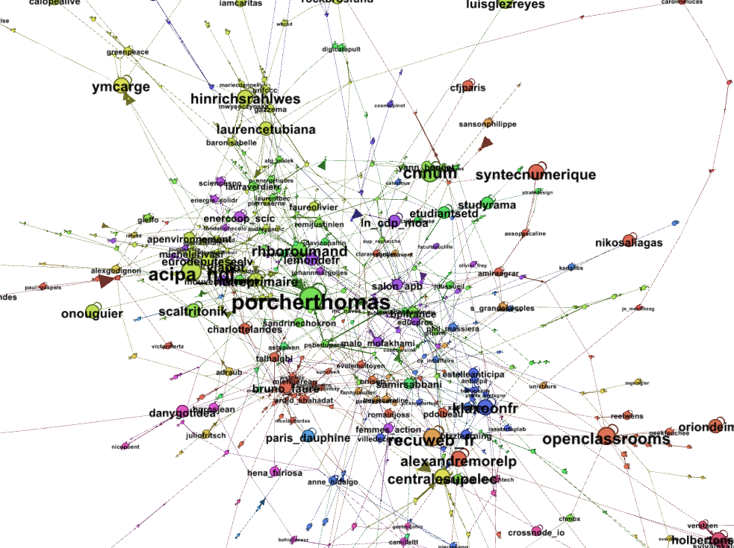
Figure 1: Representation of active profiles around the @psbeduparis Twitter page.

I Data Harvest and Graph creation
Please follow the video tutorial available on Youtube for Twitter data collection and graph creation process.
https://www.youtube.com/watch?v=KKo8rlmCouo&t=189s
Short url : https://bit.ly/2rmSYcx

II Getting started with Gephi and visualizing the graph
Follow the instructions for installing Gephi on the following page https://gephi.org/users/install/
Follow the Gephi tutorial available at the following URL https://gephi.org/users/quick-start/ for a good grip of the tool. Work only with the concepts seen in class.
Open Gephi and create a new project (File -> New Project). Import your MyGraph.csv data from the Data Lab, Links Tab, and Import Spreadsheet. If necessary, wait to have a sufficient number of tweets before uploading the graph data into Gephi.
Caution: Be sure to specify the link table in the As a table parameter.
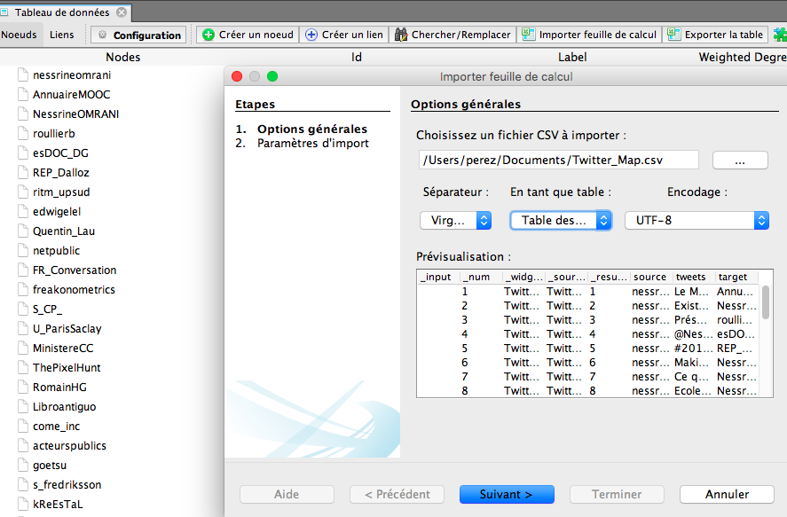
Adjust the visualization to highlight the graph and the main actors in your network as shown below.
For that make sure that:
- The knots have a size proportional to their degree
- The labels are displayed and proportional to the degree of the associated node
- The visualization algorithm is Force Atlas 2 with a gravity less than 5.
- The tag adjustment algorithm is applied

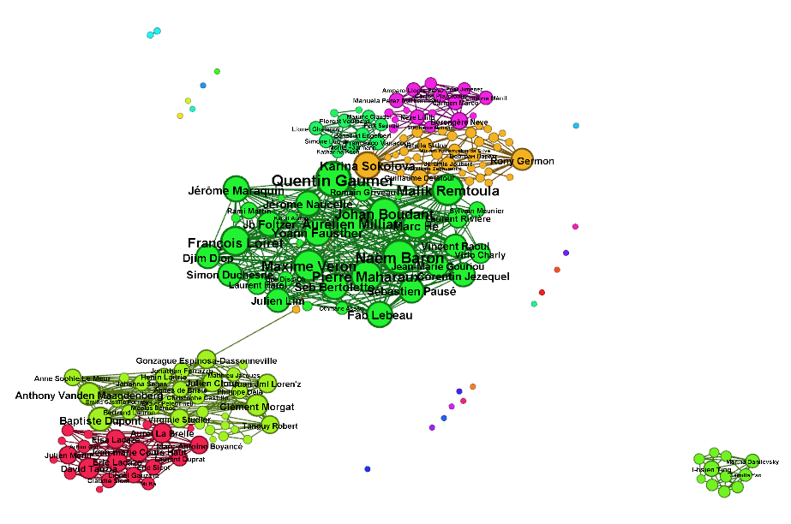

VI Graph Analysis
- Identify the value of the density. Check out your result with the software.

#Nodes | #Edges | Density

- Run the calculation of the node degree. Deduce the minimum, maximum, average and standard deviation of the degrees of the nodes.

- Using a filter on the graph, fill-in the table below (you have to pick up relevant thresholds).

ThRESHOLDS | % Below | % above
__
__
__
__

What can you conclude ?

- Identify the graph diameter such as the average distance. What can you conclude?

- Fill-in the summary table and comment the metrics obtained.

Graphe name

- Compare with other graphs collected by your colleagues. What do you obtain?

VII Identifying the central actors
- Apply the different centrality indicators to the graph (degree, centrality of intermediacy, centrality of proximity, etc.)
For each indicator, indicate the TOP 5 of the profiles (use the Gephi data laboratory) and indicate the values in the tables below.
Hint: The calculation of the diameter makes it possible to obtain the centrality of intermediate and proximity scores.
Profile | In-Degree
Profile | Out-Degree

Profile | Betweenness centrality

Profile | Closeness centrality

- Comment on the results obtained for each metric and their meaning in relation to your knowledge of the network. Are central contacts always the most important?

- Comment the possible applications of such methodology for Communication analytics?

