System Reports -
Detail Training Report
Administration User Guide

System Reports: Detail Training Report
The Detail Training Report is Systems 24-7’s preferred training report. In this permission-based report you see a detailed report of the training progress of all users within your organization. With more ﬁlters available than the Basic Training Report, you can drill down deeper to see speciﬁc reporting by course, user, category, etc.
To access the Detail Training Report follow these steps.
Step 1: Under your Admin settings, select System Reports and then Training Reports.
Step 2: From the reports list, select Detail Training Report.
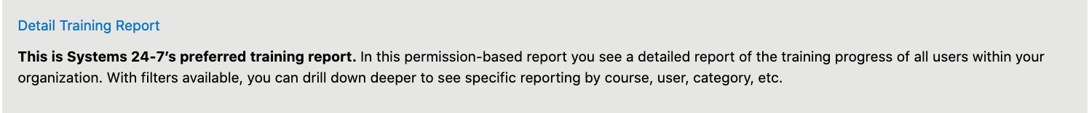
Step 3: Select the preferred record type.
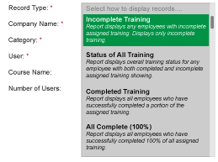
Incomplete Training: This report displays any employees with incomplete assigned training. It displays ONLY the incomplete training.
Status of All Training: This report displays overall training status for any employee with both completed and incomplete assigned training showing.
Completed Training: This report displays all employees who have completed a portion of their assigned training. This is similar to the incomplete training report, where it they report will only show you what has been complete.
All Complete: This report displays all employees who have successfully completed 100% of all their assigned training.
Step 4: Next, use the filters to drill down to the specific organizational level you would like to report on. The major difference between the Basic and Detailed Training Report is the Detailed Training Report allows you to search for a specific course; whereas the Basic Training Report will show all courses that apply to the company.
Select More Filters to expand the available search filters. In our example, we have chosen to review company-wide which employees have completed their WHMIS 2015 Training.
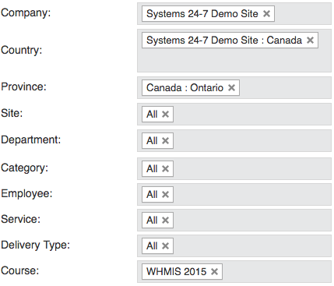
Step 5: Select the Generate Report button to create the training report. Along the top of the report is information such as the report type, who generated the report, and a time stamp. The following is an example of the Status of All Training Record Type.
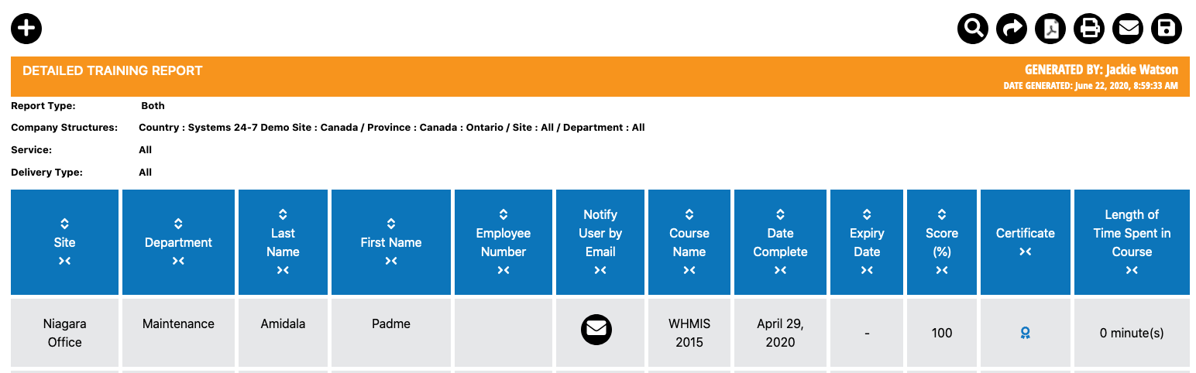
Since we chose to search for a specific course, the report will display the date the users completed the course, the expiry date (if applicable), and their course score. If the user has not completed their training, then a dash will appear and the course will be displayed in red.
You will notice up and down arrows in the column headers. By clicking on the arrows, it will either arrange the data in ascending or descending order.
If a user has successfully completed their course and they were provided a certificate; a certificate icon will appear in the Certificate column. Simply click on the icon to view it.
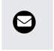
If you wish to email an employee directly from the report to inform them of incomplete training, select the email option. The email can only be sent if the employee has an email connected to their account.
There are a variety of options above the report. If you want to search for something within the report, select the Search icon and enter in the information you are searching for, such as an employee’s name.
If you want to export the report to a csv file, select the Export icon. The report will download and you can open within your preferred program, such as Excel.
If you want to export the report to a pdf file, select the PDF icon. A PDF will be generated and downloaded.
To print the report, select the Print icon.
To email all users with incomplete training within the report, select the Email icon.
And finally, to save the report filters and make this available as a saved report under the training report options page, select the save report button. Name the report and provide a description. Once you select next, you can decide to share the saved report with others in your organization. If you share the saved report and decide to delete it later, you won’t be able to delete it from those you shared it with.

