Training Report
Administration Section

Table of Contents
Accessing your Training Reports 3
Default Training Reports 3
Basic Training Report 4
Detailed Training Report 6
Percentage Training Report 9
Overview Training Report 10
Historical Training Report 12
Expiry Training Report 13
Certificate Training Report 14
User Percentage Training Report 16
Complete By Training Report 16
Saved Training Reports 18
Accessing Saved Reports 18
Edit a Saved Report 18
Delete a Saved Report 19
Training Report Toolbar 19
New Report 20
Search Report 20
Export Report 20
Save Report PDF 20
Print Report 21
Email Report 21
Save Report 21

Accessing your Training Reports
As an Administrator for your company; you are able to pull reports on just about anything in the system. These are great tools for demonstrating due diligence in the workplace! This includes the ability to access your Training Reports which allows you to pull data on training; whether it be completed, incomplete, or expired.
To access your Training Reports, we start off with accessing the Admin section via the Admin button at the top right side of your website. If you do not see this button, you may not have the proper administration privileges in the system.
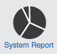
Once you are in the Administration section, click on System Report to see the different types of reports we offer. Below are some of the reports that may be available to you.
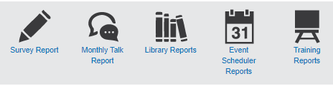
To access your Company’s Training Reports, please click on Training Reports. Here you are able to view your company’s Default Reports. If you save any reports you will be able to find them under Saved Reports.

Default Training Reports
You can choose from nine different Training Reports:
Basic Training Report: This report provides a basic overview of the training progress of all users within your organization. This is permission-based, so you can only see information based on what you have permissions to see.
Detail Training Report: This permission-based report provides a more detailed report of the training progress of all users within your organization. With more filters available, you can drill down deeper to see specific reporting by course, user, category, etc.
Percentage Training Report: This permission-based report provides a quick percentage of completion of the training progress of all users within your organization. With more filters available, you can drill down deeper to see specific reporting by course, user, category, etc.
Overview Training Report: This permission-based report provides a high-level report on your organization for the total percentage of completed training.
Historical Training Report: In this report, you can pull records from the past to view how many times a user has completed a module, etc. With more filters available, you can drill down deeper to see specific reporting by course, user, category, etc.
Expiry Training Report: In this permission-based report you can pull training records about to expire within a set time period. With more filters available, you can drill down deeper to see specific reporting by course, user, category, etc.
Certificate Training Report: In this permission-based report you can pull all certificates in the system including online training and external course certificates.
User Percentage Training Report: Use this permission-based report to view user’s overall percentage of training completion.
Complete By Training Report: In this report you can see data about the completion and non-completion of profiled courses with Complete By profiling.

Basic Training Report
Start by selecting Basic Training Report from the Training Reports page.
The Basic Training Report gives an overview of a user’s training progress.
Select the Report Type that you would like to generate. You can choose from complete, incomplete, or both. In the basic training report, the report type is defaulted to both.
Completed: This report shows employees who have completed all of their assigned training, and displays all of their assigned training.
Incomplete: This report shows employees who have not completed all of their assigned training, and displays all of their training, whether it is completed or not.
Both: This report will show all employees and all of their assigned training.
Next, use the company filters to drill down to the specific organizational level you would like to report on and click the Generate Report button. In our example, we have chosen to review online training (delivery type) at a specific location (site). Note: You must select a company before any other filters appear because the filters appear based on the company’s structure. After the company is selected, the filters will load. For example, region, location and department, etc.
All fields below the company level are multiple select; meaning you can select as many options within each field as you would like. As this is a permission-based report, you will only be able to see and generate a report based on your permissions.

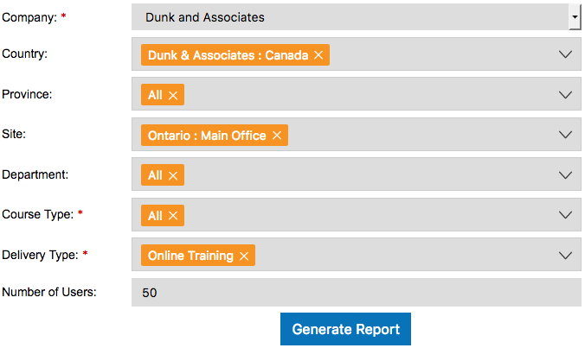
The Basic Training Report displays all users relating to the search criteria and displays a date in the course column for courses that are completed. If the user has not completed their training, a red ‘x’ will display in the column and the user information will be in red text.
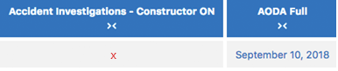
To see the results for any given user you can use the horizontal scroll bar located at the bottom of the screen. This will allow you to keep a user’s information on screen while viewing any course data that does not fit on the screen when the report is generated.
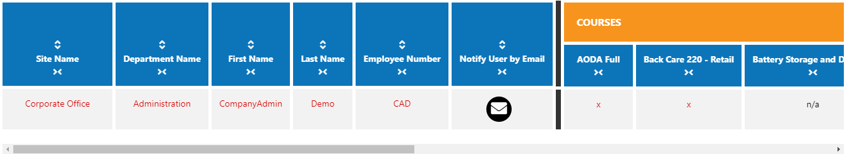
Along the top of the report are details about your search criteria. If you need to print, email, or export a report; you will always know the details of the data by reviewing this information.
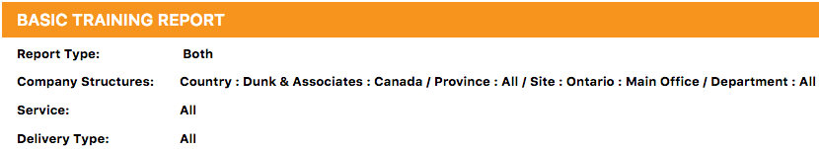
The whole report is generated within a frame so you can scroll horizontally through the report. A freeze frame is placed on the first six columns so they always remain on the left when you scroll. To scroll, place your cursor over the course columns and scroll left and right to view the data.
Columns are sortable by clicking on the up/down arrow icon above the column name allowing you to you can arrange the data in ascending and/or descending order. Columns are collapsible by clicking on the arrow icon below the column name. By collapsing a column, it will be easier to focus on only the data you are looking for. Note: Hidden columns are not shown in the exported, emailed, or printed reports.
Collapse column
Show column
Sort Column
Within the Notify User by Email column, you can let a user know they have incomplete training by sending them an email. First, select the email icon next to the user you wish to notify.
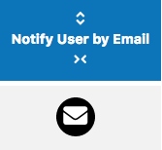
Once you have selected the email icon an email notification window will appear. The courses for the user you selected will be placed within the message template. You can customize this message or leave it as it. Next, select the user you wish to send it to, followed by Send Email.
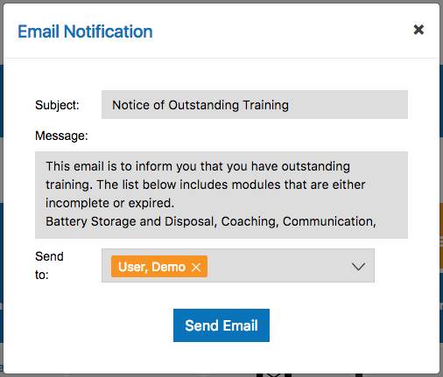
For information on emailing, printing, or exporting reports; please refer to the last section of this user guide called Training Report Toolbar.

Detailed Training Report
Start by selecting Detail Training Report on the Training Reports page.
The Detail Training Report is Systems 24-7’s preferred training report. In this permission-based report you see a detailed report of the training progress of all users within your organization. With more ﬁlters available than the Basic Training Report, you can drill down deeper to see speciﬁc reporting by course, user, category, etc.
Select the preferred record type that you would like to generate:
Incomplete Training: This report displays any employees with incomplete assigned training. It displays ONLY the incomplete training. For example, you could use this report if you wanted to view a list of each employee’s incomplete courses within a specific department.
Status of All Training: This report displays overall training status for any employee with both completed and incomplete assigned training showing. For example, you could use this report if you wanted to view a progress list of each employee. This report would show you what is not done and what is done, like a report card.
Completed Training: This report displays all employees who have completed a portion of their assigned training. This is similar to the incomplete training report, where the report will only show you what has been complete. For example, you could use this report if you wanted to view a list of each employee’s complete courses within a specific department.
All Complete: This report displays all employees who have successfully completed 100% of all their assigned training. For example, you might use this report to show you which employees within a specific department have completed all their assigned courses.
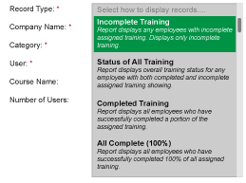
Next, use the company filters to drill down to the specific organizational level you would like to report on. The major difference between the Basic and Detailed Training Report is the Detailed Training Report allows you to search for a specific course; whereas the Basic Training Report will show all courses that apply to the company. Select More Filters to expand the available search filters. Once you have selected the appropriate search fields, click the Generate button. In our example, we have chosen to review company-wide which employees have completed their WHMIS 2015 Training. Select the Generate Report button to create the training report.
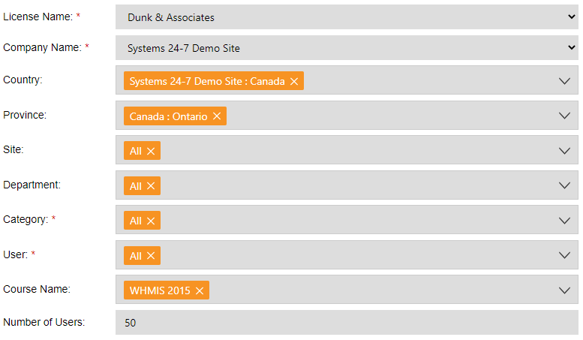
Along the top of the report is information such as the report type, who generated the report, and a time stamp. The following is an example of the Status of All Training Record Type.
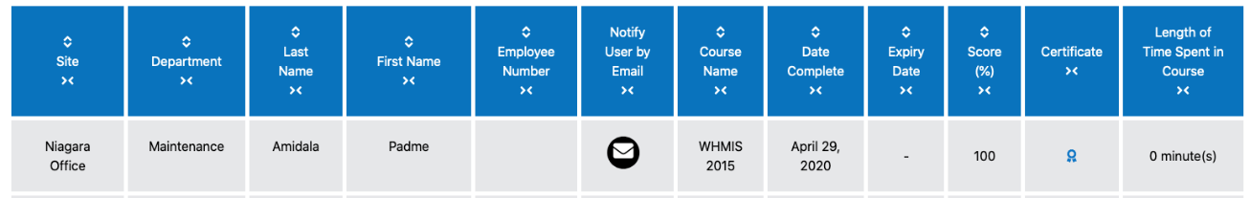
Since we chose to search for a specific course, the report will display the date the users completed the course, the expiry date (if applicable), and their course score. If the user has not completed their training, then a dash will appear and the course will be displayed in red.
Columns are sortable by clicking on the up/down arrow icon above the column name allowing you to you can arrange the data in ascending and/or descending order. Columns are collapsible by clicking on the arrow icon below the column name. By collapsing a column, it will be easier to focus on only the data you are looking for. Note: Hidden columns are not shown in the exported, emailed, or printed reports.
Collapse column
Show column
Sort Column
Within the Notify User by Email column, you can let a user know they have incomplete training by sending them an email. First, select the email icon next to the user you wish to notify.
Once you have selected the email icon an email notification window will appear. The courses for the user you selected will be placed within the message template. You can customize this message or leave it as is. Next, select the user you wish to send it to, followed by Send Email.
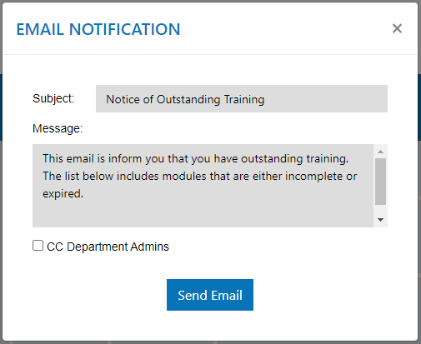
For information on emailing, printing, or exporting reports; please refer to the last section of this user guide called Training Report Toolbar.

Percentage Training Report
Start by selecting Percentage Training Report from the Training Reports page.
The Percentage Training Report is a quick way to see the percentage of users that have completed training. You can search by company level or by a specific user. The report type is defaulted to both this can be changed to the type that you would like to generate. You can choose from complete, incomplete, or both.
Completed: This report shows employees who have completed all of their assigned training and displays all of their assigned training.
Incomplete: This report shows employees who have not completed all of their assigned training, and displays all of their training, whether it is completed or not.
Both: This report will show all employees and all of their assigned training.

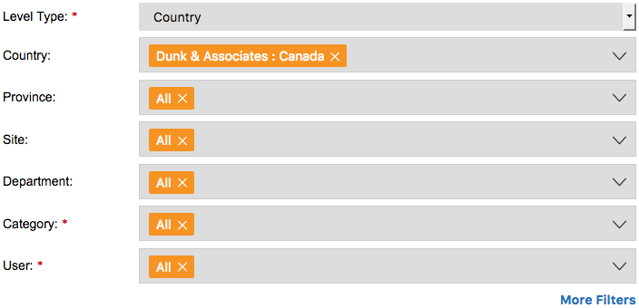
All fields below the company level are multiple select; meaning you can select as many options within each field as you would like. As this is a permission-based report, you will only be able to see and generate a report based on your permissions.
If you need to look for a specific course or delivery type, select More Filters. This will display additional search fields such as Assignment Type, Course Type, Course Bundle, and the Course Name. Generating a report on a course bundle allows you to group the courses together. When you filter the report by course bundle, the next dropdown for courses will only show the courses contained with that bundle.
Once you have selected the appropriate search fields, click the Generate Report button. In our example, we are going to search for complete and incomplete training company-wide.
Review the report and make any adjustments to the search filters as needed. If you update the search criteria, you will be required to click Generate Report to view the results. Along the top of the report is the report type and the company filters you have chosen.
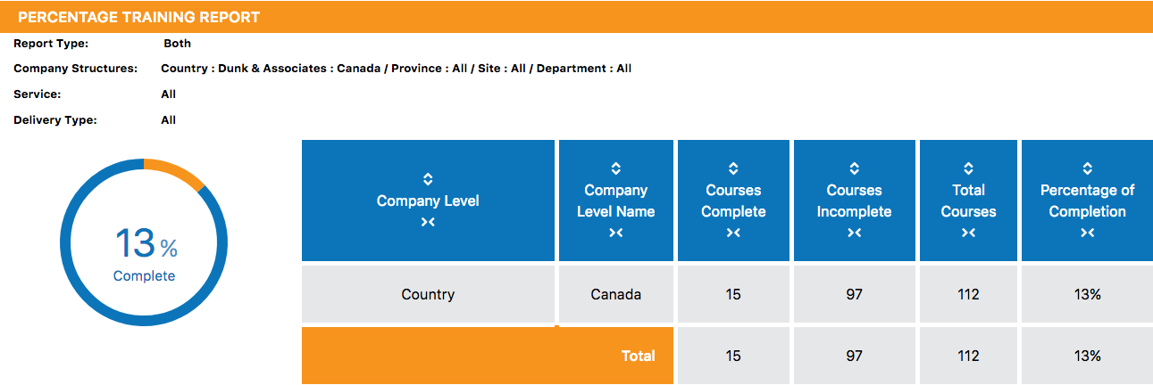
The report will tell you the number of courses completed and incomplete, as well as the total number of courses. This provides you with a percentage of completion and is displayed in a graph form.
Columns are sortable by clicking on the up/down arrow icon above the column name allowing you to you can arrange the data in ascending and/or descending order. Columns are collapsible by clicking on the arrow icon below the column name. By collapsing a column, it will be easier to focus on only the data you are looking for. Note: Hidden columns are not shown in the exported, emailed, or printed reports.
Collapse column
Show column
Sort Column
For information on emailing, printing, or exporting reports; please refer to the last section of this user guide called Training Report Toolbar.

Overview Training Report
Start by selecting Overview Training Report from the Training Reports page.
The Overview Training Report is very similar to the Percentage Training Report, the only difference being this report has no search filters. Instead your page will load an overview training report for your permission level. You can then select permission levels you have access to and the report will update and display an overview for that level of the company. For example, a company admin can see the whole company and drill down from the company level, whereas a department admin can only see their department and drill down within their department.
Let’s start at our highest permission level, Licensee. As a licensee, your first overview would be a report for all companies you have permissions to. From here, the licensee can then select a specific company by clicking on the company name from the first column. In our example, we will use Dunk & Associates.
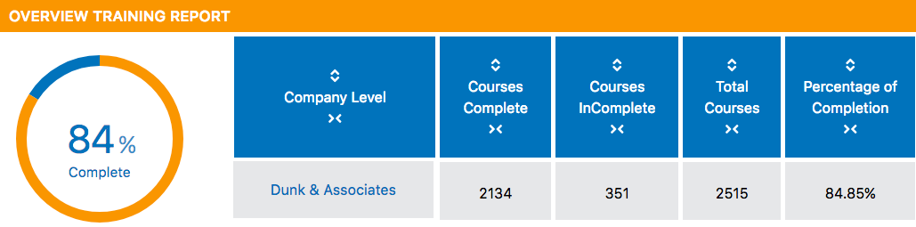
Now that we have selected the company level Dunk & Associates; we can continue to select options in the first column until we find the results we are looking for. In the example below, we used the drill down options to view an overview of our sites (locations) by selecting Dunk & Associates > Canada > Ontario.
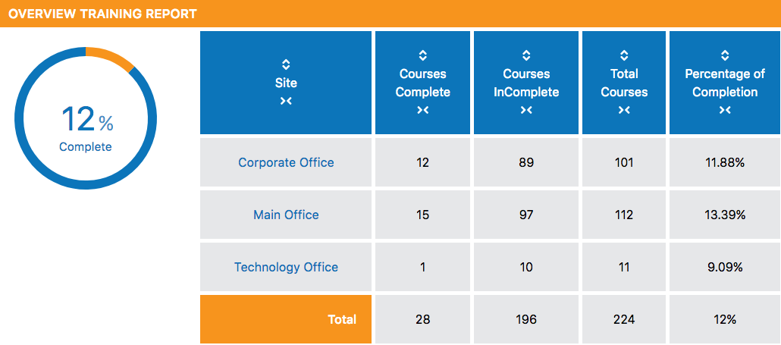
The options you will be provided in the first column will match the company structure set up in the system. If you ever need to go back to the previous company level, select the appropriate option from the breadcrumb trail at the top of the report (shown below).
The furthest you can drill down is to a specific user. When viewing a specific user, you will see an overall percentage for courses completed, as well as a breakdown for each course.
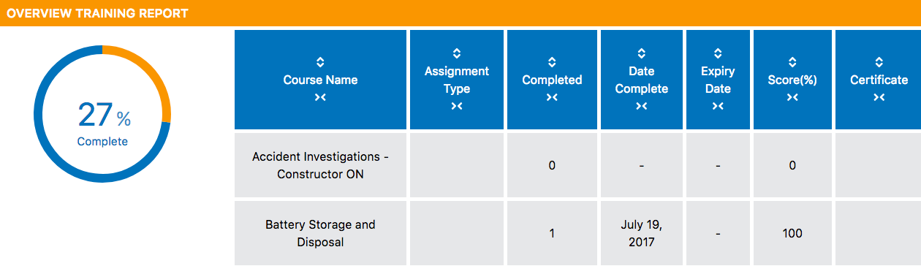
Columns are sortable by clicking on the up/down arrow icon above the column name allowing you to you can arrange the data in ascending and/or descending order. Columns are collapsible by clicking on the arrow icon below the column name. By collapsing a column, it will be easier to focus on only the data you are looking for. Note: Hidden columns are not shown in the exported, emailed, or printed reports.
Collapse column
Show column
Sort Column
For information on emailing, printing, or exporting reports; please refer to the last section of this user guide called Training Report Toolbar.

Historical Training Report
Start by selecting Historical Training Report from the Training Reports page.
The historical training report is designed to pull a report on historical data. This report only shows records for users who have completed their training, not for accessed or failed attempts.
If you need to look for a specific course or delivery type, select More Filters. This will display additional search fields such as Assignment Type, Course Type, Course Bundle, and the Course Name. Generating a report on a course bundle allows you to group the courses together. When you filter the report by course bundle, the next dropdown for courses will only show the courses contained with that bundle.
As this is a permission-based report, you can only select fields you have permission to. To select a From Date and To Date, click within the field or the calendar icon to open a date picker.
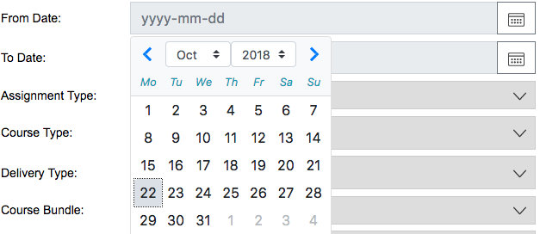
Once you have selected the appropriate search fields, click the Generate Report button. In our example, we are going to look at historical data for our main office location.
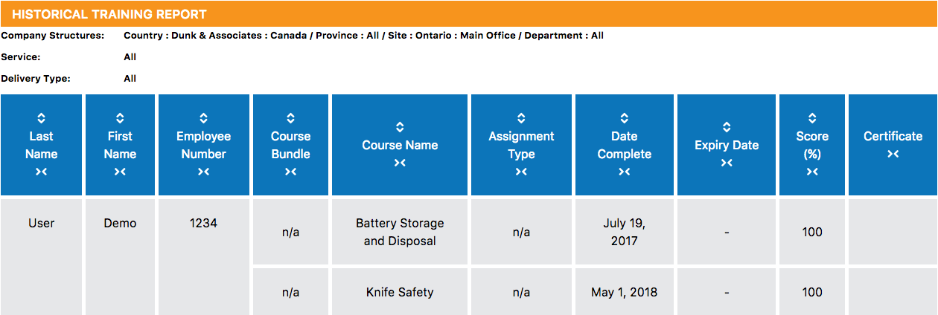
The information is displayed by user and is broken out by course. For each course, you can review the assignment type, date completed, expiry date, course score, and if there was a certificate provided.
To view the certificate, you will click on the blue certificate icon located in the last column. The certificate will open in a new window and can be printed from the browser.
Along the top of the report is the search criteria used to generate this report. If you print or export this report, you can always refer to this section to better understand the date you are viewing.
Columns are sortable by clicking on the up/down arrow icon above the column name allowing you to you can arrange the data in ascending and/or descending order. Columns are collapsible by clicking on the arrow icon below the column name. By collapsing a column, it will be easier to focus on only the data you are looking for. Note: Hidden columns are not shown in the exported, emailed, or printed reports.
Collapse column
Show column
Sort Column
For information on emailing, printing, or exporting reports; please refer to the last section of this user guide called Training Report Toolbar.

Expiry Training Report
Start by selecting Expiry Training Report from the Training Reports page.
Expired reports will show anything that has expired or will expire within the date range selected under report type.
For example, if pulling a report on courses that will expire within 7 days, the output of the report will display only courses that will expire within 7 days. If you select Expired then all currently expired courses will appear in the generated results.
Many of the filter options are multiple select; meaning you can select as many options within each field as you would like. As this is a permission-based report, you will only be able to see and generate a report based on your permissions.
If you need to look for a specific course or delivery type, select More Filters. This will display additional search fields such as Assignment Type, Course Type, Course Bundle, and the Course Name. Generating a report on a course bundle allows you to group the courses together. When you filter the report by course bundle, the next dropdown for courses will only show the courses contained with that bundle.
Once you have selected the appropriate search fields, click the Generate Report button.
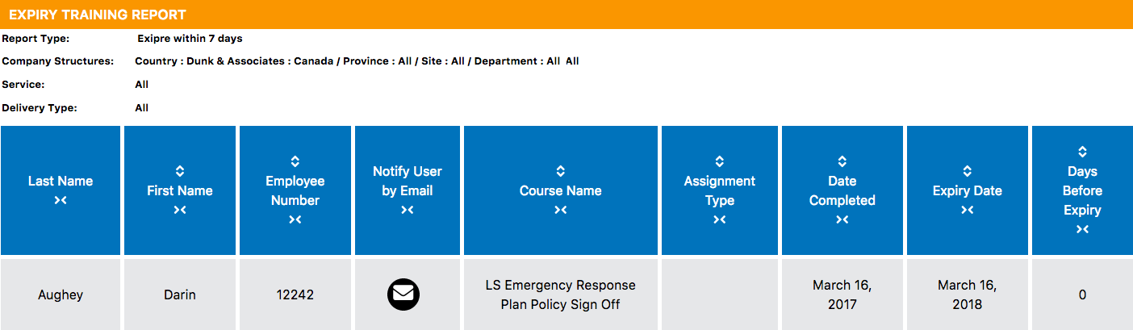
Along the top of the report is the search criteria used to generate this report. If you print or export this report, you can always refer to this section to better understand the date you are viewing.
Within the Notify User by Email column, you can let a user know they have incomplete training by sending them an email. First, select the email icon next to the user you wish to notify.
Once you have selected the email icon an email notification window will appear. You can update the template message if needed. The course that is expiring and the expiry date will autofill once the email is sent. Next, select the user you wish to send it to, followed by Send Email.
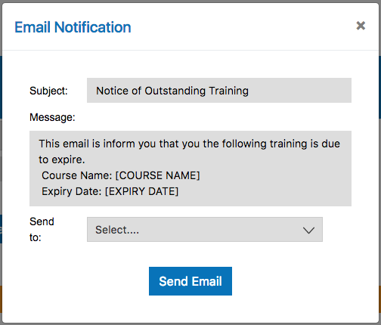
Columns are sortable by clicking on the up/down arrow icon above the column name allowing you to you can arrange the data in ascending and/or descending order. Columns are collapsible by clicking on the arrow icon below the column name. By collapsing a column, it will be easier to focus on only the data you are looking for. Note: Hidden columns are not shown in the exported, emailed, or printed reports.
Collapse column
Show column
Sort Column
For information on emailing, printing, or exporting reports; please refer to the last section of this user guide called Training Report Toolbar.

Certificate Training Report
Start by selecting Certificate Training Report from the Training Reports page.
Certificate reports will show a report on any course with a certificate. This includes certificates generated from completing online training, and certificates manually uploaded by a manager for an external training record. As this is a permission-based report, you will only generate a report based on your permissions.
First, select which Report Type you would like to generate. You can choose external, online or both. Initially the default type is both, change as desired. courses are taken in a classroom where a certificate was uploaded to the system manually and Online is for an online training course.
Select the Report Type that you would like to generate. You can choose from complete, incomplete, or both. In the basic training report, the report type is defaulted to both.
External: External courses are taken in a classroom where a certificate was uploaded to the system manually by the course facilitator.
Online: This report shows employees who have completed a course using the online system their assigned training, and displays all of their training, whether it is completed or not.
Both: This report will show all employees who have passed assigned training courses in a classroom setting or online.
Select the appropriate search fields by using the dropdown menu. If you need to look for a specific course or delivery type, select More Filters. This will display additional search fields such as Assignment Type, Course Type, Course Bundle, and the Course Name. Generating a report on a course bundle allows you to group the courses together. When you filter the report by course bundle, the next dropdown for courses will only show the courses contained with that bundle.
Once you have selected the appropriate search fields, click the Generate Report button.
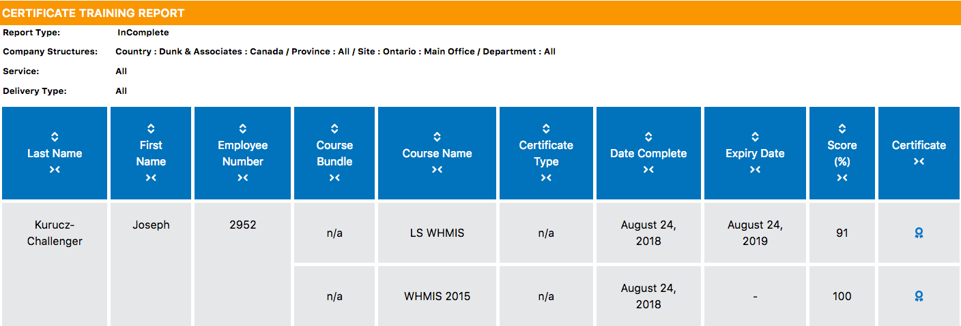
The results will be broken out by user and any courses that have a certificate and match your search criteria will be displayed.
To view the certificate, you will click on the blue certificate icon located in the last column. The certificate will open in a new window and can be printed from the browser.
Columns are sortable by clicking on the up/down arrow icon above the column name allowing you to you can arrange the data in ascending and/or descending order. Columns are collapsible by clicking on the arrow icon below the column name. By collapsing a column, it will be easier to focus on only the data you are looking for. Note: Hidden columns are not shown in the exported, emailed, or printed reports.
Collapse column
Show column
Sort Column
For information on emailing, printing, or exporting reports; please refer to the last section of this user guide called Training Report Toolbar.

User Percentage Training Report
Start by selecting User Percentage Training Report from the Training Reports page.
The User Percentage Training Report is a quick way to see the percentage of users that have completed training in a specific category.
Make your selections by using the search fields listed at the top of the page. If you need to look for a specific course or delivery type, select More Filters. This will display additional search fields such as Assignment Type, Course Type, Course Bundle, and the Course Name. Generating a report on a course bundle allows you to group the courses together. When you filter the report by course bundle, the next dropdown for courses will only show the courses contained with that bundle.
Once you have selected the appropriate search fields, click the Generate Report button. In our example, we are looking at our main office’s location using the general worker category.
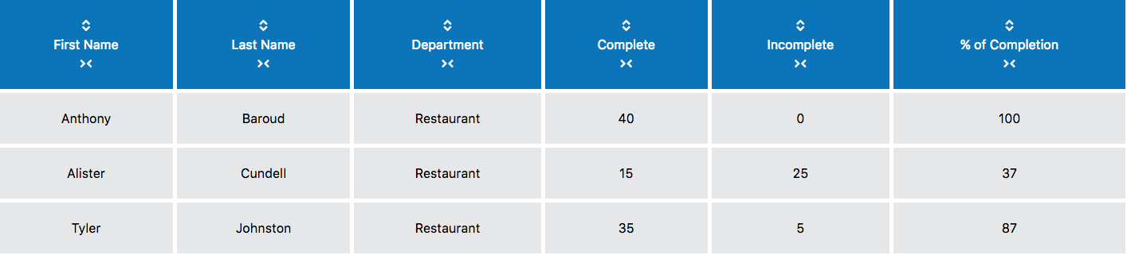
Users are broken out by row and the columns provided tell you how many courses the user has completed and courses the user still needs to complete. This generates the percentage of completion in the last column.
Columns are sortable by clicking on the up/down arrow icon above the column name allowing you to you can arrange the data in ascending and/or descending order. Columns are collapsible by clicking on the arrow icon below the column name. By collapsing a column, it will be easier to focus on only the data you are looking for. Note: Hidden columns are not shown in the exported, emailed, or printed reports.
Collapse column
Show column
Sort Column
For information on emailing, printing, or exporting reports; please refer to the last section of this user guide called Training Report Toolbar.

Complete By Training Report
Start by selecting Complete By Training Report from the Training Reports Menu.
The Complete by Percentage Training Report is a quick way to see data about courses that have a ‘complete by’ date and will show if the course is overdue. This is a great reporting tool for performance management - did an employee get their training done on time?
First, select which type of report you would like to generate.
The default selected report type is all. This will show all courses with a due date that match the search filters selected. Alternatively you can choose a different report type which ill generate a more specific list, such as courses completed before or after a due date.
Make your selections by using the search fields listed at the top of the page. If you need to look for a specific course or delivery type, select More Filters. This will display additional search fields such as Assignment Type, Course Type, Course Bundle, and the Course Name. Generating a report on a course bundle allows you to group the courses together. When you filter the report by course bundle, the next dropdown for courses will only show the courses contained with that bundle.
Once you have selected the appropriate search fields, click the Generate Report button.
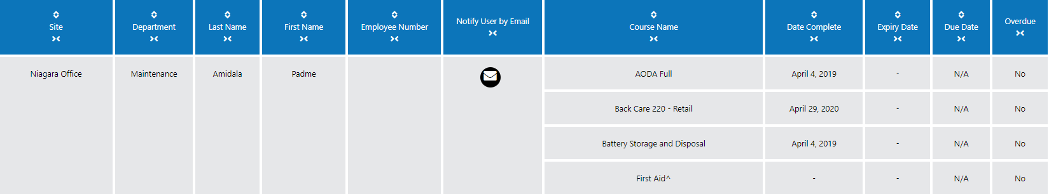
Results are grouped by user name and course names are listed. If there is a due date it will be listed here and the final column will indicate if the training is overdue. If the training is not yet complete, or if there is no expiry date then the result will be blank. If there is no due date N/A will be shown.
Within the Notify User by Email column, you can let a user know they have incomplete or expired training by sending them an email. First, select the email icon next to the user you wish to notify.
Once you have selected the email icon an email notification window will appear. You can update the template message if needed. You can choose to copy department Admins so that they receive the message too, by checking the box below the message, Next, select the user you wish to send it to, followed by Send Email.
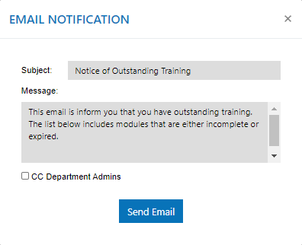
Columns are sortable by clicking on the up/down arrow icon above the column name allowing you to you can arrange the data in ascending and/or descending order. Columns are collapsible by clicking on the arrow icon below the column name. By collapsing a column, it will be easier to focus on only the data you are looking for. Note: Hidden columns are not shown in the exported, emailed, or printed reports.
Collapse column
Show column
Sort Column
For information on emailing, printing, or exporting reports; please refer to the last section of this user guide called Training Report Toolbar.

Saved Training Reports
If you selected to save a report while using one of the default training reports, you will find it under the Saved Reports header on the Training Reports page. From here, you can use your saved report, make changes to the report, or delete the report.

Accessing Saved Reports
To use a saved report, select the title of your report. This will open the report and generate results. You can modify the search fields to update the data.
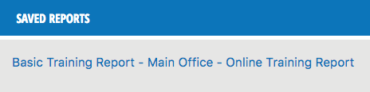

Edit a Saved Report
If you wish to edit a saved report, select the edit icon found under Report Settings. From here you can rename the report, edit the description or share it with someone.
Make the necessary changes and select Send to save the changes.
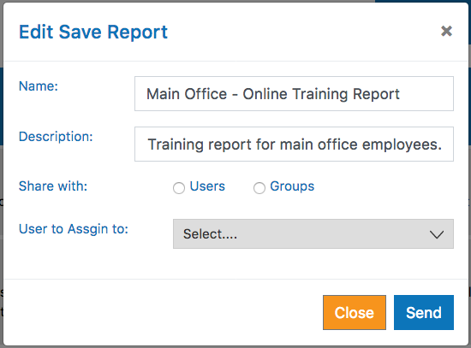

Delete a Saved Report
If you wish to delete a saved report, select the delete icon found under Report Settings. The system will ask you to confirm your request.
Select Delete to permanently delete the report.
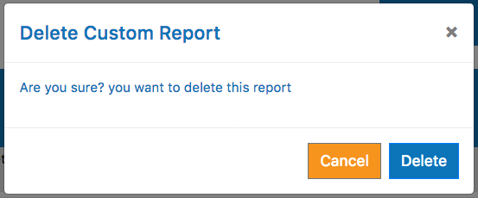
The system will notify you that your report was successfully deleted and you will no longer see the report under Saved Reports.
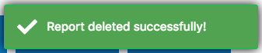

Training Report Toolbar
After you generate a report, a training report toolbar will appear below the search filters. This is the same on all reports so let’s run through what each icon’s functions are and the steps that need to be taken. We’ll start on the left.

New Report
This is the New Report icon. By selecting this icon, you will clear your current search criteria for the report and start from scratch.
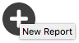

Search Report
By selecting the Search icon, you will activate the search bar for the report. The search bar allows you to look up keywords within the report by hiding all other data.
After you find the keyword you are looking for, you can erase the keyword from the search bar and the report will return back to its original state.

Export Report
This is the Export icon. By selecting it, the system will generate a CSV file (excel file). You can then choose to view or save the file from the dialogue box (shown below).
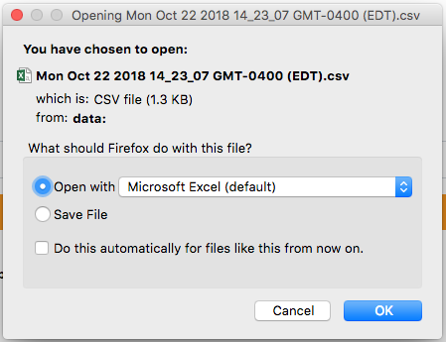

Save Report PDF
If you want to export the report to a pdf file, select the PDF icon. A PDF will be generated and downloaded.

Print Report
This is the Print icon. By selecting this, the system will generate a printer friendly version of the report.

Email Report
This is the Email icon– this only appears when viewing the Basic Training Report, Detail Training Report and the Complete By Training Report. By selecting this, you can send an email that will go to each of the users within the report. Each user will receive an email listing their outstanding training courses.
The subject line and message will load the template from the system but you can customize this if you wish. Yu can also copy Department Administrators if desired, by checking the box below the message text box.After you make your changes and select who you want to email the report to, select Send Email.

Save Report
This is the Save Report icon. By selecting this, you can save a copy of the report you just generated.
The report will remember your filter selections and when accessed, it will load the same report with current data. This is great if you are constantly running the same report frequently. Instead of selecting the search filters every time, you can just access the report in one click.
Once you have selected to save the report you will be asked by the system to name the report and insert a description. Select Next to continue.
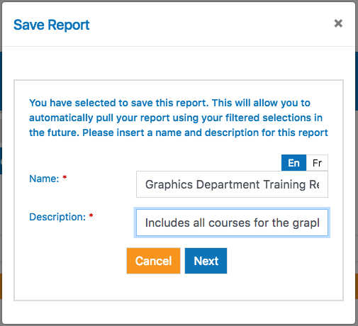
Next, you will be asked if you would like to share this report with anyone else in your organization. By choosing to share this report, this mean it will show up under the selected users Saved Reports on the Training Reports page.
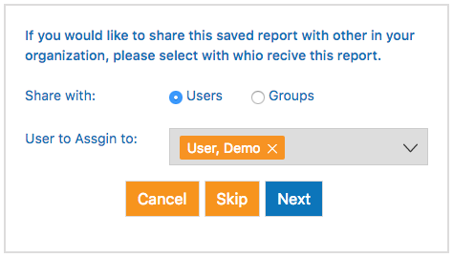
You can choose to assign it to a particular person by selecting Users or you can assign it to a group of people by selecting Groups. For example, you could be a manager creating this report and you want to share it with your supervisors so they can run the report themselves. Once you have made your selection, use the dropdown menu and assign the users or groups. If you do not want to share this saved report with anyone, select Skip.
The report will be added to the system and next time you need to access it, you can find it under Saved Reports.
