Notification Center
Administration Section
Systems 24-7 provides a variety of emails sent from the system to communicate with employees. As an Administrator for your company; you have the ability to configure and customize these automatic emails using the Notification Center feature.
To access the Notification Center, access the Admin section via the Admin button at the top right side of your website. If you do not see this button, you may not have the proper administration privileges in the system.
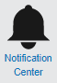
Once you are in the Administration section, click on Notification Center to see the Notification Center page and its functions. To set up and manage your email templates, click on Manage Email Message.
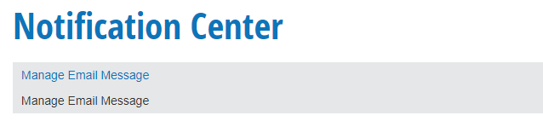

Manage Email Message
You can use the Manage Email Message function to turn on/off email templates, change their frequency or recipients, and customize the content of the emails.
Select the Systems 24-7 feature from the dropdown that you would like to customize the default email for. For example, forgot password or training.
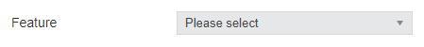
Once you have selected the feature, you will see a list of the available email templates you can customize. For example, forgot username and forgot password.
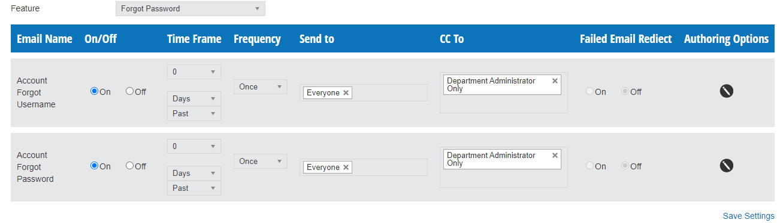
For each email template in the table, you will be able to see the following information:
Email Name: This is the title of the email template.
On/Off: If this setting is on, the system will send out this email template automatically, based on the other settings for the template. If the setting is off, this email template will not be sent out.
Time Frame: Some email templates allow you to set up a time frame for when the email will be sent out. Depending on the template, you can set up emails to be sent out at a specific date before or past the email trigger, and you can select this time frame in terms of days, weeks, months, or years. Please note that depending on the situation, the time frames you can select may be restricted. For example, 3 days before training expires.
Frequency: Some email templates allow you to choose the frequency with which emails will be sent. By default, this setting is set to once, but some email templates will allow you to choose a recurring schedule, such as once a week. For example, a reminder weekly of expired training. Please note that some email templates may not have this setting available.
Send To: This setting will allow you to choose which users will be sent emails, based on their administrative level. Some emails you may want to be sent to Everyone, some to Basic Users Only, some to their Department Admins, or any combination of the available options.
CC To: This setting will allow you to have administrators copied on the emails that are sent to your employees. For each employee that is sent an email, all administrators of the chosen level who have access to manage that employee will be copied on the email.
Failed Email Redirect: This setting, if turned on, will send an email to the user’s Department Admin in a situation where the user does not have an email address, or if the email sent to the user fails or bounces back. If the email to the Department Admin fails, or the Department Admin has no email address, the email is then sent to the Site Admin, and so on up the chain to the Company Admin.

Editing a Default Email
To edit an email:
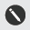
Click the edit button under the Authoring Options to customize the subject and body of the email template.
Once you have clicked the Edit button next to an email template, you can make changes to the body and subject line of the email template:
The Trigger field details the system trigger that will cause emails to be sent out automatically. For system default email templates, this field is not editable.
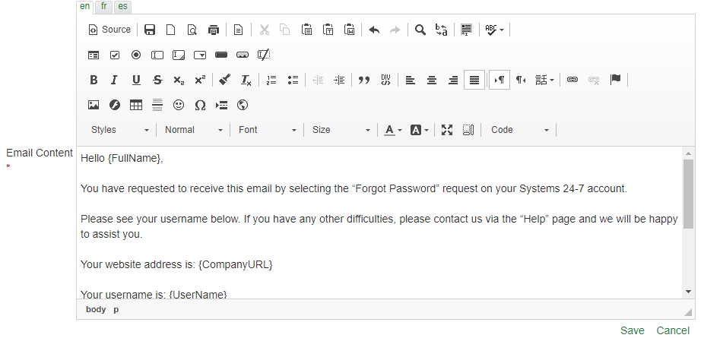
Note: The email templates use short codes such as {FullName} to dynamically populate system data. To see the list of available short codes to use in the email template you are editing, click the Code drop down list in the content editor:
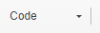
Make any necessary changes necessary to the email in the content editor and click Save. You can click the Cancel button to return to the Manage Email Messages page without saving your changes.

Email Templates
There are several system default email templates that you can customize:

Course Has Expired
To configure this email template, select Training from the Feature drop down list.
This email is sent to users on the date that a course they previously completed has expired, and includes a list of all expired training courses for that user.
As this template is sent out once on the date that a course expires, the Time Frame and Frequency fields are not editable.

Course Expiring Soon
To configure this email template, select Training from the Feature drop down list.
This email is sent to users that have courses that will expire within a specified time frame.

Account Forgot Username
To configure this email template, select Forgot Password from the Feature drop down list.
This email is sent to users as part of the Forgot your Password function. Users click this button on the login page, enter their email address, and click Send. Once they have done this, this email is sent to them, along with the Account Forgot Password email.
As this template is sent out immediately, the Time Frame and Frequency fields are not editable. The Failed Email Redirect option is also disabled for this email template, as the Forgot your Password function will not work if the user does not enter a valid email address.

Account Forgot Password
To configure this email template, select Forgot Password from the Feature drop down list.
This email is sent to users as part of the Forgot your Password function. Users click this button on the login page, enter their email address, and click Send. Once they have done this, this email is sent to them, along with the Account Forgot Username email.
As this template is sent out immediately, the Time Frame and Frequency fields are not editable. The Failed Email Redirect option is also disabled for this email template, as the Forgot your Password function will not work if the user does not enter a valid email address.

New Account Username
To configure this email template, select New Account from the Feature drop down list.
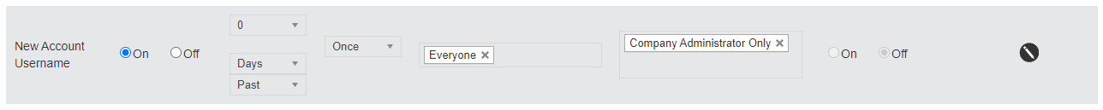
This email, along with the New Account Password email, is sent when a new user is added using the Add Employee function, if the administrator selected the option to send the employee their username and password in an email.
As this template is sent out immediately, the Time Frame and Frequency fields are not editable. The Failed Email Redirect option is also disabled for this email template, as a valid email address is required for this function.

New Account Password
To configure this email template, select New Account from the Feature drop down list.
This email, along with the New Account Username email, is sent when a new user is added using the Add Employee function, if the administrator selected the option to send the employee their username and password in an email.
As this template is sent out immediately, the Time Frame and Frequency fields are not editable. The Failed Email Redirect option is also disabled for this email template, as a valid email address is required for this function.

