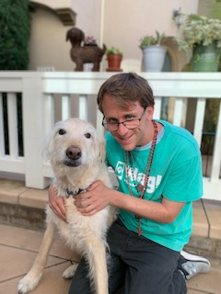

I want to Walk Your Dog!

I am a Dog Walker with Wag! I have started walking dogs when I was a child since 11 years old for four years in my former local community. There in my community, I also have bathed dogs as a Dog Bather for two Dog Grooming businesses for a total of 6 or 7 years. It has been awhile since I walked dogs, but I do remember all of my dog skills. I love being around dogs and grew up with having them all my life.
-----------------------------------------------------------------------------------------
Thought I am now currently a preschool student teacher, I devote half of my delocated life towards the care of dogs.

*HAPPY EASTER!*

Email Austin Mckinney @
austin.mckinney90@gmail.com
OR
(858)243.8792
Use code: AUSTIN04857

