How to register “Online Education Fair Korea 2016”
- Visit “www.studyinkorea.go.kr”
- Click “Online Education Fair Korea 2016”
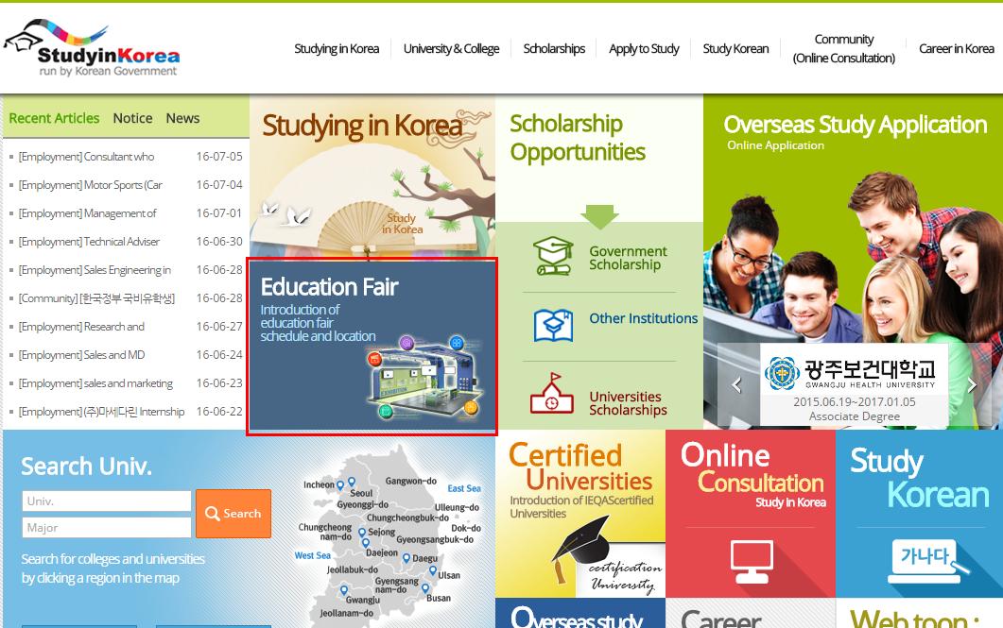
- Click “Registration” to join the Fair. For those who completed the registration, we will send a range of information about Studying in Korea by email.

- During the education fair period (July 18th - 29th), click “details” to join the Fair.
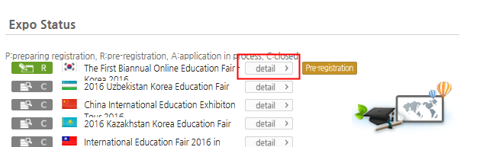
- Click icons to see the details.
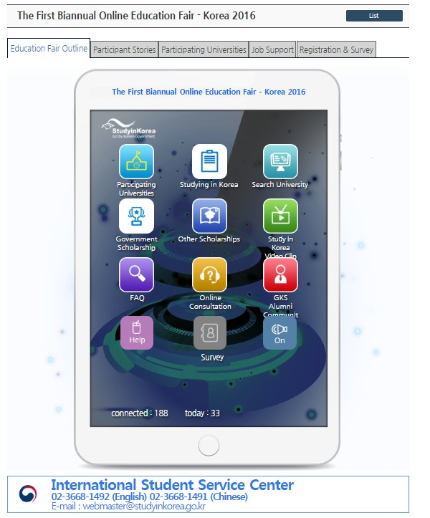
- Click the icon ‘Participating universities’ to check Korean universities.
- Click the ‘Introduction’ button to check details about the university you are interested in.
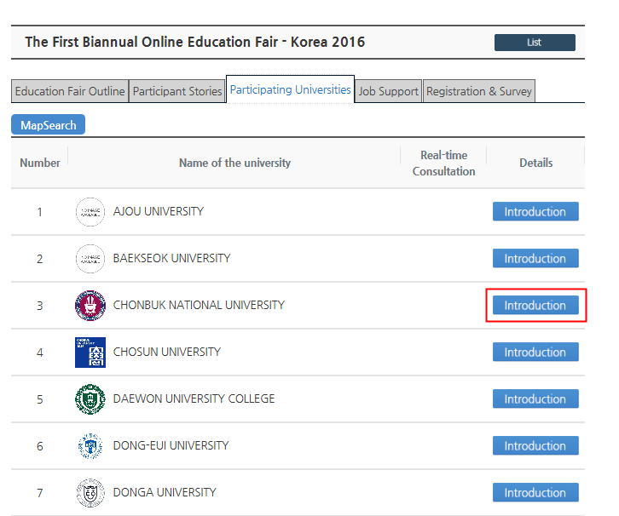
- Click icons to check the details.
