The London Fascist Summit, 1935
Study Guide
SMUN 2019

Greetings Delegates, and Welcome to the London Fascist Summit, 1935
It gives the Executive Board an honour to have you at SMUN 2019. The London Fascist Summit has one primary goal : to unify a movement that is inherently impossible to unify. Fascism was born out of hatred for Communism, but as a strong alternative to the Capitalist West. For Fascist supporters, it was the middle ground. Between two evils, the USSR and the USA.
This committee aims to test parties. Every single Delegation in this committee has a certain Policy. It may not be in line with some of their allies, but the very existence of said policy is to be adhered to. Contrary to popular opinion, Foreign Policy ​does ​matter. Deviances are understood based on the circumstances, but a deviance from policy (foreign or domestic) without just reasoning or the demand of circumstance, is not looked upon favourably. Therefore, I would urge each Delegation to do their due research, discover their party stance, and most importantly, justify all actions.
I can assure you that the Executive Board for this simulation of the Fascist Summit is more than capable to handle this committee. With a combined experience of over 50 Conferences, you can trust that you are in safe hands. We do, however, understand that this Background Guide is extremely lengthy and detailed, but this is due to the complexity of the actual situation that transpired in those fateful years in the 1930s. The Executive Board would consider it a great insult to the thousands of people who gave their lives fighting Fascism if the matter was unjustly simplified.
Hence, the original complexity is maintained and we express our unwavering hope that the Delegates will understand our reasoning for the same.
It is also important to note that though this Committee will see you step into the shoes of the Fascist Parties of Europe and the World, it is important to remember that the very same parties were the ones that orchestrated the killing of millions of political opponents, jews, and other minorities. The Executive Board, would therefore appeal to the delegates to keep this fact in their mind as they go about their research and Committee.
Looking forward to seeing you at SMUN 2019,
Adnaan Naveet Zoya Zahed
Chairperson Vice Chairperson

How to use the Study Guide?
Delegates, attached below is a comprehensive, in depth analysis of the current Geo political scenario of the world in 1935. Every single party in attendance of the London Fascist Summit has a detailed brief. For this reason, the length of this Study Guide is rather long. However, we urge you not to be dissuaded by the length, but rather consider this Study Guide as a majority of the research needed to understand committee.
What is the London Fascist Summit, 1935?
In December of 1934, 13 Fascist parties of Europe met in Montreux, in Switzerland, to discuss the possibility of creating a Fascist International, on the model of the Communist International, which was an international organisation that had been formed in 1919 after the dissolvement of Tsarist Russia and it’s replacement, the USSR. But unlike Communism, which was a movement that had stemmed from the writings of Karl Marx, Fascism had no common source material. Though there were (and are) differences in different types of Communism (such as the Communism followed by the USSR, which can be termed as Leninist, or the Communism followed by the PRC, Dengism), the end result of what Communism aims to achieve is the same: Equality in wealth amongst all people. Hence, The differences in Communism are not in the end, but in the means whereby which the end can be obtained.
It’s for that reason that the Fascist Summit at Montreux failed. Because of the very impossibility of the idea that Fascism could be reformed and made into a movement the way Communism was. This stems from the fact that Fascism was not created as a movement, but as isolated incidents. There was no writings such as those by Karl Marx to help understand what the core of Fascism was. And the differences between these isolated parties were far too strong to achieve anything fruitful. That is the reason this meeting has been called. Hosted by the British Union of Fascists (which shall be represented by the Executive Board), the London Fascist Summit is the last hope that Fascism has to put aside petty and minor differences, and unite and work together to make the entirety of the world Fascist.
This Summit in London will differ from the one held in Montreux. For starters, it shall be attended by 25 parties, and two international
Organisations. The NSDAP or the Nazi Party, the National Fascist Party (Italy) as well as the Imperial Way Faction will all be in attendance. Neither of the three had attended the summit in 1934, which could be another reason for said Summit’s failure. A representative of the League of Nations as well as the Communist International will also be present.
Perhaps the most important difference between the summit held in Montreux and the one to take place in London is the inclusion of Parties outside Europe, such as the Kuomintang and the Silver Legion of America. Attendees of the London Fascist Summit, 1935
Please note that the British Union of Fascists will be represented by the
Executive Board
Party | Country
The National Fascist Party | Italy

The Iron Guard | Romania
National Christian Party | Romania
The National Rally | Norway
The Greek National Socialist Party | Greece
The Falange Española de las JONS (Falange) | Spain
The Lithuanian Nationalist Union | Lithuania
The National Union | Portugal
The Fatherland Front | Austria
The NSDAP or Nazi Party | Germany
The Imperial Way Faction | Japan
The Kuomintang | China
The Yugoslav Radical Union | Yugoslavia
The Union of Actualists | Netherlands
The Silver Legion of America | USA
The Army Comrades Association | Ireland
The Indian Independence League | India
The National Party | South Africa
Rep. of the Communist International
Rep. of the League of Nations
The New Guard | Australia
Al Saud family | Saudi Arabia
Revolutionary Mexicanist Action | Mexico
La Cogule | France
Russian Fascist Party | Russia
Arrow Cross Party | Hungary
The Portuguese National Syndicalists | Portugal

What is a Crisis Committee? [SECTION 1.1]
A crisis committee is a non-conventional committee, which deals with a very volatile/hostile situation that needs to be addressed immediately. The UNGA Emergency Special Session is sometimes vaguely referred to as the conventional counterpart of a crisis committee, but owing to the lack of executive powers in an ESS and frequency of updates in a crisis committee, some may beg to differ. To speak of as such, a crisis committee is designed to test the problem-solving skills of a delegate, along with the diplomacy and attention to detail as the updates keep rolling in. While conventional committees are linear and set out to debate and deliberate upon a predetermined agenda, a crisis is some fluid, with constant updates that require delegates to adapt and use all the tools available to them(directives) to not only diffuse the crisis but to forward their own country.
In the case with the London Fascist Summit, each delegate shall be representing a particular party (The Fatherland Front, The Union of Actualists, etc.) instead of a country. This means that the delegation who is representing the Army Comrades Association of Ireland can use all the tools available to the Party (in this case party workers and other assets wielded by the Blueshirts) to its benefit. It is important to note that every
Party represented in the London Fascist Summit has their own motivations and goals, and it is important that delegations attempt to fulfil these as well as reach a consensus with the committee.

What is an Update? [SECTION 1.2]
In a crisis committee, a fictionalized crisis is presented, which the delegates are required to solve. The method the delegates chose to solve said crisis, however, is entirely up to them. In the London Fascist Summit of 1935, all Delegations shall assume the powers of their positions (i.e. they will be able to carry out any order, such as militaristic, economic, or political that their position entails. For e.g. The Delegate representing the Imperial way faction will have all powers of said party (or in this case, faction). The delegates utilize said powers by Directives [see SECTION 1.4] and based on the outcome of said Directives, Updates to the crisis are given by the Executive Board (EB) to the committee. The updates shall be based solely off the actions of the Delegates, and the quality of the Directives received.

Introduction to Directives [SECTION 1.4]
Each Portfolio being represented in the Fascist Summit has all the powers that their real life counterpart had. To elaborate, this means that Delegates can use their positions as Representatives of parties or organisations to impact and change the course of committee by utilizing the powers and resources of their portfolio. In the London Summit, you as delegates will have the power to utilize these resources by means of directives/ action orders. Directives are detailed documents that describe a Delegate’s plan of action with respect to the situation in the council. Directives are the means by which the Delegations can actually take action by detailing plans or operations that the delegation wishes to execute.
Please note that all directives will have consequences, sometimes positive and sometimes negative, based on the quality of said directive. Directives can be sent only when the Executive Board opens lines of communication. Directives are of the following types:
- Communiqués: Communiqués are statements that a group of portfolios shall make to the International Press. A minimum of one communique shall be required at the end of the conference to communicate the progress of the Summit to the International Press. While this might be considered as a Resolution, the communique does not require perambulatory/operative clauses and are merely a simple statement of facts about what the countries have decided to do after the end of the Summit.
- Directives: Directives (or action orders) are statements given in written to the EB that detail a plan or operation that a delegate wishes to undertake. As mentioned before, for Directives, the portfolio is granted all the powers of their real-world counterpart. Directives themselves are divided into different categories, which are:
  - Covert Directives: Covert Directives are Secret, and their contents shall not be divulged to the committee. Covert Directives include assassinations, war plans and other operations that a delegate would require confidentiality in doing.
  - Overt Directives: The content of overt directives shall be
shared with the committee, and these directives are most useful for all operations that are legal (economic reform, etc.)
Delegates, please note that the more detailed a directive, the better the possibility of it being successful. Below is the format for the directive.
Comments are in [] and in bold. Below is the format for a Directive:

Type of Directive: [Covert/Overt]

From: [If a Joint directive, multiple countries can be mentioned here]

To: The Executive Board

Objective:

Plan of Action: [Details of the operation, with specifics. All Resources used should either be available to all delegates (via the Internet, the
Crisis or the Map) or rational, informed guesses

Additional Information: [Maps for clarity, data in tables etc., optional]

Signature of the delegate(s):

Marking Scheme
Directives are marked in the London Summit on Five Criteria, which are:
- Plan
- Possibility
- Plausibility
- Details
- Execution
All Five Criteria are graded out of 3 marks, and an average is taken as the final marks for each directive.

Zones, Placements and Rules
A google sheets containing the Zone system shall be shared will all delegates. The Zones system will be a grading system whereby which the attendees of the London Fascist Summit can gauge their performance in committee. There shall be five zones, which are as follows
Zone [Colour] | Ranking in committee
 | Top Five Delegations
 | Delegations between Six and Ten
 | Delegations between Ten and Fifteen
 | Delegations between Fifteen and Twenty
 | Bottom Seven Delegations
The Google sheets will be updated with the zones at the end of every Committee Session, and can be viewed by all delegates. Furthermore, the marking sheets for the Committee will also be shared at the end of the Conference to ensure transparency between the Executive Board.
Please note that movement between the different Zones is very likely and the zones should only be used as a rough indicator of the position the delegate holds, and not the actual Placement/award he/she is going to win. Also, the individual rankings inside each zone are not released, i.e. a delegate in the Green zone will not know whether he is 1st in committee or 5th. The zones are only a general indicator of a delegate’s performance.
The Placements for the London Fascist Summit, 1935 shall be:
1 Best Delegate
1 Honourable Delegate
1 Commendable Delegate
As many Special mentions as deemed fit by the Executive Board
Please note that while the Best Delegate, Honourable Delegate and Commendable Delegate will be awarded on the basis of the points and by extension, the same zone (the Green zone, as they will be a part of the top Five delegations in committee), the Special mentions awards can be granted to any delegation that the Executive board sees fit. This means that delegations from all zones, not restricted to the Green zone can win this award.
In regard to the criteria for Awards, please note that if the Organising Committee disqualifies a delegation, they will not be able to win awards in this committee. Hence, it is recommended that the rules of SMUN 2019 are adhered to.

Position Papers and Pre-Written Directives
A mandatory position paper must be emailed prior to the conference to fascistsummitsmun19@gmail.com​. In addition, a Prewritten Directive may optionally be sent in to the same email. Please note that the two must be on seperate documents and must follow their respective formats (For position papers, see Guidelines for Position Papers; For Pre Written Directives, see the format established in SECTION 1.4)
Please note that failure to send in the Position Papers will result in Disqualification from awards.

Guidelines for Position Papers
Please note that all Position papers must be typed in ​Times New Roman font, with font size at ​12 and line spacing at ​1.5​. These Guidelines are to be followed, and if they are not, will result in negative marking.
The position paper must mandatorily consist of:
- A general Introduction to the Party represented by the Delegation
- The Questions of Fascism, which are each to be subjectively answered:
○ Is antisemitism an essential facet of Fascism?
○ Should Fascism abide by democracy? Can the two exist together in a nation?
○ Should there be an International Organisation to govern all Fascist Nations?
- Any other General Comments

The Attendees

The National Fascist Party , Italy
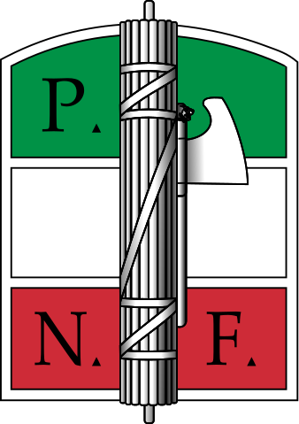
On the 7th of November, 1917, a new state was created out of the shell of the former glorious Tsarist Russia. This new state, which had just survived the long and tumultuous Russian Civil war, had established for the first time, a Communist Nation in the world. Never before had the works of Karl Marx been taken so seriously as it was when this new USSR was founded. This resulted in large populations of the world becoming more
“leftist” or sympathetic to the Socialist Cause. As Mussolini said in an Interview in ​Gerarchia ​On february 25th, 1922,
“Which Way Is the World Going? … Right or Left? … In the aftermath of the Armistice, the pendulum swung Left … with a vertiginous speed … There is no doubt that the end of 1920 marks in the whole of Europe the climax of the social crisis of the Left.”
What Mussolini was rightfully observing, was the shift of the world (as described as a pendulum) after the Armistice that ended the Great War, to more Communist or Socialist ends. As the leader of a Far Right party (As of then, the Revolutionary Fascist Party or the Partito Fascista Rivoluzionario) Mussolini opposed this shift to Communism. In Italy too, there was a large and visible support for the Leftist parties that had emerged, taking advantage of the establishment of the Soviet Union.
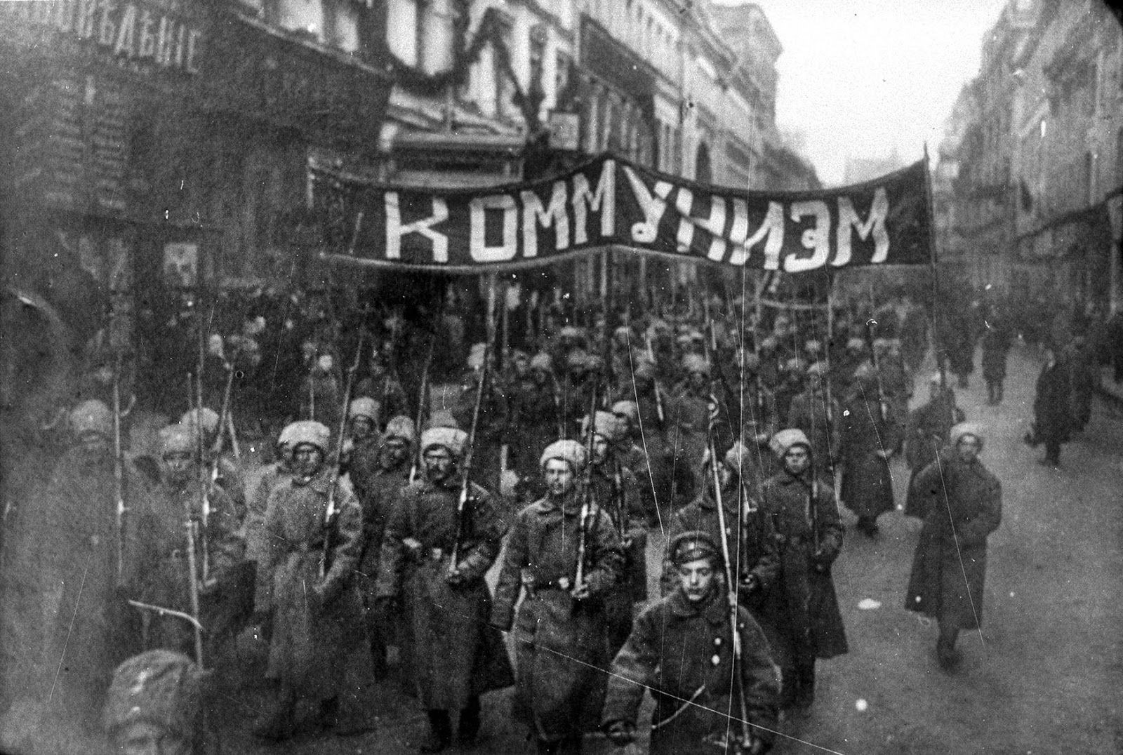
The Russian Revolution, pictured above, was the first time a mass scale revolution had been successfully carried out on the Hopes of creating a Socialist Country. This revolution sent shockwaves throughout the world, with Democratic nations fearing similar uprisings.
But Mussolini was able to achieve the near impossible. He managed to change the tide, swinging the Pendulum from the Far left into the Far right. The years immediately after the Bolshevik revolution came to be known as the Biennio Rosso or Red in Italy. In these years, it seemed almost likely that the Italian Socialist Party would form the majority in Government in the next elections. But two major events took place between the High wave of the Biennio Rosso and the 1921 General Elections. Those were:
- The Socialist Party split, with a group of more extreme Leftists forming the Communist Party of Italy or the Partito Comunista d'Italia(PCd'I). This split hurt the Socialist party, with the mass populace being split between two alternatives to the Traditional Democratic Party (in this case, the People's Party)
- The second major event that turned the tide against the Socialist Party was the formation of the National Blocs (Blocchi Nazionali) by a large number of far right parties including:
  - The Italian Liberal Party, led by former five time Prime Minister, Giovanni Giolitti who, scared by the mass appeal of the Socialist Party, had decided to form the National Blocs with the far right parties in order to attempt to win power;
  - The Itali Fasci of Combat (which was renamed into the Italian
Fascist Party), led by Benito Mussolini;
  - other Nationalist Parties such as the Italian Nationalist Association.
These two events proved fatal for the Socialists. The elections saw them losing 33 seats instead of gaining them, and The new government was formed by the People’s Party, and the Socialists were forced to be the Opposition. The election results for the major parties were:
Colour | Party | Votes | Percentage | Seats won
 | Italian Socialist Party | 1,631,435 | 24.7 | 123
 | Italian People's Party | 1,347,305 | 20.4 | 108
 | National Blocs | 1,260,007 | 19.1 | 105
 | Communist Party of Italy | 304,719 | 4.6 | 15
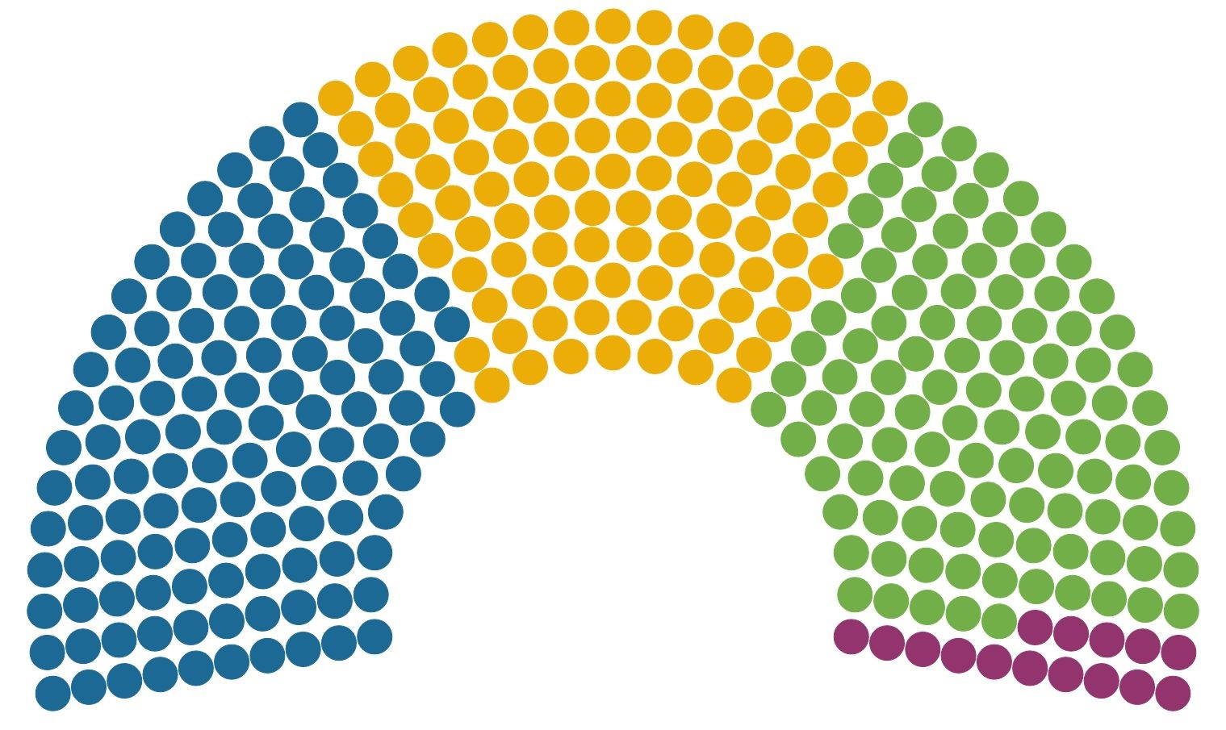
For now, due to the combined efforts of the Socialists, the Communists and the Fascists, Democracy was safe in Italy. This would not be for long, however, as Mussolini was about to launch his final attack on Democracy in Italy. And this time, he would win.
As Mussolini himself stated,
“Fascism rejects both their (Democracy’s) premises and their practical applications and implements. Fascism denies that numbers, as such, can be the determining factor in human society; it denies the right of numbers to govern by means of periodical consultations; it asserts the irremediable and fertile and beneficent inequality of men who cannot be leveled by any such mechanical and extrinsic device as universal suffrage”
The time had now come for this movement, which was so ill defined that it was everything and nothing at the same time, would define itself as the far right, nationalistic party that we know today. To understand how Mussolini rose to power in 1922, it is first important that we establish the importance of the ​Arditi ​in Italy.
The Arditi were a branch of the Italian army during World War 1 who were world renowned for being the First “Special Forces”. Though they were disbanded in 1920, their impact upon the Italian psyche was permanent.Their motto was O la vittoria, o tutti accoppati meaning "Either victory, or everyone dies".The typical unit had 13 officers and 400 soldiers selected on a voluntary basis. One such unit was completely wiped out while attacking Monte Osvaldo in April 1916.
In 1916 the supreme command decided to award special status to Arditi units but was reluctant to create new units.The Arditi badge, to be carried on the left arm, included the monogram VE (for Victor Emmanuel III of Italy), and was designed exclusively as a symbol of distinction for these soldiers. This was the first official use of the word "Ardito" by the Italian army. The Italian people adored the Arditi, and in order to take advantage of this fame, Mussolini adopted the outfit of the Arditi into what he called the “Milizia Volontaria per la Sicurezza Nazionale (MVSN, "Voluntary Militia for National Security") or in simple terms, Blackshirts. When Mussolini created this organisation, he paid homage to the Arditi by copying their uniforms, and even their logo. This paid tremendously for the party, and this paramilitary wing grew in large numbers. The majority (though not all³) of former Arditi soldiers joined the Blackshirts, and by 1923, their numbers were over 30,000.
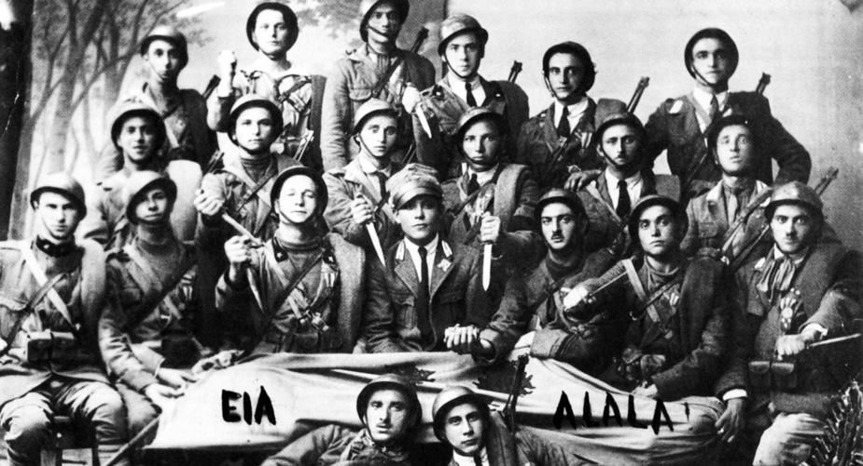
Pictured above are the original Arditi, specialist soldiers who fought for Italy. Mussolini captured on the patriotism attached with the Arditi by using their signature black uniforms to create his own private army, which were known as the Blackshirts.
Days before the now infamous March on Rome, Mussolini stated:
"Our program is simple: we want to rule Italy."⁴
Five days later, Mussolini was asked to form the government by the King, Victor Emmanuel⁵. He was then made the president of the Council, but Fascist Italy was not the dictatorship that we now know yet. That happened in 1924, after the assasination of a senior socialist who had condemned Fascism. The Socialists walked out of the Parliament in protest, granting Mussolini the power to establish his authoritarian agenda. Over the next four years, Mussolini eliminated nearly all checks and balances on his power. In 1926, Mussolini passed a law that declared he

³4 ​Several former Arditi members joined the Arditi del Popolo, a militant leftist group formed in 1921 ​24th October, 1922 to the Fascist Congress at Naples
⁵ ​In accordance with Statuto Albertino, the King can ask any Political leader to form the Government
was responsible only to the King and made him the sole person able to determine Parliament's agenda. Local autonomy was swept away; he appointed ​podestas ​and ​replaced communal mayors and councils. Soon after all other parties were banned in 1928, parliamentary elections were replaced by plebiscites in which the Grand Council nominated a single list of candidates. Mussolini wielded enormous political powers as the effective ruler of Italy. The King was a figurehead and handled ceremonial roles. However, he retained the power to dismiss the Prime Minister on the advice of the Grand Council on paper, the only check on Mussolini's power—which is what happened in 1943.
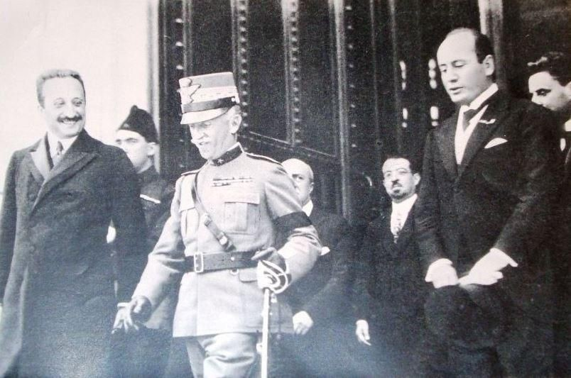
Pictured above is King Victor Emmanuel II, who, fearing a violent uprising by Mussolini and his blackshirts,
handed over power to Mussolini after the infamous March on Rome
During the reign of the Fascists in Italy, they conducted four major “battles”. Though they were supposed to help revitalise the economy and help transform Italy into a superpower, the battles were more important than merely helping the Italians: They were a mass propaganda operation to swing public support towards the Fascists.
In 1925, Mussolini began the Battle for Grain, effectively increasing import tariffs on bread so as to encourage Italian farmers to grow their own wheat and produce bread. The battle had four main reasons:
- To boost cereal production and thus make Italy self-sufficient in grain
- To reduce the balance of trade deficit
- To lower the necessity for foreign imports of bread and move towards autarky
- To show Italy as a major, self sufficient power
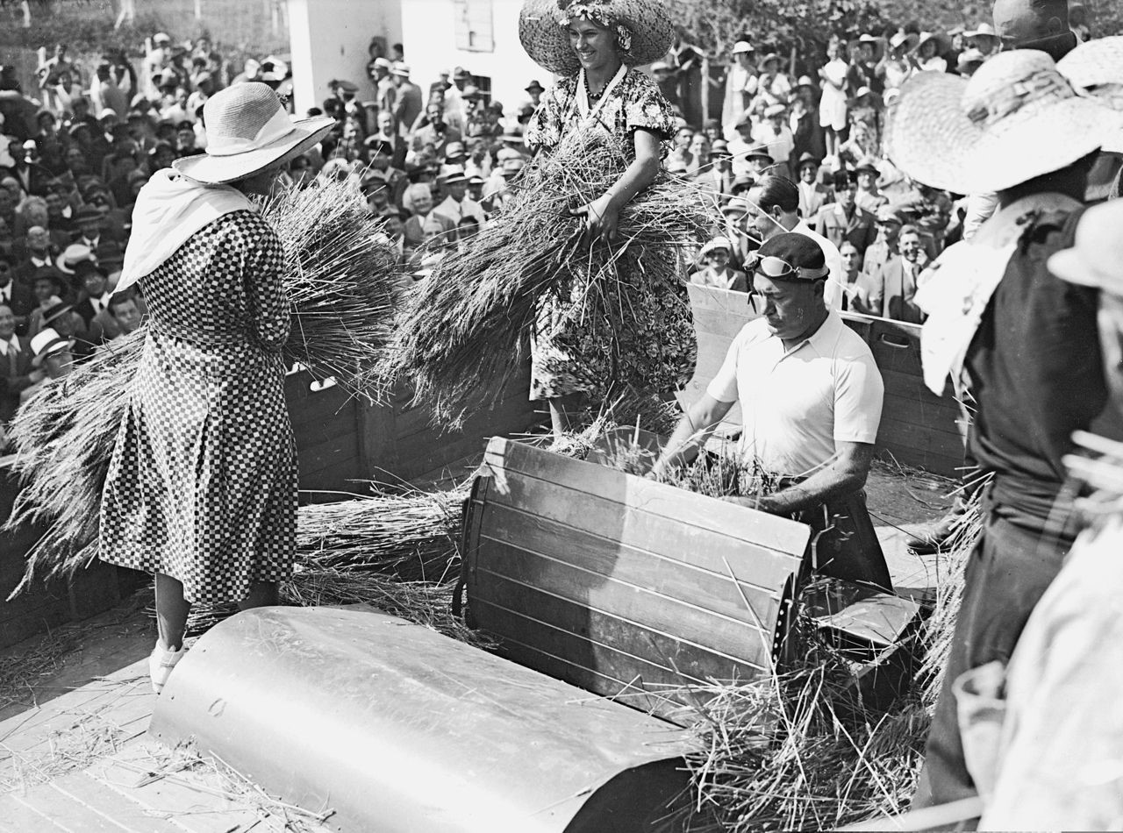
Pictured above is the Duce himself, Mussolini engaging with the public in a staged propaganda for the Battle for grain
The next year, the most controversial and important battle was launched, against the biggest barrier between Italy and its lofty ambitions of ruling the entirety of Southern Europe, the Lira. The Lira was the currency of post war Italy, and it had suffered a low value against the Pound Sterling (of Britain). In the month of July 1925, the Lira was pegged at a record high of 144.98. This rose to almost 155, and Mossolini, well aware of the fact that the Italian economy and by extension the Italian people deeply relied on this currency, took the controversial move to reevaluate the Lira, establishing it at 90 Lira to a Pound. After one year, the Lira had re-achieved full convertibility against gold through the Decree of 21st December 1927 and, at Quota Novanta, the exchange rate fixed against the British Pound. Revaluation triggered restrictive monetary measures, such as circulation limitation and credit cuts. Inflation was rampant following the battle for the Lira, and this battle, like the one for grain was a failure too.
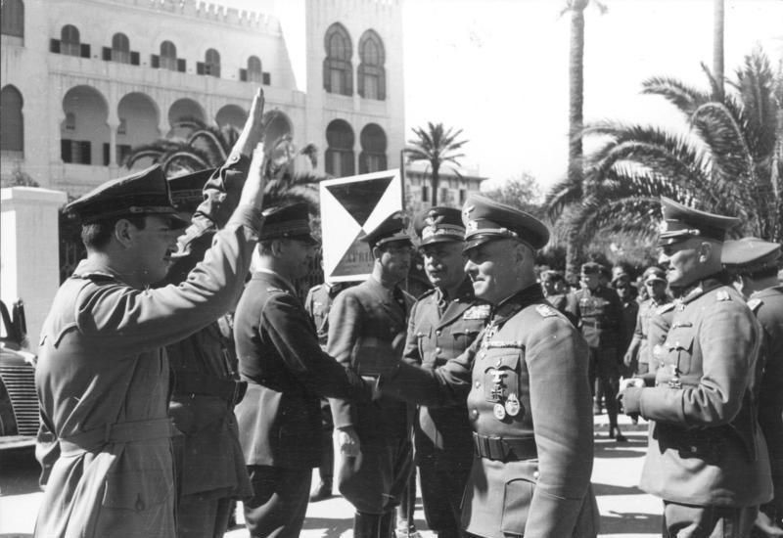
Pictured above is Mosolini meeting Army supporters after announcing the now infamous Battle for the Lira
The worldwide depression of the early 1930s hit Italy very hard starting in 1931. As industries came close to failure they were bought out by the banks in a largely illusory bail-out—the assets used to fund the purchases were largely worthless. This led to a financial crisis peaking in 1932 and major government intervention. After the bankruptcy of the Austrian Kredit Anstalt⁹ in May 1931, Italian banks followed, with the bankruptcy of the Banco di Milano, the Credito Italiano and Banca Commerciale. To support them, the state created three institutions funded by the Italian Treasure, with the first being the Sofindit¹⁰ in October 1931 (with a capital of 500 million Liras), which bought back all the industrial shares owned by the Banca Commerciale and other establishments in trouble. In November 1931 the IMI (capital of 500 million liras) was also created and it issued five and one-half billion liras in state obligations as reimbursables in a period of ten years. This new capital was lent to private industry for a maximum period of ten years. Finally, the Institute for Industrial Reconstruction (IRI) formed in January 1933 and took control of the bank-owned companies. At the end of 1933, it saved the Hydroelectric Society of Piemont, whose shares had fallen from 250 liras to 20 liras—while in September 1934, the Ansaldo trust was again reconstituted under the authority of the IRI, with a capital of 750 million liras. Despite this taking of control of private companies through (GLC), the Fascist state did not nationalize any company.

⁹10 ​For more details, see Lessons from the Credit-Anstalt Collapse By Peter Coy, Bloomberg Buissness week
Guido Montanari, Introduction to the Inventory of the Italian Industrial Financial Company (Sofindit), Milan, Banca Commerciale Italiana, 1991, pp. I-XLVIII
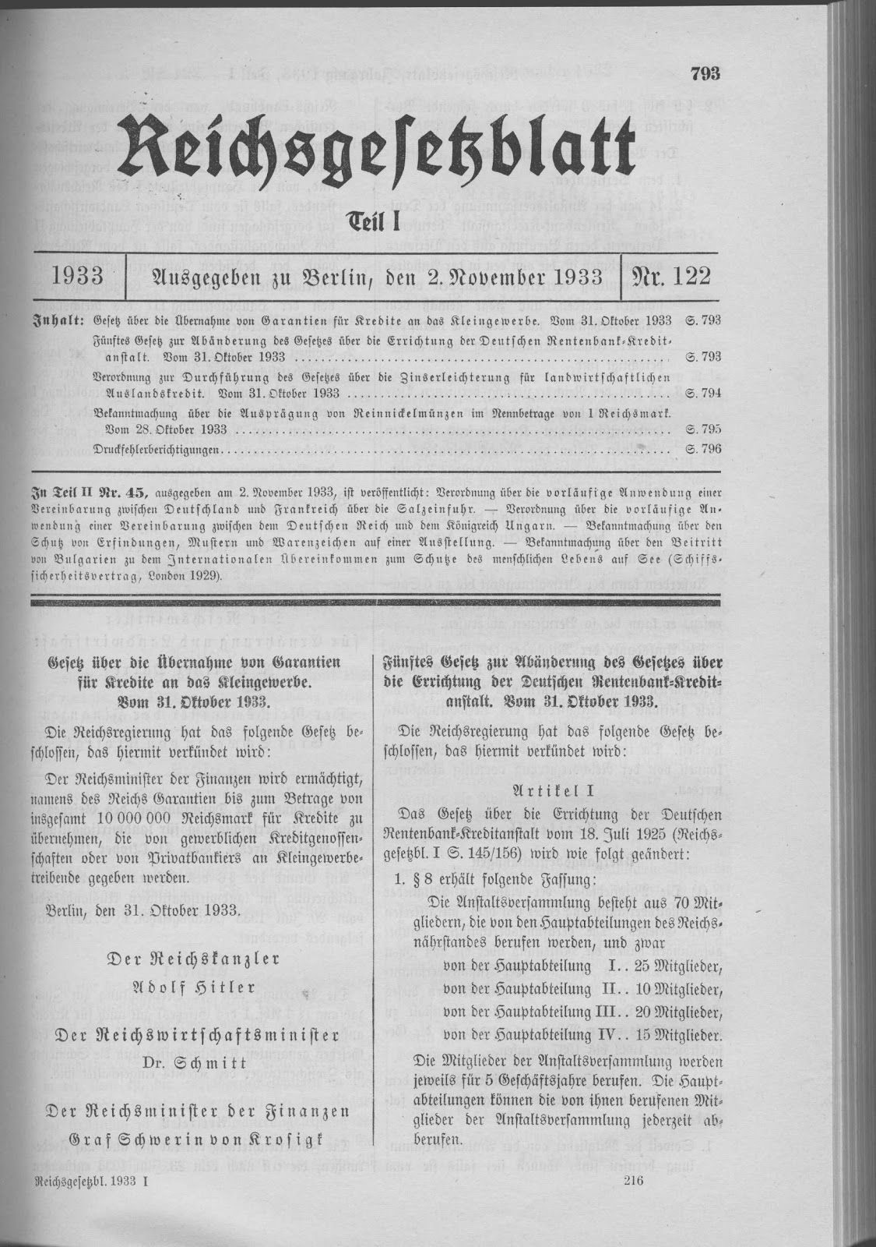
A German Newspaper describing the bankruptcy of the Austrian Kredit Anstalt, the first of a string of banks that would fall as a result of the Great Depression.
Not long after the creation of the Institute for Industrial Reconstruction,
Mussolini boasted in a 1934 speech to his Chamber of Deputies: "Three-fourths of the Italian economy, industrial and agricultural, is in the hands of the state". As Italy continued to nationalize its economy, the IRI "became the owner not only of the three most important Italian banks, which were clearly too big to fail, but also of the lion’s share of the Italian industries"
During this period, Mussolini identified his economic policies with "state capitalism" and "state socialism", which later was described as "economic dirigisme", an economic system where the state has the power to direct economic production and allocation of resources. The economic conditions in Italy, including institutions and corporations gave Mussolini sufficient power to engage with them as he could. Although there were economic issues in the country, the approaches used in addressing them in the fascist era included political intervention measures, which ultimately could not effectively solve the strife. An already bad situation ended up being worse since the solutions presented were largely intended to increase political power as opposed to helping the affected citizens.These measures played a critical role in aggravating the conditions of the Great Depression in Italy.
X- Believe, Obey, Fight -X

The National Rally, Norway
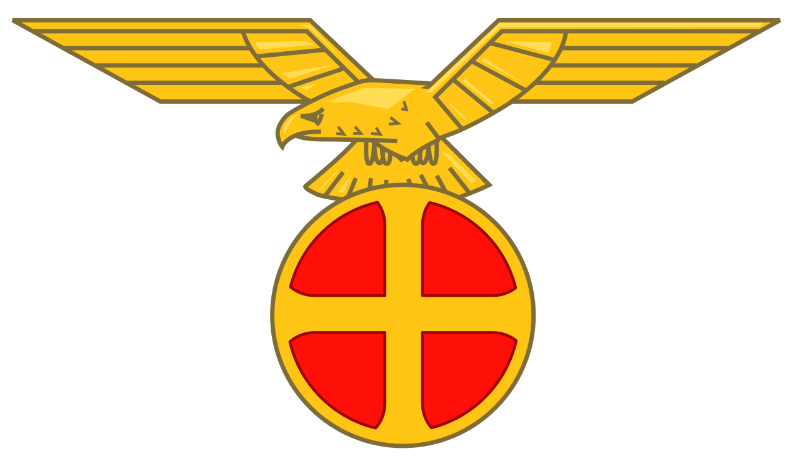
When the Great Depression hit the world, several European countries were the worst hit. lt. The depression had hit worldwide in 1929 and blame for the economic crash fell on the ruling Government, which was lead by the Labor party, which had gained popularity at the end of the 1920s. The Prime Minister, Johan Ludwig Mowinckel had been elected in 1928 but in 1931 was overthrown by the Agrarian Party under the leadership of the new Prime Minister, Peder Ludvik Kolstad. Vidkun Quisling, a relative political novice, was appointed his Defence Minister. Following Kolstad's death in March 1932, Quisling retained his post as defence minister in the second Agrarian government under Jens Hundseid for political reasons, though they remained in bitter opposition throughout.
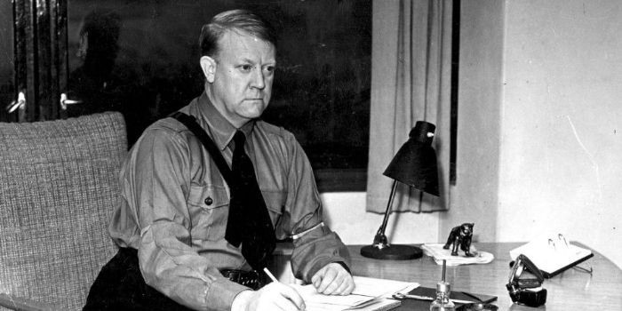
Pictured above is Vidkun Quisling, who was appointed as the Minister Of Defence after the 1929 elections. He later formed the National Rally of Norway in 1933
In March of 1933, the Liberal Party, which the Agrarian Party had beaten in the 1929 elections to gain power were able to dissolve the Government and establish their own, thus removing Quisling from his much wanted job as Defence Minister. Quisling then left the Agrarian party and formed his own rightist party known as the National Rally or Nasjonal Samling. In the 1933 Norweigian Parliamentary Elections, the results were as follows:
Colour | Party | Votes | Percentage | Seat Share
 | Labour Party | 500,526 | 40.01 | 69
 | Agrarian Party | 173,643 | 13.9 | 23
 | National Rally | 27,850 | 2.2 | 0
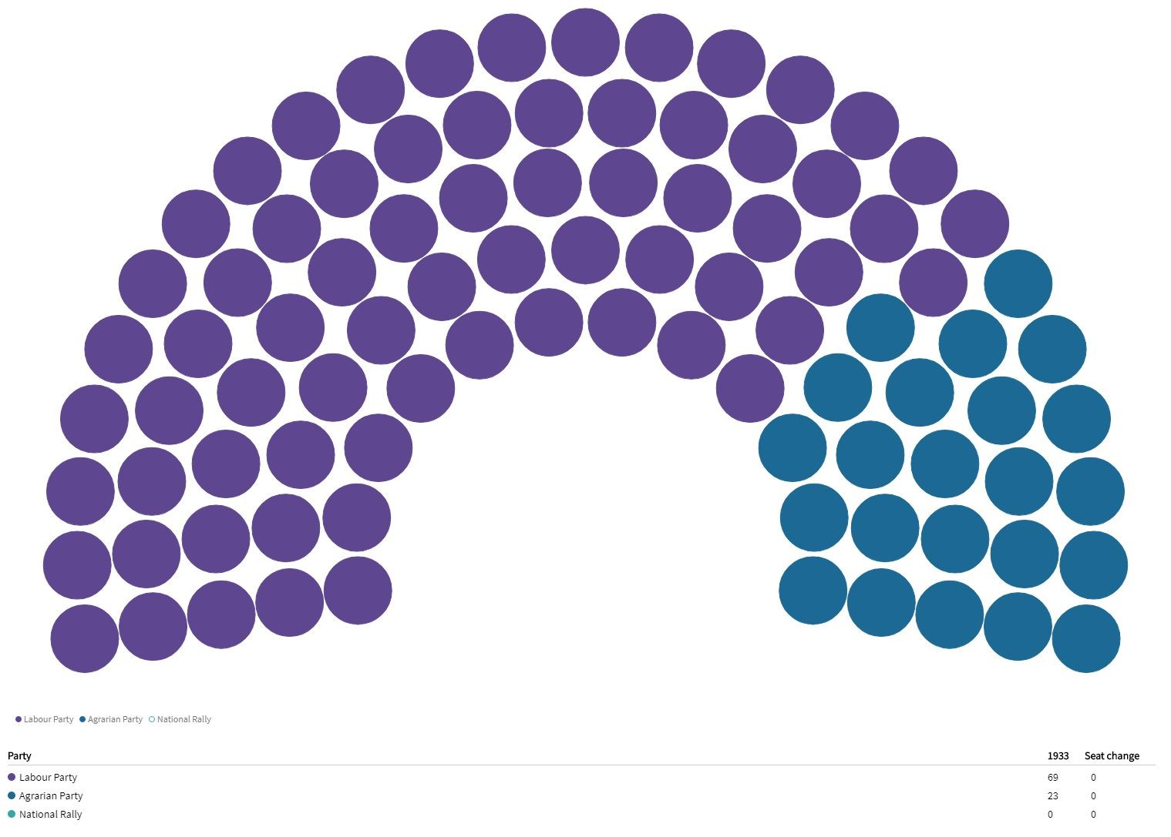
Quisling began to familiarise himself with the international fascist movement, attending the 1934 Montreux Fascist conference in December. For his party, the association with Italian fascism could not have come at a worse time, so soon after headlines of illegal Italian incursions into Abyssinia.
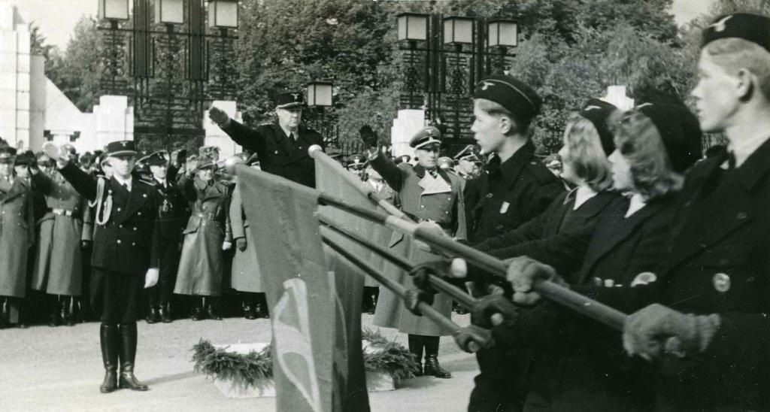
The National Rally was created on the basis of the Nazi Party of Germany, and for that reaon, shared several common feautures with the NSDAP.
On his return trip from Montreux, he met Nazi ideologue and foreign policy theorist Alfred Rosenberg, and though he preferred to see his own policies as a synthesis of Italian fascism and German Nazism, he Quisling had in part become the "Norwegian Hitler" that his opponents had long accused him of being. Part of this was due to his hardening anti-Semitic stance, associating Judaism with Marxism, liberalism and, increasingly, anything else he found objectionable, and part as a result of Nasjonal Samling's growing similarity to the German Nazi Party.
X- Health and Happiness -X

The Imperial Way Faction, Japan
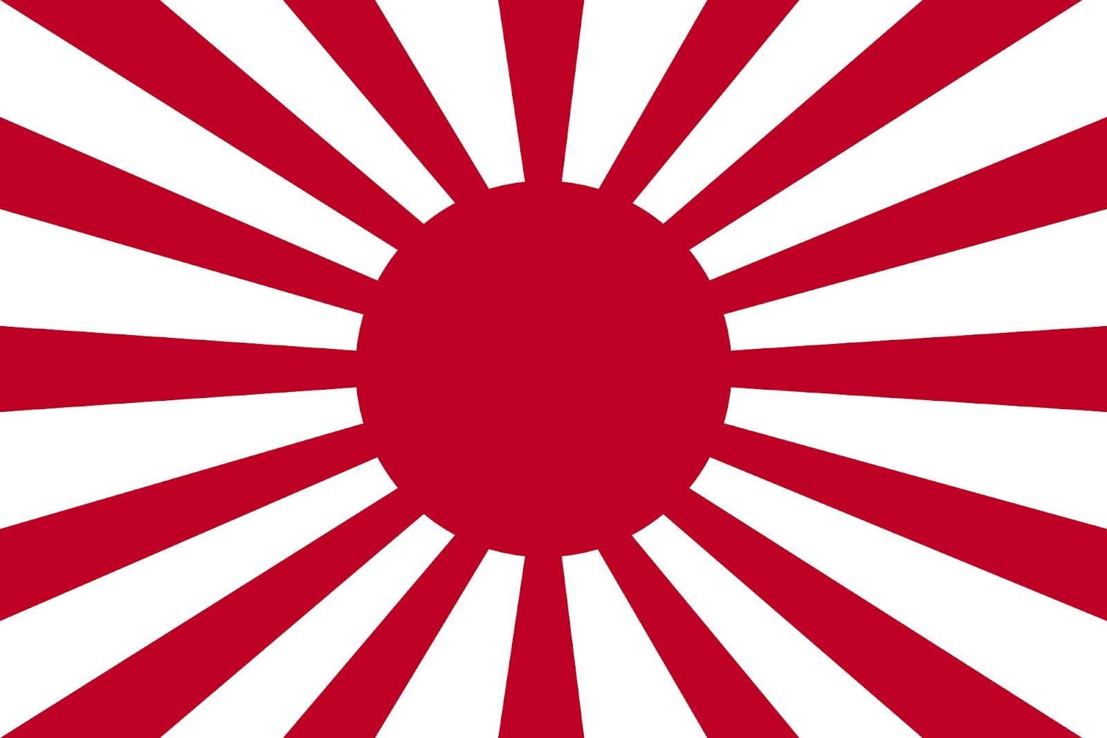
In order to understand the Imperial Way faction of Japan, known as Kōdōha, it is important to know it’s main propagator ,Sadao Araki, descendant of the legendary Tokugawa shogunate, which ruled Feudal Japan for over 200 years during the Edo Period¹² was a General in Japan.
He was made War Minister under Prime Minister Inukai Tsuyoshiin 1931. But when the Prime Minister was assassinated in 1932¹³, Araki supported the assassins. It seemed as though the Armed forces wanted to take over the Government, and fearing the same, a close advisor to the king, Saionji Kinmochi (also the last Genrō¹⁴ of Japan) appointed a senior Naval Officer as Prime Minister. Araki maintained his position as War Minister, and it was under him that the new Amau Doctrine ​ was announced.​
Parallels can be drawn between the Amau Doctrine and the Monroe Doctrine¹⁵ as they both attempted to establish spheres of Influence for both

¹²For more details, see Totman, Conrad. The Collapse of the Tokugawa Bakufu, 1862–1868. Honolulu:
University of Hawai'i Press, 1980. Totman, Conrad. Politics in the Tokugawa Bakufu, 1600–1843. Cambridge:
Harvard University Press, 1967. Waswo, Ann Modern Japanese Society 1868–1994 The Center for East Asian
Cultural Studies Meiji Japan Through Contemporary Sources, Volume Two 1844–1882
¹³Inukai was assassinated by ultra-nationalist navy officers for resisting the Army's war demands. Araki supported the assassins, calling them "irrepressible patriots"
¹⁴Omura, Bunji (2004) [1937]. The Last Genro: Prince Saionji, Japan's "Grand Old Man". Kegan Paul
¹⁵Announced by President James Monroe in 1823 where he stated that any European Interference in the
Americas would result in the "the manifestation of an unfriendly disposition toward the United States”.
countries, the Americas for the USA and East Asia for Japan.The context was the depression of the 30s, when Japan lost a substantial amount of its trade as a result of international trade barriers. The Doctrine was chiefly intended to convert the then feeble China into a client state and to establish Japan as the dominant power in the Pacific while containing Russia, resurgent then as now. For Japan, China was the main source of raw materials, as well as possessing tremendous strategic importance in its struggle with Russia. In the Amau Doctrine, Japan also declared that China does not have the right to seek foreign assistance or to resist Japan in establishing a new order under the aegis of an East Asian League and furthermore, that any third parties involved in China would have to consult Japan.
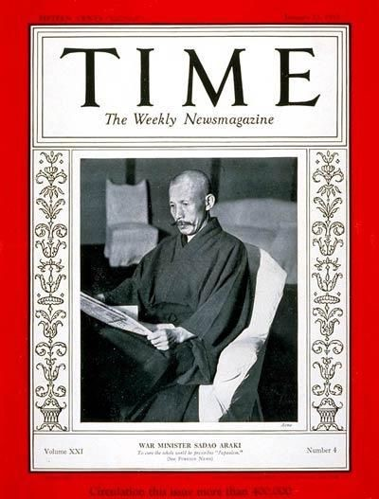
Above is ​Time ​Magazine’s cover featuring War Minister Sadao Araki as it’s Man of the year. Araki was the main propagator of the Amau doctrine, and was the leader of the Imperial way faction.
Historians believe that the policy emerged out of Japan’s nervousness of the increased Soviet presence on the Manchukuoan frontier In addition, the
Amau Doctrine directly challenged the so-called Open Door policy, under which many other powers, including Britain and the United States, enjoyed special economic privileges in China. The Kōdōha envisioned a return to an idealized pre-industrialized, pre-westernized Japan, in which the state was to be purged of corrupt bureaucrats, opportunistic politicians, and greedy zaibatsu capitalists. The state would be run directly by Emperor Hirohito in a "Shōwa Restoration" assisted by the military. Domestically, the state would return to the traditional values of Japan, and externally, war with the Soviet Union was not only unavoidable, but necessary to eliminate the threat posed by communism.In a news conference in September 1932, Araki first mentioned the word "Kōdōha" ("The Imperial Way"), from which his movement received its popular name.
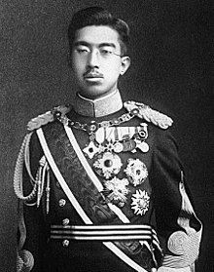
Pictured above is Emperor Hirohito, the official head of State of Japan
The main opposition to the Imperial Way faction was the Control Faction, which was created out of opposition to the existing Imperial Way Faction. Rather than the confrontational approach of the Kōdōha, which wanted to bring about the Showa Restoration through violence and revolution, the Tōseiha sought reform by working within the existing system. The Tōseiha foresaw that a future war would be a total war, and to maximize Japan's industrial and military capacity would require the cooperation of Japan's bureaucracy and the zaibatsu conglomerates which the Kōdōha despised. The Kōdōha was strongly supportive of the hokushin-ron ("Northern
Expansion Doctrine") strategy of a preemptive strike against the Soviet Union, believing that Siberia was in Japan's sphere of interest; although there were supporters of the Northern Expansion in the Tōseiha, the faction largely favored a more cautious defense expansion.
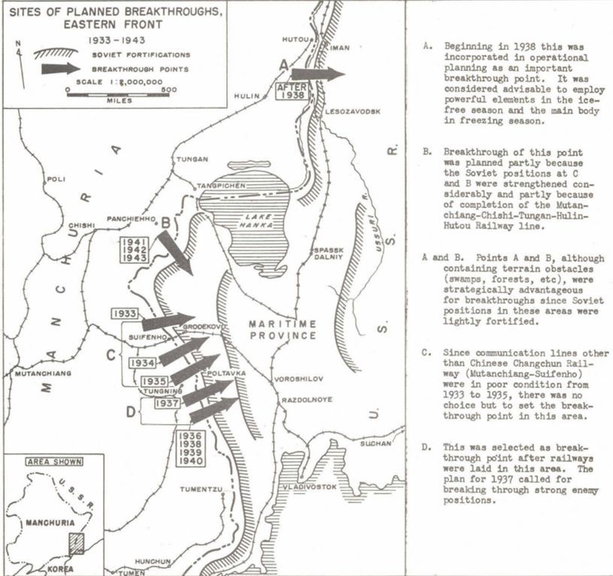
Pictured above is the Japanese plan of hokushin-ron, or Northern Expansion Doctrine, which called for a preemptive strike against the USSR
After the Manchurian Incident, the two cliques struggled against each other for dominance over the military.The Kōdōha was initially dominant; however, after the resignation of Araki in 1934 due to ill health, the Kōdōha began to suffer a decline in its influence. Araki was replaced as Minister of War by General Senjūrō Hayashi, who had Tōseiha sympathies. In November 1934, the Kōdōha attempted to assassinate several important politicians who supported the Control Faction. The plan was discovered, and the Control faction was able to prevent it from happening. Now, welding tremendous power, including the War Ministry, the Tōseiha forced the resignation Jinzaburō Masaki, who was Araki’s protege and had helped set up the Kōdōha on the grounds that he was complicit in the planned attack by the Kōdōha.. The Kōdōha, in retaliation to the forced resignation of Masaki, murdered Tōseiha leader General Tetsuzan Nagata in the Aizawa Incident. Aizawa's military tribunal was held under the jurisdiction of the First Infantry Division in Tokyo, whose commander, General Heisuke Yanagawa, was a member of the Kōdōha and follower of Araki. The trial thus became a vehicle by which the Kōdōha was able to denounce the Tōseiha, portray Aizawa as a selfless patriot, and Nagata as an unprincipled power-mad schemer.
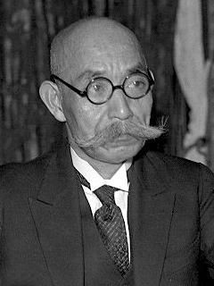
General Senjūrō Hayashi, the replacement war minister after the death of Sadao Araki, who was the founder of the Kōdōha. Hayashi was a member of the Tōseiha faction.
For the sake of clarity, understanding the complex names of the people and factions discussed, a summary of the names may be needed.
Name | Position
Sadao Araki | Founder of the Kōdōha faction.
Inukai Tsuyoshiin | Prime Minister of Japan between 1931-1932
Saionji Kinmochi | Last Genrō and close Advisor to the King
Senjūrō Hayashi | The Tōseiha member who replaced Araki as War Minister in 1934
Tetsuzan Nagata | Leader of the Tōseiha, assassinated by the Kōdōha
Heisuke Yanagawa | General of the First Infantry  Division in Tokyo, where the  Aizawa Incident was judged by a tribunal. Member of the Kōdōha

The Silver Legion, The United States of America
L​oyalty to the United States, ​L​iberation from materialism, and ​L​oyalty to the Silver Legion were the three sources for the Logo of the Silver Legion: a large, scarlet capital L that was embroidered on every white shirt, which itself had been modelled after Hitler’s Brownshirts and Mussolini’s blackshirts. It’s founder, William Dudley Pelley entered into politics when the Great Depression hit in 1929. He then started a newspaper known as the The League for Liberation (later renamed into just “Liberation” in 1932 when it became the official newspaper for the Silver Legion) and the Silver Legion Itself.
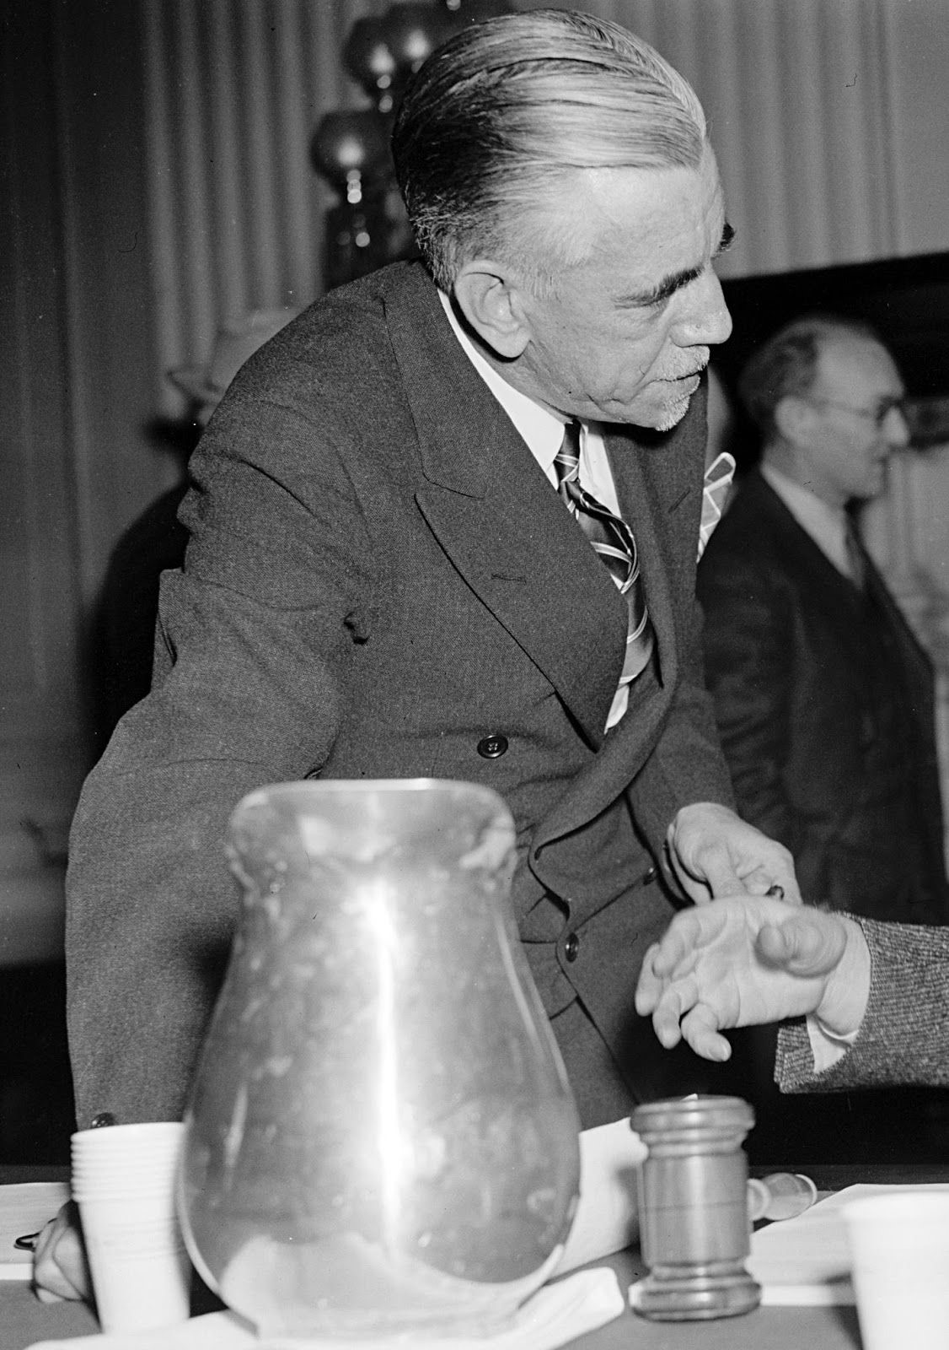
Pelly, pictured above was a renowned (though eccentric, he claimed to have met God and Jesus and had the ability to levitate) author
The Legion was modeled as a White Supremicist, Anti semetic
organisation, based strongly off of Hitler’s Nazi Party. In 1934, the Legion claimed to have over 14,000 members. They also constructed a new 33 acre Headquarters outside of California.
Pelly used the Liberation newspaper to spread large amounts of his propaganda, The material in each issue was composed of:
- Special attacks against the Jew, The nature of these attacks is indicated in the next section of this bulletin.
- Expositions of the Christ Democracy. The planks of Pelly’s Christ Democracy were:
  - A Referendum on all legislation. The government shall mail to every voter a digest of every bill passed by Congress, on which he is to vote "Aye" or "Nay". The legislation shall become effective only upon a 51% favorable vote, making the people legislators in fact and not merely in theory.
  - Opposition to anything socialistic or communistic.
  - The organization of the United States into a "Colossus Corporation". Every citizen shall be both a Common and Preferred Stockholder. Without equivocation and without any sentimentality "sometimes known as Tolerance", the debauchers within that social body will be emasculated and America reestablished on a basis where this spoliation can never again be repeated.
  - Only those from its own ranks, a Christian Militia, will be put into political office,
- A page by the Treasurer appealing for contributions and on other matters for extending the membership and subscribers.
By this, we can clearly establish the Silver Legion as an organisation that was vehemently Anti Semetic. This is additionally reinforced by Pelly’s writings in 1932 where he began to attack jews more viciously, calling them (the Jews) “ wicked and malignant spirits”.
He also gave three reasons for the enmity of the Silver Legion with jews, which are:
- The supposed “Jewish interference in Economic Life”
- The “Peculiar Business Code of the Jew”
- The “Jew's nomadic character, making him an internationalist whose ultimate objectives may well mean the destruction and
disappearance of the United States."²⁴
Pelly wished to “save” America in the same way "Mussolini and his Black
Shirts saved Italy and as Hitler and his Brown Shirts saved Germany”²⁵ Pelly, in the hopes of seizing power in a "silver revolution" and setting himself as dictator of the United States. He would be called "the Chief" just like other fascist world leaders who had similar titles such as "The
Fuhrer" for Adolf Hitler and "II Duce" for Benito Mussolini, decided to create his own Party, known as the Christain Party in order to contest in the 1936 Presidential Elections.

The Army Comrades Association, Ireland
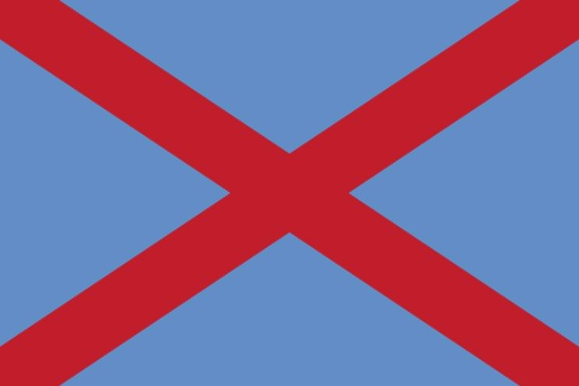
Great Britain, or as we know it, the United Kingdom consists of four smaller nation states all united (hence the name United Kingdom), England, Scotland, Wales and Ireland. Though the UK now only consists of England, Scotland and Wales and Northern Ireland (The north eastern part of Ireland), Ireland is now an independent nation. This is largely in thanks to the Irish war of Independence fought in 1919 to 1921. The War formally ended in 1921, when the Anglo Irish treaty was adopted, which granted Dominion status to the “Irish Free State”, with the Option for Northern Ireland to withdraw from this state and remain a part of Great Britain (which it did).Immediatly after the signing of the treaty, a civil war erupted in the country, known as the Irish Civil war. The civil war was waged between two opposing groups, the pro-treaty Provisional Government and the anti-treaty IRA, over the treaty. The forces of the Provisional Government (which became the Free State in December 1922) supported the Treaty, while the Republican opposition saw it as a betrayal of the Irish Republic (which had been proclaimed during the Easter Rising
27
). Many of those who fought on both sides in the conflict had been members of the Irish Republican Army (IRA) during the War of Independence.
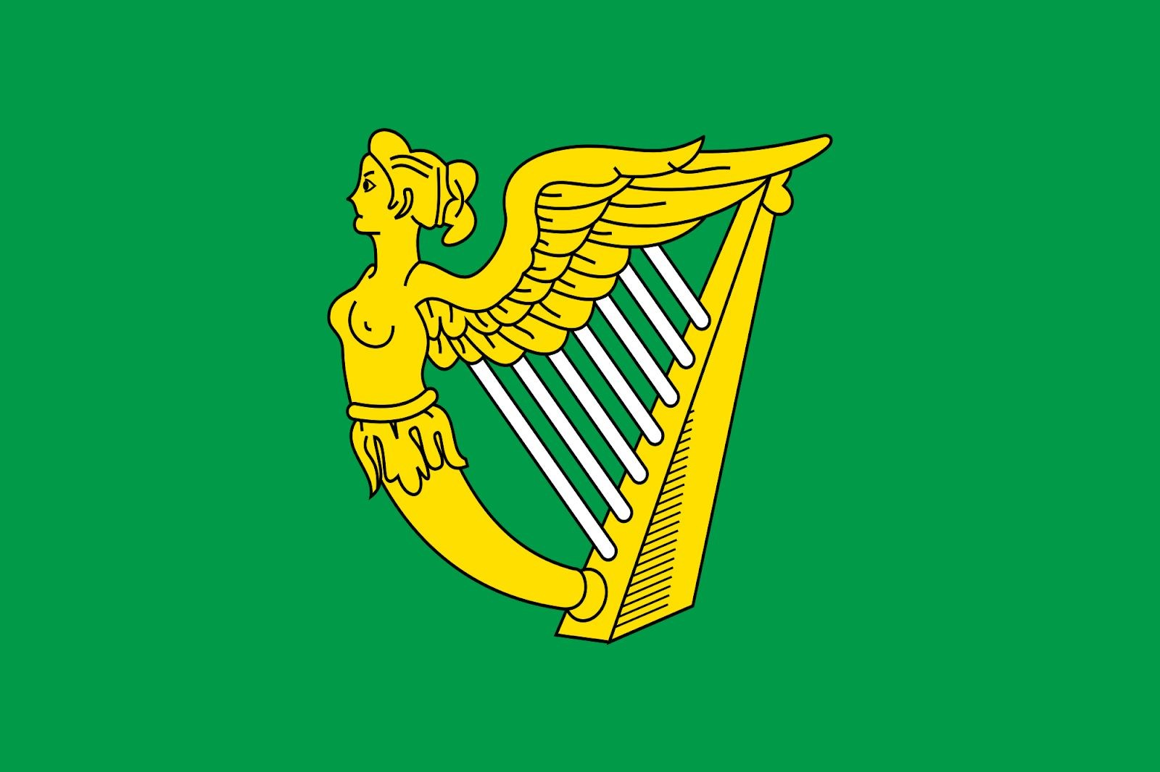
Pictured above is the Irish Flag used by the IRA, or the Irish Republican Army in their fight against the British
The Irish Civil war tore apart not only the country, but also the Sinn Féin party, which had for years been the face of Irish Nationalism and had advocated an independent Ireland. The Sinn Féin had won the 1919 Irish elections²⁸.Pro-Treaty Dáil²⁹ deputies and other Treaty supporters formed a new party, Cumann na nGaedheal³⁰, on 27 April 1923 at a meeting in Dublin, where delegates agreed on a constitution and political programme.Cumann na nGaedheal went on to govern the new Irish Free State for nine years. (It merged with two other organisations to form Fine Gael in 1933.) Anti-Treaty Sinn Féin members continued to boycott the

²⁷The Easter Rising also known as the Easter Rebellion, was an armed insurrection in Ireland during Easter Week, April 1916. The Rising was launched by Irish republicans to end British rule in Ireland and establish an independent Irish Republic while the United Kingdom was heavily engaged in the First World War. ²⁸The Sinn Féin, under the leadership of Mr. Éamon de Valera had won over 476,087 seats, which was 46.9% of all the votes cast. Winning 73 seats, the party secured 69% of the seats in the parliament.
²⁹Referring to the Dáil Éireann ( Assembly of Ireland), which was the revolutionary, unicameral parliament of the Irish Republic from 1919 to 1922. The Dáil was first formed by 73 Sinn Féin MPs elected in the 1918 United Kingdom general election. Their manifesto refused to recognise the British parliament at Westminster and chose instead to establish an independent legislature in Dublin. The convention of the First Dáil coincided with the beginning of the War of Independence. ³⁰Society of the Gaels
Dáil. At a special Ard Fheis in March 1926, de Valera proposed that elected members be allowed to take their seats in the Dáil if and when the controversial Oath of Allegiance³³ was removed. When his motion was defeated, de Valera resigned from Sinn Féin; on 16 May 1926, he founded his own party, Fianna Fáil, which was dedicated to republicanising the Free State from within its political structures. He took most Sinn Féin MPs with him, reducing the Sinn Féin to a mere 15 seats.
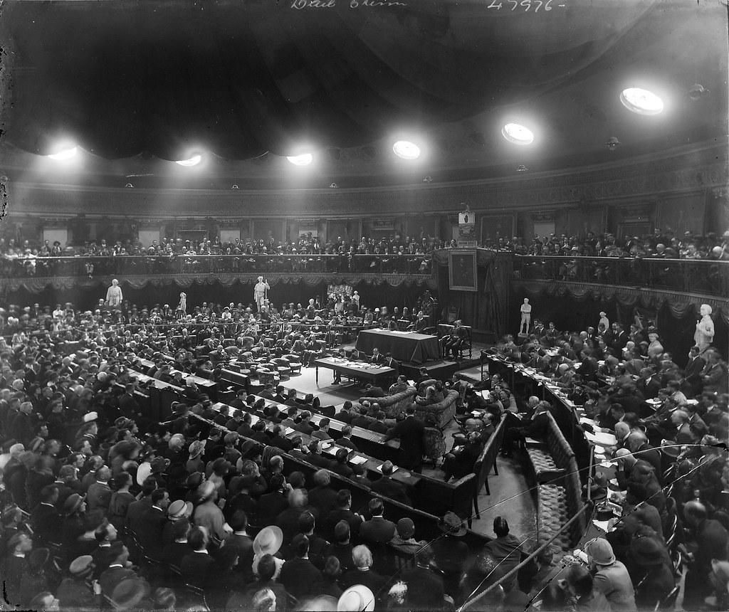
Pictured above is the historic Ard Fheis held in March of 1926 to decide on the Oath of Allegiance
We now skip forward to 1932, in between where Cumann na nGaedheal ruled Ireland for 8 long years. But in 1932, General Elections were held in Ireland. It was in the backdrop of these elections, where the Cumann na nGaedheal fought the general election on its record of providing ten years of stable government. The party brought stability following the chaos of the Irish Civil War, and provided honest government. However, by 1932 this provision of solid government was wearing thin, particularly since the party had no solution to the collapse in trade which followed the depression of the early 1930s. Instead of offering new policies the party believed that its record in government would be enough to retain power. Cumann na nGaedheal also played the "red card" tactic, describing Fianna Fáil as communists and likening Éamon de Valera to Joseph Stalin. In comparison to the lazy policy of the Cumann na nGaedheal, Fianna Fáil had an elaborate election programme, designed to appeal to a wide section of the electorate. It played down its republicanism to avoid alarm, but provided very popular social and economic policies. The party promised to free IRA prisoners, abolish the Oath of allegiance and reduce the powers of the Governor-General and the Senate. It also promised the introduction of protectionist policies, industrial development, self-sufficiency and improvements in housing and social security benefits. When the results came in, it spoke for itself:
Colour | Party | Votes | Percentage | Seat Share
 | Fianna Fáil | 566,498 | 44.5 | 72
 | Cumann na nGaedheal | 449,506 | 35.3 | 57
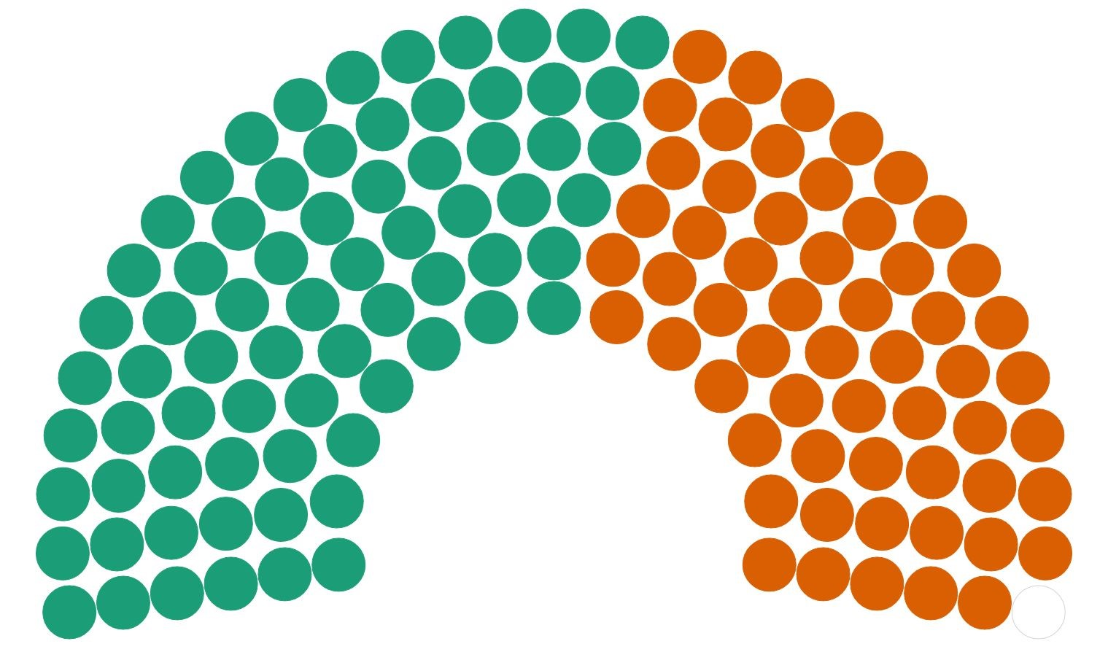
When the results were known Fianna Fáil was still five seats short of an overall majority, but it still looked like the only party capable of forming a government. Discussions got underway immediately after the election and an agreement was reached in which the Labour Party would support Fianna Fáil. The party now had the necessary votes to form a minority government.
On 18 March 1932, the new government suspended the Public Safety Act, lifting the ban on a number of organisations including the Irish Republican Army. Some IRA political prisoners were also released around the same time. The IRA and many released prisoners began a "campaign of unrelenting hostility" against those associated with the former Cumann na nGaedheal government. There were many cases of intimidation, attacks on persons, and the breaking-up of Cumann na nGaedheal political meetings in the coming months.
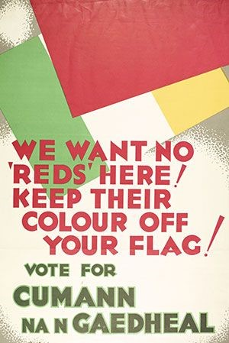
Above is a poster campaigning for the Cumann na nGaedheal. The ‘Red’ referenced in the poster refers to the flag of the British
In view of the increased activities of the IRA, National Army Commandant Ned Cronin founded the Army Comrades Association in early 1932. As its name suggested, it was designed for Irish Army veterans, a society for former members of the Free State army. The Blueshirts, as the Army Comrades Association often called themselves felt that freedom of speech was being repressed, and began to provide security at Cumann na nGaedheal events. This led to several serious clashes between the IRA and the ACA. In August 1932, Dr. Thomas F. O'Higgins, a Cumann na nGaedheal Member of Parliament (MP), became the leader of the ACA. By September 1932 it had over 30,000 members.
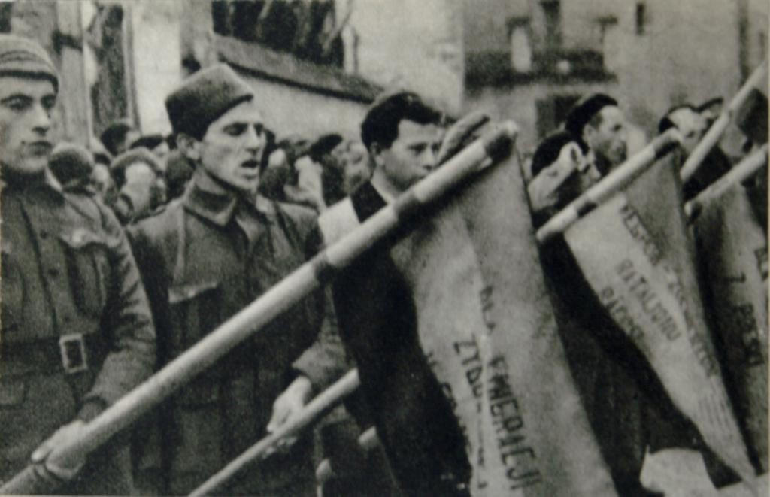
The Blueshirts, as depicted above, were a militant group created to protect the freedom of speech and expression at Cumann na nGaedheal rallies
In January 1933, the Fianna Fáil government called a surprise election, which the government won comfortably, removing the need to rely on the Labour Party for external Support. The results were:
Colour | Party | Votes | Percentage | Seat Share
 | Fianna Fáil | 689,054 | 49.7 | 77
 | Cumann na nGaedheal | 422,495 | 30.5 | 48
The election campaign saw a serious escalation of rioting between IRA and ACA supporters. In April 1933, the ACA began wearing the distinctive blueshirt uniform. After Fianna Fáil's re-election in February 1933, President of the Executive Council Éamon de Valera dismissed Eoin O'Duffy, a guerrilla leader of the Irish Republican Army (IRA) as commissioner; that July, O'Duffy was offered and accepted leadership of the ACA and renamed it the National Guard. He re-modelled the organisation, adopting elements of European fascism, such as the Roman straight-arm salute, uniforms and huge rallies. Membership of the new organisation became limited to people who were Irish or whose parents "profess the Christian faith". O'Duffy was an admirer of Benito Mussolini, and the Blueshirts adopted corporatism as their chief political aim. According to the constitution he adopted, the organisation was to have the following objectives:
- To promote the reunification of Ireland.
- To oppose Communism and alien control and influence in national affairs and to uphold Christian principles in every sphere of public activity.
- To promote and maintain social order.
- To make organised and disciplined voluntary public service a permanent and accepted feature of our political life and to lead the youth of Ireland in a movement of constructive national action.
- To promote co-ordinated national organisations of employers and employed, which with the aid of judicial tribunals, will effectively prevent strikes and lock-outs and harmoniously compose industrial influences.
In response to the banning of the Army Comrade Association after the failed Dublin March, the Cumann na nGaedheal and the National Centre Party merged to form a new party, Fine Gael, on 3 September 1933.
O'Duffy became its first president. The party's aim was to create a united Ireland within the British Commonwealth, although its programme made no mention of a corporatist state.The 1934 local elections were a trial of strength for the new Fine Gael and the Fianna Fáil government. When Fine Gael won only six out of 23 local elections, O’Duffy lost much of his authority and prestige. The Blueshirts began to disintegrate by mid-1934.The Blueshirts floundered also on the plight of farmers in the Economic War, as the Blueshirts failed to provide a solution. Following disagreements with his Fine Gael colleagues, O'Duffy left the party, although most of the Blueshirts stayed in Fine Gael. In December 1934, O'Duffy attended the Montreux Fascist conference in Switzerland.

The Kuomintang, Republic Of China
In 1915 Yuan Shikai proclaimed the Empire of China (1915–1916) with himself as Emperor of China. This period, now known as the Warlord Period, is infamous. Amidst this, a man named Sun Yat-sen, who had been instrumental in the overthrow of the Quing Dynasty in China, which had ruled for over 200 years. He then founded the Republic of China, but between this (1911) and Yuan Shikhai’s proclamation of the Warlord Period, China had become divided between different military leaders without a proper central government.
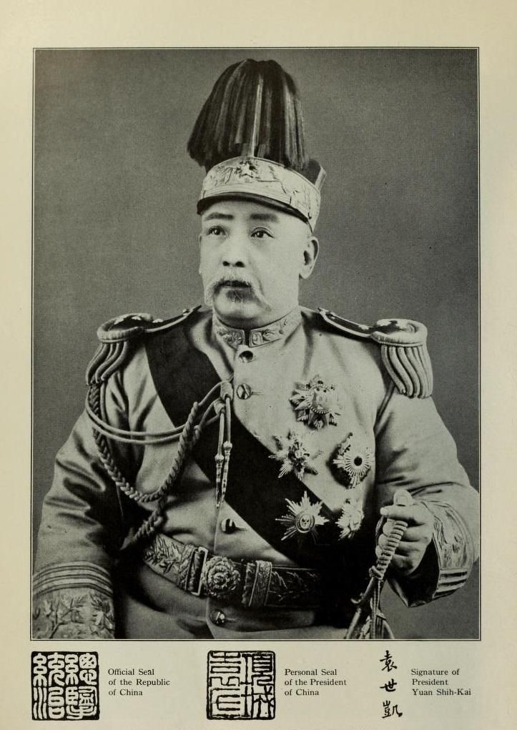
Pictured above is Yuan Shikai, who proclaimed himself Emperor of China in 1915
Sun saw the danger of this and returned to China in 1917 to advocate Chinese reunification. In 1921 he started a self-proclaimed military government in Guangzhou and was elected Grand Marshal. Between 1912 and 1927 three governments had been set up in South China: the Provisional government in Nanjing (1912), the Military government in
Guangzhou (1921–1925), and the National government in Guangzhou and later Wuhan (1925–1927). The southern separatist government in the South was established to rival the Beiyang government in the north. Yuan Shikai had banned the KMT, fearing they would attempt to begin another revolution . The short lived Chinese Revolutionary Party was a temporary replacement for the KMT. On 10 October 1919 Sun resurrected the KMT with the new name Chung-kuo Kuomintang (中国国民党), or the "Nationalist
Party of China".
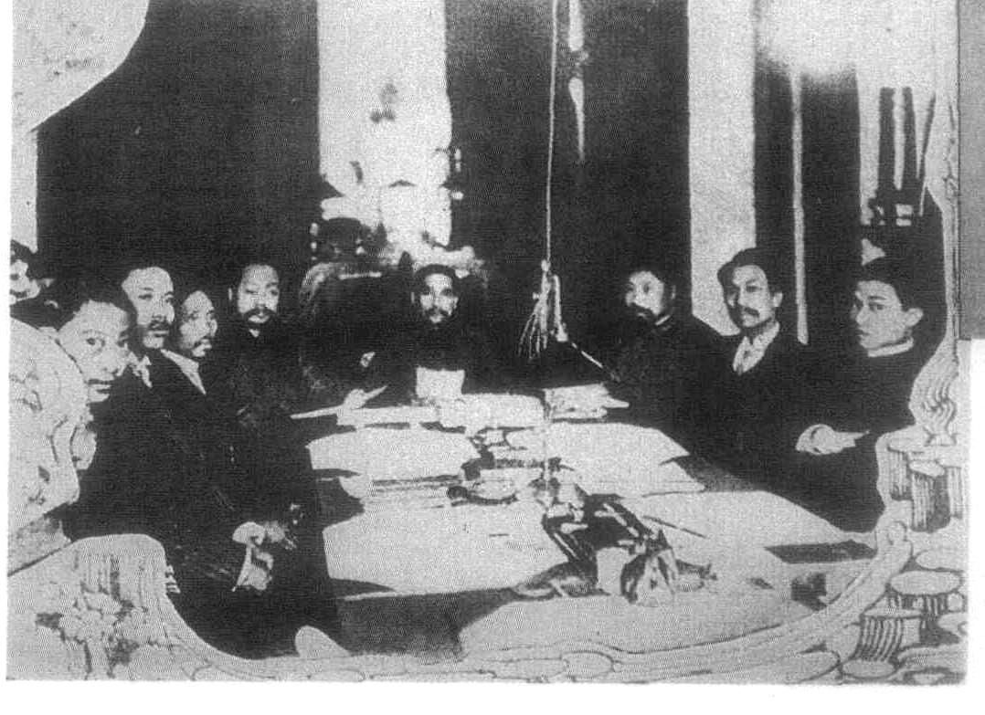
The provisional Government in Nanjing, 1912

In 1923, the KMT and its Canton government accepted aid from the Soviet Union after being denied recognition by the western powers. Soviet advisers - the most prominent of whom was Mikhail Borodin, an agent of the Comintern – arrived in China in 1923 to aid in the reorganization and consolidation of the KMT along the lines of the Communist Party of the
Soviet Union, establishing a Leninist party structure that lasted into the 1990s. The Communist Party of China (CPC) was under Comintern instructions to cooperate with the KMT, and its members were encouraged to join while maintaining their separate party identities, forming the First United Front between the two parties. Mao Zedong and early members of the CPC also joined the KMT in 1923. Soviet advisers also helped the KMT to set up a political institute to train propagandists in mass mobilization techniques, and in 1923 Chiang Kai-shek, one of Sun's lieutenants from the Tongmenghui days, was sent to Moscow for several months' military and political study.
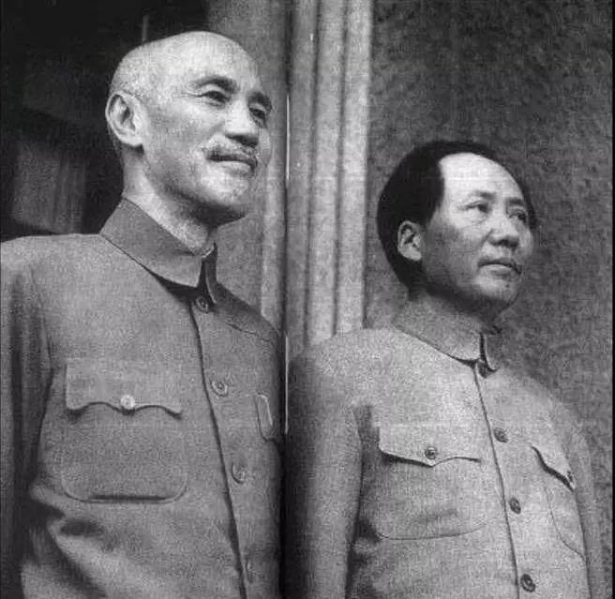
Though he considered Chiang Kai-shek a "traitor to the nation,'' Mao Zadong, who lead the CPC or the
Communist Party of China felt that the Red Army itself was unable to defeat the Japanese and hence advocated
a "government of national defence" that should be formed with the KMT and other "bourgeois nationalists" to defeat the Japanese
At the first party congress in 1924 in Kwangchow, Kwangtung, (Guangzhou, Guangdong) which included non-KMT delegates such as members of the CPC, they adopted Sun's political theory, which included the Three Principles of the People. When Sun Yat-sen died in 1925, the political leadership of the KMT fell to Wang Jingwei and Hu Hanmin, respectively the left-wing and right-wing leaders of the party. However, the real power was in the hands of Chiang Kai-shek, who was in near complete control of the military as the superintendent of the Whampoa Military Academy. With their military superiority, KMT confirmed their rule on Canton, the provincial capital of Kwangtung. The Guangxi warlords pledged loyalty to the KMT. The KMT now became a rival government in opposition to the warlord Beiyang government based in Peking.
Following the death of Sun Yat-sen, Chiang Kai-shek emerged as the KMT leader and launched the Northern Expedition to defeat the northern warlords and unite China under the party. With its power confirmed in the southeast, the Nationalist Government appointed Chiang Kai-shek commander-in-chief of the National Revolutionary Army (NRA), and the Northern Expedition to suppress the warlords began. Chiang had to defeat three separate warlords and two independent armies. Chiang, with Soviet supplies, conquered the southern half of China in nine months.
A split erupted between the Chinese Communist Party and the KMT, which threatened the Northern Expedition. Wang Jing Wei, who led the
KMT leftist allies took the city of Wuhan in January 1927. With the support of the Soviet agent Mikhail Borodin, Wang declared the National Government as having moved to Wuhan. Having taken Nanking in March, Chiang halted his campaign and prepared a violent break with Wang and his communist allies. Chiang's expulsion of the CPC and their Soviet advisers, marked by the Shanghai massacre on April 12, led to the beginning of the Chinese Civil War. Wang finally surrendered his power to Chiang. Joseph Stalin ordered the Chinese Communist Party to obey the KMT leadership.Once this split had been healed, Chiang resumed his Northern Expedition and managed to take Shanghai.
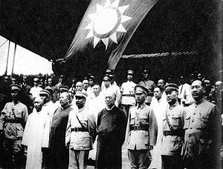
The leaders of the KMT during the Northern Expedition
During the Nanking Incident in March 1927, the NRA stormed the consulates of the United States, United Kingdom (UK) and Empire of Japan, looted foreign properties and almost assassinated the Japanese consul. An American, two British, one French, an Italian and a Japanese were killed.These looters also stormed and seized millions of dollars worth of British concessions in Hankou, refusing to hand them back to the UK.Both Nationalists and Communist soldiers within the army participated in the rioting and looting of foreign residents in Nanking. The
NRA took Peking in 1928. The city was the internationally recognized capital, though previously controlled by warlords. This event allowed the KMT to receive widespread diplomatic recognition in the same year. The capital was moved from Peking to Nanking, the original capital of the Ming Dynasty, and thus a symbolic purge of the final Qing elements. This period of KMT rule in China between 1927 and 1937 was relatively stable and prosperous and is still known as the Nanjing decade.
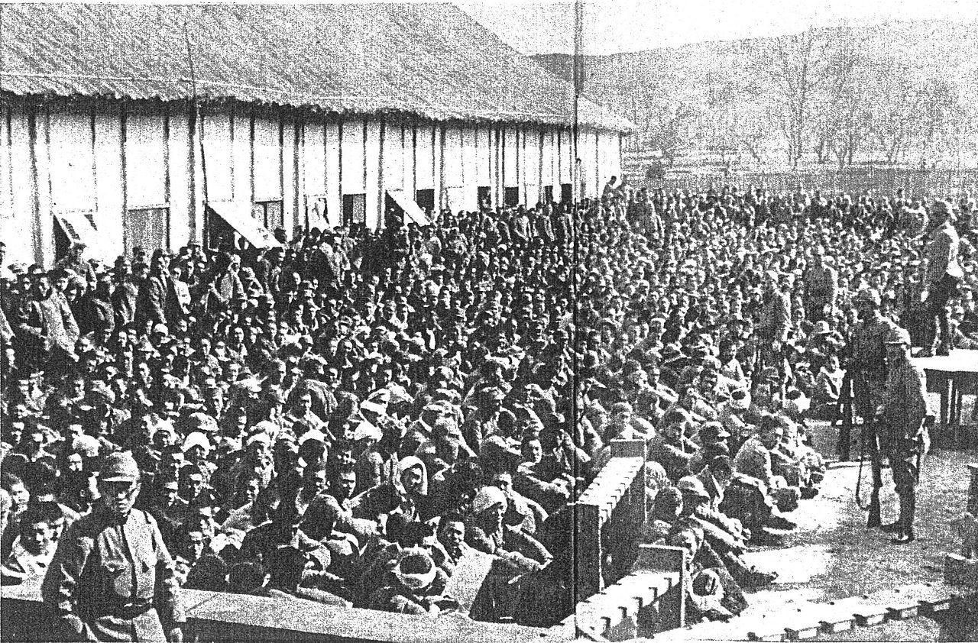
Pictured above are the large amount of Chinese detainees at Nanking
After the Northern Expedition in 1928, the Nationalist government under the KMT declared that China had been exploited for decades under unequal treaties signed between the foreign powers and the Qing Dynasty. The KMT government demanded that the foreign powers renegotiate the treaties on equal terms.
Before the Northern Expedition, the KMT began as a heterogeneous group advocating American-inspired federalism and provincial autonomy. However, the KMT under Chiang's leadership aimed at establishing a centralized one-party state with one ideology. This was even more evident following Sun's elevation into a cult figure after his death. The control by one single party began the period of "political tutelage,'' whereby the party was to lead the government while instructing the people on how to participate in a democratic system.

​ The Iron Guard, Romania
By the end of the 1930s, Romania’s Legion of the Archangel Michael (often called the Iron Guard) became proportionately the third-largest fascist movement in Europe.
Unlike Germany or Hungary, Romania was one of the main beneficiaries of World War I, which doubled the size of the country. Yet this enormous expansion—together with Romania’s severe social, economic, and cultural backwardness—posed problems of the utmost severity. The country was faced with the challenge of building a greatly expanded and multiethnic nation, creating a democratic political system, and modernizing one of the weakest economies in Eastern Europe. Partial democratization of some institutions only accelerated a kind of national identity crisis and a prolonged search for alternatives. As in some other Eastern European countries, there had developed strong currents of “populism” that espoused a kind of peasant nationalism, equally opposed to liberalism, conservatism, and Marxist socialism.
The new democratic constitution of 1923 introduced universal male suffrage, and by 1926 a mass National Peasant Party had emerged. Two years later, it won a large majority in the most democratic election in Romanian history. Yet the Peasant Party soon became divided, producing an only moderately effective government that did not institute any major reforms.
Colour | Party | Votes | Percentage | Seats
 | National Peasants Party (Alliance) | 2,208,922 | 79.2 | 348
 | National Liberal Party | 185,939 | 6.7 | 13
 | Magyar Party | 172,099 | 6.2 | 16
 | Others | x | x | 10

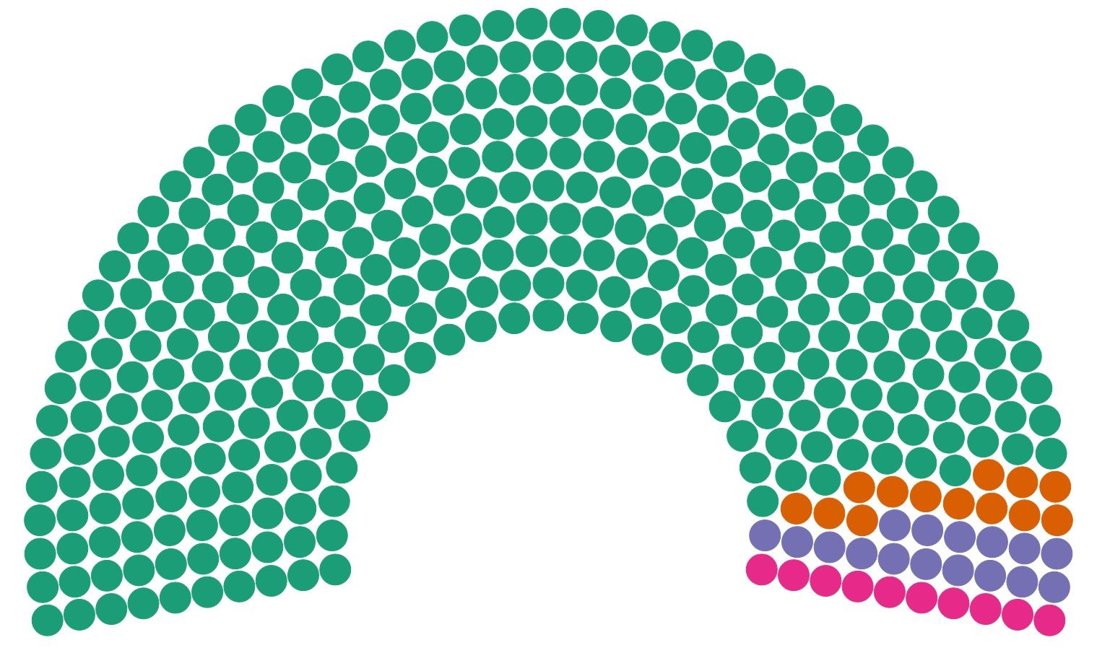
Just as the depression struck, Romania’s political equation was fundamentally altered by the return of King Carol, who had abdicated five years earlier. Though this reassumption of royal power had been
engineered by a clique of army officers and authoritarian-minded elitists, it was nonetheless accepted by the political parties when Carol promised to observe the constitution.
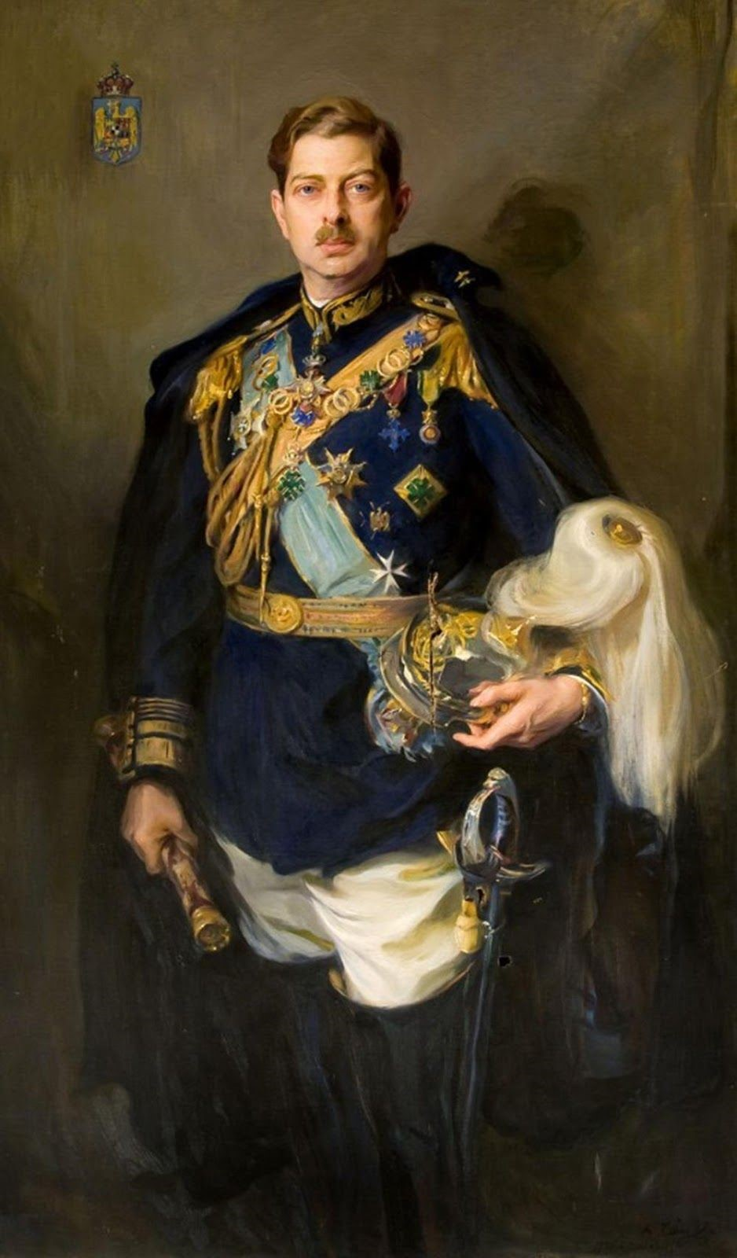
King Carol II of Romania, who returned to the throne after his abdication five years prior
In fact, Carol was the most cynical, corrupt, and power-hungry monarch who ever disgraced a throne anywhere in 20th-century Europe. An admirer of Mussolini, he quickly intervened unconstitutionally in the political process and drove the Peasant Party from power in 1931. A brief government by the National Peasants in 1932–33 was short-lived, internal division having stalemated the only large democratic party. Since these problems stemmed in part from the machinations of an increasingly authoritarian king, by 1933 the political system was in full process of decomposition, with groups in several of the parties splitting off and moving further to the right, as had occurred so recently in Germany. In Romania, the postwar democratic breakthrough seemed now to be leading toward a political breakdown.
The only major new political force to appear after the breakup of the National Peasant Party was the Legion of the Archangel Michael, founded by Corneliu Zelea Codreanu, who emerged from the ranks of LANC (Liga Apararii National-Crestine), the largest extreme anti-Semitic political party of which his father was a co-founder.
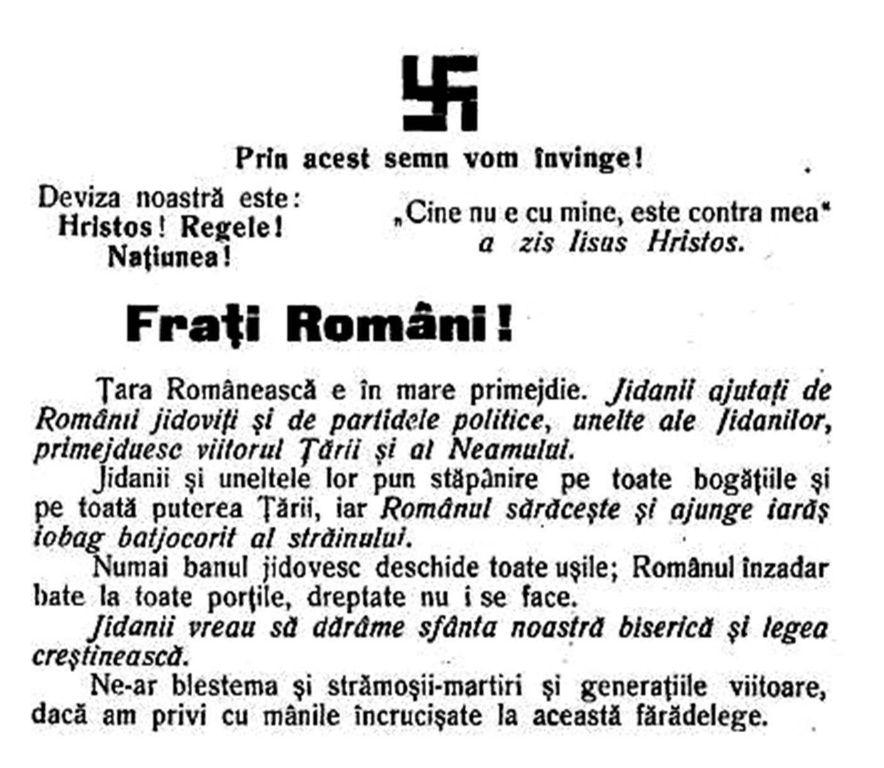
The LANC, or the Liga Apararii National Crestine frequently used the Nazi Swastika to appeal for votes
Codreanu came from a family in the northern fringe of Romania that was partly German and Slavic in ancestry but highly nationalistic (his rabidly anti-Semitic father having changed the family name from Zilinsky to the Romanian form, Codreanu). He had been a militia volunteer in 1919 and believed devoutly in redemptive violence. This conviction led to his murder in 1924 of the corrupt, “unpatriotic” police chief of Iasi (the university city where Codreanu had been a student), for which he was absolved and drew much favorable nationalist publicity. During 1925–27, Codreanu studied in Germany and further developed his extremist ideas, deciding that LANC—which won only 5 percent of the vote in the 1926 elections—was too rightist and compromising to regenerate Romania.
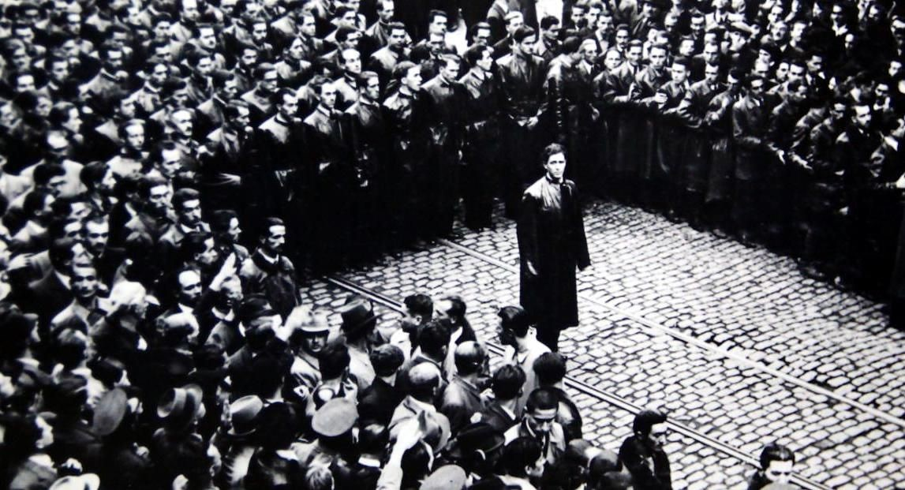
Codreanu was known as a far right member, yet was never formally arrested and was instead worshipped by Nationalist Groups
The Legion of the Archangel Michael was arguably the most unusual mass movement of interwar Europe. It is generally classified as fascist because it met the main criteria of any appropriate fascist typology, but it presented undeniably individual characteristics of its own. German historian and philosopher Ernst Nolte has written that it “must not only be declared, but also plainly appears, to be the most interesting and the most complex fascist movement, because like geological formations of superimposed layers it presents at once both prefascist and radically fascist characteristics.” What made Codreanu especially different was that he became a sort of religious mystic, and though the Legion had the same general political goals as other fascist movements, its final aims were spiritual and transcendental—“The spiritual resurrection! The resurrection of nations in the name of Jesus Christ!” as he put it.
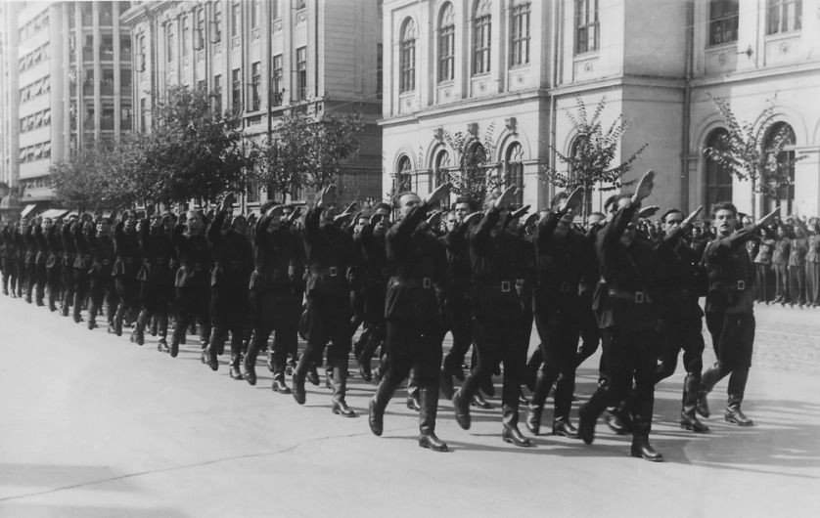
The legion of the Archangel Michael, which would soon transform itself into the Iron Guard of Romania hoped to build a personality cult around the rituals and proceedings of the Romans, mixed with a strong view of Spirituality
This seemed to be contradicted by the Legion’s primary emphasis on life and politics as “war,” but Codreanu propounded a doctrine of two spheres: sinful human life, which must be the arena of political endeavor, and the reconciled and redeemed spiritual community of nation, ultimately to participate in eternal life. Ordinary human life was a sphere of constant war and eternal struggle, above all against the enemies of the Tara (Fatherland). The Legionnaire must forgive his personal enemies but not those of the Tara, who must be punished and destroyed even at the risk of the Legionnaire’s personal salvation. Violence and murder were absolutely necessary for the redemption of the nation; if the acts that this required placed in jeopardy the individual soul of the militant who carried them out, his necessary sacrifice was simply the greater. His punishment would consist of the earthly punishment for his deed (which he ought not to avoid) as well as the possible loss of eternal life, the ultimate sacrifice for the Fatherland, which must be accepted with joy. A principal effect of this political theology was a unique death cult, unusually morbid even for a fascist movement.
Self-sacrifice was exalted in all fascist and revolutionary movements, but in the Legion, martyrdom was virtually required, accompanied by theological heterodoxy. Legionnaires were aware of the uniqueness of their doctrines and of the major differences between their organization and the secular fascist movements, though at the same time they also felt common identity and partially parallel goals with other fascists. While Ernst Nolte is correct to point out that in single-minded fanaticism, Codreanu was the other European fascist leader most like Hitler (whom he also resembled in intense personal magnetism), the Legionnaire martyr complex created a degree of self-destructiveness unequaled in other fascist movements.The Legion reflected the anti-individualism and emphasis on the collectivity often found in sociopolitical movements in Eastern Orthodox societies, and it has even been termed a kind of heretical Christian sect. What placed it outside even a heretical Christianity, however, was not merely its maniacal insistence on violence but its biological concept of the nation, whose essence supposedly lay in the blood of the Romanian people.
The Legion had little in the way of a concrete program.Codreanu pointed out that a dozen different political programs already existed in Romania, and he proclaimed the need instead for a new spirit, a cultural-religious revolution whose goal was the creation of the omul nou—the “new man” sought in varying ways by all revolutionary movements, but one that for the Legion would be consubstantial with its interpretation of the Romanian Orthodox Church and the national community. Its leaders recognized that the country had in some fashion to be developed economically, but they disagreed sharply with the Neoliberal (moderate conservative authoritarians) call for rapid industrialization. The high tariff maintained by the government was strongly denounced for increasing living costs among the peasantry.
The Legion sought a more national and collective or communal basis for the economy, while abhorring the materialism of capitalism and of socialism. Industrialization per se was not the goal, and it was to be pursued only to the extent necessary for wellbeing, though, conversely and somewhat contradictorily, the Legion insisted on development of a strong modern army. Legionnaires would later engage in small-scale collective enterprises of their own for public works, retail goods, and restaurants. Codreanu always emphasized that “everything is possible” and, in typical revolutionary and fascist manner, that “everything depends on will.”Material conditions were always secondary: “Cry out loud everywhere that the evil, misery and ruin originate in the soul!” The chief enemies were the leaders of the present corrupt system and the Jews. If the former were immediate targets, Jews constituted the special archenemy, to the extent that the Legion was possibly the only other fascist movement as vehemently anti-Semitic as German Nazis.
For several years, the Legion remained a tiny sect, a common experience for most fascist movements in the 1920s, lacking both money and support. In 1930, it founded a sort of militia called the Iron Guard, to include all Legionnaires between the ages of 18 and 30, and managed to win two local by-elections, gaining parliamentary representation for the first time in 1931. In the subsequent national elections of 1932, which were the most honest elections held in Romania during the decade, the main sector of the National Peasants won approximately 40 percent of the vote, while the Legion’s support rose to only 2.37 percent, in ninth place among Romanian political organizations, barely ahead of the small Romanian Jewish party. Nonetheless, the democratic National Peasant government that then briefly came to power showed some interest in gaining Legionnaire support, and for the first time, the National Peasants began to take a position of limited anti-Semitism.

Indian Independence League, India
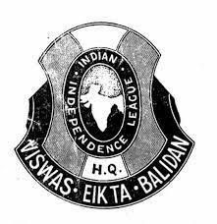
The Indian Independence League (also known as IIL) was a political organisation operated from the 1920s to the 1940s to organize those living outside of India into seeking the removal of British colonial rule over India. It was located in various parts of South-East Asia and included Indian expatriates, and later, Indian nationalists in-exile under Japanese occupation following Japan's successful Malayan Campaign during the first part of the Second World War.
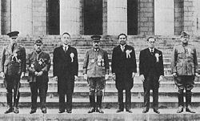
The original members of the IIL

The Yugoslav Radical Union, Yugoslavia
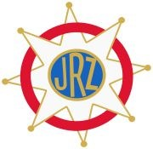

The Yugoslav Radical Union was a political party founded by Yugoslav Prime Minister Milan Stojadinović in 1935 as the ruling party of Yugoslavia that sponsored authoritarian mass mobilization. The party, whose agenda was based upon fascism, was the dominant political movement in the country. Party members wore green shirt uniforms and Šajkača caps and addressed Stojadinović as Vođa ("Leader"). The party also had a paramilitary wing called the Greenshirts, who assaulted and clashed with those who were against Stojadinović's rule. Stojadinović told Italian foreign minister Galeazzo Ciano that although the party was initially established as a moderate authoritarian movement, his intention was to model the party after the Italian National Fascist Party. The party advocated closer ties with Nazi Germany and Fascist Italy. Yugoslav National Party Milan Stojadinović formed a successor party, called Yugoslav Radical Union (JRZ), based on a more conservative political alliance, which included the Yugoslav Muslim Organization(JMO) and Slovene People's Party (SLS).

In 1935 he became the leader of the Serbian Radical Party, which with some other parties formed a coalition Jugoslovenska Radikalna Zajednica (Yugoslav Radical Union, JRZ) and won the elections. The JRZ was made of the Serb Radicals, the Slovene People's Party led by Father Anton Korošec and the Yugoslav Muslim Organization led by Mehmed Spaho, which Stojadinović called a "three-legged chair" that was missing a "fourth leg", namely the support of the Croats. Stojadinović wrote in his memoirs: "I called our party the three-legged chair, on which it was possible to sit when necessary, although a chair with four legs is far more stable".
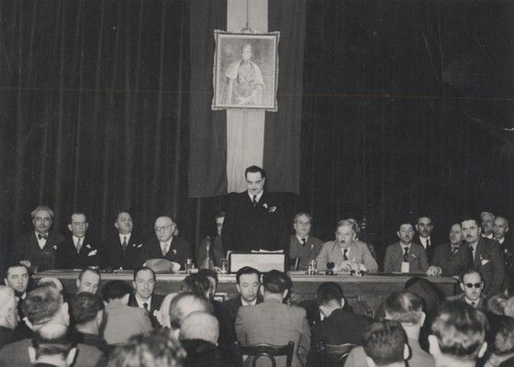
On 24 June 1935 he was elected Prime Minister and Minister of Foreign Affairs. 1932, the worst year of the Great Depression, did win Stojadinović a measure of popularity. Stojadinović believed that the solution to the Great Depression were closer economic links with Germany, which lacked many of the raw materials necessary for a modern industrial economy and whose population exceeded the capacity of German farmers to feed it. As Germany needed both food and raw materials such as iron, bauxite, copper and manganese, Yugoslavia enjoyed an economic bloom from 1935, exporting minerals and agricultural products to Germany on an enormous scale, leading to an economic revival and to placing Yugoslavia in the German economic sphere of influence.

Falange Espanola De Las Jons, Spain
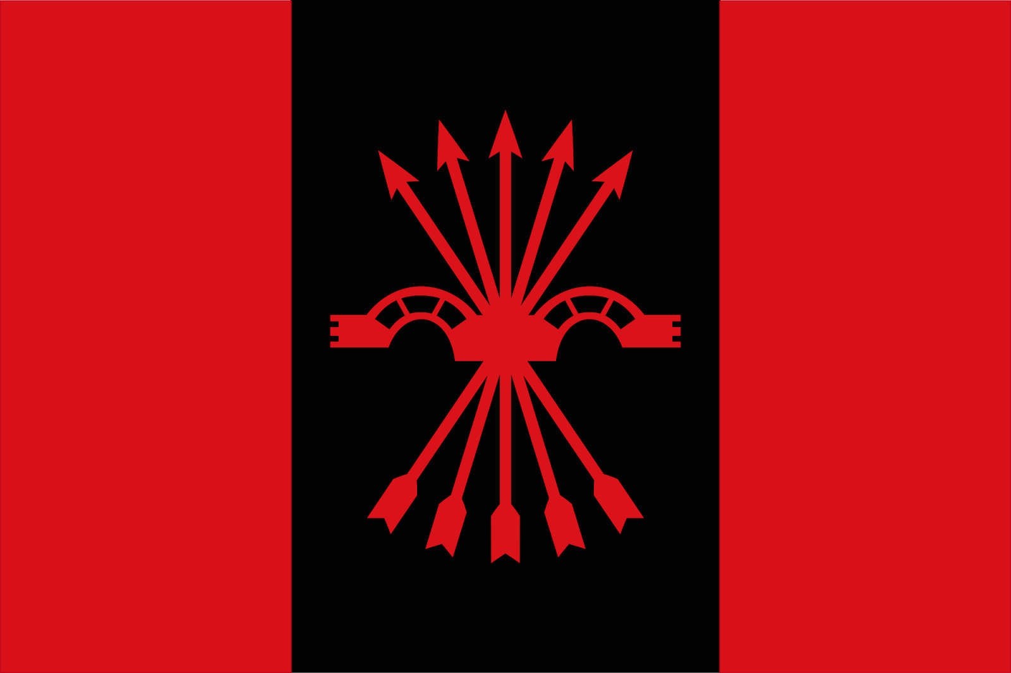
The first fascist political grouping in Spain was created by Ramiro Ledesma Ramos, an underemployed university graduate who had specialized in mathematics and philosophy. Here again the inspiration was primarily Italian, his little band being named Juntas de Ofensiva Nacional-Sindicalista (rather equivalent to Fasci Italiani di Combattimento) and its weekly publication La Conquista del Estado (“The
Conquest of the State”). Yet though Ledesma drew his inspiration from Italy (and also partly from Germany), and the official program of the JONS, aiming at a “national syndicalist state,” might be read as a carbon copy of the ideas and goals of Italian Fascism, Ledesma preferred not to use the label, realizing that it was counterproductive in the generally left-liberal Spanish atmosphere.
The JONS remained totally isolated at the small-sect level, relying mainly on university and secondary students. During its two and a half years of independent existence (1931–34), the JONS failed to have the slightest impact on Spanish affairs.
A more vigorous, better-financed attempt at a Spanish fascism was essayed by sectors of the right in 1933. The triumph of Hitler stimulated interest in Spain, not so much among potential fascists—of whom there seemed to be few in the peninsula—but among right radicals or potential right radicals, who were distinctly more numerous. Basque financiers went shopping during the summer of 1933 for the leader of a potential counterrevolutionary, demagogic Spanish fascism. Though they provided a trickle of support to Ledesma and the JONS, the latter were deemed to be both too radical and too unimportant to merit major support.
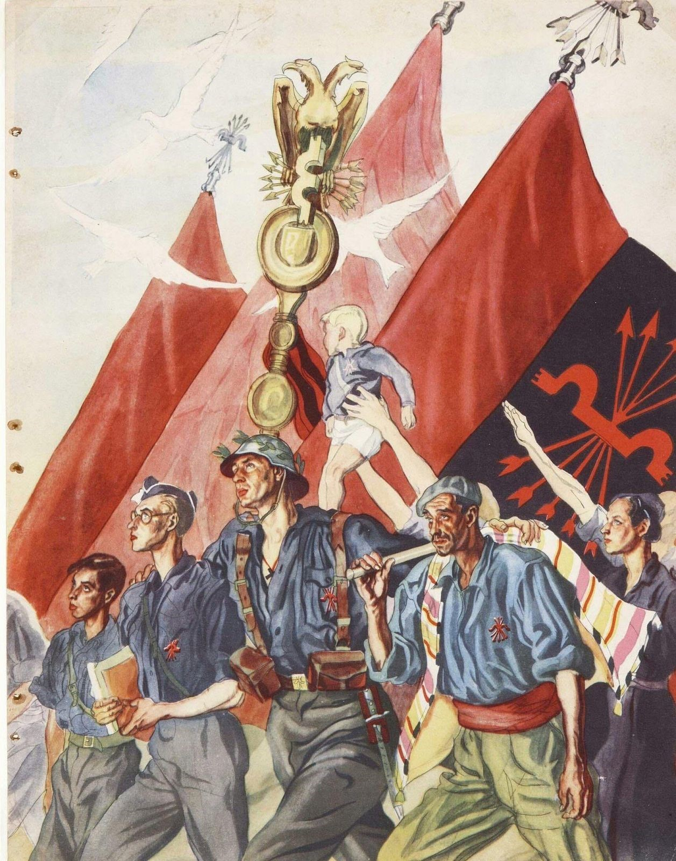
A propaganda poster used by the Falange
The main leader of a would-be Spanish fascism who came to the fore in the summer and autumn of 1933 was José Antonio Primo de Rivera, eldest son of the late dictator, Gen. Miguel Primo de Rivera, who ruled from 1923 to 1930. He first evolved from conservative authoritarian monarchism to a more radical brand of nationalist authoritarianism. By 1933, the younger Primo de Rivera—soon to be known generally as José
Antonio—had become interested in something rather like fascism (Italian-style) as the vehicle for giving form and ideological content to the national authoritarian regime attempted so uncertainly and unsuccessfully by his father. Unlike Ledesma, José Antonio was not averse to using the label fascist, though the new movement that he founded with a group of colleagues in October 1933 was eventually called by the more original title of Falange Española (“Spanish Phalanx”).
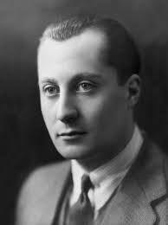
José Antonio Primo de Rivera
The Falange began with much more financial support from big business prone to the radical right than had the JONS, prompting the JONS to merge with it in early 1934. (The resulting organization was called Falange Española de las JONS.) During the next two years, the Falange was distinguished primarily by its insignificance.
This period in the wilderness did, however, give the movement’s leaders some time to reflect on what they were about. After a year or so, José Antonio Primo de Rivera began to move “left,” as the national syndicalism of the Falangists took on more socially radical overtones. There was a somewhat belated reaction to the danger of mimesis, and before the close of 1934, most Falangists were denying that they were fascists. By 1935, the criticism of Italian corporatism as too conservative and capitalistic—a criticism fairly common among the more radical types of fascists and Nazis abroad—was being echoed by some Falangist leaders, including Primo de Rivera.
It was all somewhat bewildering to Italian Fascists. During the “universal fascism” phase of the mid-1930s, the Italian taxonomists somewhat inconclusively decided that Falangists were indeed fascists because of their belief in “authority, hierarchy, order” and their anti-materialist Falangist “mysticism.”3 José Antonio, for his part, recognized that all the “nationalist renewal” movements opposing Marxism, liberalism, and the old conservatism had some things in common but also exhibited pronounced national differences.
That Falangism exhibited certain distinct characteristics of its own is undeniable, but these did not prevent it from sharing nearly all the general qualities and characteristics that would compose an inventory of generic fascism. As hypernationalists, all fascist groups by definition revealed certain distinct national traits. In the Spanish case, Falangism differed somewhat from Italian Fascism in its basic Catholic religious (if politically anticlerical) identity, for this was central to Falangism and only marginal to Fascism. The Falangists’ concept of the “new man” thus incorporated nearly all the qualities of the traditional Catholic hero, while fusing them with 20th-century components.
Large sectors of the Spanish right were becoming “fascistized,” as Ledesma aptly put it, in one or more superficial senses, but the erstwhile fascist movement itself was worse than anemic. Anti-fascism had been strong among the left from 1932 on, but it was precisely the leftists who registered, as Ledesma commented ironically, the only truly “fascist” activity in Spain in violence and direct action. In its first phases,
Falangism seemed so fastidious, rhetorical, and averse to direct action that rightist critics labeled it “franciscanism“ rather than fascism. The profound debility of fascism, so long as the regular Spanish political system existed had several causes. The absence of any strong sense of Spanish
nationalism deprived fascism of that key rallying point. In Spain mobilized nationalism was inverted: It was expressed through the intense “peripheral nationalism” of Catalans and Basques, directed against the unified Spanish nation-state. Another key factor was the limited secularization of rural and provincial society in much of Spain, particularly in the north. There, the most obvious and attractive cross-class alternative to liberal or leftist politics was political Catholicism. Moreover, the nominal electoral success of the conservative Catholic political party CEDA (the Spanish Confederation of Autonomous Right-Wing Groups) from 1933 gave this tactic the appearance of victory. Fascism enjoyed much less cultural reinforcement in Spain than in central Europe, for the cultural and intellectual revolution of the 1890s had achieved less resonance in the peninsula. There was a rightist Catholic culture of considerable force, but not a secular-vitalist-Darwinist cultural environment of any vigor. As far as political revolutionism was concerned, the left seemed able to enforce a monopoly of its several brands; it enjoyed greater political success and support in Spain than in any other country in the world during the 1930s. There remained less of an outlet for fascism as the consummation of a frustrated, deviant revolution there than in central Europe.

National Socialist German Workers’ Party (Nazi Party)
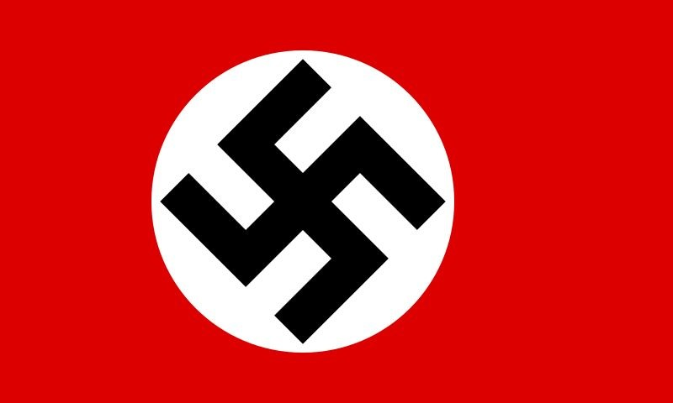
World War One; The Great War; known by numerous names, was responsible for the deaths of Nine Million soldiers, and Twenty One Million were left wounded. Germany formally surrendered at the 11th hour on the 11th day of the 11th month of 1918. At 5 a.m. that morning, Germany, bereft of manpower and supplies and faced with imminent invasion, signed an armistice agreement with the Allies in a railroad car outside Compiégne, France. And the war officially came to end with the signing of the Treaty of Versailles on June 28th, 1919. It came into existence to prevent a war like the Great one from ever occurring again but it instead led to the birth of one of the most devastating movements the world has or will ever see.
Post-war peace was achieved with the abdication and exile of Kaiser Wilhelm II, the creation of the Weimar Republic, and German acceptance of the Treaty of Versailles. The Weimar constitution created a semi-presidential system in which power was divided between the president, a cabinet and a parliament. The office of Chancellor was appointed by the president and was basically the chairman of the Reichstag. The Treaty of Versailles held Germany responsible as the sole aggressor in the war and she was made to pay a heavy price; war reparations were fixed at 32 billion dollars, as well as mass reductions in the size of her military and territory.
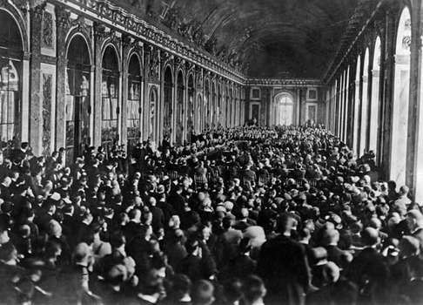
The “Treaty of peace” as it was called, was signed between the victorious Allies and the defeated Central
Powers. The Ottoman Empire had been defeated, replaced by Turkey, Austria Hungary was divided into two independent nations; Austria and Hungary, and Germany was forced to pay large amounts of War reparations
The newly formed Weimar Republic was compelled to accept the demands of the Treaty in order to maintain “peace” but the German public felt betrayed, embarrassed by the disrespectful treaty of Versailles. And who else was to blame for accepting this shameful treaty other than the weak Weimar Republic. The unpopularity of the Weimar republic created an atmosphere that fueled the growth of a large number of right-wing, extremist parties. There was widespread political infighting between the left and right.
One such party was the German Workers’ Party on January 5, 1919. Anton Drexler, Karl Harrer,Dietrich Eckhart and Gottfried Feder took advantage of this political turmoil and joined together to create the right-wing GWP. This party evolved from the German working class, the class worst affected by the Great War. The party’s founders had strong anti-semitic and nationalistic underpinnings; they held out that the capitalists, trade unions, liberals, communists should be held responsible for all the problems that were being faced by Germany, which were of course all connected to the conniving Jewish community. They sought to promote a paramilitary Friekorps culture.
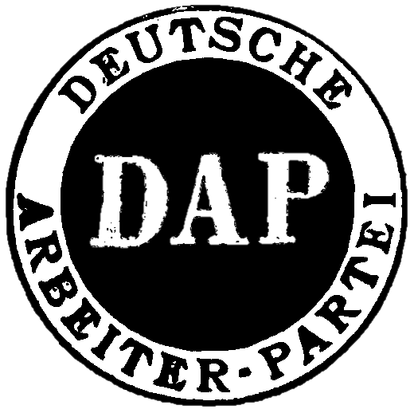
The insignia of the German Workers party, the main forerunner to the NSDAP
Adolf Hitler, the future leader of the Nazi party, served as a corporal in the
Reichswehr (German Army) in World War 1. He was unable to re-integrate himself in civil society after the war ended and thus, he accepted the job of serving as an informant for the Army. The army suspected the GWP to be a left-wing revolutionary group and sent Hitler to attend its meetings and spy on its inner workings. But Adolf soon found himself agreeing with the ideologies of the party, this ultimately culminated in Hitler resigning from the Reichswehr and becoming a member of the party himself, he was unable to remain quiet and non-descript when, during a meeting, an audience member questioned Feder and hitler quickly rose to his defense; Feder was greatly impressed with Hitler’s oratory skills and invited him to join the party.
Hitler was only the 55th member of the party and he soon rose up the ranks, first being a part of the executive committee and then was appointed as the party’s propaganda chief. During his tenure as chief of propaganda, he was able to secure a number of memberships mainly of his old comrades and army officers, including one of his commanding officers, Captain Ernst Röhm. The arrival of Röhm was an important development as he had access to the army political fund and was able to transfer some of the money into the GWP. It became clear to everyone that hitler’s charismatic personality was the main reason people were joining the party which in turn gave him tremendous power in the party because he was an irreplaceable asset.
On February 24th, 1920, Hitler organized a party rally at Munich. This event was largely recognized as the day the foundations of Nazism were laid. Hitler made an infamous speech about his parties’ newly formulated ‘25 point platform’ which laid down the exact goals of the party: it laid great emphasis on promoting a national, unified, pure Aryan German community, laying all blame of the country’s plight on the Jews and Eastern European immigrants, as well as the disgusting treaty of Versailles. One of the reasons why this speech catapulted Hitler to the front of the party and the movement was because he used the people’s weakened state and their emotions to his advantage, telling them exactly what they wanted to hear, lighting the fire of their hatred with his words.
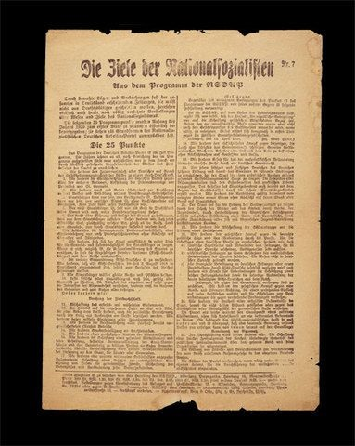
The National Socialist Program, also known as the 25-point Program or the 25-point Plan was the main
programme for the Nazi party
Soon after the events at Munich, Harrer resigned from the party and the core group now decided to add Socialist to the party’s name; becoming the Nationalsozialistische Deutsche Arbeiterpartei in 1920, (National Socialist German Workers’ Party) or NSDAP for short. Hitler, therefore redefined socialism by preceding it with the word ‘national’, equality but only for those with German blood. His impact reverberated throughout the party and thus, it came as a huge blow to the members when he decided to resign in July 1921 due to a movement within the party to merge with the German Socialist Party but he rejoined the party by the end of the month and was elected party leader two days later, on July 28th,1921.
Hitler’s private army, the SA, terrorized Germany, the main targets of their violence being the communists and socialists. This finally led up to the beer hall putsch on November 8th, 1923. A meeting of the Bavarian government was interrupted by hitler and his men who stormed into the building, Hitler then threatened to kill the leaders and himself if he was not made the leader of Germany right then and there. Ultimately this ended with him being captured and imprisoned for committing high treason but the Nazi sympathizers in the government were a plenty and they would never let him suffer a sever a punishment, though normally for such cases it is the penalty of death but he was awarded the minimum sentence of five years. In prison he authored his biography ‘Mein Kampf’, where he spread the Jewish conspiracy as well as the demand for ‘Lebensraum’ or living space for the Germans.
Hitler was released from prison on December 20th,1924, just a year into his sentence, the Nazi party was banned during his time in prison but the ban was lifted in 1925 and Hitler re-founded the Nazi Party. Hitler redirected the party’s emphasis toward strengthening their power via the political arena rather than the paramilitary route. He also formed a second paramilitary group called the Schutzstaffel or SS for the protection of Hitler and his inner circle.
In the elections of December 1924 the NSDAP could only win 14 seats compared with the 131 obtained by the Socialists (German Social Democrat Party) and the 45 of the German Communist Party (KPD).
Colour | Party | Votes | Percentage | Seats
 | Social Democratic Party | 7,881,041 | 26 | 131
 | German National People’s Party | 6,205,802 | 20.5 | 103
 | Centre Party | 4,118,849 | 13.6 | 69
 | National Socialist  Freedom Movement | 907,242 | 3 | 14
 | Others | x | x | 176
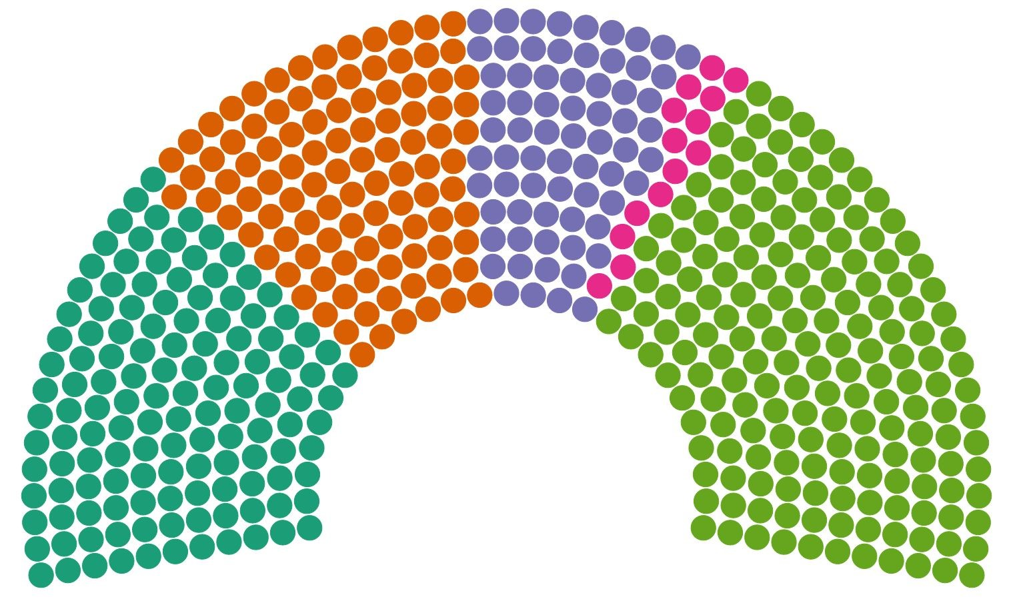
In the 1928 German elections, less than 3% of the people voted for the Nazi Party. This meant that they only got twelve seats, twenty fewer than what they achieved in the May, 1924 election. However, the party was well organized and membership had grown from 27,000 in 1925 to 108,000 in 1928. The Nazi party was low on funds and mainly relied on the contributions from the party members to function effectively and mainly, to spread propaganda. He wrote a pamphlet in 1927 named ‘The Road to Resurgence’, it was meant only for the eyes of the industrialists because the content of the pamphlet would have upset the Nazi party’s working class base, this pamphlet was release in order to gain some much necessary funds from the industrialist, thereby implying that anti-capitalist measures in his Twenty Five point platform would not be enforced if he came to power.
The German economy continued to improve and as unemployment fell, so did the support for extremist political parties such as the NSDAP. In the General Election held in May, 1928, the Nazi Party won only 14 seats, while the left-wing parties, the German Social Democrat Party (153) and the German Communist Party (54) still continued to grow in popularity.
The fortunes of the NSDAP changed when the Great Depression hit in October 1929. One of the consequences of this was a rapid increase in unemployment. Germany, whose economy relied heavily on investment from the United States, suffered more than any other country in Europe. Before the crash, 1.25 million people were unemployed in Germany. By the end of 1930 the figure had reached nearly 4 million. But this was a blessing for the Nazi party as more and more Germans began believing in Hitler’s beliefs. The general elections held in 1930 saw a huge increase in the representatives of the NSDAP in the Reichstag, it increased from 14 to 107. Though the German Socialist Party was the largest in the reichstag, it did not have majority and this provided for an unstable government. Although Hitler lost the election, he captured an impressive 30% of the vote in the first round of the elections, forcing a run-off election during which he captured 36.8%.
Colour | Party | Votes | Percentage | Seats
 | Social Democratic Party | 8,575,244 | 24.53 | 143
 | National Socialist  German Workers  Party (Nazi Party) | 6,379,672 | 18.25 | 107
 | Communist Party Of Germany | 4,590,160 | 13.13 | 77
 | Others | x | x | 250
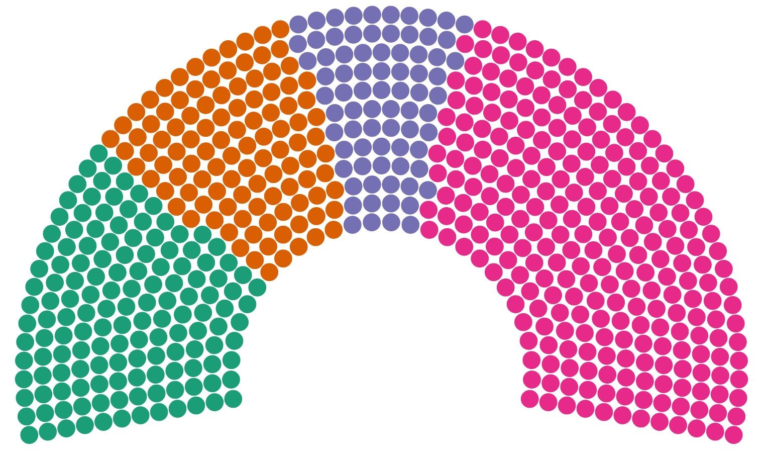
In the elections of July 1932, the Nazi party won 230 seats, 37.4% of the total seats, but the party still did not have clear majority. In order to weaken the Nazis, Chancellor Von Papen dissolved the Reichstag and called for new elections in November of the same year. But the Nazi party did not lose much ground. A weakened and desperate Papen decided that his best strategy was to elevate the Nazi leader to the position of chancellor so that he, himself, could maintain a role in the disintegrating government. With the support of media magnate Alfred Hugenberg, and new chancellor Kurt von Schleicher, Papen convinced President Hindenburg that placing Hitler into the role of chancellor would be the best way to contain him.
The group believed that if Hitler were given this position then they, as members of his cabinet, could keep his right-wing policies in check. Hindenburg reluctantly agreed to the political maneuvering and on January 30, 1933, officially appointed Adolf Hitler as the chancellor of Germany.
On February 28, at the urging of Hitler, President Hindenburg passed the Decree for the Protection of the People and the State. This emergency legislation extended the Decree for the Protection of the German People, passed on February 4. It largely suspended the civil liberties of the German people claiming that this sacrifice was necessary for personal and state safety. This was known as the “Reichstag fire Decree” following the fire that destroyed the Reichstag building, this act of arson was blamed on the communists by the Nazis.
The last “free” election in Germany took place on March 5, 1933. In that election, members of the SA flanked the entrances of polling stations, creating an atmosphere of intimidation that led to the Nazi Party capturing their highest vote total to-date, 43.9% of the votes.
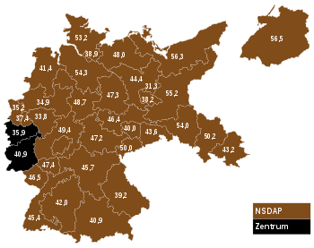
The Election map of Germany in 1933
The Nazis were followed in the polls by the Social Democratic Party with 18.25% of the vote and the KPD, which received 12.32% of the vote. It was not surprising that the election, which occurred as a result of Hitler’s urging to dissolve and reorganize the Reichstag, garnered these results.
This election was also significant because the Catholic Centre Party captured 11.9% and the German National People’s Party (DNVP), led by Alfred Hugenberg, won 8.3% of the vote. These parties joined together with Hitler and the Bavarian People’s Party, which held 2.7% of the seats in the Reichstag, to create the two-thirds majority that Hitler needed to pass the Enabling Act.
Enacted on March 23, 1933, the Enabling Act was one of the final steps on Hitler’s path to becoming a dictator; it amended the Weimar constitution to allow Hitler and his cabinet to pass laws without the Reichstag approval.

The Greek National Socialist Party
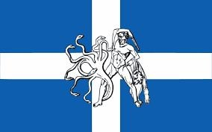
The economic crisis of the early 1930s, which brought about the devaluation of the drachma (1932) and the paralysis of Greece’s political system, also affected the country in other ways, one of which was facilitating the spread of fascist ideas.
With the eruption of the economic crisis in Greece in 1932, however, this picture changed, as the political climate became more polarised and anti-parliamentary fascist ideas spread, challenging the parliamentary system ever more vigorously and overtly. One characteristic sign of the new current was the complicity of the larger middle class parties, corrupted by fascist ideas, in weakening the work of the Greek Parliament and thus in effect debilitating parliamentary democracy per se.
It was in this context, the paralysis of the parliamentary system, that
George Merkouris, son of Athens mayor Spyros Merkouris, founded the National Socialist Party of Greece, which came into existence on 7 April 1933,3 although its advent had been announced in the press at least two months earlier. George Merkouris had held high office, including ministerial posts, under the Populist Party. In 1932 he was elected deputy in Athens with more votes than any other candidate, but disagreed with party leader Panagis Tsaldaris on the question of forming a grand coalition cabinet. In March 1933 he left the Populist Party to form his own group, which despite its name was not in fact an expression of national socialism. Its tenets, positions and contacts place it closer to those parties that were leaning towards fascism and right-wing totalitarianism and seeking the support of and association with Italy, the “great and mighty” state that was the chief protagonist and unchallenged model for the system: “The National Socialist Party of Greece turns spontaneously to the principles of Fascist belief and embraces it fraternally”.
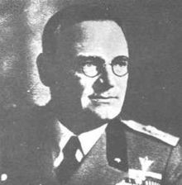
George Merkouris, son of Athens mayor Spyros Merkouris, founded the National Socialist Party of Greece
Its purpose, as declared in its Constitution, was to “restore National Unity, Social Solidarity and Discipline as a means of achieving the fuller moral and material well-being of the people”. This aim would be pursued through labour in the service of the country’s interests, the moral and political education of the people, strengthening patriotic, religious and family feeling and inspiring national self-confidence. Another point worth noting is the fact that one element of the organisational structure described in that Constitution was the “National Socialist Combat Units” that were to be set up at the party headquarters in each prefecture, in obvious imitation of the corresponding “Italian Fasci di combattimento”, the political organisations through which Mussolini entrenched his authority at local level before his October 1922 ‘March to Rome’.
If elected, the National Socialist Party proclaimed, it would suspend the operation of Parliament (which was in any case bankrupt) for at least three years, abolish the Senate and rewrite the Constitution. The gap would be filled by creating a professional and economic assembly of delegates representing all productive classes (employers and workers), and by expanding the jurisdiction of the Council of State, which would assume the task of drafting legislation. It also called for elections to elect, by popular vote, a president with increased rights and responsibilities.
The Italian Embassy in Athens, however, headed by Ambassador De Rossi del Lion Nero, frequently expressed reservations about this policy in its reports to Rome on the aims and actions of Merkouris and the National Socialist Party, with comments less enthusiastic than those Rome was receiving from its CAUR representative in Greece. Thus, while holding to its initial assessment that Merkouris had founded his new political party as a ‘third way’, allowing Greece to escape the deeply divisive Liberal/Populist fork, the Embassy observed that Merkouris himself was neither able to carry out such a difficult task nor, unlike party secretary Miltiadis Iossif, a genuine champion of fascist ideology. On the contrary, he was using his personal new party as a vehicle to keep him on Greece’s political stage. And his success in doing so was in no small measure due to the rise to power of the German national socialists.
The Embassy was just as negative regarding the National Socialist Party, which it said had too few members (no more than thirty thousand in Athens and the provinces) to play a real role in shaping political events, and those of doubtful quality, being in the main elderly political clients of Spyros Merkouris, whose name was in fact his son’s chief political capital.
We shall not dwell on the general work or specific agenda of the Montreux Conference, which progressed very much as its organisers had planned,but shall limit our focus to the Greek presence there. Merkouris is reported as having taken an active part in the discussion of specific topics, such as the theoretical finding that two schools of fascism were developing in Europe, a ‘Mediterranean’ and a ‘Northern European’, the latter
(Scandinavian/Flemish, through to Romania and Switzerland) displaying a stronger affinity with German national socialism. Merkouris, along with the Belgian (Walloon) representing the National Legion, the Irish Blueshirt and the delegate from the French Mouvement Franciste, adhered to the first school, which patently had a closer affinity with Rome. This trend sharpened into a clear dividing line, which appeared during the Montreux Conference and undermined the solidarity of the various movements, as well as the final outcome of its work.
Specifically as regards Greece, Merkouris accepted that the Jewish community had shown itself to be law-abiding and patriotic and had deservedly won full equality and freedom from discrimination. On another occasion, indeed, he had declared a wholly non-hostile attitude towards the Jewish question, at least as it was presented by European national socialism at that time.

Al Saud Family, Saudi Arabia
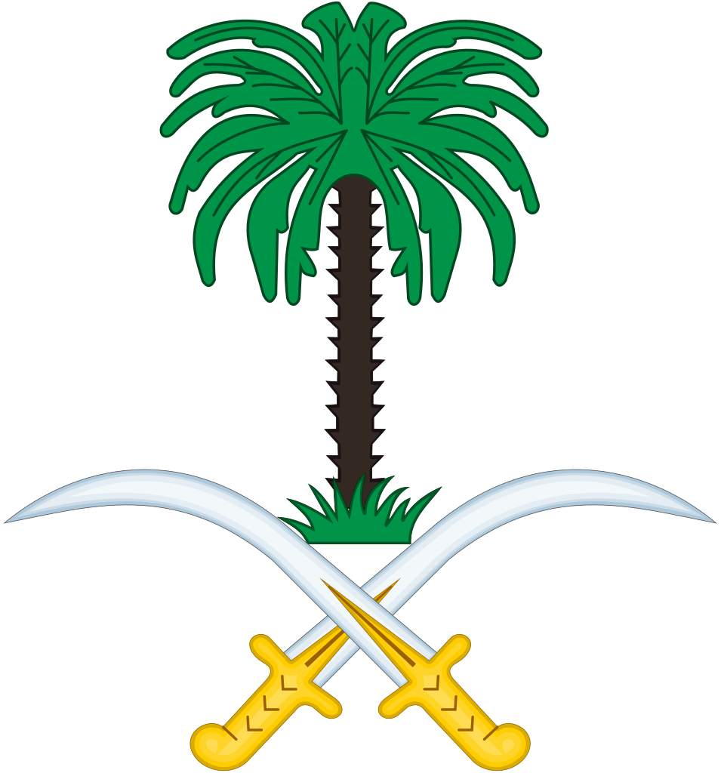
In 1902, a young 21-year-old by the name of AbdulAziz Al Saud, armed with 70 men and a few horses, a gift from the Emir of Kuwait, stormed into his ancestral city of Riyadh and lay siege to it in the dead of night. By the next morning, the head of the governor of Riyadh, Rashid Ibn Ajlan, had been thrown down from the ramparts of the fort. In 1916, with the encouragement and support of Britain (which was fighting the Ottomans in World War I), the Sharif of Mecca, Hussein bin Ali, led a pan-Arab revolt against the Ottoman Empire to create a united Arab state.Although the Arab Revolt of 1916 to 1918 failed in its objective, the Allied victory in World War I resulted in the end of Ottoman suzerainty and control in Arabia and Hussein bin Ali became King of Hejaz.
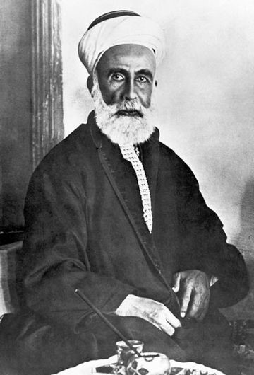
Rashid Ibn Ajlan, the Governor of Riyadh
Ibn Saud avoided involvement in the Arab Revolt, and instead continued his struggle with the Al Rashid. Following the latter's final defeat, he took the title Sultan of Nejd in 1921. With the help of the Ikhwan, the Kingdom of Hejaz was conquered in 1924–25 and on 10 January 1926, Ibn Saud declared himself King of Hejaz.A year later, he added the title of King of Nejd. For the next five years, he administered the two parts of his dual kingdom as separate units.
After the conquest of the Hejaz, the Ikhwan leadership's objective switched to expansion of the Wahhabist realm into the British protectorates of Transjordan, Iraq and Kuwait, and began raiding those territories. This met with Ibn Saud's opposition, as he recognized the danger of a direct conflict with the British. At the same time, the Ikhwan became disenchanted with Ibn Saud's domestic policies which appeared to favor modernization and the increase in the number of non-Muslim foreigners in the country. As a result, they turned against Ibn Saud and, after a two-year struggle, were defeated in 1929 at the Battle of Sabilla, where their leaders were massacred.On 23 September 1932, the two kingdoms of the Hejaz and Nejd were united as the Kingdom of Saudi Arabia,and that date is now a national holiday called Saudi National Day
30 Years later, AbdulAziz had unified a country of tribal nomads and feudalistic families into the State of Saudi Arabia. The same year, his second born, Saud Bin AbdulAziz was nominated as the Crown Prince (The firstborn, Crown Prince Turki Bin AbdulAziz was killed in 1919 and as Saudi Succession follows brothers, rather than sons, the then young child of Turki did not become Crown Prince, and instead his younger brother Saud did).
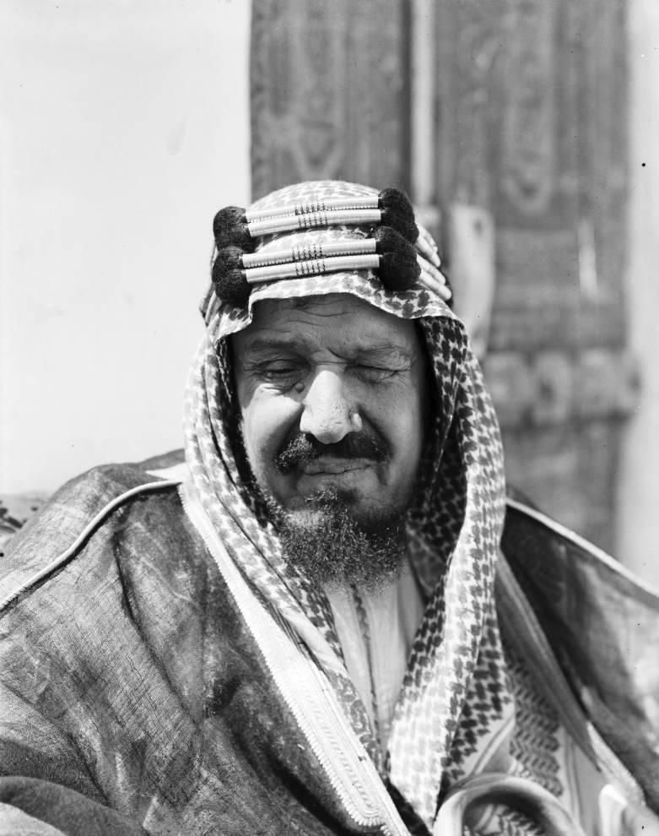
First King of Saudi Arabia, AbdulAziz Ibn Saud

The National Party,South Africa
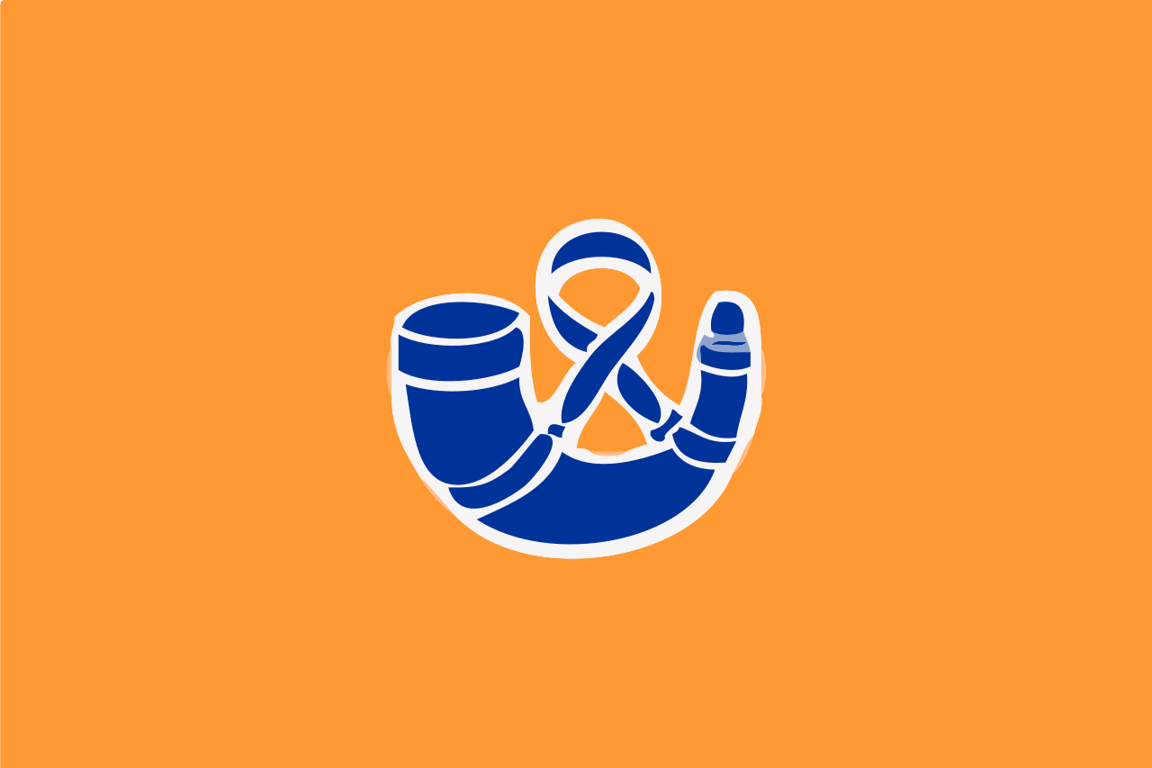
In 1910 the Union of South Africa was established, and the previously separate colonies of the Cape, Natal, Transvaal and the Orange Free State became provinces in the Union. After the 1910 elections Louis Botha became the first prime minister of the Union, and headed the South African Party (SAP) - an amalgam of Afrikaner parties that advocated close cooperation between Afrikaners and persons of British descent.
The founder of the NP, General JBM Hertzog, was a member of the Union Government, and was fiercely and publicly nationalistic. This offended English-speaking South Africans and stood in opposition to Botha’s policies of national unity. However, many Afrikaans people saw Hertzog as their representative and many important Afrikaans political and cultural leaders supported him- particularly people from the Orange Free State and the Cape. Hertzog often publicly disagreed with the opinions of his fellow leaders of the SAP, in particular, those of Prime Minister Louis Botha and General Jan Smuts. He placed the country’s interests above the Britain and saw both, South Africa and Britain as equals.
In May 1913, there were conflicted emotions on whether Hertzog should be a part of the Cabinet or not. At the national SAP Congress in November 1913, in Cape Town, Botha won enough support to keep Hertzog out of the cabinet. This was the last straw for Hertzog and he left the SAP to form the National Party.
From 1 to 9 January 1914, Hertzog’s supporters met in Bloemfontein to form the National Party, and to lay down its principles. The main aim was to direct the people’s ambitions and beliefs along Christian lines towards an independent South Africa. They demanded two things:
- Political freedom from Britain
- Equality of the two official languages, English and Dutch
On 1 July 1914 the National Party of the Orange Free State was born and on 26 August the Transvaal followed. The Cape National Party was founded on 9 June 1915. Since it had no official speakers, Die Burger newspaper was therefore created in the Cape on 26 July 1915 for this specific purpose, with D. F. Malan as editor.
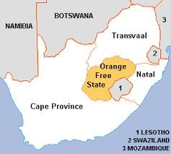
Map showing the different South African States

The NP’s power began to strengthen during World War 1. Most Afrikaners were against South African participation in World War 1 on the side of the British. Therefore, when South Africa was asked to invade German South West Africa (SWA) in August 1914 there was opposition from the ranks of the newly formed National Party (NP), and even from some who were part of the South African government.
The economic depression after the war and dissatisfaction from Black South Africans and other extra-parliamentary groups made the SAP's rule more difficult. The main reason for black anger was Smuts' acceptance of the Stallard report that stated:
”It should be a recognised principle that natives (men, women and children) should only be permitted within municipal areas in so far and for as long as their presence is demanded by the wants of the white population. The masterless native in urban areas is a source of danger and a cause of degradation of both black and white. If the native is to be regarded as a permanent element in municipal areas there can be no justification for basing his exclusion from the franchise on the simple ground of colour.” (This report later led to the passing of the Natives (Urban Areas) Act no 21 of 1923).
The death of General Louis Botha in 1919 pushed away more of the SAP supporters, and by the end of the Great War many of the SAP’s supporters had left the party and joined the others.
In the 1920 elections, SAP realised that they would need to form a combined cabinet for political stability. Members of both parties met at Robertson on 26 and 27 May 1920, and made a potential agreement. On 22 September the two parties met again, but they could not finalize an agreement. The main point of disagreement concerned South Africa’s relationship with Britain - Hertzog wanted independence, while Smuts was happy with the situation as it was.
The Rand Rebellion of 1922 further strengthened the popularity, as it led to cooperation between the National Party and the Labour Party (LP). The Rebellion was the result of severe labour unrest that had been simmering for some time. Both parties wanted to protect White labour, and decided to make a pact in April 1923 that would ensure that they would not oppose each other in the elections, and would support each other’s candidates in certain areas. This Pact resulted in the defeat of the SAP in the 27 June 1924 general elections. Afrikaans then became an official language and the country got a new flag.
After the Pact Government's 1924 election victory, South Africa had a new government. Hertzog was Prime Minister and also Minister of Native Affairs. o express his gratitude to the Labour Party (for their help in getting him into power) Hertzog included two English-speaking Labour Party men in his cabinet, namely Colonel F. H. P. Creswell, as Minister of Defence, and T. Boydell, as Minister of Public Works, Posts and Telegraphs.
The Hertzog government curtailed the electoral power of non-Whites, and furthered the system of allocating “reserved” areas for Blacks as their permanent homes- while regulating their movements in the remainder of the country.
In 1926 South Africa’s position in relation to Britain was made clear in the Balfour Declaration, drawn up at the Imperial Conference of the same year. The Declaration became a law in 1931.
The Pact Government managed to keep the white voters happy, and five years later in the 1929 election, they were able to win again - therefore securing a second term, from 1929 to 1934. After the 1929 election Hertzog still gave his Pact partner, the LP, some representation in the new cabinet - with Colonel F. H. P. Creswell keeping the portfolios of Defence and Labour, while H. W. Sampson was named Minister of Posts and Telegraphs.
The Great Depression, from 1930 to 1933, made the government’s rule difficult. Britain left the gold standard on 21 September 1931, and Tielman Roos returned to politics in 1932 to oppose Hertzog in his position to retain the gold standard. His campaign was successful and the government met their demand.
Over time, the difference between the NP and SAP became smaller, and in 1933 the two parties merged to form a coalition government. The two parties were named the United Party (UP) in 1934, but D. F. Malan and his Cape NP refused to join. He remained independent to form the new opposition, which was called the Purified National Party (PNP).

The National Christian Party, Romania
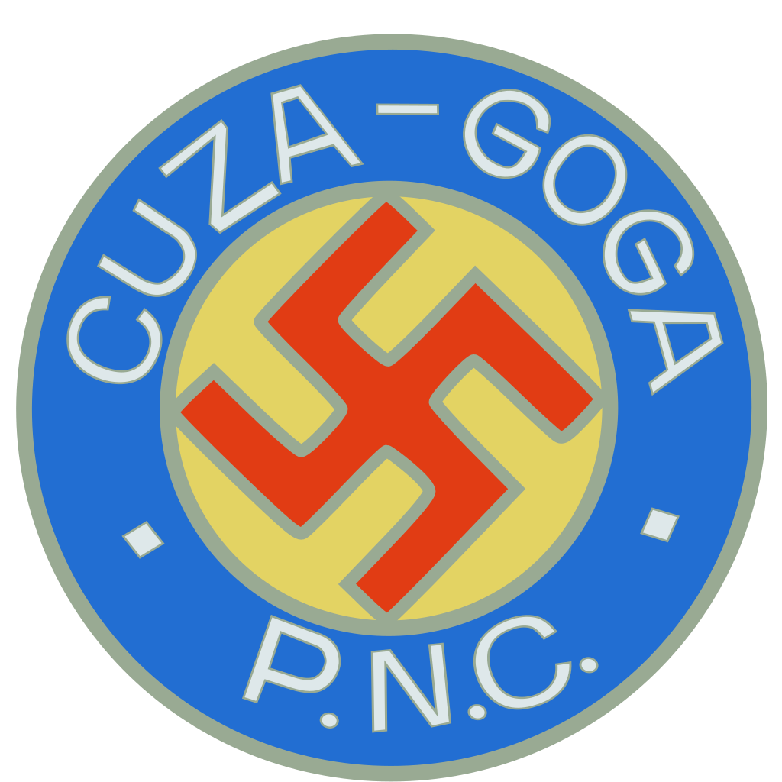
The National Christian Party government of Octavian Goga. and Alexandru C. Cuza, which came to power on December 27, 1937, was "the first Germanophile government which Romania had had in a quarter century. "
After its creation in 1935 as a nationalistic and virulently anti-Semitic party of the Conservative Right, 2 the National Christian Party was unquestionably the leading competitor of the well-known Right-radical Iron Guard among the new breed of Romanian political "parties”3 which developed while the two traditional parliamentary parties, the National
Liberals and National Peasants were decaying as a result of the anti-party machinations of King Carol the Second and their own internal lack of integrity.
In addition, the National Christian Party—before 1935 Goga's National Agrarian Party—was the principal Romanian recipient of German National Socialist support in the 1930's, despite the closer ideological affinity of the Iron Guard movement to Nazism.And finally, Goga's and Cuza's ideas survived their regime's precipitate fall from power in February, 1938. Their principles continued to exert considerable influence on Romanian politics by virtue of the altered domestic and international situations left to the National Christian Party government's successors, and by virtue of the fact that the civilian bureaucracy of wartime dictator Ion Antonescu's regirne was staffed with a preponderance of one-time
Gogacuzist adherents

The Nationalist Socialist Movement, Netherlands
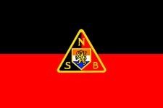
Nationaal Socialistische Beweging or NSB, was a Nazi movement in the Netherlands. The NSB was established in 1931 by the Dutch nationalist Anton Adriaan Mussert. Its platform borrowed full paragraphs from that of the German Nazi Party, but left out all paragraphs referring to Jews.
The NSB was founded in Utrecht in 1931 during a period when several nationalist, fascist and national socialist parties were founded. The founders were Anton Mussert, who became the party's leader, and Cornelis van Geelkerken. The party based its program on Italian fascism and German national socialism, however unlike the latter before 1936 the party was not anti-semitic and even had Jewish members.
In 1933, after a year of building an organization, the party organized its first public meeting, a Landdag in Utrecht which was attended by 600 party militants. Here the party presented itself. After that the party's support began to grow. In the same year the government forbade civil servants to be members of the NSB.
Practical demands of the NSB were: abolition of individual voting rights, corporatism, a duty to work and serve in the army, limits on the freedom of the press, laws against strikes. It demanded a unification of the Netherlands with Flanders and French Flanders in a Greater Netherlands, which would also control a large colonial empire consisting of Belgian Congo, Dutch East Indies and perhaps South Africa. This state would not be a part of Germany, but only an independent loyal ally to Germany.
This result was achieved against the background of the economic hardship of the Great Depression. Mussert's image as a reliable politician and his pragmatism allowed him to unite the different types of fascism and contributed to the party's success. This was bolstered by the party's strong organization and its political strategy, which was not oriented towards violent revolution but a democratic legal take over of the country.
The NSB wanted a strong state with a strong leader that would deal with the problems. It had its own Weer Afdeling (WA). WA members formed a sort of assault team within the NSB. They were feared, hated, and despised. They often marched singing loudly through the streets. The NSB also published its own weekly newspaper Volk en Vaderland (People and Fatherland).

The Lithuanian Nationalist Union
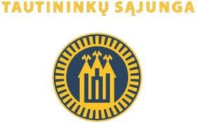
The Lithuanian Nationalist and Republican Union (Lithuanian LTS), also known as the Nationalists is a nationalist, right-wing political party in Lithuania, founded in 1924 when the Party of National Progress merged with the Lithuanian Farmers' Association. It was the ruling party of Lithuania from the 1926 Lithuanian coup d'état in December 1926.
The party did not enjoy popular support and in the May 1926 parliamentary elections and won only 3 seats out of 85. However, its leaders Antanas Smetona and Augustinas Voldemaras were popular and influential public figures. The party was conservative and nationalistic; it stressed the need for a strong army and a strong leader.
During the December 1926 coup, the military deposed the democratically elected government and invited Smetona to become the new President of Lithuania, and Voldemaras the new Prime Minister. The Nationalists and the Lithuanian Christian Democrats formed a new government. However, the relationship between the two parties soon became tense as Christian Democrats regarded the coup as a temporary measure and wished to hold new elections to the Seimas. In April 1927 Smetona dissolved the Seimas and in May Christian Democrats resigned from the government. The Nationalists remained the only party in power.
Voldemaras established Iron Wolf (Geležinis Vilkas) as the paramilitary wing of the Nationalists. Political opponents were incarcerated. The new constitution of 1928 established a presidential dictatorship. In 1929, Smetona removed his party colleague Voldemaras from the office of prime minister and ruled autocratically.
The Nationalist Union had initial sympathies and contacts with the Mussolini regime.Prior to 1923, Memelland had been Prussian for five centuries – since 1422. Before it was the land of Balto-speaking Curonians, Teutonic Order conquered Curonians during Northern Crusade and territory was colonized by Germans during Ostsiedlung. On January 10, 1923, Lithuanian militia, dressed as civilians, entered Memel and staged the “Klaipėda Revolt.” Soon after, a program of intense Lituanization began. German teachers and officials were dismissed and replaced by counterparts from Kaunas. The tie of the region's Lutheran congregations to the Prussian ecclesiastical hierarchy was severed. Most of the region's population were Lutherans and considered themselves to be
East Prussians, including the Lithuanian-speaking,
“Memellanders/Klaipėdiškiai.” Hitler's call for the integration of German-speaking peoples resonated with the local population, who organized groups to resist the Lithuanian occupation of their homeland. In response, on February 8, 1934, the Lithuanian government adopted a law making it a criminal offense to denigrate or insult the Lithuanian nation, people, state symbols, or flag, or to work for "foreign" interests against Lithuania. Under this law, actions were taken against Nazi-inspired organizations in the Klaipėda region. From July 1934 to March 1935, Lithuania prosecuted Ernst Naumann and Theodor Freiherr von Sass and 120 of their followers on charges of anti-state activity. Most of the accused stated that they viewed Klaipėda to be part of Germany. Eighty-seven were convicted. Those convicted were not Nazi war criminals. They were Prussian-German irredentists who were convicted of wanting their land returned to Germany.

The National Union, Portugal
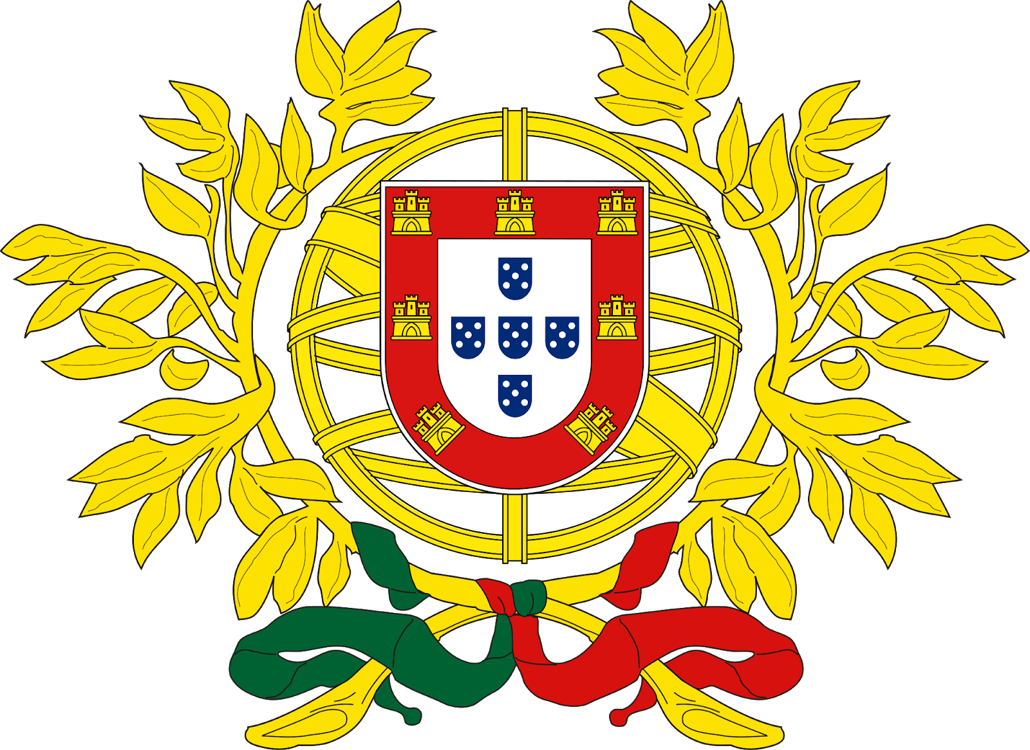
The National Union is the sole legal party of the Estado Novo regime in Portugal. Ideologically the National Union is an authoritarian, clerical fascist organisation. It was founded in July 1930 and dominated by António de Oliveira Salazar during most of its existence.
Unlike in most single-party regimes, the National Union was more of a political arm of the government, rather than holding actual power over it. The National Union membership was mostly drawn from local notables: landowners, professionals and business men most of them catholics, monarchists or conservative republicans. The National Union was never a militant nor a very active organization.
Once Salazar assumed premiership the National Union became the only partner legally allowed to function under the Estado Novo
The party was founded in 1930 during the period of the Ditadura Nacional. Officially it was not a political party, but an "organisation of unity of all the Portuguese". Salazar in the speech that launched the party was vague in terms of its role and he incorporated all the parties supporting the dictatorship, whether republican, monarchic or catholic. Its first organic principles expressly declared that “all citizens, regardless of their political or religious beliefs” would be admitted as long as they adhered to the principles of Salazar’s speech of 30 June 1930.
The National Union was formed as a subservient umbrella organisation to support the regime itself. It was the only party legally allowed under the Estado Novo regime, all other political parties were banned and persecuted, this later included the National Syndicalists, led by Francisco Rolão Preto, who were originally supporters. In 1934 Salazar arrested and exiled Francisco Rolão Preto as a part of a purge of the leadership of the Portuguese National Syndicalists. The Portuguese National Syndicalists broke into factions, some going into exile while the majority ended up joining the National Union. Salazar denounced the National Syndicalists as "inspired by certain foreign models" (meaning German Nazism) and condemned their "exaltation of youth, the cult of force through direct action, the principle of the superiority of state political power in social life, [and] the propensity for organising masses behind a single leader" as fundamental differences between fascism and the Catholic corporatism of the Estado Novo.
The National Union ideology was corporatism, and it took as many inspirations from Catholic encyclicals such as Rerum novarum and Quadragesimo anno as well as from Mussolini's corporate state.Compared to other ruling Fascist parties, the National Union played a much smaller role in its regime. The National Union was set up to control and restrain public opinion rather than to mobilize it, and ministers, diplomats and civil servants were never compelled to join the party. The party had no real philosophy apart from support for the regime.

The Fatherland Front, Austria
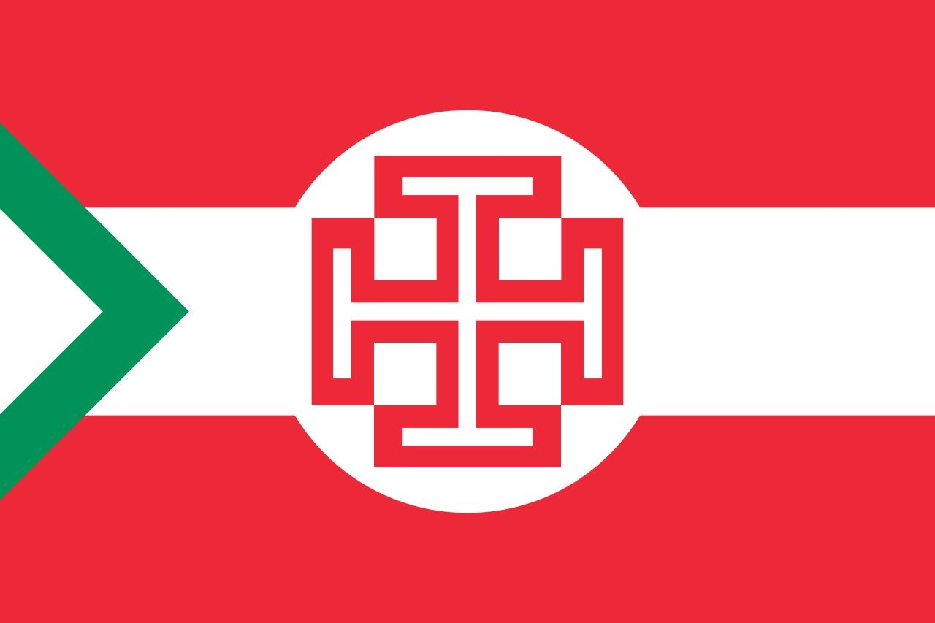
After World War I and the dissolution of Austria-Hungary sealed by the 1919 Treaty of Saint-Germain, three political camps controlled the fate of the Austrian First Republic: the Social Democrats, the Christian Social Party, and the German nationalists, organised in the Greater German People's Party and the Landbund. Since 1921 the Christian Social Party had formed coalition governments along with the German nationalists; Chancellor Ignaz Seipel, a proponent of Catholic social teaching, advocated the idea of a "corporated" state surmounting the parliamentary system, based on the encyclicals Rerum novarum (1891) by Pope Leo XIII and Quadragesimo anno (1931) by Pope Pius XI.
On 10 May 1932, the Christian Social politician Engelbert Dollfuss was designated Chancellor of Austria by President Wilhelm Miklas. Dollfuss formed another right-wing government together with the Landbund and the Heimatblock, the political organisation of the paramilitary Heimwehr forces. He began to surpass the slim majority of his government in parliament ruling by emergency decrees, and on 15 March 1933 finally prevented the gathering of the National Council. Two months later the "Fatherland Front" was founded by Chancellor Dollfuss as a merger of his Christian Social Party, the Heimwehr forces and other right-wing groups, and was intended to collect all "loyal Austrians" under one banner.
While the Front's aim was to unite all Austrians, superseding all political parties, social and economic interest groups (including trade unions), it only enjoyed the support of certain parts of the society. It was mainly backed by the Catholic church, the Austrian bureaucracy and military, most of the rural population—including both landowners and peasants—(with its centre of gravity in western Austria), some loyalists to the Habsburg dynasty, and a significant part of the large Jewish community of Vienna. The VF was strongly linked with the Catholic student fraternities of the Cartell-Verband—that maintained networks similar to old boys in English-speaking countries—in which most VF leaders had been members.
In contrast, it was in a two-fronts conflict with the Social Democrats, supported by unionised workers and having its stronghold in the capital Vienna and other industrialised towns, and their paramilitary Republikanischer Schutzbund ("Republican Protection League")—whose February 1934 uprising (or "Austrian Civil War") was crushed in a few days—on the one, and Austrian Nazis on the other hand. The latter, having taken over Austria's older pan-German nationalist current, were supported by a part of the secular, urban middle and lower middle class, including civil servants and public sector workers, professionals, teachers and students. However they did not have a mass following as in Germany.
The Fatherland Front, which was strongly linked with Austria's Catholic clergy, absorbed Dollfuss's Christian Social Party, the agrarian Landbund and the right-wing paramilitary Heimwehren, all of which were opposed to socialism, free-market capitalism and liberal democracy. It established an authoritarian and corporatist regime, the Federal State of Austria, which is commonly known in German as the Ständestaat ("corporate state"). According to the Fatherland Front this form of government and society implemented the social teaching of Pope Pius XI's 1931 encyclical Quadragesimo anno. The Front banned and persecuted all its political opponents, including Communists, Social Democrats—who fought against it in a brief Civil War in February 1934—but also the Austrian Nazis who wanted Austria to join Germany.
On 30 May 1933, the government banned the Republikanischer Schutzbund, the paramilitary troops of the Social Democratic Party; the Communist Party and the Austrian Nazi Party were prohibited shortly afterwards. From 12 February 1934 onwards, the remaining Schutzbund forces revolted against their disbanding, sparking the Austrian Civil War against Heimwehr troops and the Austrian Armed Forces. After the suppression, the Social Democratic Party too was declared illegal and dissolved. Social Democratic officials like the Vienna mayor Karl Seitz were deposed and replaced by VF politicians.
On May 1, the Federal State of Austria was declared a one-party state under the authoritarian leadership of the VF. Thereafter, the organisation held a monopolistic position in Austrian politics with both civilian and military divisions. Dollfuss remained its undisputed leader until his assassination during the Nazi July Putsch on 25 July 1934. He was succeeded by Ernst Rüdiger Starhemberg, while his VF fellow Justice Minister Kurt Schuschnigg became chancellor.

X-X-X
Looking forward to seeing you at SMUN 2019 and wishing you all the very best in your research,

Adnaan Naveet On behalf of the Dias

​The Rise of Italian Fascism (1919-1922): Changing Social Relations in Revolutionary Periods by Roberto Franzosi, Emory University and Italian Academy of Columbia University
​The doctrine of Fascism by Benito Mussolini
For further reading, see Mussolini and the Italian Industrial Leadership in the Battle of the Lira 1925-1927 by Roland Sarti
See Austerity and repressive politics: Italian economists in the early years of the fascist government,LEM Working Paper Series, No. 2015/17
For a detailed understanding of inflation, see An understanding of Inflation
​For more reading, see National Collection - participation and recruitment, NDLA National Collection, Great Norweigien Encyclopedia
See Gareth Jones notes. February 1935, Interview with Amau
For information of the Reaction of the US to this doctrine, see The Ambassador in Japan (Grew) to the Secretary of State( April 20, 1934) published in FOREIGN RELATIONS OF THE UNITED STATES DIPLOMATIC PAPERS, 1934, THE FAR EAST, VOLUME III
For more information on the Amau Doctrine, see The Literary Encyclopedia. Volume 10.2.2: Japanese Writing and Culture.
Abolishment of the Democracy and the restoration of the Emperor with a close group of advisors
​Field Marshal Prince Yamagata Aritomo,traced the lines of a defensive strategy against Russia and was the first propagator of this preemptive strike against the USSR. A February 1907 Imperial National Defence guideline envisioned two strategies: Nanshu Hokushin Ron (南守北進, defence in the South and advance in the North) and Hokushu Nanshin Ron (北守南進, defence in the North and advance in the South)
The Mukden Incident, or Manchurian Incident, was an event staged by Japanese military personnel as a pretext for the Japanese invasion in 1931 of northeastern China, known as Manchuria.
Murphy’s ranch
In an editorial piece for the Liberation known as “The fate awaiting the Hebrews” ²⁴Why the Silver Shirts are fighting the Influence of the Jew ²⁵As quoted by him.
Republic of Ireland
Party Conference
Éamon de Valera was the leader of the group within the Sinn Féin who opposed the Anglo Irish Treaty ³³The Oath of Allegiance was highly controversial, mostly because of its content, which said: "I (name) do solemnly swear true faith and allegiance to the Constitution of the Irish Free State as by law established, and that I will be faithful to H.M. King George V​, his heirs and successors by law in virtue of the common citizenship of Ireland with Great Britain and her adherence to and membership of the group of nations forming the British Commonwealth of Nations."
Republicanism is a representative form of government organization,a political ideology centered on citizenship in a state organized as a republic.
The Labour Party,which proclaimed itself as a “democratic socialist Party” was lead by Thomas J. O'Connell and had won only 7 seats in the Parliament
Meeting immediately after the overthrow of the quing dynasty, the revolutionary provincial assembly representatives held a conference in the district of Wuchang, China, which framed the organizational outline of the Provisional Government.
As Hitler and other members of the Nazi party were under arrest after the failed beer hall putch, the National Socialist Freedom Movement contested in elections in the place of the NSDAP
N. P. Petrescu-Comnéne, Preludi del Grande Dramma (Roma, 1947), p. 340. Petrescu-Comnene was Romanian Minister to Berlin from 1928 to 1930 and from 1932 to 1938.
Lucretiu Patrascanu, one of the most perceptive observers of Romanian interwar politics wrote in his Sub Trei Dictaturi (Bucuresti, 1944), p. 36: "In fact, these two political groupings —neither called itself a party in the beginning—constituted the fascist movement of Romania. All of the other organizations which called themselves national socialist, national, or wallachist, had ephemeral existences and never played any role of importance.”
In his excellent introduction to Hans Rogger and Eugen Weber, eds., The European Right : A Historical Profile (Berkeley and Los Angeles, 1966), Eugen Weber defines the three major components of the political Right as (a) Reaction against the tendencies of the present, looking back to some more or less remote golden age which it would like to recapture; (b) Resistance to change or conservatism, defending the established socio-political order, but willing to accept reforms if they conform to the habits and traditions of the society in question; and (c) Radicalism, seeking revolutionary change usually by violent means, yet uncertain of explicit goals except the conquest of total power. No absolute dividing lines can be made among these components, since for example, radicals and reactionaries may share certain characteristics (e.g., rejection of the existing order and a propensity for violence), and conservatives may adopt radical positions and tactics when important issues or interests are involved. Nevertheless, Professor Weber's distinctions can be very useful analytical tools, and it is according to his definitions that the terms conservative Right-radical, and reactionary Right are used in this essay. The National Christian Party adopted certain outward trappings of Right-radicalism yet remained in essence an establishment party. Its repudiation of economic and civil rights concessions granted to Jews in the aftermath of World War 1 should be viewed less as a reactionary revolt against the status quo than as a denial of the contention that these concessions, imposed on the country by the victorious Allied and Associated Powers, had become part of the established socio-political order.
This essay is part of a longer study, "German Foreign Policy and the Romanian National Christian Party," prepared by the author in the winter of 1971-72. The original study included extensive material on the personal and political backgrounds of the PNC founders Goga and Cuza and on the nature and extent of German support of Romanian opposition parties. In the present essay this material is included—in summary form—only where it pertains directly to the domestic fortunes of PNC,
For accounts of the rise and fall of the National Liberal Party and the National Peasant Party, see R. W. Seton-Watson, A History of the Roumanians from Roman Times to the Completion of Unity (London, 1934) and Henry L. Roberts, Rumania: Political Problems of an Agrarian State (New Haven, Conn., 1951). Roberts' chapters on the Carolist period (pp. 170-223) still constitute the best study of the decline of the Liberals and National Peasantists.

