16 November 2017
IMPORTANT UPDATE – PICTON FERRY TERMINAL LOCATION

Dear Valued Partners
We are writing to advise you of minor disruptions that your clients may experience over the next few months when collecting rental vehicles at the Picton Ferry Terminal.
Due to building safety concerns at the Picton Ferry Terminal, Car Rental suppliers are being moved to temporary offices within the Inter-Island offices for a period of approximately 6 weeks.
The Hertz offices are in the process of being moved and the Port Authority are ensuring that all customers arriving into Picton will be directed to the new collection points for rental vehicles.
The temporary space, will at peak times cause some delay however Hertz will continue to operate two system terminals at the counter and we would like to assure our customers that both Hertz and the Port Authority are working together to ensure disruption during this period is minimal.
All Hertz Phone numbers and contact details will remain the same. Our service centre in Picton is unaffected by this change so there will be no adverse effect on our vehicle turnaround and availability. Our team at Picton will be available to liaise with Customers at the rental offices. To speed process, we will where possible be pre-printing rental documents to minimises further delays or disruption.
We do apologise in advance for any inconvenience that may be caused to your clients and our customers in Picton over the next few months. please be assured will be doing our very best to ensure we can make your customers experience as faultless and stable as possible.
For your information only, please see below images of the new temporary facilities.
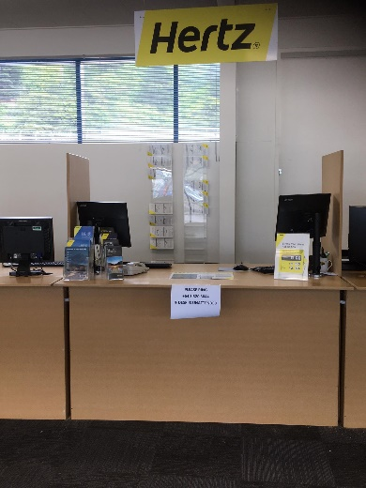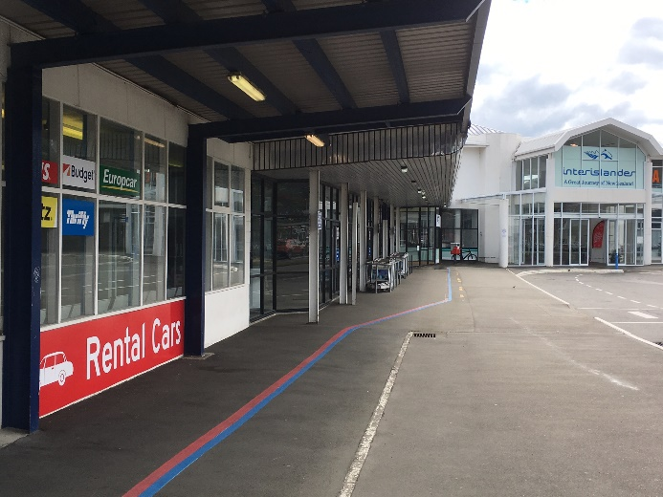

Please ensure your team and your customers are advised if these changes.

For further information or queries please contact Hertz Travel Distribution Department on +64 9 367 6368, or alternatively email apactours@hertz.com.

Thank you for your continued support.

