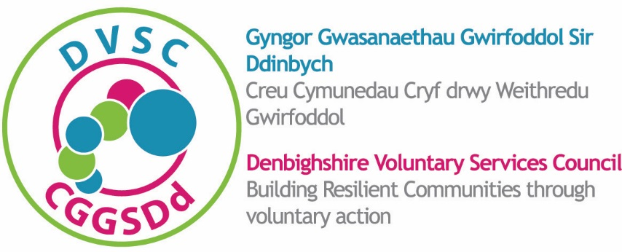
DVSC TRAINING BOOKING FORM
FFURFLEN ARCHEBU HYFFORDDIANT CGGSDd

COURSE TITLE:
TEITL Y CWRS:
VENUE:
LLEOLIAD:
DATE:
DYDDIAD:
COMPANY NAME:
ENW’R CWMNI:
ADDRESS:  CYFEIRIAD: |  | CONTACT NUMBERS:  RHIFAU CYSWLLT:
Postcode:  Cod Post: |  | Tel:  Ffôn:
Mobile:
Ffôn Symudol:
E-mail:
E-bost:
DVSC MEMBER: Yes/No (delete as applicable)
AELOD CGGSDd: Ie / Na (dileër fel bo’n briodol)
COST OF COURSE: £
COST Y CWRS: £
AMOUNT PAID: £ by BACS/CHEQUE (delete as applicable)
SWM A DALWYD: £ trwy DALIAD ELECTRONIG / SIEC
(dileër fel bo’n briodol)

DELEGATES  CYNRYCHIOLWYR | JOB TITLE  TEITL SWYDD | PLEASE STATE ANY SPECIAL REQUIREMENTS  NODWCH OS OES UNRHYW OFYNION ARBENNIG

Please return this completed form to / Dychwelwch y ffurflen hon, ar ôl ei chwblhau, at
e-mail/e-bost: debbien@dvsc.co.uk

Or return the form to / Neu postiwch y ffurflen i:
Naylor Leyland Centre / Canolfan Naylor Leyland
Well Street / Stryd y Ffynnon
Ruthin / Rhuthun LL15 1AF

BACS Payment / Taliad electronig
Account holder / Deilydd y cyfrif: NEWVOL
Sort Code / Cod didoli: 20-25-76
Account no / Rhif y cyfrif: 90446432

Places will be allocated on a first come first served basis.
Rhoir lleoedd ar sail y cyntaf i’r felin.
Charging for cancellation of training courses
Codi tâl am ganslo lle ar gwrs hyfforddiant

A £25.00 charge will be made if a cancellation is not received within one week of the course commencement date. Suitable replacement names will be accepted.
Codir tâl o £25.00 os na dderbynnir hysbysiad yn canslo’r lle ar y cwrs o fewn wythnos i ddyddiad dechrau’r cwrs. Derbynnir enwau unigolion addas i ddod ar y cwrs yn eu lle.
Cancellations and changes MUST be sent to DVSC in writing (e-mails are acceptable) so that an audit trail is in place.

RHAID anfon hysbysiad canslo a newidiadau yn ysgrifenedig i Gyngor Gwasanaethau Gwirfoddol Sir Ddinbych (mae e-bost yn dderbyniol) fel bod trywydd archwilio’n bodoli.

