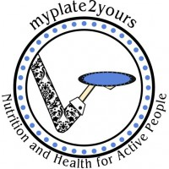
PB Blueberry Banana Smoothie
MyPlate2Yours - Lynn Dugan

Serving Size: 2

Ingredients
1/2 cup vanilla yogurt
1/2 cup milk
1/4 cup quick oats
1/2 large banana
1/2 cup frozen blueberries
2 tablespoons creamy peanut butter

Directions
Blend on high for 1 minute until smooth. Pour into two glasses. Enjoy!

