1. | January | 43. | become  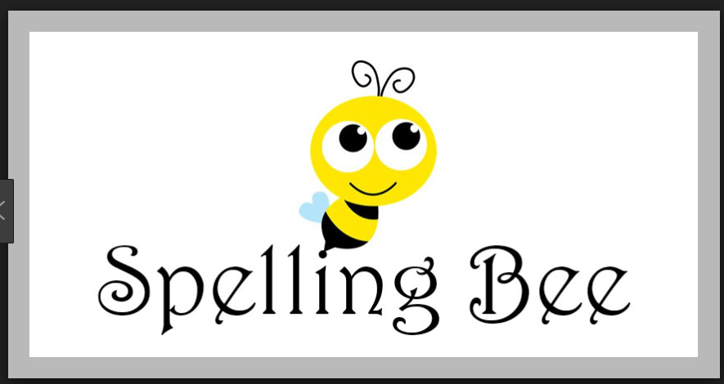
2. | February | 44. | became
3. | March | 45. | begin
4. | April | 46. | began
5. | May | 47. | bite
6. | June | 48. | bit
7. | July | 49. | blow
8. | August | 50. | blew
9. | September | 52. | break
10 | October | 53. | broke
11 | November | 54. | bring
12 | December | 55. | brought
13. | one | 56. | buy
14. | two | 57. | bought
15. | three | 58. | catch
16. | four | 59. | caught
17. | five | 60. | choose
18. | six | 61. | chose
19. | seven | 62. | come
20. | eight | 63. | came
21. | nine | 64. | do
22. | eleven | 65. | did
23. | twelve | 66. | drink
24. | thirteen | 67. | drank
25. | fourteen | 68. | eat
26. | fifteen | 69. | ate
27. | sixteen | 70. | fall
28. | seventeen | 71. | fell
29. | eighteen | 72. | feel
30. | nineteen | 73. | felt
31. | twenty | 74. | fight
32. | thirty | 75. | fought
33. | forty | 76. | find
34. | fifty | 77. | found
35. | sixty | 78. | fly
36. | seventy | 79. | flew
37. | eighty | 80. | get
38. | ninety | 81. | got
39. | be | 82. | give
40. | was | 83. | gave
41. | were | 84. | go
42. | beat | 85. | went
 |  | 86. | have
 |  | 87. | had

