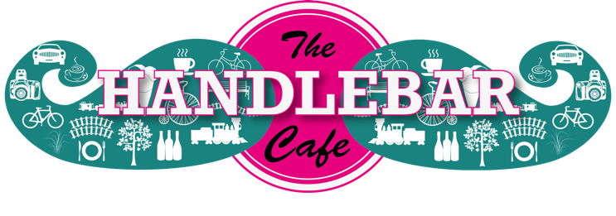

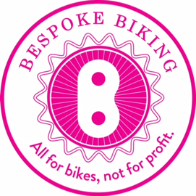
Press Release

Winchester’s Handlebar Café spins into action

The Handlebar Café, Winchester’s highly anticipated community project, is open for business following its official launch on Sunday 29 September.

The new community café and bike workshop is the brainchild of a group of local teenagers who five years ago worked with Hampshire-based charity SPUD (as part of their spudYOUTH programme) to design a bicycle café located on the old railway track at the bottom of St Catherine's Hill, Winchester.

After extraordinary community support from local businesses, individuals and the local authorities, over £350,000 was raised turning their concept into a reality with Handlebar Café officially opening for business yesterday.

Over [1500] people attended the launch event, who were encouraged to walk or cycle sporting a ‘handlebar’ moustache. The five teenagers Alex Grice, Sebbie Mc-Donald Maskell, Nick Tsangaris, Joshua Snow and George Judge who were part of the original design team in 2013 and have now completed or are about to start studying architecture at university, officially opened the Handlebar Café. VIPs at the opening included the Mayor of Winchester and Bishop David of Basingstoke.

Quote from Joshua Snow (spudYOUTH teenager):

“It's such a strange feeling being able stand there and look at something that was just an idea a few years ago and has now become such an amazing project. I’ve learnt so much from being part of this amazing project and really looking forward to starting my degree in Architecture.”

Mark Drury, Director, SPUD said:

“this is the culmination of a tremendous amount of hard work by all the team involved. The support from the local authorities, local businesses and individuals has been truly incredible and without it we could not have reached this point. It’s been a fantastic journey working with all the team and in particular the young people. SPUD believes passionately in enabling young people to make take an active role in their community and make a real difference.”

Heather Evans, Director, Bespoke Biking said:

“We are passionate about encouraging and helping everybody, no matter what their age or ability, to cycle. After over five years of dreaming, planning and building, the Handlebar Café is now a reality. We are so excited and proud to see it complete and open for business in its beautiful Winchester setting. Alongside our main Bike Hub in the centre of town, we are delighted to offer the Handlebar Café as a fantastic destination to walk or ride to. We can’t wait for people to come and taste our great coffee, cakes and locally sourced sausage rolls, pies and pastries.

“Our aspiration is for the Handlebar Café to become a focal point for the local community and visitors, helping everyone appreciate the area’s fantastic natural environment. We are looking forward to continuing our partnership work with Hampshire and Isle of Wight Wildlife Trust to help enhance the area and encourage the public to come and enjoy everything that this wonderful beauty spot has to offer.”

About the Handlebar Café (St Catherine's Hill, Garnier Road car park, Winchester SO23 9PA):

The cycle themed Handlebar Café is a community cafe and small bike workshop on the viaduct cycle and walking path at the foot of St Catherine's Hill, south of Winchester. Echoing the shapes of two train carriages passing on the railway bridge, it is crafted largely from timber and is a model of sustainable design.

Open seven days a week 0830-1730 the Handlebar Café offers:
- Food, drinks and refreshments
- Bike workshop for roadside and basic get-you-home bike repairs
- Cycling accessories
- Bike Maintenance classes
- Information on local walks and rides around the area
- Organised cycle rides and community events

SPUD is an award-winning arts charity that brings people together to collaborate on educational, art and architectural projects. SPUD is responsible for the Cycle Café concept and has been client, project manager, fundraiser and now owner of the building.

Local Community Interest Company, Bespoke Biking, is the tenant and operates Handlebar Café and bike workshop.

Contact details:

Bespoke Biking - Heather Evans - heather@bespokebiking.com 07920 776994
SPUD - Mark Drury mark@spudgroup.org.uk 07881950196

Architects: architecturePLB
Construction Team: Bespoke Modular Developments and BlueFish Construction
Engineers: ARUP

Notes to editors:

About SPUD
A world leader in developing collaborations involving art, architecture and education.

SPUD is committed to promoting quality design and increasing engagement for people of all ages in understanding and influencing the nature and quality of the places where they live.
﻿
We believe that a broad understanding within professionals and the public of what makes a good place in which to live and work is vital in creating healthy, vibrant and sustainable communities.
​
We deliver projects with people from all age groups, backgrounds and abilities - often bringing groups together who may not normally collaborate. This approach adds to the vibrancy and creativity of the work we do.
﻿
We can bring a wide range of experience and knowledge to projects involving education, training, consultation, strategy and advocacy, across the disciplines of the arts, architecture, urban design and placemaking.
​
SPUD has delivered projects nationally and internationally.
www.spud.org.uk

About Bespoke Biking
Bespoke Biking is a not for profit, social enterprise. We are a team of people who love cycling and enjoy cycling around the area. We are dedicated to helping people realise how easy and fun cycling is, especially riding in a group. We have taught adults and children who have never ridden; we also have a great team of mechanics ready to fix, service or repair your bike. Added to that we take donated bikes, refurbish them and find them new homes.

Major Sponsors:
Winchester City Council and Town Forum
Hampshire County Council
Sport England
Utilita
James Lathams (timber)
Accsys Technologies (timber)
Redevco Foundation
Garfield Weston Foundation

Key Delivery Partners/Sponsors:
ArchitecturePLB
ARUP
Bespoke Modular Developments
BlueFish Construction

Cycle Sculpture PRESS RELEASE:

‘Handlebar People’
By Nadine Collinson

The Handelbar Café – a SPUD Youth Community programme and the brainchild of and driven to fruition by Mark Drury.

When I first met Mark in Coffee lab, Winchester back in 2017 he handed me a gift of wonderful coffee beans in an organic box. He proceeded to tell me about the incredible work he champions with the SPUD Youth Community Programme. I was fascinated. His vision to create a café at the very origin of the South Downs Way to congregate cyclists, walkers, runners, dog walkers, horse riders alike and to encourage outdoor activity for all is inspirational. When he told me that the construction would all be cited on top of a Victorian railway bridge at the foot of St Catherine’s Hill, my mind started to whir.

Those who use South Downs Way are all individuals, each with their own skills, ambitions and stories to tell. They enjoy the beautiful pathways, people of all ages and from all walks of life, able bodied and otherwise. But when the human race is otherwise occupied, Hampshire’s natural inhabitants take advantage of the natural habitat - a whole host of wildlife who inhabit this land. Occasionally we are blessed with the glimpse of a deer – a special moment to cherish and remember. Their presence is just as important to the heritage as is our own history.

For this sculpture, I gathered elements from all of these characters and gave them a Steampunk flavour, transcending time and amalgamating modern technology with classical machinery, instruments and pastimes.

‘Handlebar People’ represents a family with their friends; father, mother, teenage biker/punk and ballet dancing daughter. All enjoying each other’s company and leaping as if they were deer, happy, carefree and enjoying the outdoor air.

To really appreciate the South Downs Way you can transport yourself to another time, turn off your phone (if you dare) and imagine you exist 100 years ago. What would Winchester have looked like then? What would you be wearing? What would your kitchen look like at home? But I expect the view of the path in front of you wouldn’t be much different to how you see the majority of it today.

The South Downs Way – escape, exercise or just amble/cycle with a friend - it is all there to be enjoyed.

