Brainstorm (5 min)

Setting
Describe your setting here: __________________________________________________________________________________________________________________________________________
_______________________

Character 1
Describe your main character here: __________________________________________________________________________________________________________________________________________
_______________________

Character 2
Here, describe your secondary character (if you have one): __________________________________________________________________________________________________________________________________________
_______________________

SIMPLE Short story plot
Write a 3-Act Short Story in 30 Minutes (6 Steps)

Writing Prompt Examples
Find more at www.thewritepractice.com/short-story-ideas/
- Tell the story of a scar, physical or emotional.
- They couldn’t believe what they saw.
- A young prodigy loses everything.
- She swore it was a ghost.
- Start a timer for 30 minutes.
- Choose a prompt (2 min)
- Brainstorm ideas generated by the prompt below. Think medium—not too big (World War III)—and not too small (tripping over a curb). Don’t censor yourself! (3 min)

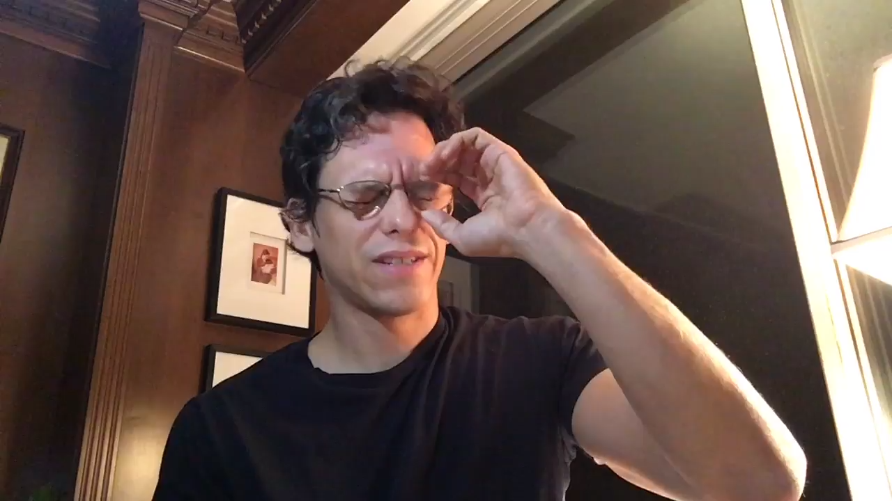
Plot Your Story (4 min)

What does “restate your idea as a problem” mean?
Let’s say your idea was to write a story about an architect building a house. In this example, restating the idea as a problem might be the following: The architect starts building only to realize she doesn’t have enough wood.

What is a “triggering event”?
The triggering event is the action that gets your story moving. So, in the example above, the architect recruits her husband, and the two stand the first beam in the ground. That’s it.

Remember: Be DETAILED!
Which description is better?
A) He was short and stocky. He coughed a lot.
B) Geronimo La Grange was shaped like an eggplant. He had black hair and dark stubble, and he often doubled over from his bouts of asthma, but his wit could paper cut you.
4) Now, from your ideas, choose your best one. Restate your idea as a problem. (1 minute)

5) Plot your story. (3 min)
Beginning: Write the triggering event for your story.

Middle: Write what happens as your main character pursues their goal.

End: Does your character achieve the main goal?

Describe Your Setting & Characters (4 min)
6) Return to page 1 and fill in the information for your characters and setting. Remember to be detailed!

Write Your Story (15 min)

A Few Extra Pointers
Here are a few more tips to make your story stellar:
- Choose one tense and stick with it. Reading’s hard enough; go easy on your reader!
- You’ll never write the perfect story. This is an exercise. Choose an an idea and run with it. Do the best you can within the constraints of your choice and the timer.
- Write in paragraphs. They give your readers a moment to catch their breaths.
7) Write your story, beginning to end. Don’t worry about being perfect. Remember: perfection is the enemy of good.

Proofread (2 min)
8) Finally, go back and proofread your work. This step is important! Catch anything that makes your work look less than perfection.

Write any editing/writing questions you have an in the comments section of the accompanying video to this worksheet:
https://youtu.be/5HhJjZTn9wc

Editing & Writing Questions
Use the space below to jot down any grammar/writing questions that came up as you wrote and proofread: __________________________________________________________________________________________________________________________________________
_________________________________________________________________________________________________________________________________________________________________________________________________________________________________________________________________________________________________________________________________________________________

Photos Courtesy of:
Photos courtesy of:
- Bich Tran
- Pixabay
- Me

