

Assalaamu Alaikum Wa Rahmatullahi Wa Barakatuhu, September 3rd, 2020

Dear Parents/Guardians:

The staff at Saskatoon Misbah School would like to thank you for your patience and support as we prepare for the upcoming 2020-2021 school year. Please read the following information in detail as this will guide our process to begin another wonderful school year.

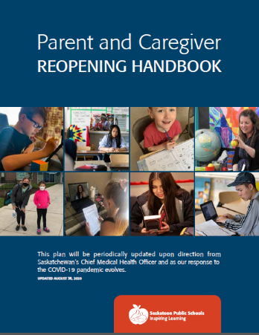Please refer to the [Parent and Caregiver Reopening Handbook](https://www.spsd.sk.ca/division/pandemicresponse/Documents/Parent%20and%20Caregiver%20Reopening%20Handbook.pdf) that was sent to you for general information on the Saskatoon Public School’s reopening plan. This parent handbook provides detailed information on many important topics including:

* Safety Precautions
* Curriculum and Assessment
* Support Services
* Food and nutrition programs
* Facilities

The guidelines of the Parent Handbook will be followed by our school along with elements specific to Saskatoon Misbah School.

The following information represents our school’s specific plan for a safe return to school.

*Please note that the plan is subject to change at any time based on direction from Saskatchewan’s Chief Medical Health Officer. Changes will be communicated as they occur.*

**Important Safety Precautions**

* Any child who is demonstrating any of the following symptoms must stay home**.**



* If your child is staying home due to illness, or for any other reason, please notify the school by calling 306-384-9499.
* Parents/guardians **must** book an appointment to enter the school building. Doing so, we ensure our staff and students’ safety.
* Please remember that all visitors must complete a health check, wear a mask and complete sanitizing procedures such as disinfecting of hands, when entering the building.
* All visitors must complete a health questionnaire on the day of their visit, prior to entering the front door of our school (the back door will be locked). This can be done by accessing a QR code with a smart phone that will be posted at the front entrance or a paper copy that will be provided on a table at the front entrance.
* If a child becomes ill during the school day, parents and guardians will be notified. The child will be placed in an isolation room located by the front entrance of the building. The supervising staff member will wear a mask and face shield and the child will be provided with a mask. The student’s parents or caregivers will be contacted and must pick up their child immediately. The child will be supervised by a staff member until parents/guardians are able to pick them up to take them home.
* Staff members are not permitted to transport students’ home.

**Entering the school**

* Our school has created a plan to ensure efficient and safe pickup and drop off of students. Parents and caregivers are asked to transport their own children where possible.
* To limit traffic congestion on the street, please drop your children off at the **front** of the school by 8:20. Do not exit your vehicle. Supervisors will ensure that your child will meet other children at their muster point. Our buses will also be dropping students off at the front door. Students will wait **outside** for their teacher at designated muster points. These muster points will be labelled with each grade and attached to an orange pylon. Teachers will bring their class into the school at 8:25. All doors to the school will be locked until this time (**See map below**)
* Please refrain from dropping your child at the back door of our school as the doors will be locked and the gate will be closed.
* Teachers will enter the school with their children, one class at a time to promote physical distancing.
* Grades Kindergarten, 3 and 4 (Ms. Kenny’s classroom), 7, and 8 will enter through the front door.
* Grades 1, 2, 4 and 5 (Ms. Turner’s classroom), and 6 will enter through the back door. Teachers for these grades will lead the students to the back door.
* Students will be met by their home room teachers until further notice.

**Exiting the school**

* Students will exit through the same doors they enter through with their teacher.
* Muster points will remain the same at the end of the day.
* Please wait inside your vehicle to pick up your child.
* Please ensure that you pick up your students at dismissal.  **There will be no supervision of students after this time.**

**Busing Information**

* For the safety of all, everyone riding or boarding buses or taxis is required to wear a mask

including students, the driver, school staff, parents/caregivers as required to assist a

student, and any others as maybe required to be on the bus.

* For contact tracing purposes, students will be assigned seats on buses, and a record of the

seating plan will be kept. Students who live in the same household should be seated together.

**Staggered Start Grades 1-8**

* Sept 8-11 will be 4 days of a staggered start
* Alternating Days (T/TH, W/F) with half the class on T/Th and other half attending W/F, students will attend for full days.
* This will allow for students to see the space and learn routines alongside a smaller group of students
* Regular classes begin on Sept 14.

**Specific Kindergarten and Preschool Information**

* Staggered starts will be the week of **September 8** to **September 11**.
* All Kindergarten students will attend ONE half day staggered start day. Kindergarten classes will consist of 5-6 students for each designated day.
* Kindergarten will start **September 14**.
* Staggered starts for preschool student will be the weeks of **September 8** to **September 16.** Preschool students will be alternating days of attending the school during this time.
* All Preschoolers will start **September 17**.

**Bell Times**

* **Monday-Thursday**
  + 8:30-9:20
  + 9:20-10:10
  + 10:10-11:00
  + 11:00-11:50
  + **Lunch 11:50-12:40**
  + 12:40-1:50
  + 12:40-1:30
  + **Prayer 1:30-1:50**
  + 1:50-2:40
  + 2:40-3:30
  + **Dismissal 3:30**
  + **Morning recess will be determined by individual teachers.**
* **Friday**
  + 8:30-9:20
  + 9:20-10:10
  + 10:10-11:00
  + 11:00-11:50
  + **Dismissal 12:00**
  + **There will be no Preschool on Friday afternoons.**
  + **Due to the number of people entering our building for Jummah prayer, dismissal time for Friday has changed to 12:00. All students are required to be picked up at this time. Please ensure that you pick up your child by 12:10. After this time, there will be no staff available to supervise children. There will be no class for preschool students on Friday afternoons.**

**Prayers**

* Students will be trained to perform Tayammum and praying in their own classroom.
* **Please send a prayer rug with your child as a part of their supply list.**
* There will be **no** Jumma prayer on Friday at our school due to early dismissal.

**Lunch at School**

* Students who stay at school for lunch will be eating in their classrooms at their desk.
* Students will be dismissed to their designated play area and will stay with their recess cohort.
* Students will be supported and required to sanitize their hands prior to heading out for recess. Students will also sanitize their hands prior to entering the classroom after recess.
* All sports equipment will be sanitized after each recess. We will be providing a variety of equipment to allow for safe movement and play.

**Flow of Traffic Through the School**

* Students will be expected to walk on the right side of the hallway following the directional arrows.
* Students will follow well labelled arrows on the floor in their classrooms.
* Washrooms will be limited to a specific number of students to promote social distancing. Signs have been posted to show how many students should be in the washroom at one time.
* The washroom in our main hallway will be designated for Preschool to grade 2 students. All other students will use the washrooms at the front of our school.

**Parent/Caregiver Access to School**

* A reminder that parents/caregivers are encouraged to contact the main office to make an appointment if they need to come into the school. **At this point, we request that this occur only if necessary.**
* If a parent has a scheduled appointment, they must use the front entrance.
* Parents/guardians will be required to complete a health questionnaire prior to entering the building the day of their visit. Parents/guardians can complete the questions using a QR code posted at the front door or complete a paper copy of the Covid-19 questionnaire.
* Hand sanitizer will be available in the front entryway for parents/guardians entering the school.
* Parents/Guardians will need to wear a mask when inside the school. If parents/guardians require a mask prior to entry a disposable mask will be provided.
* To support alleviating the need for parents/guardians to come into the school, teachers will establish efficient methods of communication. This may happen through email, phone calls, Class Dojo or classroom platforms such as See Saw or Google Classroom.

**Storage of Student Materials**

Teachers will inform students around new procedures for storing of school supplies and personal materials.



**Hygiene**

Students will be reminded to sanitize when they enter and exit classrooms as well as when they enter and exit for recess and washroom breaks. Social distancing signs will be placed outside the washrooms and water bottle filling stations to ensure sufficient space is given to students to social distance.



**Mask usage**

* Grade 4-8 students are required to wear masks when appropriate physical distancing cannot be maintained.
* Masks are **strongly recommended** for prekindergarten to Grade 3 students.
* All staff are required to wear masks at all times when appropriate distancing cannot be maintained.
* When physical distancing is achievable, mask breaks may occur (i.e. outdoor learning).
* All students are required to wear masks while riding the bus.
* All visitors must wear masks.
* Saskatoon Public Schools will provide one reusable mask for each student. Additional disposable masks will be made available to students when needed and required.
* Students are welcome to bring their own masks.
* 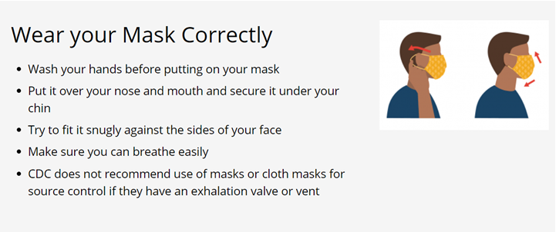In some situations, wearing a mask may not be possible for a student. In these instances, school staff members will work with parents/caregivers to consider accommodations. More information can be found on the CDC website.

**Mental Health and Social-Emotional Supports**

* At the Saskatoon Misbah School, we want to ensure that students who need additional support for their well-being may receive support from our school counsellor. Parents who think that their child needs support can contact their teacher or administrator. The counsellor will work with the teacher and administrator to determine proper supports, which may include direct support and/or assisting students and families to access other services in the community.
* Well-being is one of our four student goals in our school division strategic plan. Opportunities to learn about and practice well-being exist across multiple curricular areas.

We look forward to seeing students the week of September 8th, 2020. Please do not hesitate to contact the school if you have any questions or concerns 306-384-9499 or email SMS-AA@spsd.sk.ca.

Jazak Allahu Kharian,

SMS Administration