Nuachtlitir Feabhra 2020

Laethanta Saoire
Beidh na páistí saor ar na laethanta seo leanas
20ú & 21ú Feabhra Briseadh Leath Téarma
16ú &17ú Márta Lá Fhéile Pádraig
Íocadh ar line/ Online Payments
Beidh fógraí agus litreacha ag dul amach chuig tuismitheoirí an mhí seo chugainn maidir le híocaíocht a dhéanamh ar líne. Beidh tuimitheoirí in ann billí a íoc ar line ag baint úsáide as an Aladdin App. Tá súil ag an mBord Bainistíochta go mbeidh an córas i bhfeidhm i gcomhair téarma a trí nuair a bheidh na táillí le haghaidh turais scoile agus an scéim cíosa leabhar á n-íoc .
Parents will receive written and text notification of a new online payments system which the Board of Management are bringing in to the school. Parents will have the facility of paying bills online on the Aladdin App. We hope to have the system up and running for term three and payments for school tours and book rental can be made in this manner.
Feachtas Gaolainne na Scoile
Tá feachtas tosaithe le cupla mí anois cabhrú le tuismitheoirí feabhas a chur ar gcuid Gaolainne féin. Tá frásaí le feiscint ar an gclár i gclós na scoile. Ón mhí seo ar aghaidh beidh físeanna beaga le feiscint ar nasc ar suíomh na scoile . Beidh daltaí agus tuismitheoirí ag eiseamláiriú frásaí na míosá.
At the request of parents the school is encouraging and helping parents to improve their own use of Irish. The green board in the school yard has phrases posted regularly. A short video link helping with pronunciation can be found on the school website. These videos of pupils and parents will be updated regularly.
Drámaíocht
Comhghairdeas do Rang a ceathar a chur scéal Naomh Bríd i láthair duinn an Aoine seo chaite. Beidh Rang a 4 páirteach i gCoirm an mhí seo chugainn agus le cúnamh Dé beidh lá deas acu ag an gComórtas
Rang a 4 hopefully will perform at Coirm in March following their successful performance of Scéal Naomh Bríd for February 1st.
Eolaíocht
Beidh Rang a Cuíg ag freastal ar an mBleaist Eolaíochta i mBaile Átha Cliath ar an 5ú Márta. Beidh deis acu bualadh le páistí ó Ghaelscoileanna eile agus labhairt faoi taighde atá déanta acu féin agus na h-imscrúdaithe atá déanta ag páistí / scoileanna eile.
Rang a 5 are off to the R.D.S. on March 5th to participate in Bleaist Eolaíochta ( Science Blast). They will have the opportunity to discuss their own project and see and discuss what other schools have done…all as Gaeilge.
Brat Ghníomhach.
Tá obair idir láimhe anois go cinnte ar an mBrat Ghníomhach faoi stiúir Mhúinteoir Denise agus Múinteoir Deirdre. Tá a damhsa féin á dhéanamh ag gach Rang agus beidh taispeántas againn ag an tionól ag deireadh na míósa.
The children are working hard at keeping active as part of the work being done to achieve an Active Flag our active flag.. Each class is learning a new dance and we will see the end result at assembly at the end of the month.
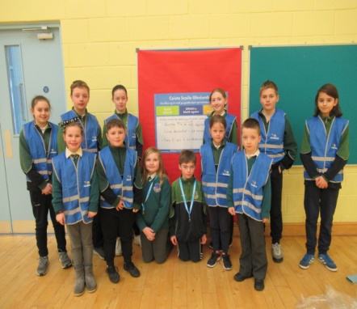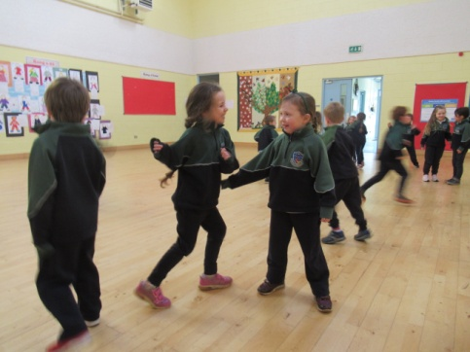
Naíonáin ag rince agus na daltaí atá ar an gCoiste don Bhrat Ghníomhach
Lá na bpancóga .
Beidh foireannn de thuistí linn ar an 3ú Márta le cabhrú le Rang a Sé pancóga a chur ar fáil do gach páiste. Beidh costas €1 an pháiste ar na pancóga. Rachaidh an t-airgead go dtí Ospidéal na Leanaí i gCrumlin.
Parents and Rang a 6 will cook pancakes for all the pupils on Pancake day on March 3rd. Children are asked to bring in €1 donation and all the funds will go to Crumlin Children’s Hospital.

Mí Feabhra…. Mí an Chinnealtais agus Cairdeas
I rith na míosa seo beidh foireann na scoile ag cur béime ar chairdeas agus slite inar féidir linn bheith deas lena chéile. Tá an obair ealaíne sa halla bunaithe ar an téama sin. Labhair leis na páistí , deirfinn go mbeidh neart smaointe acu.
During the Month of February the staff will be discussing all the positive attributes of friendships and kindness. The art work in the school hall is based on this theme The children have lots to say if you would encourage them to talk.
Sláinte agus Sábháilteacht
Meabhrú do dhaoine go mbeidh an trácht trom ar an 10ú Feabhra leis an gcomhaireacmh don toghachán ag dul ar aghaidh in Ionad Naomh Iosaf. Beidh foireann de thuismitheoirí ag cabhrú linn cinntiú go dtagann gach páiste slán isteach sa scoil.
Parents are reminded that there will be heavy traffic and possible a large number of cars parked in the area due to the election count happening in St Josephs. A team of parents will be at the school gate and carpark to help ensure that all children arrive safely.

Cuairt ó chigirí na Roinne.
Mar a duirt san teachtaireacht ar Aladdin beidh cigirí na Roinne ag tabhairt cuairte ar an scoil le haghaidh MUS ( Meastóieacht Uile Scoile)an tseachtaine seo chugainn. Meabhraím do thuistí nach bhfuil tar éis an ceistneoir a sheoladh thar nais chuig an scoil é a dhéanamh chomh luath agus is féidir.
As mentioned in Aladdin message a team of inspectors will visit the school next week for a WSE ( Whole School Evaluation) Parents who have not retured their questionnaires should return them as soon as possible.

