Nuachtlitir na Nollag 2018

Carúl na Nollag19ú &20ú/12/2018
Laethanta Saoire 21/12/2018
Ag Filleadh ar scoil 7/1/2019
Lá Inseirbhíse 20/02/2019

Carúl na Nollag.
I mbliana beidh na Naíonáin bainteach le Carúl na Nollag. Le sin a éascú beidh taispeántas agus drámaí ó Naíonáin Bheaga , Naíonáin Mhóra , Ranganna 1agus 2 sa scoil ar an 20ú ag 12.30. Beidh fáilte is fiche roimh tuismitheoirí freastal ar an dtaispeántas seo. Beidh cead ag na páistí dul abhaile tar éis an seó ach beidh seirbhís an chlub ar fáil chomh maith.
Ar an 19ú beidh na h-ard ranganna ag canadh carúil sa séipéal i Sr Ruaidh ag 7 a chlog. Mairfidh na carúil thart ar 45 noiméad. Beidh fáilte roimh tuismitheoirí.
This year the Infant classes will participate in the school’s celebration of Christmas. The Junior classes , Infants 1st and 2nd class will perform in the school at 12.30 on December 20th. All parents are welcome and children can go home after the performance but the club will also operate on that day.
On December 19th the Senior classes will sing at the Carol Service in Rowe St. Church at 7.00p.m All are welcome.
Bazaar na Nollag
Míle buíochas dona tuismitheoirí a dhein an obair don ullmhúchain agus cur i láthair le h-aghaidh Bazaar na Nollag. Bhí an lá againn go léir agus d’éirigh leis an gCoiste €4600 a bhailiú le dul idtreo an athchóireamh ar an gclós
Many thanks to all the parents who prepared and helped with the Bazaar. The feedback has been wonderful and the Parents Council have succeeded in raising €4600 towards the fund for developing the school playground.

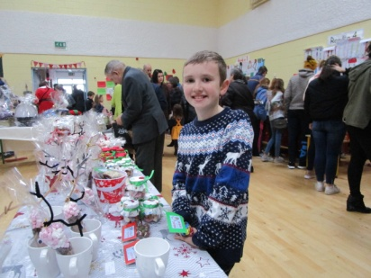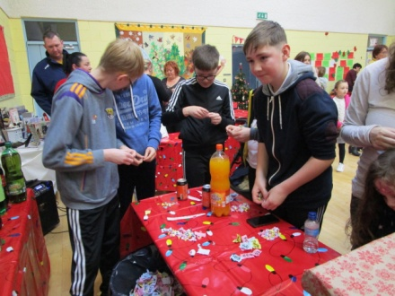
Na buachaillí ag baint sult as an bazaar

Banc taisce
Beidh airgead á bhailiú don lá deireanach roimh Nollag ar an 13/12/2018 Beidh ar na páistí atá ag iarraí airgead a thógaint amach as a gcuntais an teolas sin a thabhairt ar an lá sin chomh maith. Gheobhaidh na páistí a gcuid airgead an tseachtain roimh na laethanta saoire.
The final day for saving in the Banc Taisce is December 13th. Children who wish to withdraw money should notify Caroline on that day also.The withdrawals will be distributed the following week.
Lá Staire sa scoil.
Bhí cuairt ag na h-ardranganna agus na Naíonáin Mhóra ó stairí Michael Moylan a ndearna ana chuid earraí agus deantúsáin a thaispeáint dona páistí agus bhaineadar an sult as.
Rinne sé scéalta a n-insint dona Naíonáin Mhóra.
The school had a visit from one of the Heritage in Schools facilitators. Michael Moylan brought a van full of interesting historical objects for the children to handle, talk about and discuss, a real hands on history lesson.
Naíonáin Mhóra were enthralled with his telling of some of our ancient legends.
Gleacaíocht
Beidh na ranganna gleacaíochta críochnaithe roimh Nollag,meabhrú beag do dhaoine nach bhfuil tar éis an táille a níoc. Gymnastics finishes for Junior Classes next week, reminder to those who have yet to pay €10 fee.
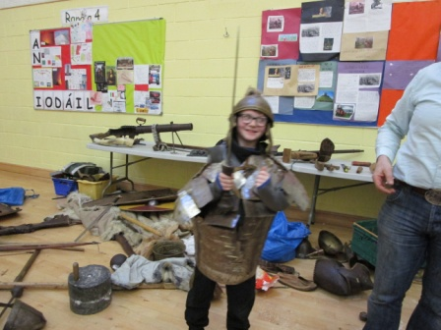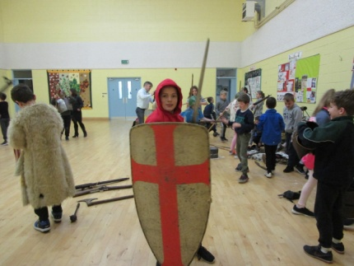
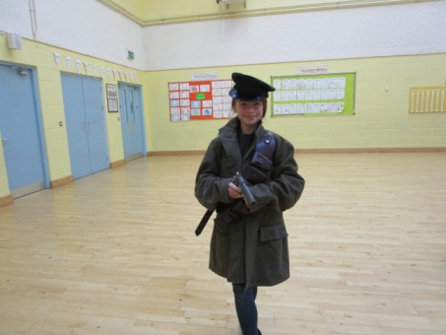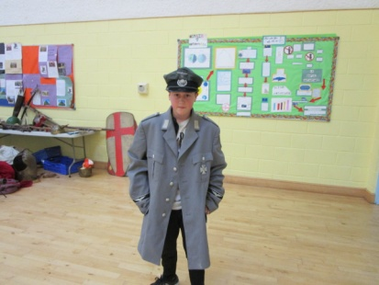
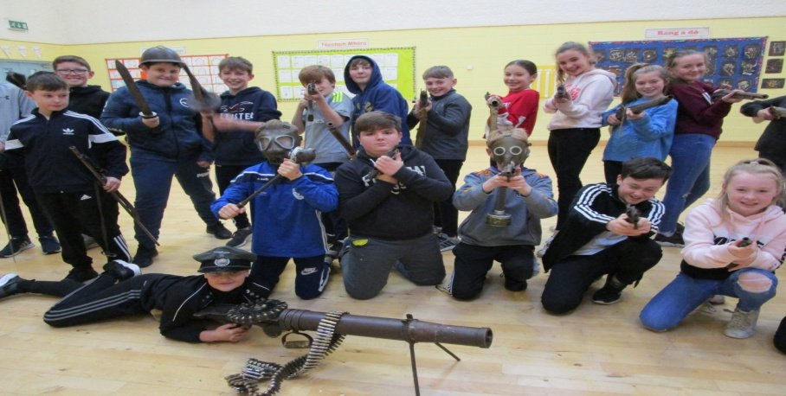
Nollaig Shona Díobh go léir

