Nuachtlitir
Deireadh Fómhair 2018
Ra
Rang
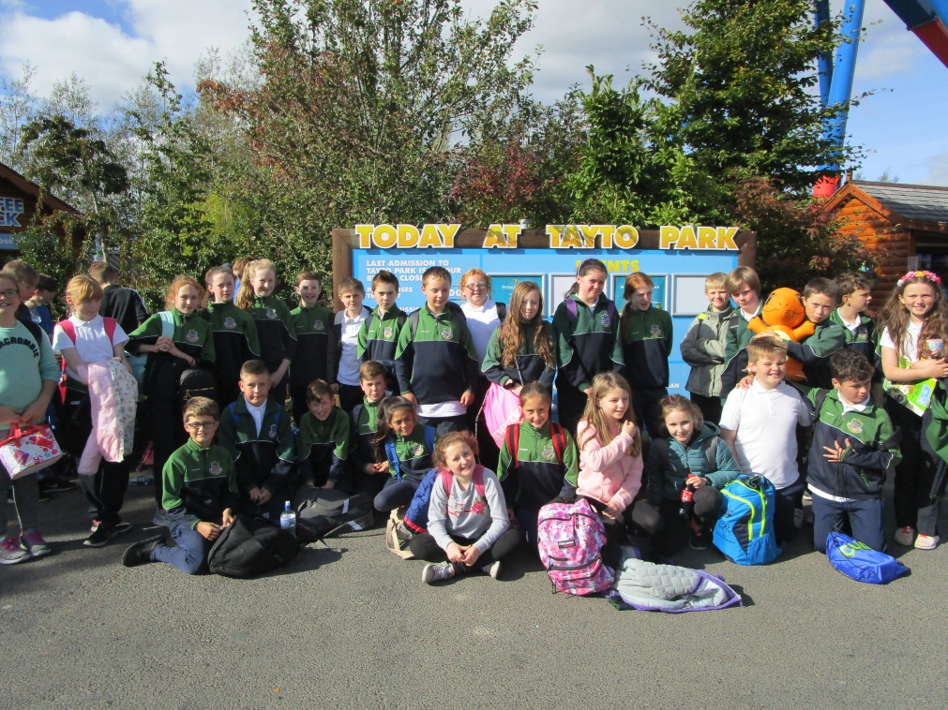
Rang a Cúig tuirsech traochta tar éis an lá i Tayto Park
Bhí an lá ag ranganna 5 &6 ag Tayto Park ar an 28/9/2018. Tháinig soileanna ó chian agus ó chongar….Sligeach , Corcaigh. Baile Átha Cliath, Ciarraí sr le breithlá an Fhorais a cheiliradhl. Bhí neart Gaeilge le cloisteáil agus bhíomar ana bhródúil as na daltaí i nGaelscoil Charman toisc gur labhraíodar i nGaeilge an lá ar fad agus bhíodar deabheasach agus ciallmhar. Buíochas do Susan agus Róisín a tháinig linn ar an lá le cabhrú linn.
Fifth and Sixth class had a fantastic day in Tayto Park on Friday September 28th. They met with other children attending Gaelscoileanna from all over the country. The children did us proud as they spoke Irish fluently all day and they were extremely well behaved. A big Míle Buíochas to Susan and Róisín(tuismitheoirí) who came with us to help on the day.
Ag Bailiú airgid.
Bhí tuismitheoirí gnóthach ag pacáil i Dunnes ag an deireadh seachtaine ag bailiú airgid ar son na scoile. D’éirigh leo €1380 a bhailiíú don scoil. Míle, Míle buíochas dona tuismitheoirí a chabhraigh ag an deireadh seachtaine.
Tá réamh obair agus pleanáil idir láimhe ag an mBord Bainistíochta le athchóireamha dhéanamh ar an gclós Spraoi ar chúl na scoile. Beidh an thuilleadh eolas ag teacht chugaibh amach anseo. Tá gach pingin atá á bhailiú againn á choigilt don tionscadal seo.
While we were away in Tayto Park members of the Parents Council with the support a team of parents were bag packing in Dunnes Stores. They also worked there on Saturday. They managed to collect€1380.
All the monies collected at events this year are to be spent on upgrading our JUNIOR YARD. The Board of Management are planning and costing this project. We hope to get started on the project soon.
Oíche Eolais do thuismitheoirí.
Bhí aoichainteoir ag caint le Rang a Sé faoi sábháilteacht agus iad ag baint úsáide as an idirlíon ag tús na míosa seo chaite. Beidh an aoichainteoir John Dwyer ag tabhairt oíche eolais do thuismitheoirí bunaithe ar an gcaint aát cloiste ag na páistí ag scoile na Faiche ag 7.30 ar an 8ú Deireadh Fómhair. Tá an oíche eolais oscailte d’aon thuismitheoir ní amhain tuismitheoirí na bpáistí i Rang a 6. Tá sé beartaithe ag an scoil duine a fhostú le labhairt le Rang an 5 níos déanaí sa bhliain.
Parents are invited to an Information Night about Internet Safety for your children which will be held in The Faythe Scool on October 8th at 7.30. The present 6th class had a talk on the subject in September from John Dwyer the presenter on the night The same talk was given most of 6th class pupils in the town schools. The information night is open to all parents not just those of 6th class pupils. We hope to arrange a guest speaker for Rang a 5 later in the year.
Banc Taisce
Beidh Caroline agus Majella ar fáil gach Déardaoin ón Déardaoine seo chugainn an 4ú Deireadh Fómhair le hairgead a bhailiú don bhanc taisce. Is féidir le páistí ó rang a 1-6 airgead a choigilt gach seachtain más mian leo.
Caroline and Majella will restart the Savings club for children in Ranganna 1-6 next Thursday.
Síntiús Deonach.
Meabhrú beag do thuismitheoirí an síntiús deonach a íoc muna bhfuil go dtí seo. Beidh Caroline ar fáil é a bhailiíú roimh scoile 8.30-8.50 agus i ndiadh scoile 1.30-3.00 ar an 3ú agis an 4ú Deireadh Fómhair. Míle buíochas do thuismitheoirí a d’íoc an síntiús deonach cheanna
A Reminder to parents who haven’t yet paid the Voluntary Contribution that Caroline be available to collect it on Wednesday 3rd and 4th from 8.30-8.50 and from 1.30-3.00. Thanks to all the families who have paid to date.
Siúlóid Spraoi
Beidh na páistí ag gleasadh i gcomhair an Siúlóid Spraoi ar an 26ú Deireadh Fómhair. Beidh na sonraithe á sheoladh amach ag múinteoirí na Naíonáin agus beidh na cártaí urraithe curtha ar fáil an tseachtain seo chugainn. Tá fáilte roimh tuismitheoirí bheith i láthair ar an lá. cártaí. Beidh cead dul abhaile ag 12.00 ar an lá.
Children will be dressing up for The Siúlóid Spraoi on October 26th. Parents are welcome to come to watch the walk and all children are allowed to go home at 12.00 on that day. Sponsorship cards will be available soon.
Is féidir teach tar fógraí maidir le heactaí scoile ar an bhféilire ar an suíomh. Notices of all school events are posted on calendar on the school website
Taispeántais sa halla.
Bhí na hardranganna ar siúlóid staire sa bhaile mór agus tá a thuilleadh beartaithe dóibh amach anseo.
Rinne na páistí an obair ar ábhair staire an mhí seo. Tá obair na bpáistí le feiscint sa halla. Tá fáilte roimh tuismitheoirí teacht isteach agus na taispeántais sin a fheiceáil.
The Senior classes went on a number of historical walks in September and all classes have displayed the work that they covered in history during this month in the hall. Parents are welcome to come to see the work and talk to their children about it
Meabhrú maidir le páirceáil.
Tá boscaí buíthe ag geataí na scoile dona busanna sa tráthnóna. Baintear úsáid astu ar maidin do thuismitheoirí na bpáistí is óige le na leanaí a fhágail chomh chongarach don chosáin agus is féidir. Iarrtar ar thuismitheoirí na bpáistí sna hardranganna na páistí a fhágáil ag áiteanna gur féidir leo siúl. Chomh maith le sin impím ar thuismitheoirí gan an ionad do dhaoine faoi mhí chunas a úsáid. Tá tuismitheoirí agus gar thuistí gan chumas ag teacht chuig an scoil agus tá an áit gafa nó níos measa tá carr párcáilte taobh thuas de ionas nach féidir dul isteach Ná dean do charr a phárcáil san áit sin gan cúis le do thoil.
A reminder to parents that the yellow boxes at the front of the school are designated parking for buses in the afternoon and drop off areas for the parents of younger children in the morning. Older children should be dropped off at other parking areas. Also the disabled area is designated for disabled and elderly only. Parking above the disabled area is also a hindrance to the disabled driver and it blacks access to and from the school carpark. Please refrain from parking in these areas
Rang a Sé an sásta leo féin tar éis an lá deas a chaitheamh I Tayto Park. Beirt breise sa Rang ag teacht abhaile le Josh agus Darragh!!!!

