Nuachtlitir
Samhain 2019
Dátaí Tabhachtacha
18ú Samhain Lá Inseirbhíse. Beidh an scoil dúnta ar an lá sin. School Closed
21ú Samhain Cruinnithe leis na Múinteoirí. Páistí ag críochnú ag 1.15 agus 2.15/ School finishes at 1.15 &2.15 to facilitate meetings
1ú Nollaig Bazaar na Nollag
13ú Nollaig Ceolchoirm na Naíonáin agus Rangann 1&2
18ú Nollaig Ceolchoirm na h-Ard ranganna
Bord Bainistíochta Nua
Beidh an Bord Bainistíochta nua ag feidhmiú ón 1ú Nollaig.
The new Board of Management will be functioning from December 1st
Seo iad thíos na baill/ The following are the Board Members
Ionadaithe an Fhorais Tomás Ó Gallachóir ( Cathaoirleach)
Máire Uí Liatháin
Ionadaithe na dTuistí Orla Uí Fhathaigh
Briain O Flathartaigh
Ionadaithe na Foirne Dearbhla Mhic Coillte
Áine Uí Ghionnáin
Ionadaithe ón bPobal Seán Ó Riain
An t-Athair Mícheál Ó Sé
Sport
Chaill na cailíní agus na buachaillí amach sna cluichí deiridh den Rackard League. Tá an dá fhoireann bainteach leis an gcomórtas Rising Stars anois agus beidh cluichí acu an mhí seo. Go néirí leo.
Unfortunately the boys and girls teams were unsuccessful in their efforts to come through in The Rackard League. However both teams are participating in the Rising Stars now and will have a number of matches this month.
Caidreamh agus Gnéas. R.S.E.
Tá fógra maidir le múineadh an Caidreamh agus Gnéas curtha suas ar Aladdin. Chomh maith le sin beidh na ceachtanna ag dul abhaile an leath téarma seo. Beidh deiseanna ag tuismitheoirí aon cheisteanna nó buairt atá acu a phlé le múinteoirí ag na cruinnithe nó coinne a dhéanamh má tá cúis aon rud a phlé.
Relationships and Sexuality Education will be taught in all classes this half term. Parents can have access to the material being taught or they can discuss concerns etc with class teachers at the parent /teacher meetings . The school is happy to facilitate meetings with parents who wish to discuss any concerns they might have.
Ceadúnais/ Permssions
Tá cead lorgaithe do pháistí an idirlíon a úsáid ar Aladdin. Baineann seo leis an gceadúnas reatha atá ón scoil. Tá polasaí na scoile maidir le húsid Imghlactha Ríomhairí ar fáil ar suíomh na scoile. Nuair atá an ceadúnas faighte ar Aladdin beidh sé gcód an pháiste. Ní bheidh cúis an cead a lorg arís. Molaim do thuismitheoirí an ceadúnais a scaoileadh chomh luath agus is féidir.
The school has sought permission for children to use the internet at school. The permission has been sought on Aladdin. The Internet Use Policy can be accessed on the school website. Once the permission has been granted on Aladdin it will be stored on your child’s file. We would encourage Parenst to release the permission at your earliest convenience.
Tá ceadúnais don snámh lorgaithe i gcomhair Ranganna 3&4
Permission for swimming has been sought in the same manner for Ranganna 3&4
Obair ar an gclós agus Bailiúchn airgid
Tá an cuid deireanach den chlós le bheith déanta roimh Nollag le cúamh Dé. Míle buíochas do gach duine a chabharaigh linn an obair sin a chur i gcrích.
Tá Coiste na dTuistí fós gnóthach ag eagrú eachtraí le hairgead a bhailiú leis na billí deiridh a íoc.
Bhailigh an scoil €1415 ar an Siúlóid Spraoi. Míle buíochas dona páistí a d’imigh amach san fhuacht agus an bhaisteach le hurraíocht a lorg. Tá meon an choiste anois dírithe ar an Bazaar. Beidh lá gan éide scoile aginn ar an 15ú Samhain agus beidh earraí seacláide á lorg againn don Bazaar. Arís beidh lá gan éide scoile againn ar an 22ú Samhain is buideil a bheidh uainn don seastán sin don Bazaar. Beidh an Bazaar féin ar siúil ar an 1ú Nollaig. Tá súil againn go leor airgead a thuilleadh le críoch a chur leis an gclós.
The final stage of the work on the school playground will be done before Christmas. Thank you to all the parents and friends who supported our fundraising activities in the last few years. The Siúlóid Spraoi raised €1415 this year. Thanks to all the pupils who went out in the wind and rain to collect for the school. The next event on the calendar is the Christmas Bazaar. The pupils will have a no uniform day on the 15th of November and we will be collecting chocolate items for the chocolate stall. On the 22nd the second no uniform day bottles will be collected for the bottle stall. The Bazaar itself will be held on December 1st. All monies will go to finishing the work on the playground.
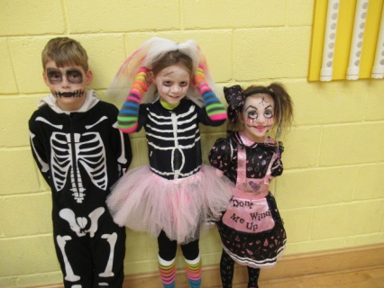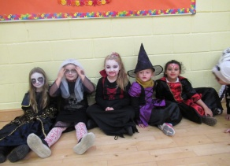

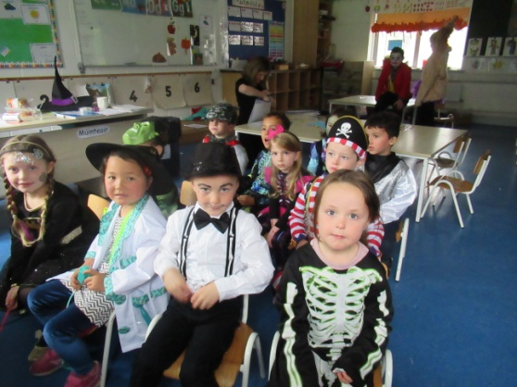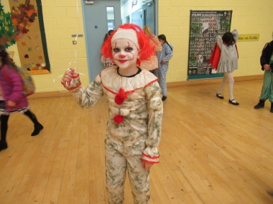
Gaeilge sa Scoil.
Ba mhaith le Coiste na dTuistí tuismitheoirí a spreagadh Gaeilge a labhairt ag geataí na scoile , lena bpáistí agus i measc pobal na scoile. Dá bharr san beidh abairtí agus frásaí a scaipeadh acu ar Whatsapp, agus beidh na frásaí scaipthe ar fud na scoile , sna Nuachtlitreacha agus ar fógraí os comhair na scoile. Bainigí triail as na cupla focal! Beidh na frásaí chéanna ag na páistí
The Parents Council have been approached by parents who wish to improve their Irish , to aid this wish we will be sending out phrases and sentences for parents to use at the school gate , with children and with the school population. The phrases will be posted at the school door, sent out on the class WhatsApps and will be noted in the Newsletters. Please try out your cupla focal. Your children will know these phrases too.
Frásaí na Míosa seo.
Nach bhfuil sé fuar? ( Isn’t it cold?)
Tá mé preachta leis an bhfuacht.( I’m frozen with the cold)
Aon scéal? (Any News?)

